**Distributed Operating Systems, Project 4 Part I: Twitter Simulator**

**Group Members:**

1. **Nishtha Shrivastav, UFID: 2594-5398**
2. **Tushar Kaley, UFID: 9126-1421**

**Instructions to RUN Simulation:**

1. Run following commands from the directory which has mix.exs

**mix compile**

**mix run proj4.exs num_user num_msg**

num_user = number of twitter users

num_msg = number of tweets per user

**Working:**

1. Simulation of Twitter Engine.

2. Tweet, Retweet, Subscribe to twitter user

3. Query using - hashtags, mentions

**Largest Simulation:**

200 active users each tweeting 5

**Time Required:** 3min 15.730s

100 active users each tweeting at least 1 tweet

**Time Required:** 986.558s

**Sample Outputs**

Num of users = 50

Num of messages = 5

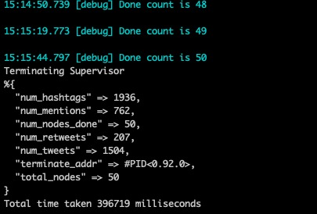

**Testing**

We have used ExUnit, elixir’s built-in test framework to write the following tests

**Instructions to RUN Tests:**

1. Run following commands from the directory which has mix.exs

**mix test test/class.exs --trace**

**class.exs** is the name of the test class. We have 3 test classes:

* **core_tests.exs**
* **register_delete_tests.exs**
* **utils_tests.exs**

**Test Cases**

1. Add a user
2. Delete a user
3. Follow a user
4. Query using hashtag
5. Query using mentions
6. Get all tweets
7. Get my notifications
8. Deliver tweets to the tweeter’s followers if they are alive
9. Save tweets to the tweeter’s followers’ table if they are alive

**Execution Times:**

|  |  |  |
| --- | --- | --- |
| num of users | 5 Messages | 10 Messages |
| 10 | 63.242 | 101.181 |
| 20 | 148.164 |  |
| 50 |  |  |
| 100 |  |  |
| 200 |  |  |