**ASSIGNMENT – 6:**

**CCNA- NETWORK FUNDAMENTALS**

|  |
| --- |
| **TERM - 2** |

**1. Which of the following messages in the DHCP process are broadcasted? (Choose two)**

**A. Request**

**B. Offer**

**C. Discover**

**D. Acknowledge**

**Answer: (a)** Request & **(c)** Discover

**2. Which command would you use to ensure that an ACL does not block web-based TCP traffic?**

**A. permit any**

**B. permit tcp any any eq 80**

**C. permit tcp any eq 80**

**D. permit any any eq tcp**

**Answer:** (b) permit tcp any any eq 80

**3.** **Explain Network Topologies.**

**Answer:**

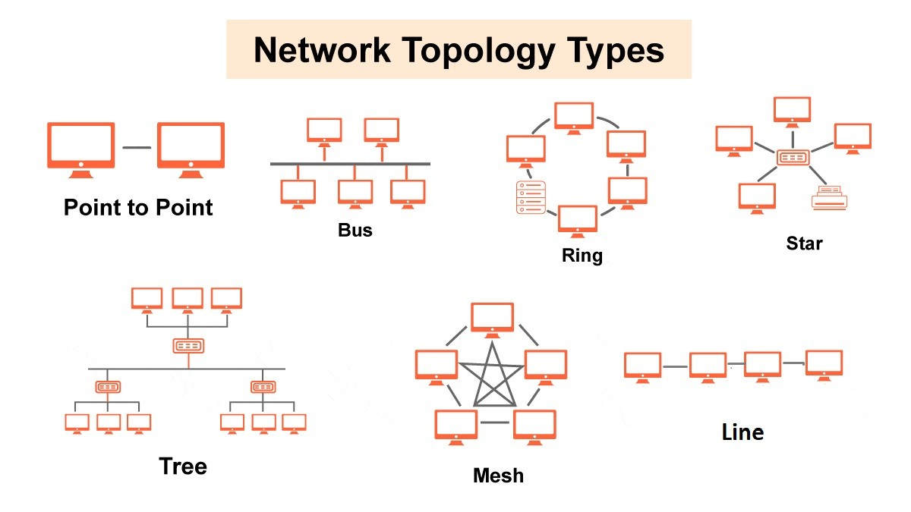

Network topology refers to the arrangement of network devices and how they communicate. Common types include:

* **Bus Topology:** All devices share a single communication line. Simple but prone to failures.
* **Star Topology:** All devices connect to a central switch or hub. Reliable but depends on the central device.
* **Ring Topology:** Devices form a closed loop. Data travels in one direction, reducing collisions but failing if one device breaks.
* **Mesh Topology:** Every device connects to multiple others. Very reliable but costly.
* **Hybrid Topology:** A mix of two or more topologies, offering flexibility.

**4. Explain TCP/IP Networking Model**

**Answer:**

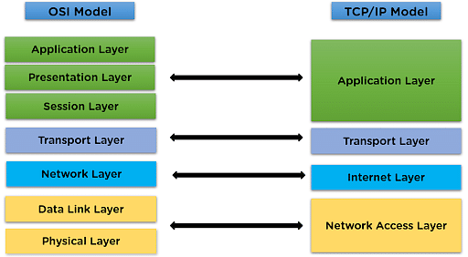

The TCP/IP model operates on four distinct layers: Application Layer, Transport Layer, Network Layer, and Network Access Layer, with each layer performing specific tasks related to data transmission.

* **Application Layer:**

This layer interacts directly with user applications like email, web browsing, and file transfer, defining how data is presented and formatted before being sent to the network.

* **Transport Layer:**

Responsible for reliable end-to-end data delivery by establishing connections between applications, managing data segmentation, and ensuring data is received in the correct order through protocols like TCP (Transmission Control Protocol) and UDP (User Datagram Protocol).

* **Network Layer:**

Handles packet routing across networks by assigning logical addresses (IP addresses) to devices and determining the best path to send data using the Internet Protocol (IP).

* **Network Access Layer:**

Manages the physical connection to the network and Deals with hardware addressing (MAC)

**5. Explain LAN and WAN Network**

**Answer:**

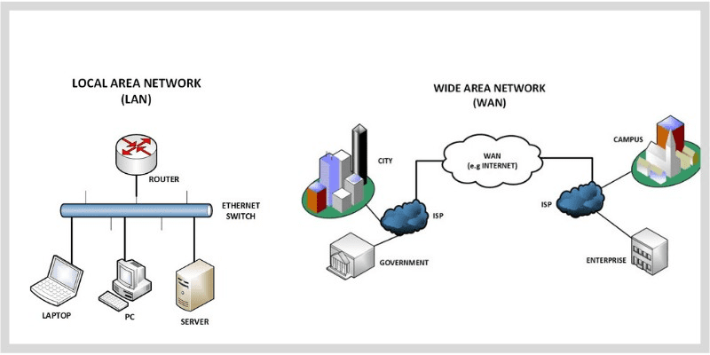

**LAN (Local Area Network)**

* A LAN connects devices in the same building or office complex
* LANs are often used in homes, schools, and offices
* LANs use cables or Wi-Fi to connect devices
* LANs are usually more secure than WANs
* LANs use Ethernet technology and Layer 1 and Layer 2 devices

**WAN (Wide Area Network)**

* A WAN connects devices across cities, countries, or continents
* WANs are often used to connect multiple LANs together
* WANs use satellite links, leased lines, and multiprotocol label switching (MPLS)
* WANs are more susceptible to security threats than LANs
* WANs use Layer 3 devices such as multi-layer switches and routers

**6. Explain Operation of a Switch**

**Answer:**

A **network switch** is a Layer 2 device that connects multiple devices within a LAN. It operates using:

1. **MAC Address Learning** – The switch builds a table mapping MAC addresses to switch ports.
2. **Forwarding & Filtering** – It forwards packets only to the intended destination instead of broadcasting them.
3. **Collision Domain Separation** – Each port creates its own domain, preventing collisions and improving efficiency.

**7. Describe the purpose and functions of various network devices**

**Answer:**

**Switch:**

A fundamental device that connects multiple devices within a network, directing data only to the intended recipient, improving network efficiency by avoiding unnecessary traffic.

**Router:**

Determines the best path for data to travel between different networks, translating IP addresses and routing packets across networks.

**Access Point (AP):**

Provides wireless connectivity to devices by acting as a central hub, allowing them to join a network and communicate with each other.

**Firewall:**

A security system that monitors incoming and outgoing network traffic, blocking suspicious or malicious data to protect a network from unauthorized access.

**Bridge:**

Connects two different networks together, filtering traffic between them based on MAC addresses

**Repeater:**

Amplifies a weak signal to extend the range of a network by retransmitting the signal at a higher strength.

**Gateway:**

The entry point to a network, translating between internal network protocols and external networks like the internet.

**Modem:**

Converts digital data signals from a computer into analog signals that can be transmitted over phone lines, enabling internet access

**8. List of Appropriate Media, Cables, Ports, and Connectors to Connect Switches to Other Devices**

**Answer:**

|  |  |  |  |  |
| --- | --- | --- | --- | --- |
| **Connection Type** | **Media Type** | **Cable Type** | **Port Type** | **Connector Type** |
| **Switch to Switch** | Copper (Ethernet) | Cat5e, Cat6, Cat6a | Gigabit Ethernet (RJ45) | RJ45 |
|  | Fiber Optic | Single-mode/multi-mode fiber | SFP/SFP+ Port | LC, SC |
| **Switch to Router** | Copper (Ethernet) | Cat5e, Cat6, Cat6a | Gigabit Ethernet (RJ45) | RJ45 |
|  | Fiber Optic | Single-mode/multi-mode fiber | SFP/SFP+ Port | LC, SC |
| **Switch to PC/Server** | Copper (Ethernet) | Cat5e, Cat6, Cat6a | Gigabit Ethernet (RJ45) | RJ45 |
| **Switch to Access Point** | Copper (Ethernet) | Cat5e, Cat6, Cat6a | Gigabit Ethernet (RJ45) | RJ45 |
| **Switch to Firewall** | Copper (Ethernet) | Cat6, Cat6a | Gigabit Ethernet (RJ45) | RJ45 |
| **Switch to ISP/Internet** | Fiber Optic | Single-mode/multi-mode fiber | SFP/SFP+ Port | LC, SC |

* SFP/SFP+ - Small Form-Factor Pluggable
* RJ45 - Registered Jack-45
* SC - Subscriber Connector
* LC- Light Connector

**9. Define Network Devices and Hosts**

**Answer:**

**Network Devices:**

These are hardware components used to connect and manage communication in a network. Examples include:

* **Router:** Directs network traffic between different networks (e.g., LAN to WAN).
* **Switch:** Connects multiple devices within a LAN and forwards traffic efficiently.
* **Hub:** A basic device that broadcasts data to all connected devices.
* **Firewall:** Secures the network by filtering incoming and outgoing traffic.
* **Access Point (AP):** Extends Wi-Fi connectivity in a network.
* **Modem:** Converts digital data to analog signals for internet access.

**Hosts:**

These are end devices that send or receive data within a network. Examples include:

* **Computers (Desktops, Laptops, Servers)**
* **Smartphones and Tablets**
* **Printers and Network Storage (NAS)**
* **IoT Devices (Smart TVs, Security Cameras, Smart Home Devices)**