Customer Churn Prediction in Telco Company
Customer churn arise when customer stop doing business with a company or services within a specific amount of time. Retaining customer is important for companies in order to enhance their revenue and it built meaningful association with customer. Customer retention is actually more valuable then customer acquisition. So we will see and analyze the customer churn based on the given data.
First of all we will import all the libraries from python which are require for the analysis of the given set of data. Some of the important libraries are pandas, numpy, sklearn, seborn, matplotlib etc. and then upload the csv file using pd.read command into data frame. To look at the data we will use head() command and see the first five row and column of data set
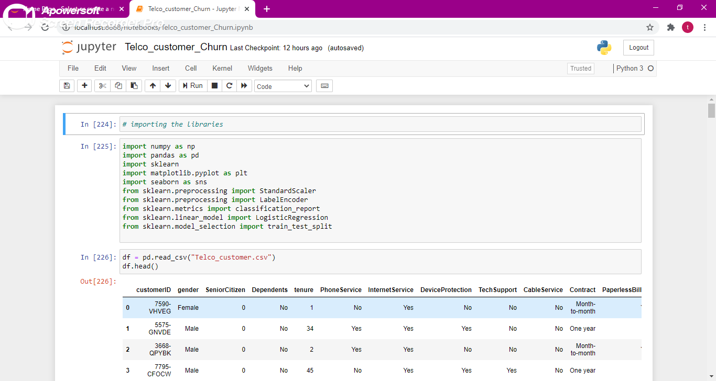
To see the number of rows and column in given data set we will use shape function and that shows 7043 rows( customers) and 16 column(data points) in our data set. We will use column.values function to see all the column name e.g, customerID', 'gender', SeniorCitizen', 'Dependents', 'tenure', 'PhoneService', 'InternetService', 'DeviceProtection', 'TechSupport', 'CableService', 'Contract', 'PaperlessBilling', 'PaymentMethod', 'MonthlyCharges', 'TotalCharges', 'Churn'
Now we will check for any missing data or NA values in our data set. We will use .isna().sum() command for that and now we can see that column name on right side and na values in left side. We can clearly see that values belongs to each column is zero, so this data has no missing values.
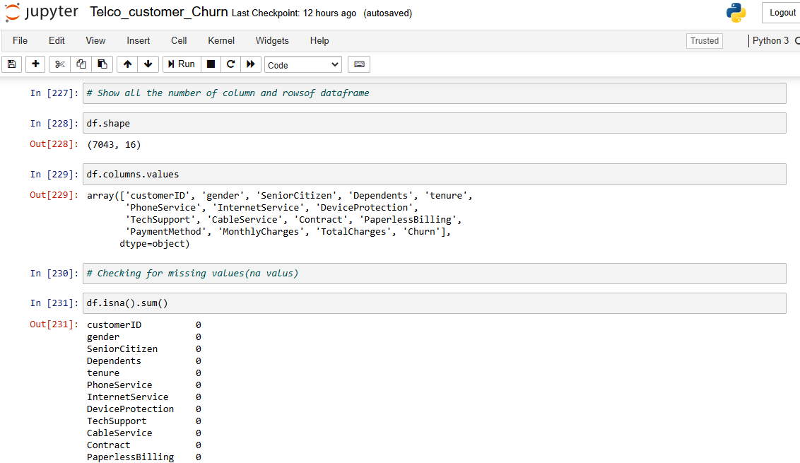

To see the statistics data related to our data set use describe function. This shows the count mean, Std. deviation, max, min , first quartile and third quartile values for columns having integer values. To get customer churn count use values_count() function. To visualize the count of customer churn use countplot function which show the bar charts .
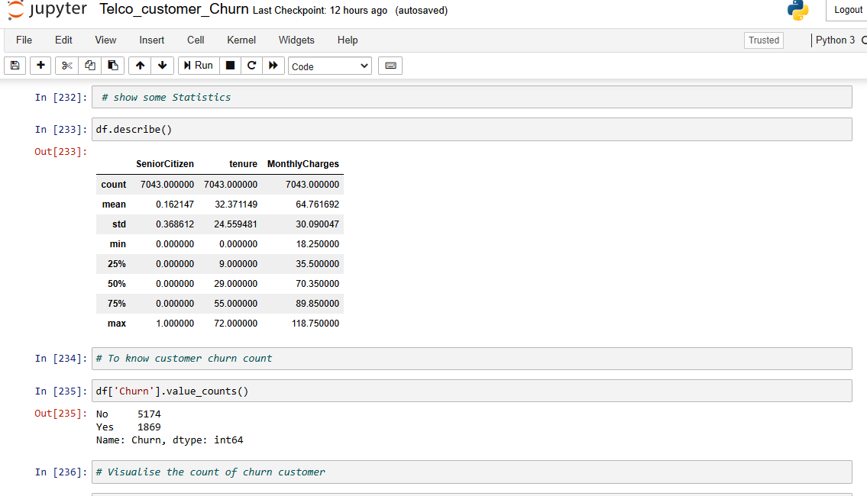
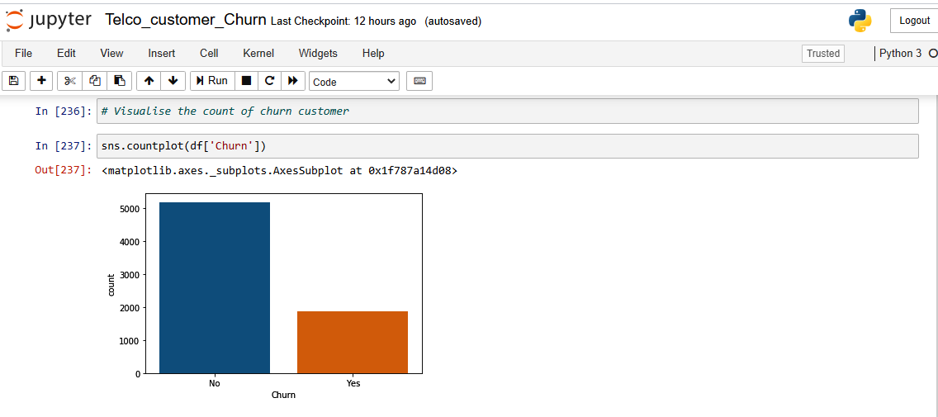
Q1. What is the percentage of customer leaving?
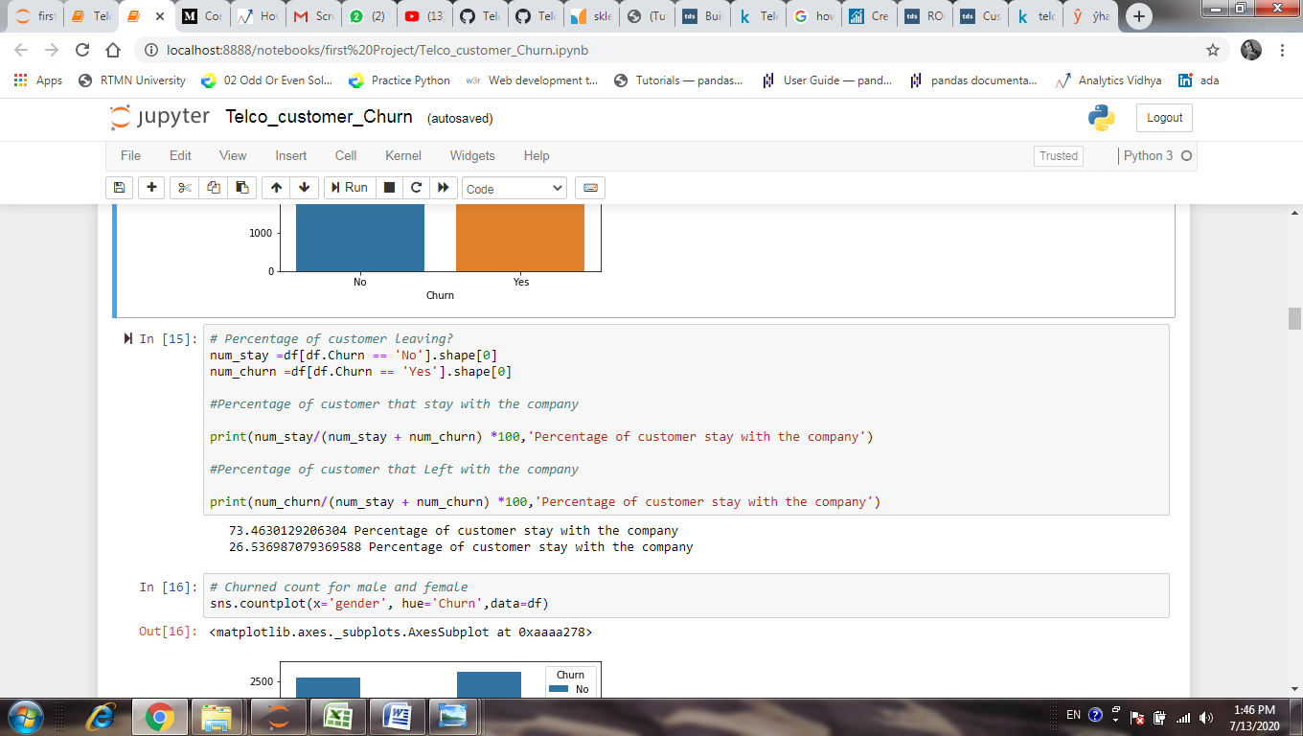
Q2. Visualized Churn count based on gender.
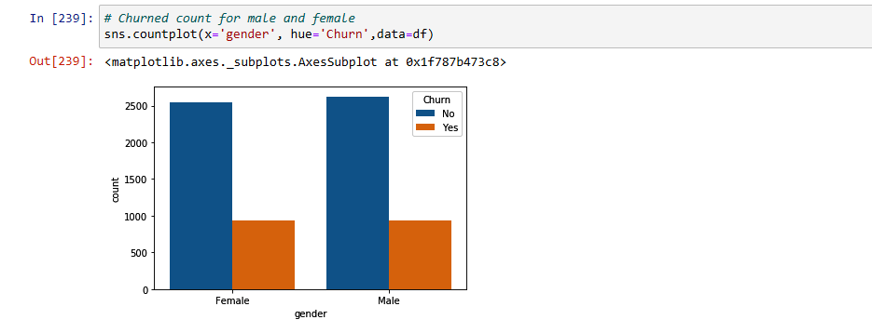
Q.3 Visualized the churn count based on internet service
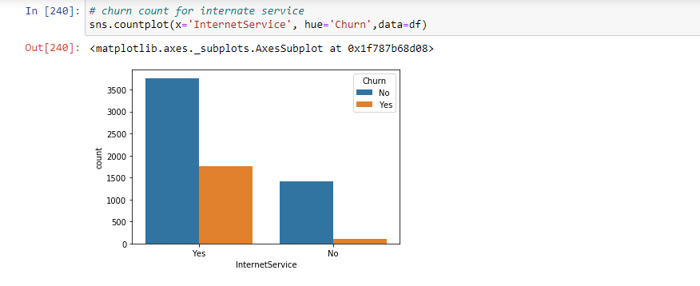
Q.4 visualized the effect of monthly charges and tenure on churn count.
From this first histogram, we can see the customer that are stay with company having monthly charge between 20 to 30 dollars and the churn count is lot higher between 70 to 100 dollars monthly charges. On right side histogram of tenure most of the customer that are churn between 0 to 10 months and those who are having 65 to 70 months tenure will stay with company.
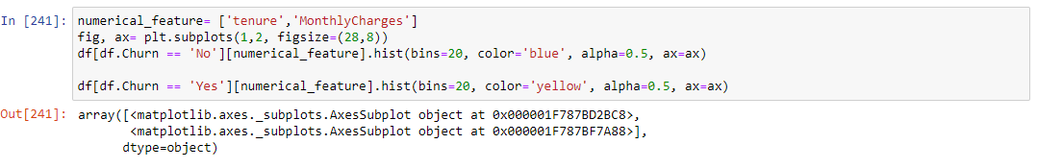
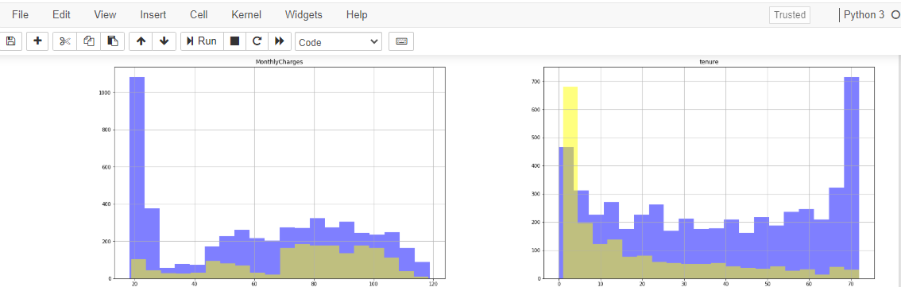

Now will drop the unnecessary column from the given data set and see the shape of given dataset.
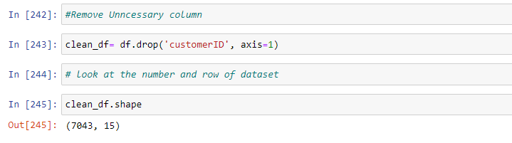
Convert the entire non numerical column to numerical column for further analysis of data. So all the data types of our data set are number and see the first five rows of new data set.
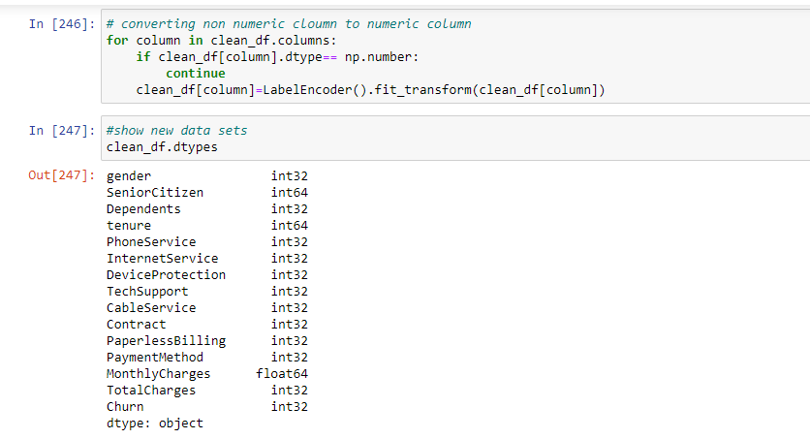
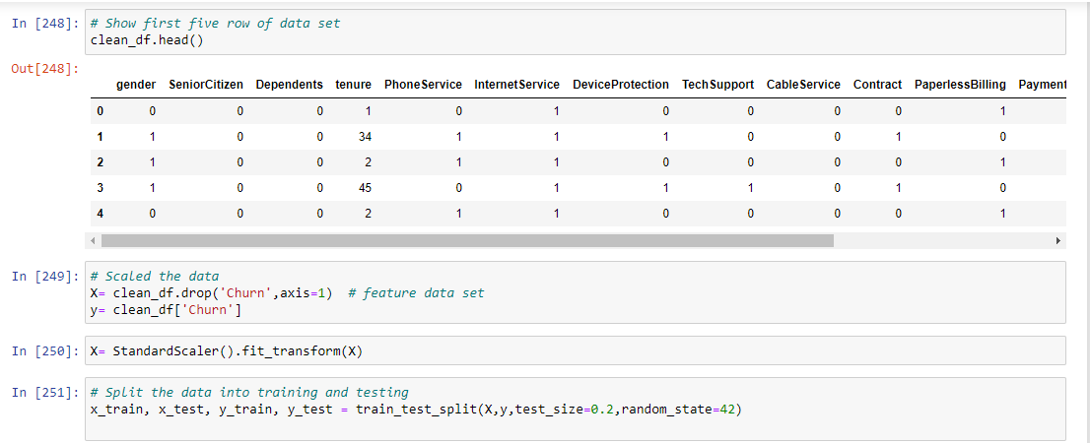

Applying Various Algorithm to check Accuracy of Model
Now our training data is pre-processed, from this we can see that our dataset for output variable is skewed.So we have disproportionate amount of both the class(YES or NO) .Our prediction is to make the case where it is YES but the number of record for the YES portion is very small compare to the normal class which is NO is this case. If we pass this directly into machine learning algorithm there will be a bais in machine learning output. So to avoid this we will use stratified KFold technique, in this technique it will try to take equal proportion of both the classes for each of its fold while doing the cross validation. Now we are going to try different machine learning algorithm and we will see the accuracy of model based on this split data set.
1. Gradiant Boosting Classifier
The first classifier we are going to apply for our model is Gradiant Boosting Classifier. We are using this from Sklearn librar .First we define a classifier or initiate a classifier using gb_clf is equal to the name of classifier then we will use skfold split method. Science we are using stratified kfold method, we have to pass X (training data) and y (output variable). For this values of dataset we are preparing our training and test data. Since we have used n_split equal to 10, which will gives us 10 different values of accuracy. We can see that the maximum accuracy that we got from Gradiant Boosting Classifier is 81.25%
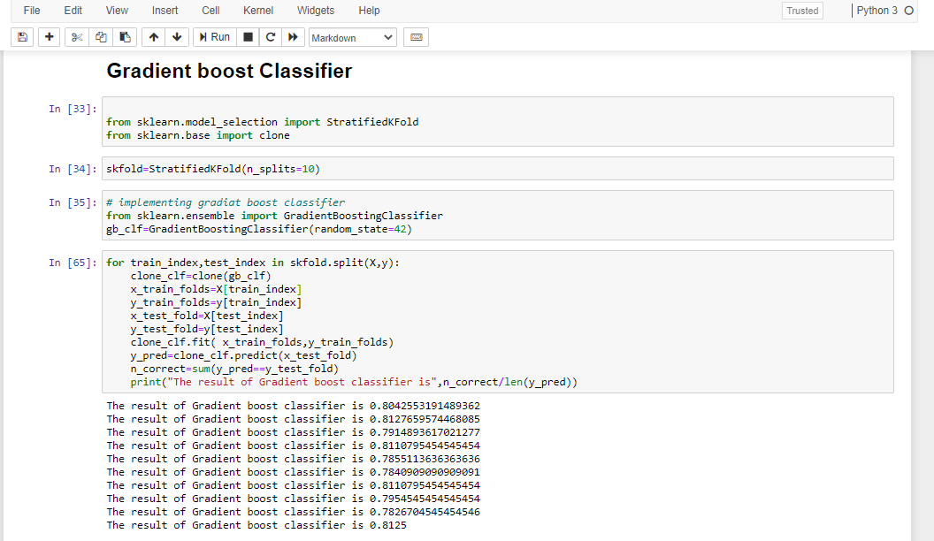
2. Support vector machine
Now we are applying Support Vector Machine algorithm for our dataset .we are passing X and y dataset through stratified kfold method and using portion of the data to calculate our accuracy. We can see the support vector machine gives the accuracy is about 80 %
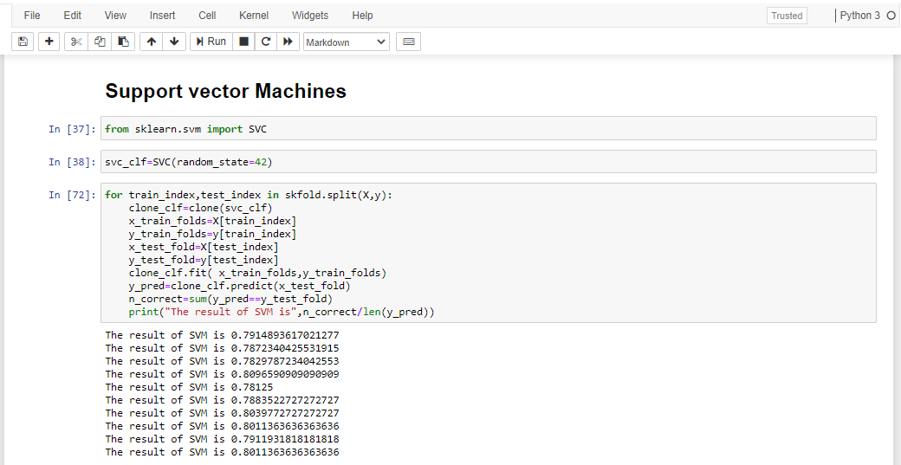
3. Random forest classifier
In random forest classifier , we have define a classifier and pass classifier to variable. We have utilised this to calculate the accuracy, which comes out to be is 79 %
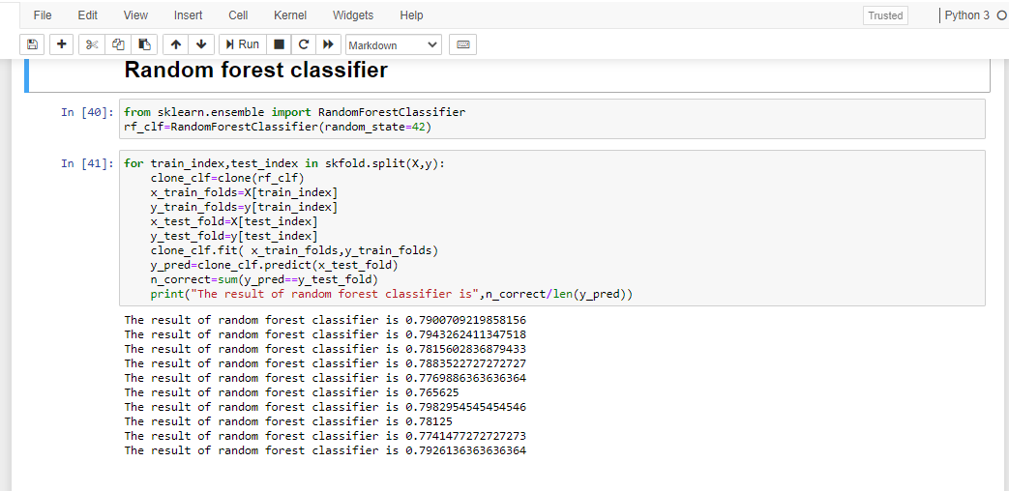

4. K-Nearest neighbour
In K-Nearest neighbour, we are passing X and y dataset through stratified kfold method and using portion of the data to calculate our accuracy. We can see the KNeighborsClassifier gives the accuracy is about 80 %
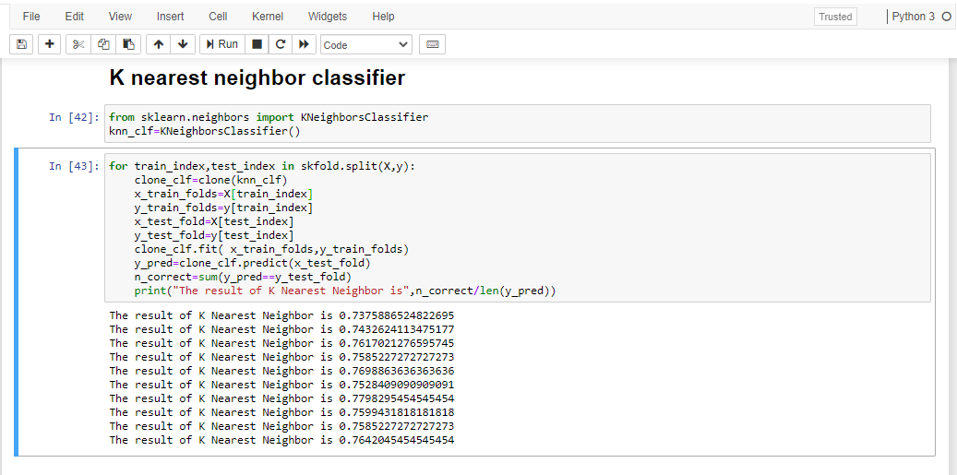
5. DecisionTreeClassifier
In Decision Tree Classifier, we are passing X and y dataset through stratified kfold method and using portion of the data to calculate our accuracy. We can see the Decision Tree Classifier gives the accuracy is about 74 %.
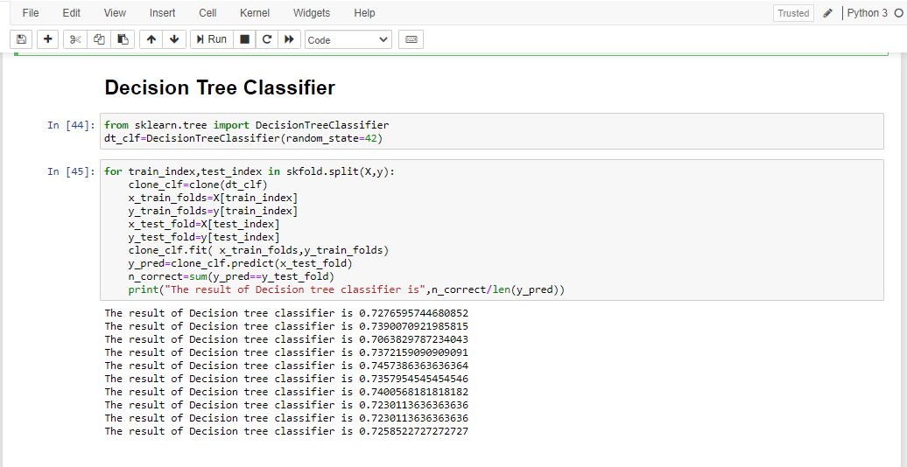
6. Logistic Regression
In Logistic Regression, we are passing X and y dataset through stratified Kfold method and using portion of the data to calculate our accuracy. We can see the Logistic Regression gives the accuracy is about 82 %
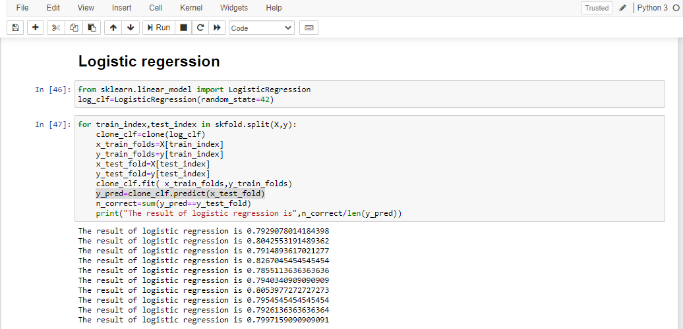

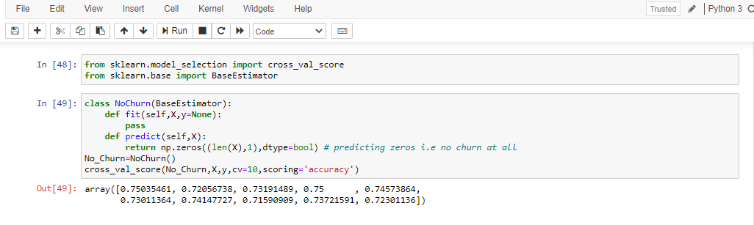
We have implemented different modern classifiers but strangely they are only slightly better than the random guessing so we cannot look into just accuracy but also explore precision recall and ROC as well.
Let’s evaluate the confusion matrix. All the classifier we have built so far are :gb_clf, svc_clf, rf_clf, knn_clf, dt_clf, log_clf.
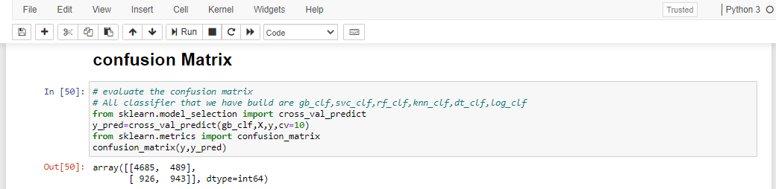
In the first row of confusion matrix ,4685 are not churn and my code correctly predicted no churn (True Negative), 489 wrongly classified as no churn (also known as false positive)
In the Second row of confusion matrix ,926 were churn and my code correctly identified as churn.(True Positive), 943 were not churn but was classified as churn (false Negative)
We are interested in two terms
Precision=TP/(TP+FP)
Recall=TP/(TP+FN)
So in this particular problem it’s okey to predict that a person is going to churn even if in reality he/she is not going to churn. This situation is still okey .This is used to calculate precision. However if we predict a person is not going to churn then it could mean loss of business. This is used to calculate Recall .Hence Recall is important.
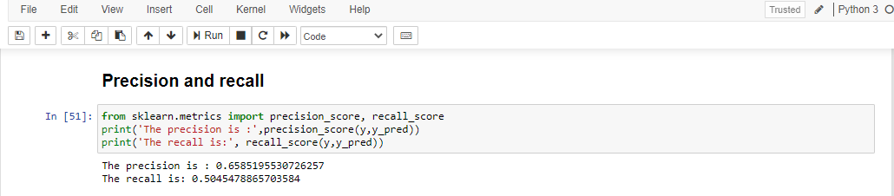
It could happen that the threshold is not properly set for the decision making .so a simple thing is to move the threshold Up and Down. But the Scikit learn library doesn’t let to change that threshold directly. But there is way for that we can find the threshold and plot it against Precision-Recall
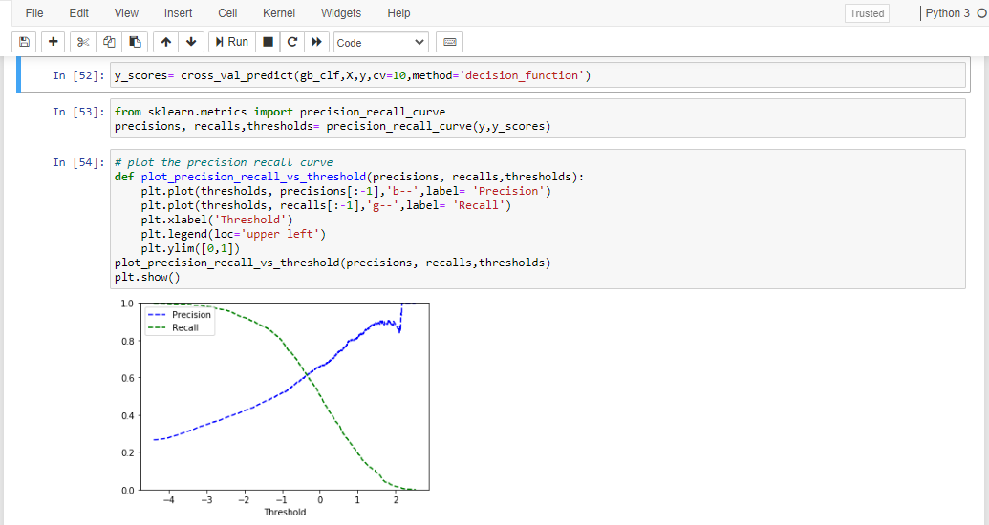

Let’s try by using new threshold, previous precision and recall with Gradient boosting classifier
The precision is: 0.6585195530726257
The recall is: 0.5045478865703584

The new precision is : 0.5253676470588236
The new recall is: 0.7645799892990904

So by changing the classifier threshold we can change the precision and recall depending on the demand of the business. Here we were able to improve the recall at the expense of precision, but for business recall is more important. Say if we want to improve the churn by giving discount on charges and other promotion, its okey to give customer these offers that we thought would churn. In this way at least we can try to stop the actual churn.
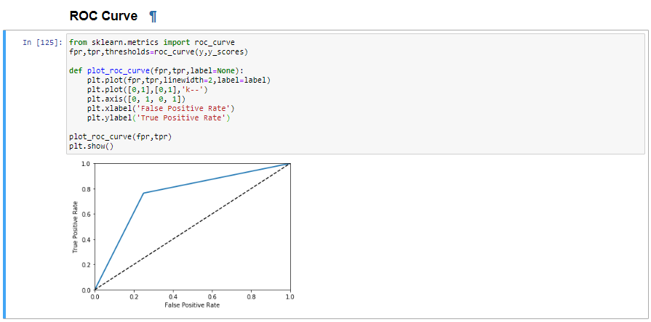

Last thing that we will check is ROC curve, the receiver operating characteristic (ROC) curve is another common tool used with binary classifier. It is similar to the precision recall curve but instead of plotting precision versus recall, the ROC curve plots the true positive rate (another name for recall) against the false positive rate.

