ShadowFox Data Science Internship
Beginner Level Task
A Comprehensive Documentation Guide to Python Data Visualization
Matplotlib and Seaborn
Prepared as part of the ShadowFox Data Science Internship Program
Topic: Python Data Visualization Libraries
Document Type: Technical Documentation Report
Official References: matplotlib.org | seaborn.pydata.org

Table of Contents

(Right-click the table above and choose "Update Field" in Microsoft Word to populate page numbers.)

0. Introduction to Data Visualization in Python
Data visualization is the graphical representation of information and data. It translates rows and columns of raw numbers into charts, plots, and diagrams that the human eye can interpret quickly, making it an essential step in every data science workflow — from initial exploratory data analysis to the final presentation of results to stakeholders.
The Python ecosystem offers a wide range of visualization libraries, but two of them form the foundation upon which most others are built: Matplotlib, the original and most widely used plotting library, and Seaborn, a statistical visualization library built directly on top of Matplotlib. This report documents both libraries in detail, as required for the ShadowFox Data Science Internship Beginner Level Task.
The report is organised into the following parts: a full overview of each library (introduction, features, advantages, disadvantages, installation and typical use cases), a catalogue of eleven chart types implemented in both libraries with complete runnable code and an explanation of the expected output, a professional side-by-side comparison of the two libraries, and a concluding discussion with references.
All code samples in this report were written to be complete and independently executable, assuming a tabular dataset called tips (columns: total_bill, tip, sex, smoker, day, time, size) and an iris-style dataset called iris (columns: sepal_length, sepal_width, petal_length, species) are loaded into memory, exactly as demonstrated in the accompanying Jupyter Notebook and Python script that are included with this submission.

1. Matplotlib — Library Overview

1.1 Introduction
Matplotlib is the foundational 2D plotting library for the Python programming language, originally created by John D. Hunter in 2003. It was designed to give Python a plotting capability similar to MATLAB, and its pyplot interface still mirrors much of MATLAB's command-style syntax. Matplotlib produces publication-quality figures in a wide range of static, animated, and interactive formats, and it underlies many higher-level visualization libraries in the Python ecosystem, including Seaborn itself.
Because Matplotlib exposes fine-grained control over every element of a figure — axes, ticks, legends, colours, fonts and layout — it is often described as the low-level, highly customizable 'graphics engine' of the Python data science stack.

1.2 Features
- Object-oriented API (Figure, Axes) as well as a simpler state-based pyplot interface.
- Support for a very wide range of plot types: line, scatter, bar, histogram, pie, box, contour, 3D plots, images, and more.
- Fine-grained control over every visual element: colours, markers, line styles, fonts, spacing, annotations and layout.
- Multiple output formats, including PNG, PDF, SVG and EPS, suitable for print publication.
- Cross-platform rendering backends that integrate with GUI toolkits (Tkinter, Qt, wxPython) and with Jupyter notebooks.
- A large, mature ecosystem of extensions and third-party libraries built on top of it.

1.3 Advantages
- Extremely flexible: virtually every element of a chart can be customised.
- Mature and stable, with over two decades of development and extensive documentation.
- Large community, meaning most problems already have a documented solution online.
- Works well for both simple, quick plots and complex, multi-panel publication figures.
- Free, open-source, and actively maintained.

1.4 Disadvantages
- Verbose syntax — even simple statistical plots often require several lines of code.
- Default styling looks dated compared to modern visualization libraries.
- No built-in statistical estimation (confidence intervals, regression fits, etc.) — this must be computed manually or with a helper library such as SciPy.
- Steeper learning curve for beginners who need more than a basic plot.
- Limited native interactivity; interactive features generally require extra libraries or backends (e.g. mplcursors, ipympl).

1.5 Installation
Matplotlib can be installed using pip or conda:
pip install matplotlib

# or, using conda
conda install matplotlib
To verify the installation, import the library and print its version:
import matplotlib
print(matplotlib.__version__)

1.6 Typical Use Cases
- Producing publication-quality static figures for research papers and reports.
- Building fully custom dashboards or scientific figures with precise layout control.
- Plotting engineering, signal-processing, or numerical-simulation results (e.g. NumPy arrays).
- Serving as the rendering backend for higher-level libraries such as Seaborn and Pandas' .plot().
- Creating simple, quick exploratory plots directly from a Python script or notebook.

2. Seaborn — Library Overview

2.1 Introduction
Seaborn is a Python data visualization library built on top of Matplotlib, first released by Michael Waskom in 2012. It provides a high-level interface for drawing attractive and informative statistical graphics, and it integrates tightly with pandas DataFrames, allowing charts to be built directly from column names rather than raw arrays.
Seaborn's core design goal is to make common statistical visualizations — distributions, relationships between variables, and categorical comparisons — accessible with a single function call, while still allowing the resulting Matplotlib Figure and Axes objects to be further customised when needed.

2.2 Features
- High-level functions for statistical plots: distributions (histplot, kdeplot), relationships (scatterplot, lineplot), and categorical data (boxplot, violinplot, barplot, countplot).
- Native, first-class support for pandas DataFrames using simple column-name arguments (data=, x=, y=, hue=).
- Automatic statistical estimation, including confidence intervals, regression lines, and kernel density estimates, computed internally without extra code.
- Built-in, aesthetically refined themes and colour palettes (e.g. darkgrid, whitegrid, deep, pastel) that are visually appealing by default.
- Figure-level 'multi-plot grid' functions such as pairplot() and FacetGrid that build complex, multi-panel figures automatically.
- Seamless interoperability with Matplotlib — every Seaborn plot returns Matplotlib Axes/Figure objects that can be fine-tuned with normal Matplotlib commands.

2.3 Advantages
- Concise, readable syntax — complex statistical plots often need only one line of code.
- Visually appealing default styles that require little manual tweaking.
- Built-in statistical computation saves significant development time.
- Excellent, native support for tidy (long-format) pandas DataFrames.
- Multi-plot grids (pairplot, FacetGrid) make multivariate exploratory analysis very fast.

2.4 Disadvantages
- Less low-level control than raw Matplotlib for highly customised or unconventional figures.
- Adds an extra dependency (on top of Matplotlib) to a project.
- Some figure-level functions (e.g. pairplot, catplot) create their own Figure internally, which makes them harder to combine with other subplots on the same page.
- Performance can degrade on very large datasets, since some functions perform statistical computation (e.g. bootstrapped confidence intervals) at plot time.
- No native support for interactive or web-based charts.

2.5 Installation
Seaborn depends on Matplotlib, pandas, and NumPy, all of which are installed automatically. It can be installed using pip or conda:
pip install seaborn

# or, using conda
conda install seaborn
To verify the installation, import the library and print its version:
import seaborn as sns
print(sns.__version__)

2.6 Typical Use Cases
- Rapid exploratory data analysis (EDA) on tabular, tidy datasets.
- Visualising statistical relationships, such as correlations and regression trends.
- Comparing distributions of a numeric variable across multiple categorical groups.
- Producing polished, presentation-ready statistical charts with minimal styling effort.
- Building multi-panel exploratory grids (pairplot, FacetGrid) to inspect many variables at once.

3. Shared Setup Code for the Graph Catalogue
The chart examples in Sections 4 and 5 all reference two shared, tidy DataFrames: tips (restaurant billing data) and iris (flower measurement data). The exact code used to build both DataFrames for this report is shown below, and is also included in full in the accompanying Jupyter Notebook (01_matplotlib_seaborn_guide.ipynb) and Python script (visualization_guide.py).
import numpy as np
import pandas as pd

np.random.seed(42)

# ---- Build the 'tips' DataFrame (restaurant billing records) ----
n = 244
days = np.random.choice(["Thur", "Fri", "Sat", "Sun"], size=n, p=[0.25, 0.08, 0.35, 0.32])
sex = np.random.choice(["Male", "Female"], size=n)
smoker = np.random.choice(["Yes", "No"], size=n, p=[0.38, 0.62])
time_ = np.where(np.isin(days, ["Sat", "Sun"]), "Dinner",
np.random.choice(["Lunch", "Dinner"], size=n))
total_bill = np.round(np.random.gamma(shape=5, scale=4, size=n) + 3, 2)
tip = np.round(total_bill * np.random.normal(0.16, 0.05, n).clip(0.05, 0.35), 2)
size_ = np.random.choice([1, 2, 2, 3, 4, 4, 5, 6], size=n)

tips = pd.DataFrame({
"total_bill": total_bill, "tip": tip, "sex": sex, "smoker": smoker,
"day": pd.Categorical(days, categories=["Thur", "Fri", "Sat", "Sun"], ordered=True),
"time": time_, "size": size_
})

# ---- Build the 'iris' DataFrame (flower measurement records) ----
species = np.repeat(["setosa", "versicolor", "virginica"], 50)
sepal_length = np.concatenate([np.random.normal(5.0, 0.35, 50),
np.random.normal(5.9, 0.5, 50),
np.random.normal(6.6, 0.6, 50)])
sepal_width = np.concatenate([np.random.normal(3.4, 0.38, 50),
np.random.normal(2.8, 0.3, 50),
np.random.normal(3.0, 0.3, 50)])
petal_length = np.concatenate([np.random.normal(1.5, 0.17, 50),
np.random.normal(4.3, 0.47, 50),
np.random.normal(5.6, 0.55, 50)])
iris = pd.DataFrame({
"sepal_length": sepal_length, "sepal_width": sepal_width,
"petal_length": petal_length, "species": species
})
Note: the ShadowFox task references the official Seaborn tutorial, which typically loads the well-known tips, iris and flights sample datasets via sns.load_dataset(). Those functions download data from the internet; the code above builds statistically similar data locally so that every example in this report and its accompanying files runs end-to-end without requiring network access. In an environment with internet access, tips = sns.load_dataset('tips') and iris = sns.load_dataset('iris') may be used instead.

4. Graph Types in Matplotlib

1. Line Plot

Description
A line plot connects sequential data points with a continuous line. It is Matplotlib's most fundamental chart type and is produced with the plot() function, which draws a line through an ordered series of (x, y) coordinates.

When to Use
Use a line plot to visualise trends over a continuous variable such as time, to track how a metric changes across an ordered sequence, or to overlay multiple time series for comparison.

Python Code
import matplotlib.pyplot as plt
import numpy as np

np.random.seed(42)
x = np.linspace(0, 10, 100)
y = np.sin(x) + np.random.normal(0, 0.1, 100)

fig, ax = plt.subplots(figsize=(6, 4))
ax.plot(x, y, color="#1f77b4", linewidth=2, label="sin(x) + noise")
ax.set_title("Matplotlib Line Plot")
ax.set_xlabel("X values")
ax.set_ylabel("Y values")
ax.legend()
plt.savefig("mpl_line.png", dpi=150, bbox_inches="tight")
plt.show()

Expected Output
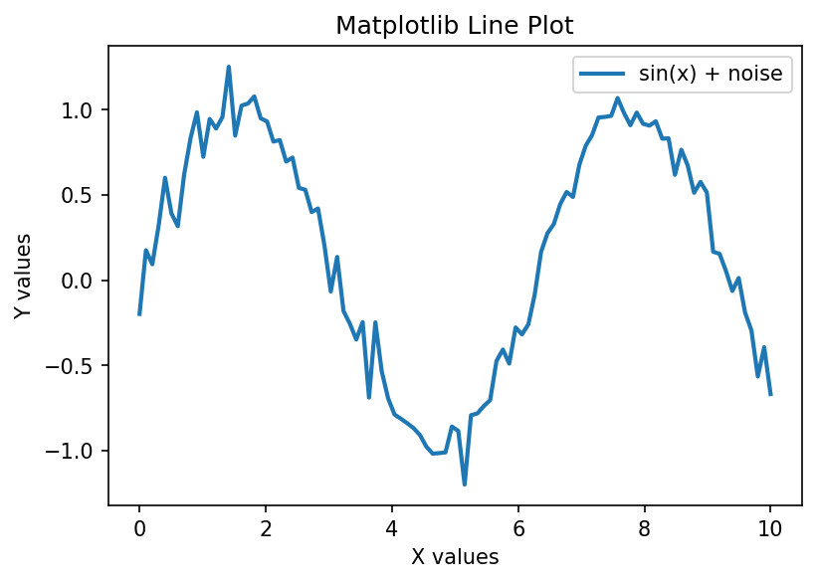
The output is a smooth, noisy sine wave rendered as a single connected blue line across the figure, with axis labels, a title and a legend identifying the series. The general upward-and-downward oscillation of the sine function is clearly visible despite the added random noise.

2. Scatter Plot

Description
A scatter plot displays individual data points as markers positioned according to two numeric variables. Matplotlib's scatter() function additionally supports mapping a third variable to marker colour (c) and a fourth to marker size (s).

When to Use
Use a scatter plot to examine the relationship or correlation between two continuous variables, to detect clusters, or to spot outliers in a dataset.

Python Code
import matplotlib.pyplot as plt

fig, ax = plt.subplots(figsize=(6, 4))
sc = ax.scatter(
tips["total_bill"], tips["tip"],
c=tips["size"], cmap="viridis", alpha=0.8
)
ax.set_title("Matplotlib Scatter Plot")
ax.set_xlabel("Total Bill ($)")
ax.set_ylabel("Tip ($)")
fig.colorbar(sc, label="Party Size")
plt.savefig("mpl_scatter.png", dpi=150, bbox_inches="tight")
plt.show()

Expected Output
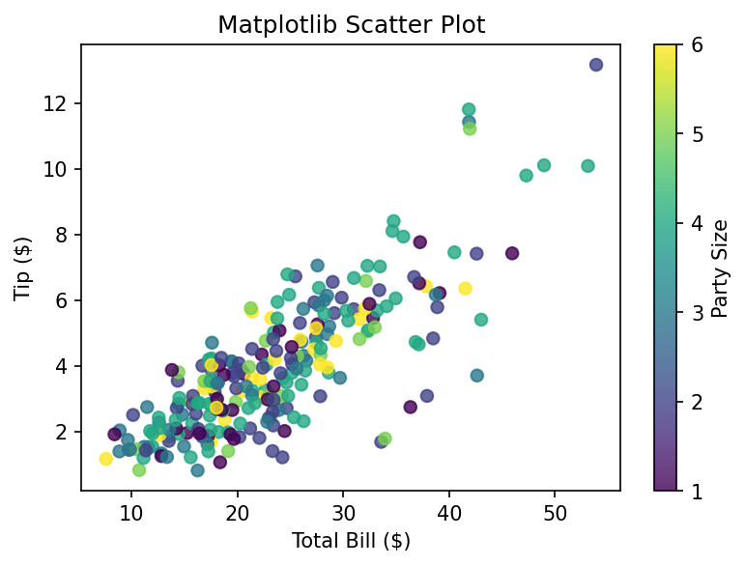
Each point represents one restaurant bill, positioned by total bill amount (x-axis) and tip amount (y-axis). Point colour encodes party size via the viridis colour map, with an attached colour bar. A positive trend is visible: larger bills tend to correspond to larger tips.

3. Bar Chart

Description
A bar chart represents categorical data with rectangular bars whose length is proportional to the value they represent. Matplotlib provides this through the bar() (vertical) and barh() (horizontal) functions.

When to Use
Use a bar chart to compare a numeric quantity across discrete categories, such as average sales per region or average bill per day of the week.

Python Code
import matplotlib.pyplot as plt

day_avg = tips.groupby("day", observed=True)["total_bill"].mean()

fig, ax = plt.subplots(figsize=(6, 4))
ax.bar(day_avg.index, day_avg.values, color="#4c72b0")
ax.set_title("Matplotlib Bar Chart")
ax.set_xlabel("Day")
ax.set_ylabel("Average Total Bill ($)")
plt.savefig("mpl_bar.png", dpi=150, bbox_inches="tight")
plt.show()

Expected Output
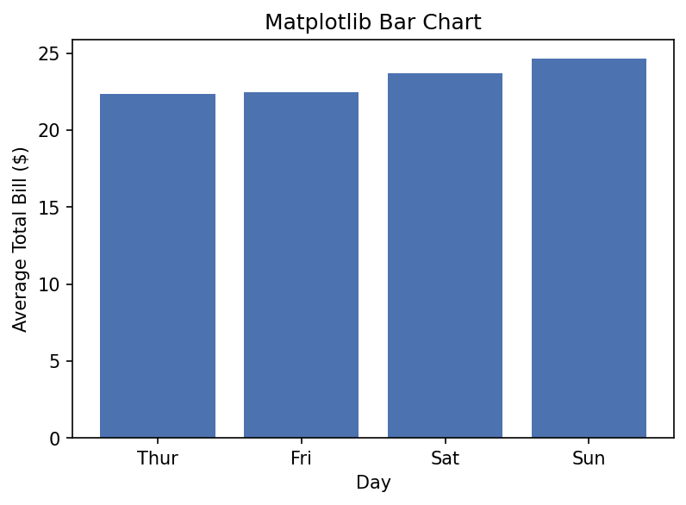
Four vertical bars are shown, one per day (Thur, Fri, Sat, Sun), with bar height representing the average total bill for that day. This makes it easy to see which day has the highest and lowest average spend at a glance.

4. Histogram

Description
A histogram groups continuous numeric data into a set of bins and displays the frequency (or density) of observations that fall into each bin as adjacent bars. It is created with hist().

When to Use
Use a histogram to understand the distribution, spread, and skewness of a single numeric variable, such as the distribution of total bill amounts.

Python Code
import matplotlib.pyplot as plt

fig, ax = plt.subplots(figsize=(6, 4))
ax.hist(tips["total_bill"], bins=20, color="#55a868", edgecolor="black")
ax.set_title("Matplotlib Histogram")
ax.set_xlabel("Total Bill ($)")
ax.set_ylabel("Frequency")
plt.savefig("mpl_histogram.png", dpi=150, bbox_inches="tight")
plt.show()

Expected Output
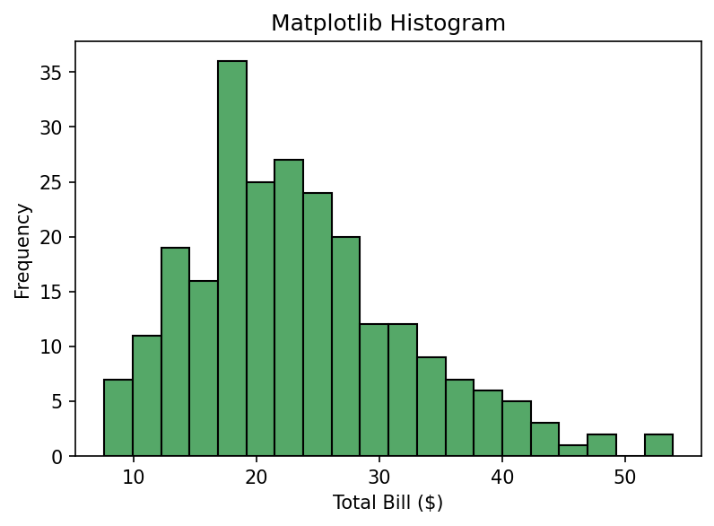
The chart shows 20 adjacent bars covering the range of total bill values. Taller bars indicate bill ranges that occur more frequently. The distribution is right-skewed, with most bills concentrated in the lower-to-middle range and a long tail of higher bills.

5. Pie Chart

Description
A pie chart represents parts of a whole as circular sectors, where each sector's angle is proportional to the value it represents. It is created using the pie() function.

When to Use
Use a pie chart sparingly, only when showing the relative proportion of a small number of categories (ideally fewer than six) that sum to a meaningful whole, such as market share.

Python Code
import matplotlib.pyplot as plt
import seaborn as sns

day_counts = tips["day"].value_counts()

fig, ax = plt.subplots(figsize=(6, 4))
ax.pie(
day_counts.values, labels=day_counts.index,
autopct="%1.1f%%", startangle=90,
colors=sns.color_palette("pastel")
)
ax.set_title("Matplotlib Pie Chart")
plt.savefig("mpl_pie.png", dpi=150, bbox_inches="tight")
plt.show()

Expected Output
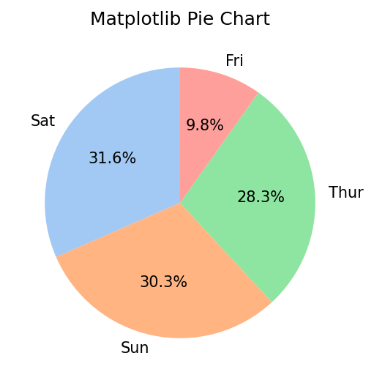
The pie chart is divided into four wedges representing the share of restaurant visits recorded on each day. Each wedge is labelled with the day name and its percentage share, making the relative contribution of each category immediately visible.

6. Box Plot

Description
A box plot (box-and-whisker plot) summarises a numeric distribution using five statistics: minimum, first quartile, median, third quartile and maximum, while marking outliers as individual points. It is created with boxplot().

When to Use
Use a box plot to compare the spread and central tendency of a numeric variable across several categories, and to quickly identify outliers.

Python Code
import matplotlib.pyplot as plt

categories = list(tips["day"].cat.categories)
data_by_day = [tips.loc[tips["day"] == d, "total_bill"] for d in categories]

fig, ax = plt.subplots(figsize=(6, 4))
ax.boxplot(data_by_day, tick_labels=categories)
ax.set_title("Matplotlib Box Plot")
ax.set_xlabel("Day")
ax.set_ylabel("Total Bill ($)")
plt.savefig("mpl_box.png", dpi=150, bbox_inches="tight")
plt.show()

Expected Output
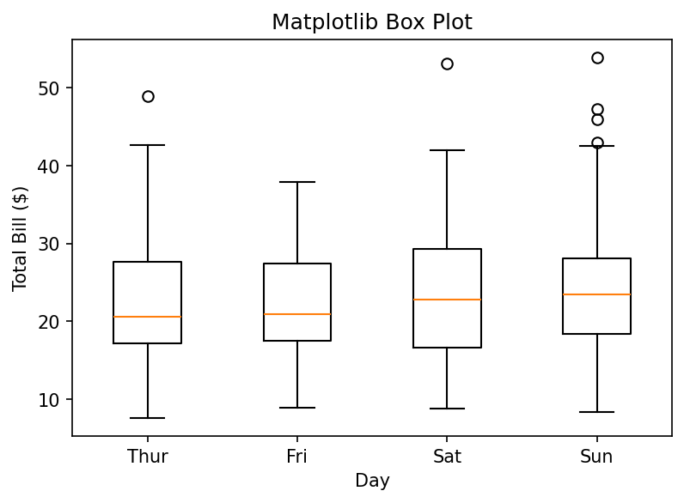
Four boxes are drawn, one per day. Each box spans the interquartile range with a line at the median, whiskers extending to the typical data range, and individual points marking outlier bills. Differences in median spend and variability between days are easy to compare.

7. Violin Plot

Description
A violin plot combines a box plot with a rotated, mirrored kernel density estimate, showing both summary statistics and the full shape of the underlying distribution. It is created with violinplot().

When to Use
Use a violin plot instead of a box plot when the shape of the distribution (e.g. bimodality) matters, not just its summary statistics.

Python Code
import matplotlib.pyplot as plt

categories = list(tips["day"].cat.categories)
data_by_day = [tips.loc[tips["day"] == d, "total_bill"] for d in categories]

fig, ax = plt.subplots(figsize=(6, 4))
ax.violinplot(data_by_day, showmedians=True)
ax.set_xticks(range(1, len(categories) + 1))
ax.set_xticklabels(categories)
ax.set_title("Matplotlib Violin Plot")
ax.set_xlabel("Day")
ax.set_ylabel("Total Bill ($)")
plt.savefig("mpl_violin.png", dpi=150, bbox_inches="tight")
plt.show()

Expected Output
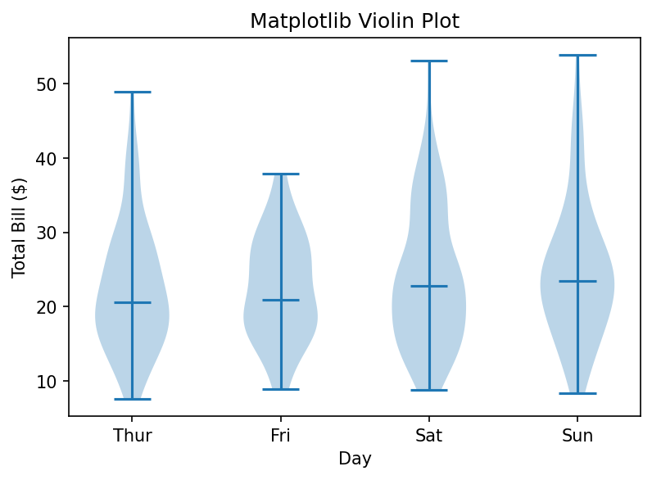
Each 'violin' shape represents the density of total bill values for one day: wider sections indicate more observations at that value. A horizontal marker shows the median. The shapes reveal whether spending is concentrated around one typical value or spread across several peaks.

8. Heatmap

Description
A heatmap encodes a matrix of numeric values as a grid of coloured cells, where colour intensity represents magnitude. In pure Matplotlib it is produced with imshow() combined with manual colour-bar and text annotations.

When to Use
Use a heatmap to visualise a correlation matrix, a confusion matrix, or any two-dimensional table of numeric values where colour makes patterns easier to spot than raw numbers.

Python Code
import matplotlib.pyplot as plt

corr = tips[["total_bill", "tip", "size"]].corr()

fig, ax = plt.subplots(figsize=(6, 5))
im = ax.imshow(corr, cmap="coolwarm", vmin=-1, vmax=1)
ax.set_xticks(range(len(corr.columns)))
ax.set_yticks(range(len(corr.columns)))
ax.set_xticklabels(corr.columns)
ax.set_yticklabels(corr.columns)
for i in range(len(corr.columns)):
for j in range(len(corr.columns)):
ax.text(j, i, f"{corr.iloc[i, j]:.2f}", ha="center", va="center")
ax.set_title("Matplotlib Heatmap (Correlation Matrix)")
fig.colorbar(im)
plt.savefig("mpl_heatmap.png", dpi=150, bbox_inches="tight")
plt.show()

Expected Output
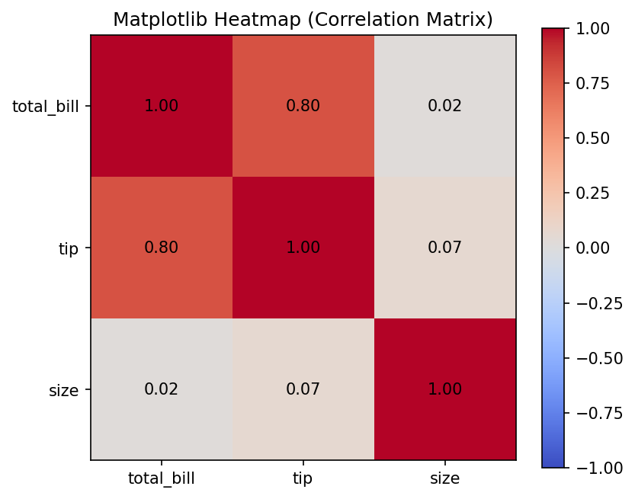
A 3x3 grid of coloured cells is displayed, one cell per pair of numeric columns. Cells shaded toward red indicate strong positive correlation, cells toward blue indicate negative correlation, and the numeric correlation coefficient is printed inside each cell.

9. Count Plot

Description
A count plot shows the number of occurrences of each category in a categorical variable. Matplotlib has no dedicated countplot() function, so it must be built manually by counting values with pandas and passing the result to bar().

When to Use
Use a count plot to inspect the frequency (class balance) of categories in a dataset, for example to check how many records fall into each category before further analysis.

Python Code
import matplotlib.pyplot as plt

counts = tips["day"].value_counts().sort_index()

fig, ax = plt.subplots(figsize=(6, 4))
ax.bar(counts.index.astype(str), counts.values, color="#c44e52")
ax.set_title("Matplotlib 'Count Plot' (built via bar())")
ax.set_xlabel("Day")
ax.set_ylabel("Count")
plt.savefig("mpl_countplot.png", dpi=150, bbox_inches="tight")
plt.show()

Expected Output
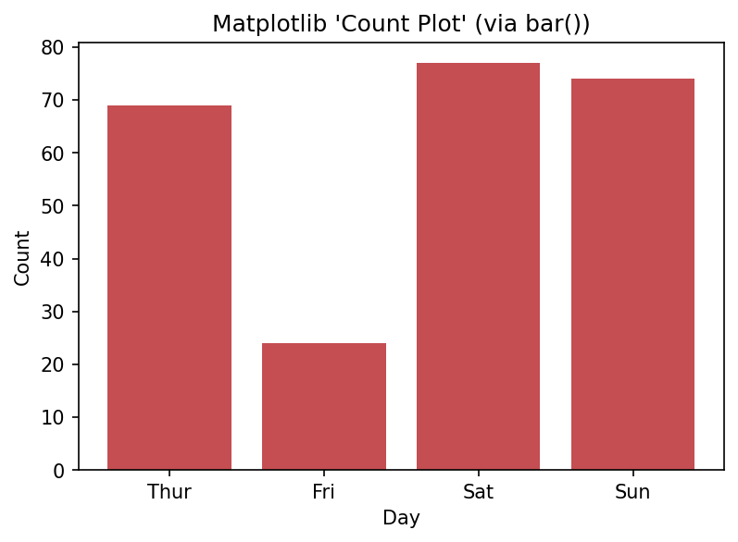
The chart shows one bar per day, with bar height equal to the number of records recorded for that day. It is visually identical to a standard bar chart but the underlying value being plotted is a frequency count rather than an aggregated statistic.

10. Pair Plot

Description
A pair plot shows pairwise relationships between several numeric variables as a grid of small scatter plots, with univariate distributions on the diagonal. Matplotlib has no built-in pairplot() function, so it must be assembled manually using a grid of subplots().

When to Use
Use a pair plot during exploratory data analysis to quickly scan for relationships, clusters, or separability across every combination of several numeric variables at once.

Python Code
import matplotlib.pyplot as plt

cols = ["sepal_length", "sepal_width", "petal_length"]
species_colors = {
"setosa": "#4c72b0", "versicolor": "#55a868", "virginica": "#c44e52"
}

fig, axes = plt.subplots(len(cols), len(cols), figsize=(7, 7))
for i, ci in enumerate(cols):
for j, cj in enumerate(cols):
ax = axes[i, j]
if i == j:
for sp, color in species_colors.items():
ax.hist(iris.loc[iris["species"] == sp, ci], color=color, alpha=0.5, bins=10)
else:
for sp, color in species_colors.items():
subset = iris[iris["species"] == sp]
ax.scatter(subset[cj], subset[ci], color=color, s=10, alpha=0.7)
if i == len(cols) - 1:
ax.set_xlabel(cj)
if j == 0:
ax.set_ylabel(ci)
fig.suptitle("Matplotlib 'Pair Plot' (manually constructed grid)")
fig.tight_layout()
plt.savefig("mpl_pairplot.png", dpi=150, bbox_inches="tight")
plt.show()

Expected Output
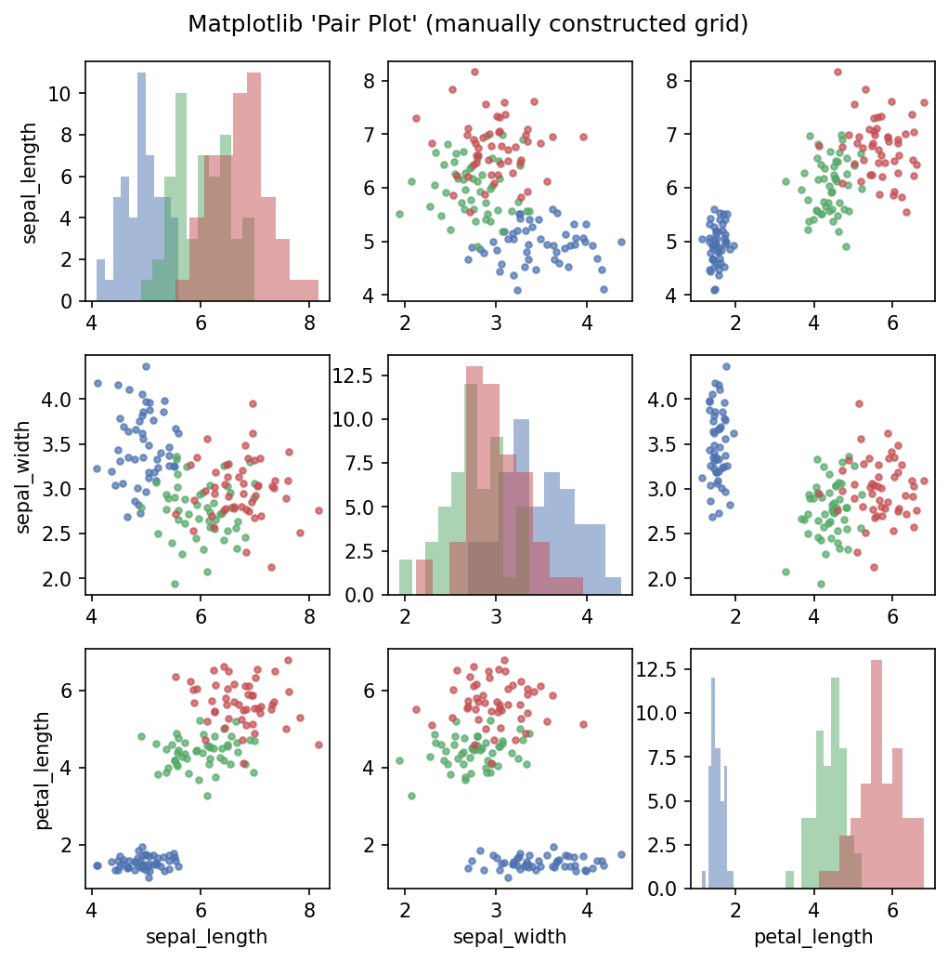
A 3x3 grid of subplots is produced. Off-diagonal cells are scatter plots comparing two variables at a time, coloured by species; diagonal cells are histograms of a single variable per species. The grid reveals that petal measurements separate the three species particularly well.

11. KDE Plot

Description
A Kernel Density Estimate (KDE) plot shows a smoothed, continuous estimate of a variable's probability density function. Matplotlib has no native KDE function, so SciPy's gaussian_kde is typically used to compute the curve, which is then drawn with plot().

When to Use
Use a KDE plot as a smoother alternative to a histogram when you want to see the underlying shape of a distribution without the visual artefacts introduced by bin-width choice.

Python Code
import matplotlib.pyplot as plt
import numpy as np
from scipy.stats import gaussian_kde

values = tips["total_bill"].values
kde = gaussian_kde(values)
xs = np.linspace(values.min(), values.max(), 200)

fig, ax = plt.subplots(figsize=(6, 4))
ax.plot(xs, kde(xs), color="#8172b2", linewidth=2)
ax.fill_between(xs, kde(xs), alpha=0.3, color="#8172b2")
ax.set_title("Matplotlib KDE Plot (via scipy.stats.gaussian_kde)")
ax.set_xlabel("Total Bill ($)")
ax.set_ylabel("Density")
plt.savefig("mpl_kde.png", dpi=150, bbox_inches="tight")
plt.show()

Expected Output
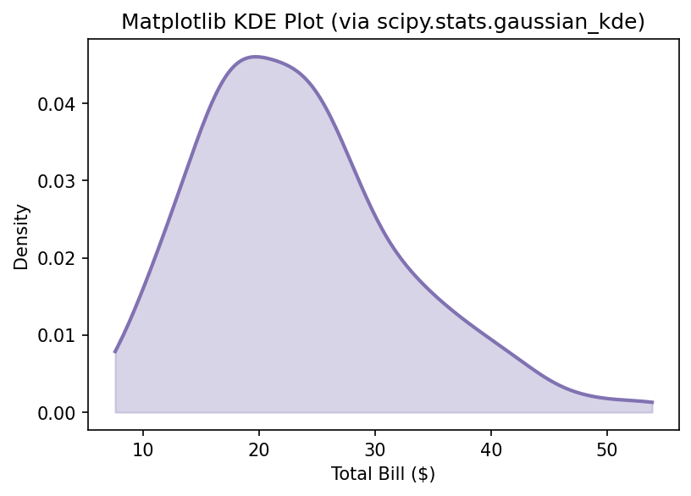
A single smooth curve is displayed showing estimated probability density across the range of total bill values, with the area beneath the curve shaded. The curve peaks where bill amounts are most common and tapers off toward the extremes.

5. Graph Types in Seaborn

1. Line Plot

Description
Seaborn's lineplot() draws a line through ordered data and, by default, automatically aggregates repeated x-values by plotting the mean with a shaded confidence interval band.

When to Use
Use it for time-series or trend data, especially when you want automatic aggregation and confidence-interval shading without writing extra statistical code.

Python Code
import seaborn as sns
import matplotlib.pyplot as plt

sns.set_theme(style="whitegrid")
avg_by_year = flights.groupby("year")["passengers"].mean().reset_index()

fig, ax = plt.subplots(figsize=(6, 4))
sns.lineplot(data=avg_by_year, x="year", y="passengers", marker="o", ax=ax)
ax.set_title("Seaborn Line Plot")
plt.savefig("sns_line.png", dpi=150, bbox_inches="tight")
plt.show()

Expected Output
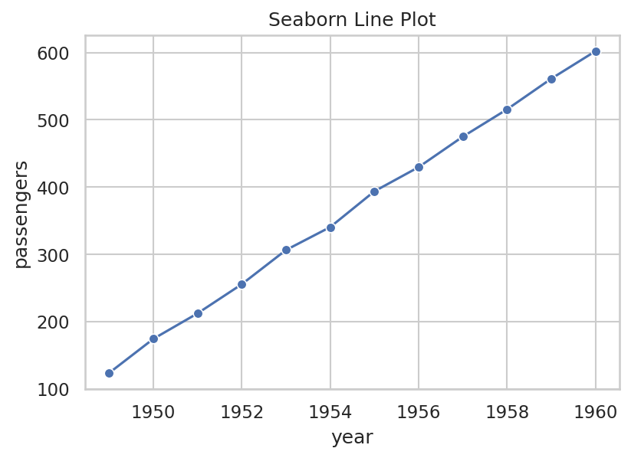
A single upward-trending line with circular markers shows average monthly passengers rising year over year. Seaborn's default whitegrid theme adds light gridlines that make it easy to read approximate values off the axes.

2. Scatter Plot

Description
Seaborn's scatterplot() extends Matplotlib's scatter by accepting a tidy DataFrame directly and mapping extra columns to visual encodings such as hue (colour) and style (marker shape) with a single function call.

When to Use
Use it when you need to explore a relationship between two numeric variables while also distinguishing multiple categorical groupings by colour and/or marker shape.

Python Code
import seaborn as sns
import matplotlib.pyplot as plt

fig, ax = plt.subplots(figsize=(6, 4))
sns.scatterplot(data=tips, x="total_bill", y="tip", hue="time", style="smoker", ax=ax)
ax.set_title("Seaborn Scatter Plot")
plt.savefig("sns_scatter.png", dpi=150, bbox_inches="tight")
plt.show()

Expected Output
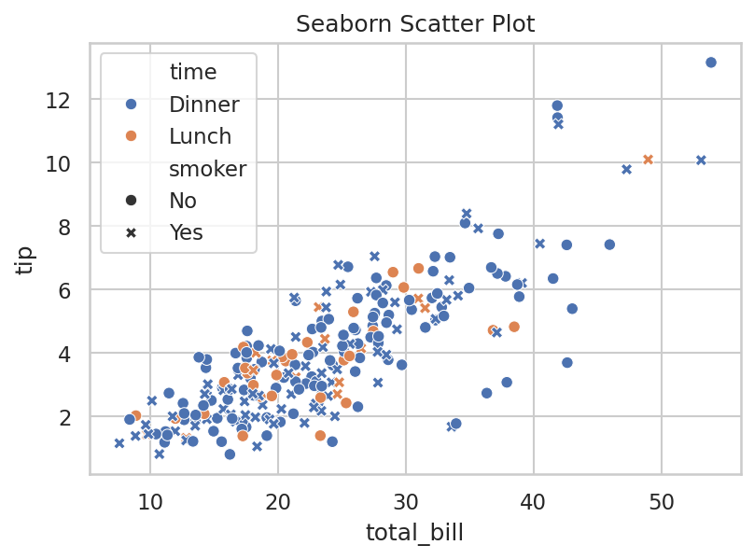
Points are automatically coloured by meal time (Lunch/Dinner) and given different marker shapes for smoker status, with a combined legend generated automatically. This makes it possible to study the bill-tip relationship broken down by two categorical variables simultaneously.

3. Bar Chart

Description
Seaborn's barplot() draws bars representing an aggregate statistic (mean, by default) of a numeric variable per category, and automatically overlays error bars representing uncertainty.

When to Use
Use it to compare an aggregated statistic across categories while also visualising the variability or confidence interval of that statistic, optionally split further by a hue variable.

Python Code
import seaborn as sns
import matplotlib.pyplot as plt

fig, ax = plt.subplots(figsize=(6, 4))
sns.barplot(data=tips, x="day", y="total_bill", hue="sex", errorbar="sd", ax=ax)
ax.set_title("Seaborn Bar Chart")
plt.savefig("sns_bar.png", dpi=150, bbox_inches="tight")
plt.show()

Expected Output
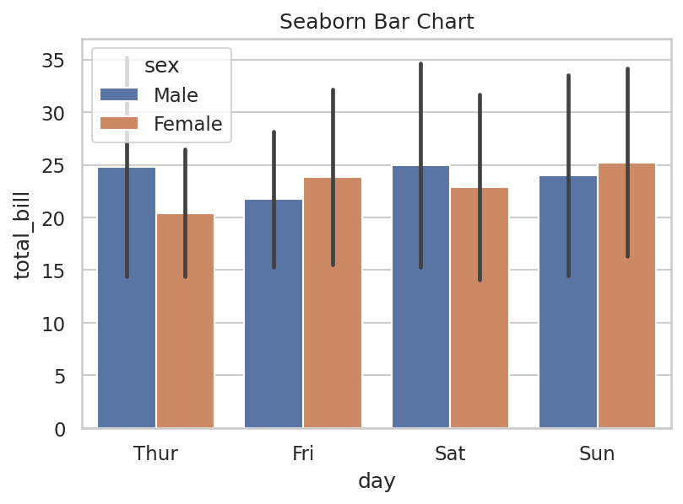
Bars are grouped by day and split into two colours representing sex, with black error bars on top of each bar showing one standard deviation. This allows a two-factor comparison (day and sex) in a single chart with statistical context built in.

4. Histogram

Description
Seaborn's histplot() draws a histogram from a DataFrame column and can optionally overlay a KDE curve and split bars by a categorical hue variable in a single call.

When to Use
Use it to study the distribution of a numeric variable while simultaneously comparing that distribution across subgroups, or when you want a smoothed density curve layered on the bars.

Python Code
import seaborn as sns
import matplotlib.pyplot as plt

fig, ax = plt.subplots(figsize=(6, 4))
sns.histplot(data=tips, x="total_bill", hue="time", kde=True, ax=ax)
ax.set_title("Seaborn Histogram")
plt.savefig("sns_histogram.png", dpi=150, bbox_inches="tight")
plt.show()

Expected Output
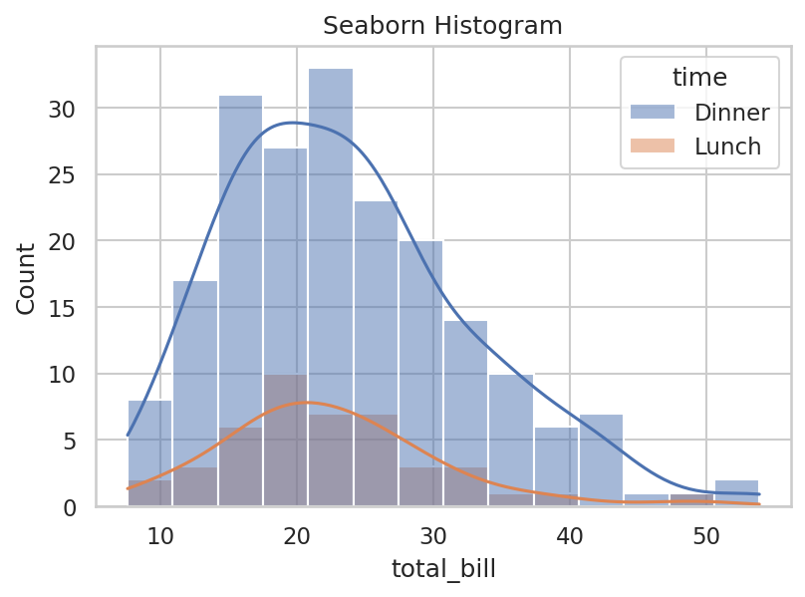
Stacked, colour-coded bars show the distribution of total bill amounts split by meal time, with a smooth KDE line overlaid on top of the bars for each group. This combines the detail of a histogram with the smoothness of a density curve in one chart.

5. Pie Chart

Description
Seaborn does not provide a native pie-chart function, since the library's design philosophy favours statistical charts over part-to-whole charts. A pie chart is still produced by calling Matplotlib's pie() function, optionally styled with a Seaborn colour palette.

When to Use
Use this approach only when a pie chart is specifically required; Seaborn's own documentation and community generally recommend a bar chart instead, as it is easier to compare bar lengths than pie-wedge angles.

Python Code
import matplotlib.pyplot as plt
import seaborn as sns

day_counts = tips["day"].value_counts()

fig, ax = plt.subplots(figsize=(6, 4))
ax.pie(
day_counts.values, labels=day_counts.index,
autopct="%1.1f%%", startangle=90,
colors=sns.color_palette("Set2")
)
ax.set_title("Pie Chart styled with a Seaborn Palette")
plt.savefig("sns_pie.png", dpi=150, bbox_inches="tight")
plt.show()

Expected Output
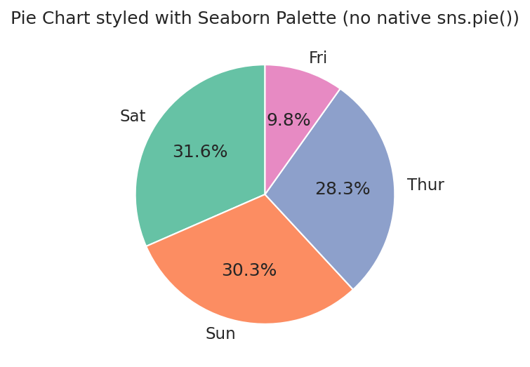
The result looks similar to the Matplotlib pie chart but uses Seaborn's softer 'Set2' colour palette for the wedges. This demonstrates that while Seaborn contributes attractive colour palettes, the chart geometry itself still comes from Matplotlib.

6. Box Plot

Description
Seaborn's boxplot() produces the same statistical summary as Matplotlib's box plot, but works directly with tidy DataFrames and supports an additional hue dimension for further grouping.

When to Use
Use it to compare distributions across categories, especially when a second categorical variable (via hue) should further split each category's box.

Python Code
import seaborn as sns
import matplotlib.pyplot as plt

fig, ax = plt.subplots(figsize=(6, 4))
sns.boxplot(data=tips, x="day", y="total_bill", hue="smoker", ax=ax)
ax.set_title("Seaborn Box Plot")
plt.savefig("sns_box.png", dpi=150, bbox_inches="tight")
plt.show()

Expected Output
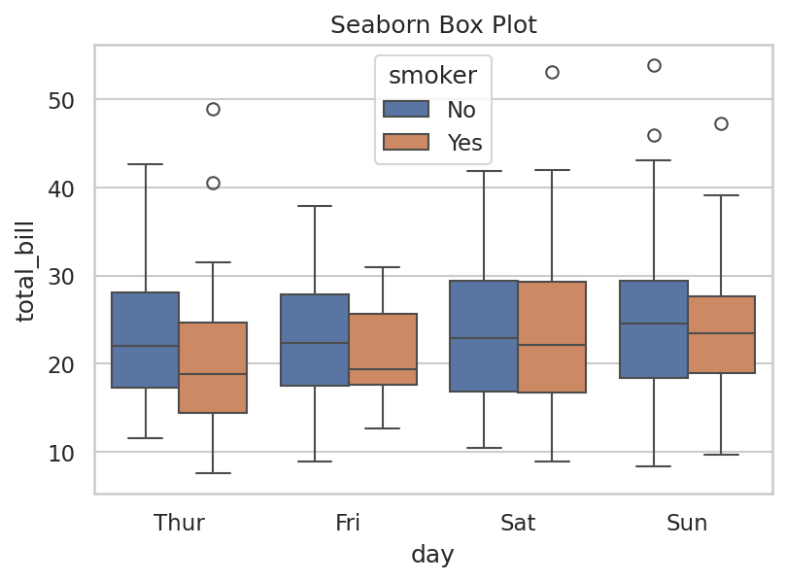
For each day, two boxes are shown side-by-side representing smokers and non-smokers, each with its own median line, interquartile box and outlier points, plus an automatically generated legend distinguishing the two groups.

7. Violin Plot

Description
Seaborn's violinplot() offers the same density-plus-summary visualisation as Matplotlib's violin plot, with the added ability to 'split' violins so two hue categories share one violin shape, each half representing one group.

When to Use
Use the split option when directly comparing two subgroups (for example, male vs female) within each category is important, since it allows a direct shape-to-shape comparison.

Python Code
import seaborn as sns
import matplotlib.pyplot as plt

fig, ax = plt.subplots(figsize=(6, 4))
sns.violinplot(data=tips, x="day", y="total_bill", hue="sex", split=True, ax=ax)
ax.set_title("Seaborn Violin Plot")
plt.savefig("sns_violin.png", dpi=150, bbox_inches="tight")
plt.show()

Expected Output
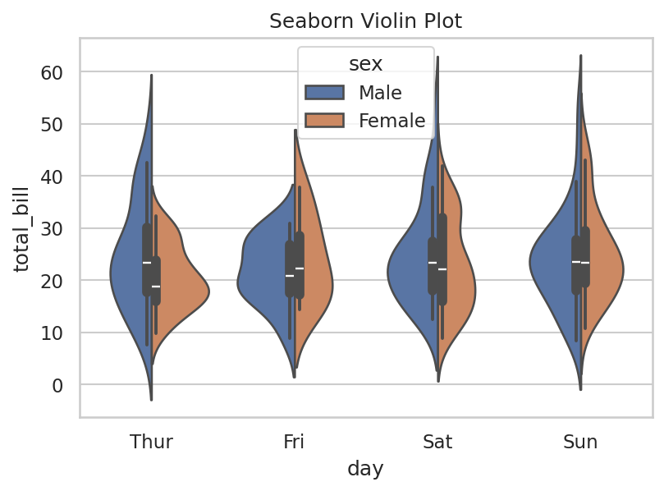
Each day shows one violin shape split down the middle: the left half shows the density for one sex and the right half the other. This makes it straightforward to compare the shape of the distributions between the two groups within each day.

8. Heatmap

Description
Seaborn's heatmap() renders a matrix as coloured cells and, unlike Matplotlib's imshow(), provides built-in cell annotation (annot=True), automatic colour-bar placement and sensible default colour maps in a single function call.

When to Use
Use it whenever a correlation matrix, pivot table or confusion matrix needs to be visualised quickly with readable numeric annotations inside each cell.

Python Code
import seaborn as sns
import matplotlib.pyplot as plt

corr = tips[["total_bill", "tip", "size"]].corr()

fig, ax = plt.subplots(figsize=(6, 5))
sns.heatmap(corr, annot=True, cmap="coolwarm", vmin=-1, vmax=1, ax=ax)
ax.set_title("Seaborn Heatmap (Correlation Matrix)")
plt.savefig("sns_heatmap.png", dpi=150, bbox_inches="tight")
plt.show()

Expected Output
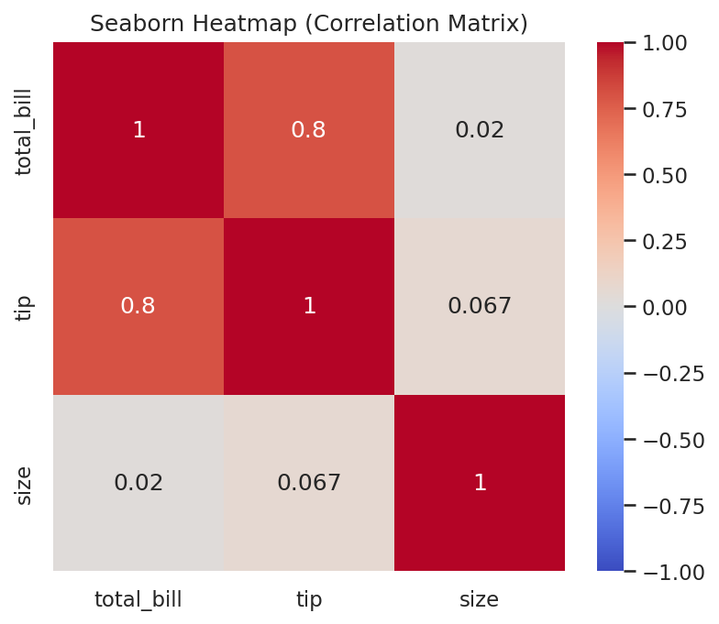
The same 3x3 correlation grid as the Matplotlib version is produced, but with considerably less code: cell annotations, the colour bar and axis tick labels are all generated automatically by the single sns.heatmap() call.

9. Count Plot

Description
Seaborn's countplot() is a dedicated function that counts and plots the occurrences of each category directly from raw (non-aggregated) data, removing the need to call value_counts() manually.

When to Use
Use it any time you need a quick frequency chart of a categorical column, optionally broken down further by a second categorical variable using hue.

Python Code
import seaborn as sns
import matplotlib.pyplot as plt

fig, ax = plt.subplots(figsize=(6, 4))
sns.countplot(data=tips, x="day", hue="sex", ax=ax)
ax.set_title("Seaborn Count Plot")
plt.savefig("sns_countplot.png", dpi=150, bbox_inches="tight")
plt.show()

Expected Output
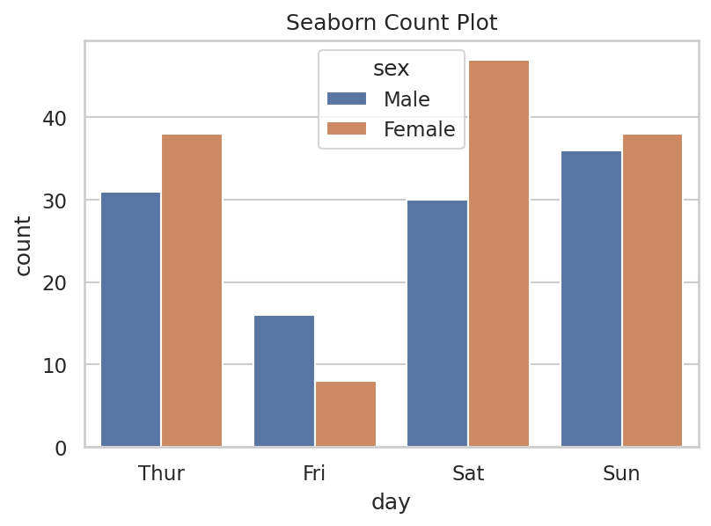
Bars show the raw number of records for each day, split into two colours for male and female customers. Unlike the Matplotlib version, no manual aggregation step with pandas was required before plotting.

10. Pair Plot

Description
Seaborn's pairplot() automatically builds a full grid of pairwise scatter plots (and diagonal histograms or KDEs) for every numeric column in a DataFrame, with a single function call, and can colour every point by a categorical hue variable.

When to Use
Use it as the fastest way to perform exploratory, multivariate analysis on a new dataset, particularly when checking how well a categorical target separates across several features.

Python Code
import seaborn as sns

g = sns.pairplot(
iris, hue="species",
vars=["sepal_length", "sepal_width", "petal_length"],
diag_kind="hist", height=2.2
)
g.fig.suptitle("Seaborn Pair Plot", y=1.02)
g.savefig("sns_pairplot.png", dpi=150, bbox_inches="tight")

Expected Output
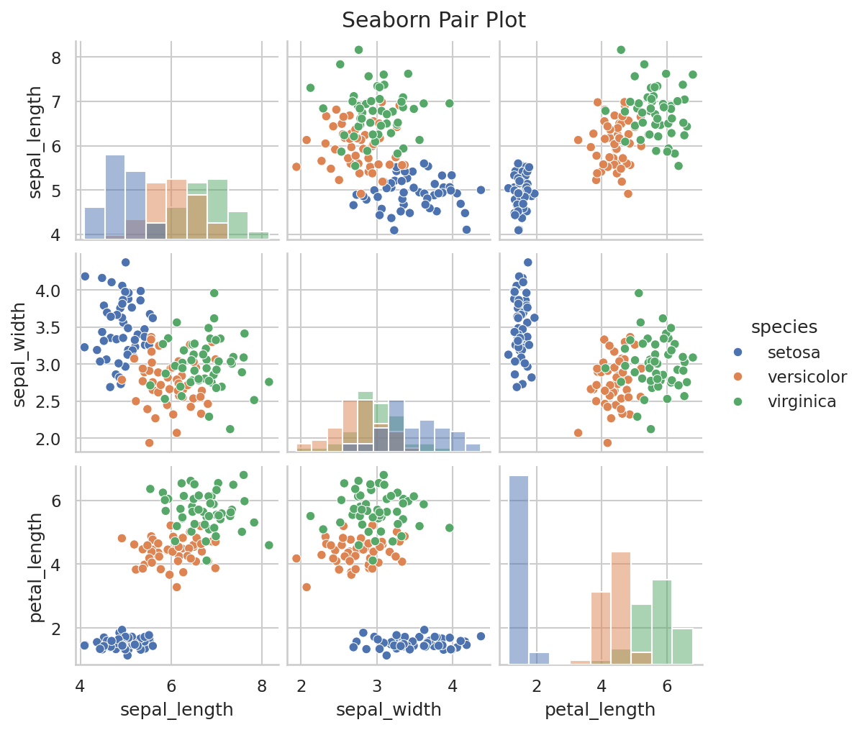
A full grid of scatter plots is generated automatically, colour-coded by iris species, with histograms along the diagonal. Compared to the Matplotlib version, the entire grid, legend and colour-coding were produced with one line of code instead of a manual nested loop.

11. KDE Plot

Description
Seaborn's kdeplot() is a first-class, dedicated function for kernel density estimation that supports hue-based grouping and optional area-fill shading directly, without needing SciPy.

When to Use
Use it to compare the smoothed distribution shape of a numeric variable across multiple groups on the same axes, which is difficult to do cleanly with raw Matplotlib.

Python Code
import seaborn as sns
import matplotlib.pyplot as plt

fig, ax = plt.subplots(figsize=(6, 4))
sns.kdeplot(data=tips, x="total_bill", hue="time", fill=True, ax=ax)
ax.set_title("Seaborn KDE Plot")
plt.savefig("sns_kde.png", dpi=150, bbox_inches="tight")
plt.show()

Expected Output
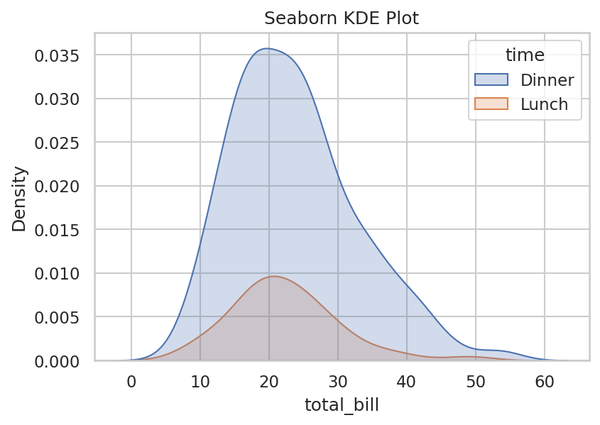
Two overlapping, semi-transparent, shaded density curves are drawn, one per meal time (Lunch and Dinner), making it easy to compare how the distribution of total bill amounts differs between the two groups on a single set of axes.

6. Comparison: Matplotlib vs Seaborn
Both libraries are complementary rather than strictly competing: Seaborn is built on top of Matplotlib and returns native Matplotlib objects, so most real-world projects use the two together — Seaborn for fast, attractive statistical charts, and Matplotlib for fine-tuning or for chart types Seaborn does not cover. The table below compares them across the criteria requested for this task.
Criteria | Matplotlib | Seaborn
Ease of Use | Lower-level; more code required for statistical charts. | Higher-level; concise, one-line statistical charts.
Customization | Extremely high — every element can be controlled manually. | Good, but deep customisation often requires dropping into Matplotlib.
Performance | Fast for basic charts; scales well with large arrays via NumPy. | Slightly slower on very large datasets due to built-in statistical computation.
Interactivity | Limited natively; needs extra tools (mplcursors, ipympl, mpld3). | Same limitation as Matplotlib, since it renders through Matplotlib.
Large Datasets | Handles large numeric arrays efficiently (e.g. NumPy-based plots). | Can slow down when aggregating/estimating statistics on very large DataFrames.
Learning Curve | Steeper for beginners; many parameters to learn. | Gentler; sensible defaults let beginners produce good charts quickly.
Best Use Cases | Publication-quality custom figures; full layout control; non-statistical plots (images, 3D, engineering plots). | Rapid statistical EDA; distribution and relationship analysis; polished default styling.

6.1 Summary of Findings
In practice, Matplotlib is the better choice when a project needs precise, low-level control over every visual element, or needs a chart type outside Seaborn's statistical focus (such as 3D plots or custom annotated diagrams). Seaborn is the better choice when the goal is fast, attractive, statistically informed exploration of tidy tabular data. Because Seaborn plots return the underlying Matplotlib Figure and Axes objects, the most effective workflow — and the one demonstrated throughout this report — is to build the initial chart quickly with Seaborn and then fine-tune titles, labels, and layout using Matplotlib's Axes API.

7. Conclusion
This report has documented Matplotlib and Seaborn, the two most widely used data visualization libraries in the Python data science ecosystem, covering their design philosophy, features, advantages, disadvantages, installation steps, and typical use cases, followed by a complete catalogue of eleven graph types implemented in both libraries with runnable code and explained output.
The exercise makes clear that the two libraries are not rivals but partners: Matplotlib supplies the low-level rendering engine and total customisability, while Seaborn supplies a high-level, statistically aware interface that removes boilerplate code for the most common chart types. For quick statistical exploration of a tidy DataFrame, Seaborn is generally faster to write and produces more polished results by default. For fully bespoke figures, unusual chart types, or situations requiring pixel-level control, Matplotlib remains indispensable.
For a beginner data scientist, the recommended learning path is to first become comfortable with Matplotlib's core Figure/Axes model, since it underlies almost every other Python plotting library, and then to layer Seaborn on top of that knowledge to accelerate day-to-day statistical visualization work. This combination forms a strong, practical foundation for the data visualization tasks encountered throughout the remainder of the ShadowFox Data Science Internship.

8. References
The following official documentation sources were used as the primary reference material for this report. All explanations, advantages/disadvantages and code patterns in this document were written independently by the author in original language based on general knowledge of both libraries and the concepts introduced in these official sources; no text has been copied verbatim from the documentation.
- Matplotlib Development Team. "Quick Start Guide." Matplotlib Documentation. https://matplotlib.org/stable/users/explain/quick_start.html
- Waskom, M. et al. "An Introduction to Seaborn." Seaborn Documentation. https://seaborn.pydata.org/tutorial/introduction.html
- Matplotlib Development Team. Matplotlib Official Documentation. https://matplotlib.org/stable/
- Waskom, M. et al. Seaborn Official Documentation. https://seaborn.pydata.org/

— End of Report —

