Date – 15th Feb, 2013

NATIONAL INSTITUTE OF TECHNOLOGY KARNATAKA COMPUTER SCIENCE AND ENGINEERING DEPARTMENT.



Microprocessors Lab Project Abstract

Batch: 4th Sem B. Tech (Batch D)

Team Members: Tushar Makkar (11CO98)
Vinod Rathod (11CO101)
Vishnuraj M (11CO104)
Jayendra Dewani (11CO106)
Beta2Alpha Game

Aim:

The aim of the project is to develop a game (Beta2Alpha) by modifying “a code breaker paper and pencil game” popularly known as, Bulls and Cows.

Introduction & Description of Game:

It is a code breaking game for 2 players. The game can also be played with 3 digits instead of 4.

On a sheet of paper, the players each write a 4-digit secret number. The digits must be all different. Then, in turn, the players try to guess their opponent's number who gives the number of matches. If the matching digits are on their right positions, they are "beta", if on different positions, they are "alpha".

(Example of bulls and cows)
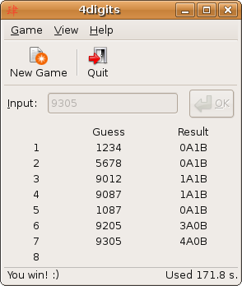
•Secret number: 4271
•Opponent's try: 1234
•Answer: 1 beta and 2 alphas.
(The beta is "2",
the alphas are "4" and "1".)

Game Plan:

LEDs are used to display the inputs by the user and the output is also displayed with the help of LEDs (7-segment display).We are implementing an artificial intelligence algorithm to guess the correct solution effficiently. The implementation will be done using an 8086 microprocessor.

Bibliography:

•Wikipedia
(http:/en.wikipedia.org/wiki/Bulls_and_cows)

•Artificial Intelligence (Mastermind)
(http://home.pacific.net.hk/~kfzhou/mmh.html#Tutor)

•8086 Microprocessor Instruction Set.

