**OUTPUTS FOR SEARCHING FOR A SPECIFIC USER AND UPDATING THE USER INFORMATION**

1. When entered valid id

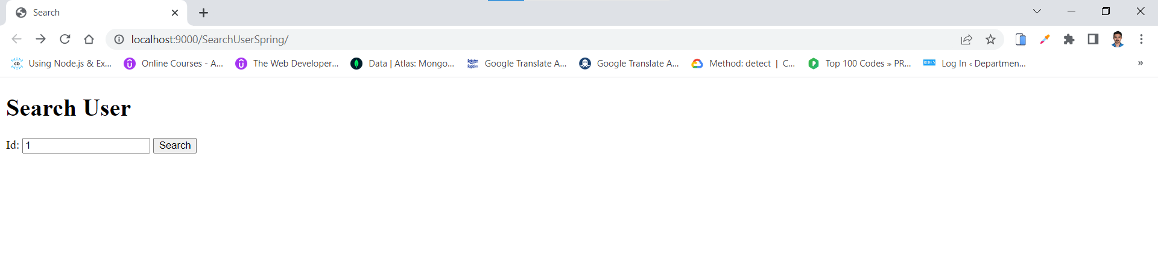

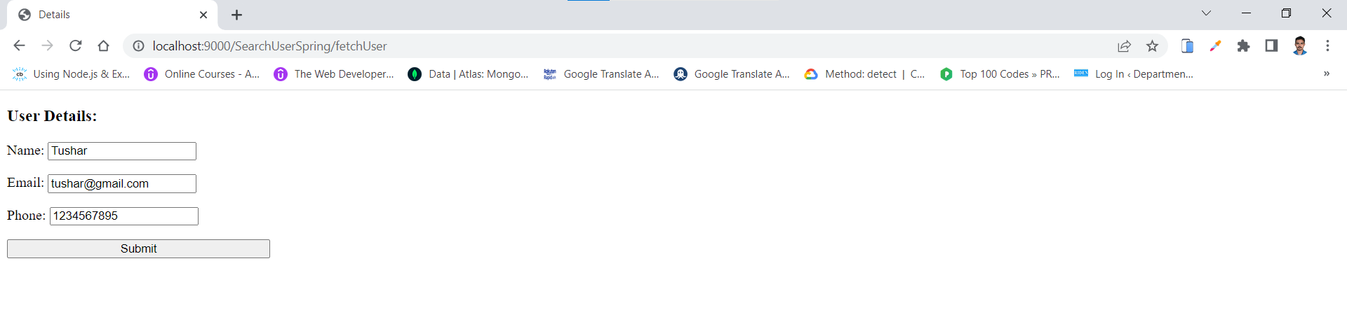

2. When editing the details and clicking on submit

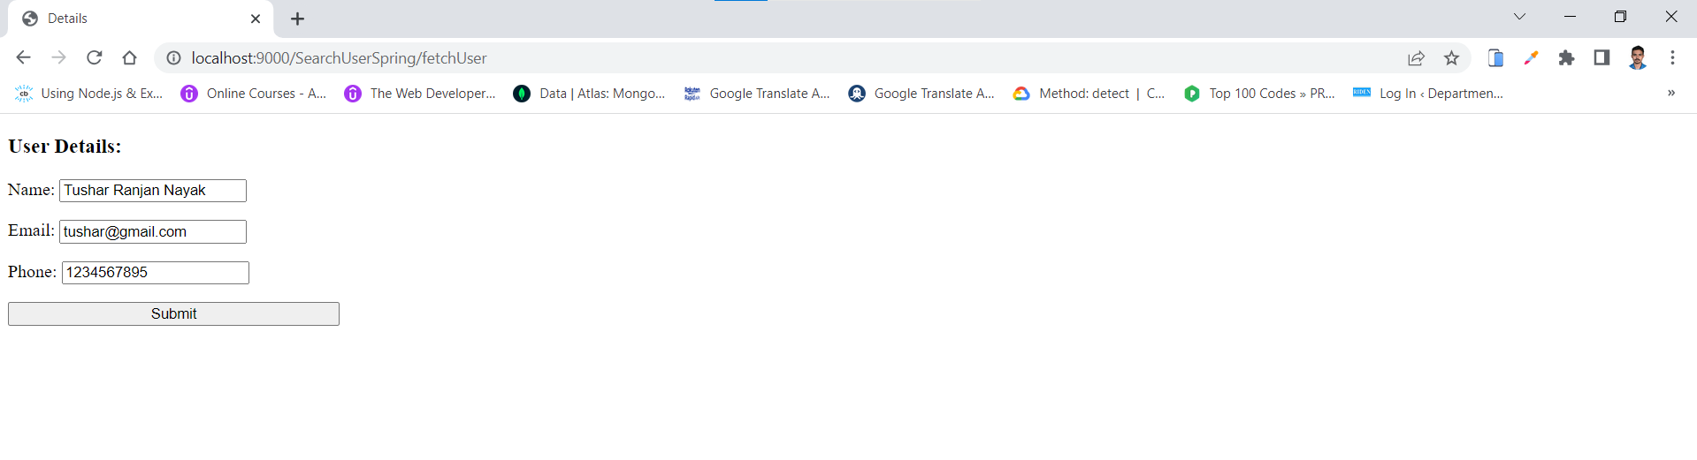

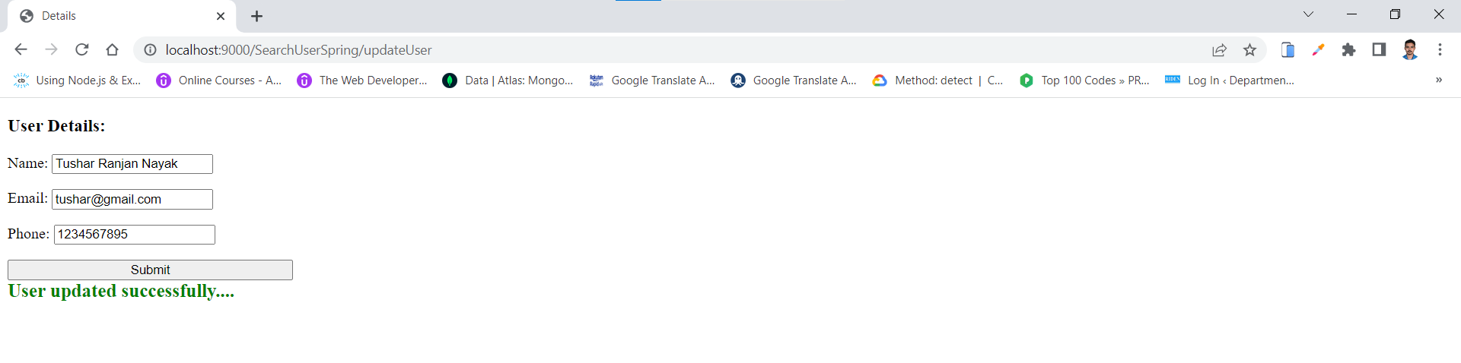

3. When user is not found with the entered id

