**OUTPUT FOR CAMERA RENTAL APP**

1. 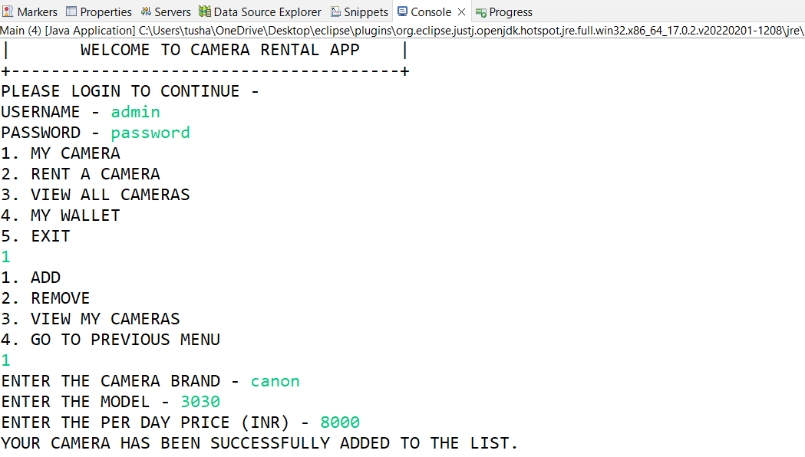Add camera
2. Rent a camera

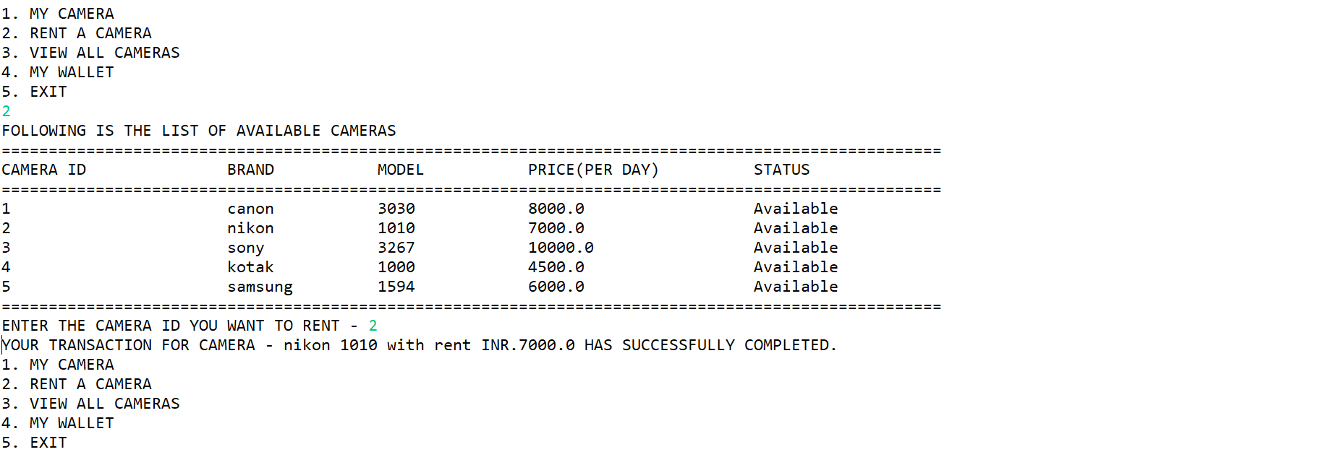

1. View all cameras

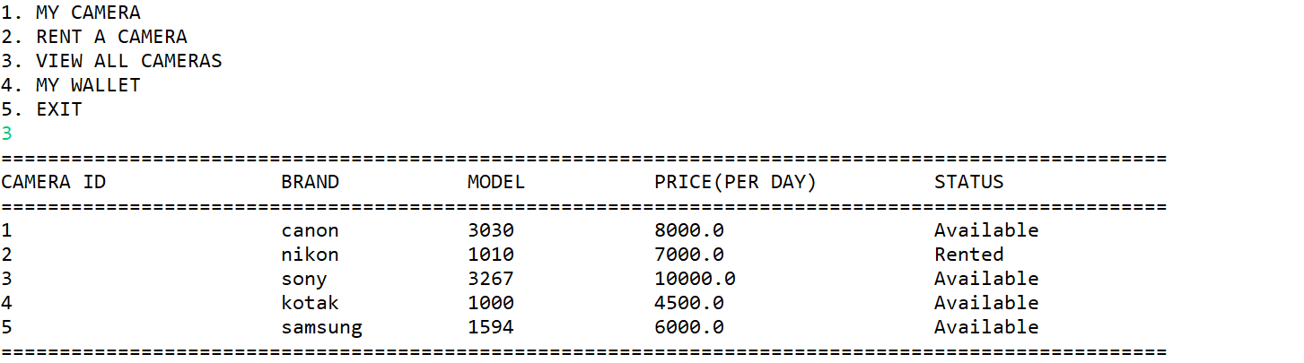

1. 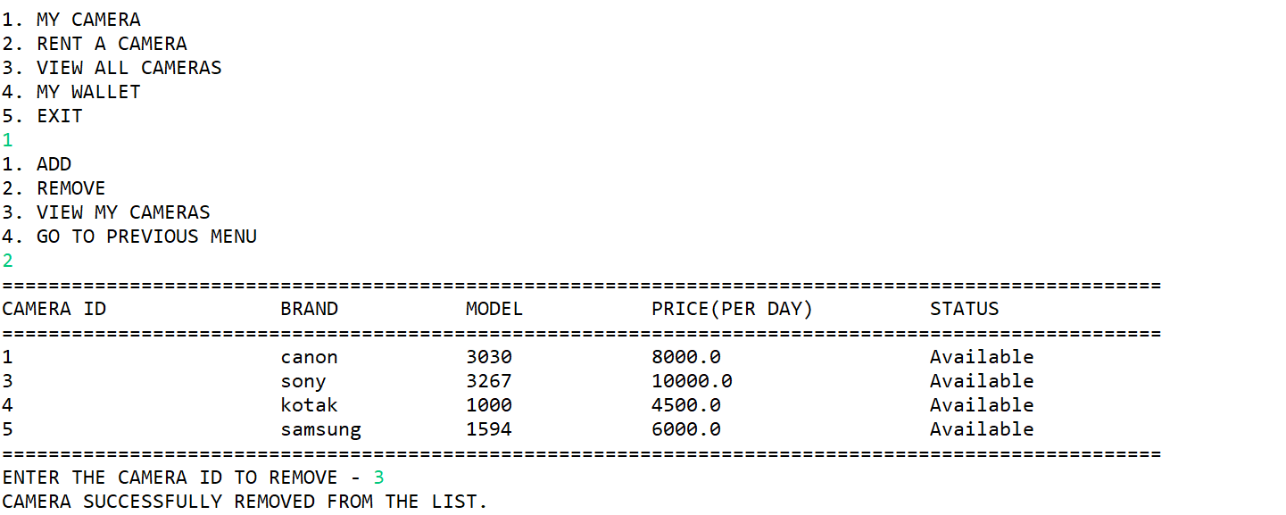Remove camera
2. 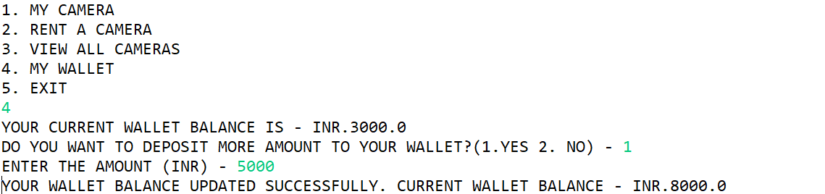My wallet or Add money
3. 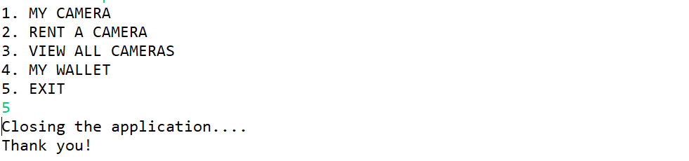Exit or close the application