1. Servlet/JSP Overview
------------------------------------------------------------------------------------------------------------------------
-> What is a web application?
➤ A website where the HTML pages are generated dynamically based on user action

-> What are Servlet and JSP?
➤ Servlet and JSP are server-side technologies written in Java and run on the server to generate dynamic web pages.

-> What types of apps can we create by using Servlet and JSP?
We can develop many types of apps such as:
➤ E-Commerce Apps
➤ Banking Apps etc.

2. Servlet/JSP Flow:
------------------------------------------------------------------------------------------------------------------------

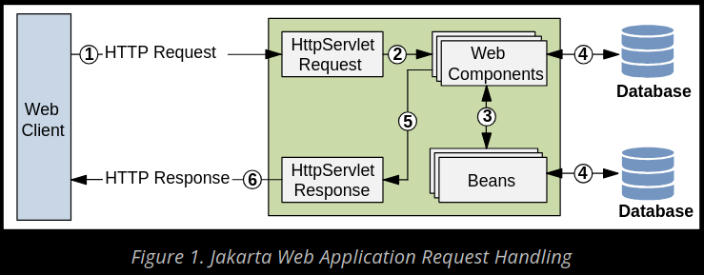

Note: The java package has changed from javax.servlet to jakarta.servlet.

2. Servlet Basics
------------------------------------------------------------------------------------------------------------------------

3. Servlet Interface with example
------------------------------------------------------------------------------------------------------------------------

4. GenericServlet with example
------------------------------------------------------------------------------------------------------------------------

5. HttpServlet with example
------------------------------------------------------------------------------------------------------------------------

6. Servlet Lifecycle
------------------------------------------------------------------------------------------------------------------------

7. Form Submission
------------------------------------------------------------------------------------------------------------------------

8. RequestDispatcher: forward() and include() method
------------------------------------------------------------------------------------------------------------------------

9. sendRedirect() method
------------------------------------------------------------------------------------------------------------------------

10. Servlet Config and Servlet Context
-------------------------------------------------------------------------------------------------------------------------------------------------------------

11. Servlet using Annotation
-------------------------------------------------------------------------------------------------------------------------------------------------------------

12. init param using annotation
-------------------------------------------------------------------------------------------------------------------------------------------------------------

13. Session Management using Cookies in servlet
-------------------------------------------------------------------------------------------------------------------------------------------------------------

14. Session Management using Hidden form field
-------------------------------------------------------------------------------------------------------------------------------------------------------------

15. Session Management using URL rewriting
-------------------------------------------------------------------------------------------------------------------------------------------------------------

16. Session Management using HttpSession
-------------------------------------------------------------------------------------------------------------------------------------------------------------

17. Filter basics
-------------------------------------------------------------------------------------------------------------------------------------------------------------

18. Filter using annotation
-------------------------------------------------------------------------------------------------------------------------------------------------------------

19. User validation using MySQL JDBC and Tomcat
-------------------------------------------------------------------------------------------------------------------------------------------------------------

20. Listener
-------------------------------------------------------------------------------------------------------------------------------------------------------------

21. Employee registration using MySQL JDBC and Tomcat
-------------------------------------------------------------------------------------------------------------------------------------------------------------

22. Miscellaneous topic
-------------------------------------------------------------------------------------------------------------------------------------------------------------

