**GOVT. ARTS AND SCIENCE COLLEGE RATLAM**

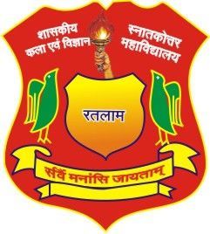

**A Project Report**

**On**

**Tourism Website “YOUR DESTINSTION”**

**Submitted in the partial fulfilment of the requirement of the degree of**

**MASTERS OF COMPUTER SCIENCE**

**2020-2022**

**GUIDED BY**

**Prof Nitesh Pathak**