**Testing the Application RESTfulness using Postman Client**

Specifically, implement API behaviors to:

1. Create an Author
2. Run the node program node server.js

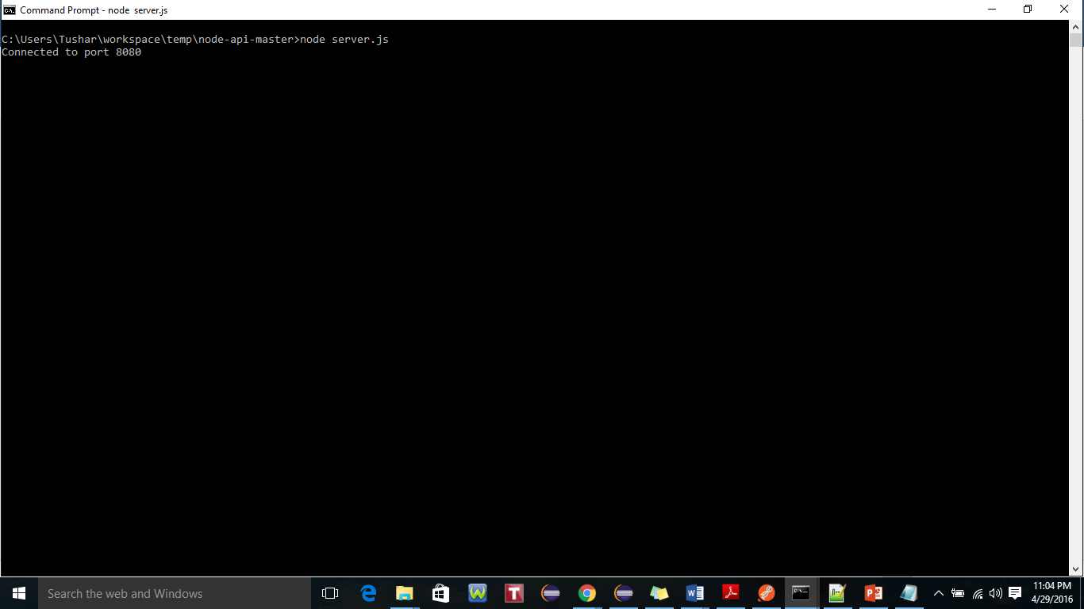

1. Enter the values for First name and Last name for authors as Tushar and Pandey, respectively. Author id created “57244b39a4cfa7bc26000001"

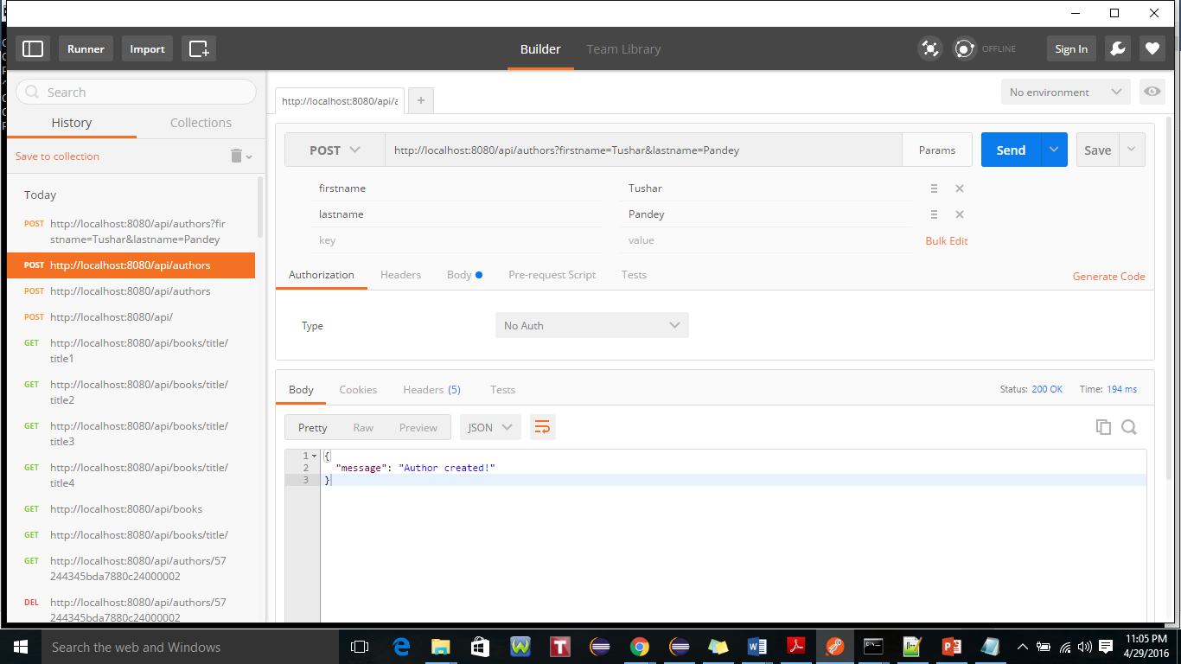

1. Verify by using GET method to read author. Author created successfully.

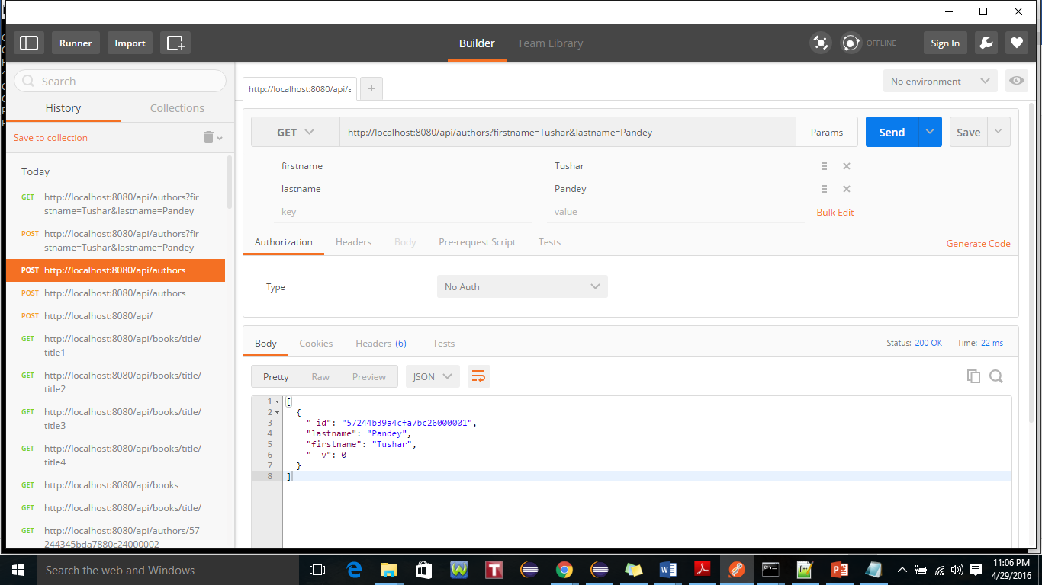

1. Create a Book (note it must have at least one Author)

Book ID 57244c68a4cfa7bc26000002 created as per steps followed in below snapshot.

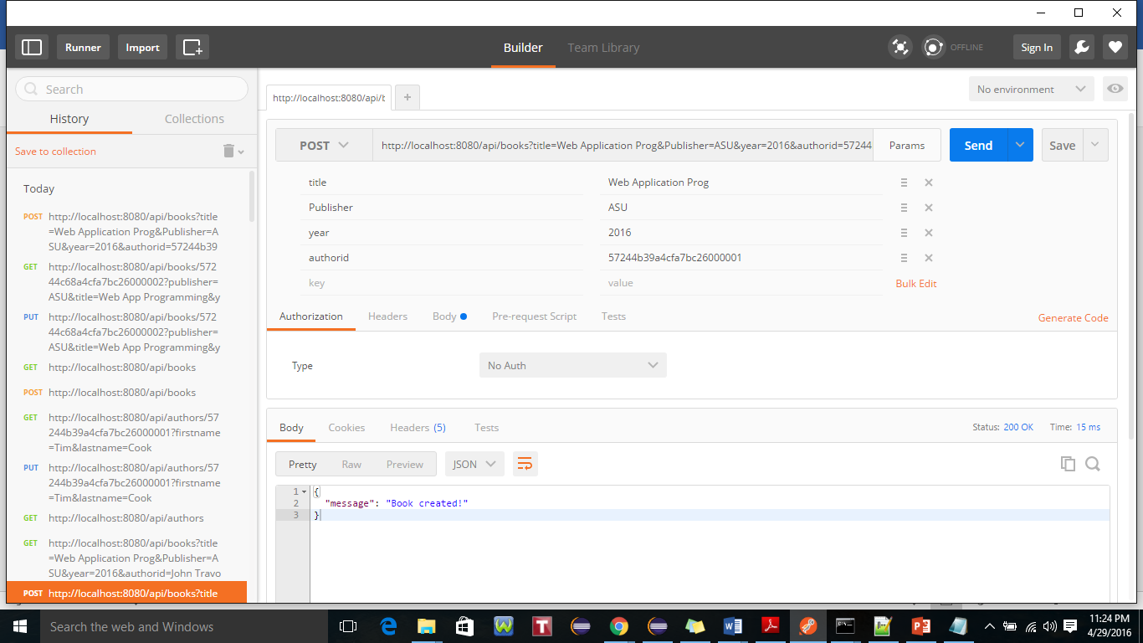

1. Update an Author’s first or last name

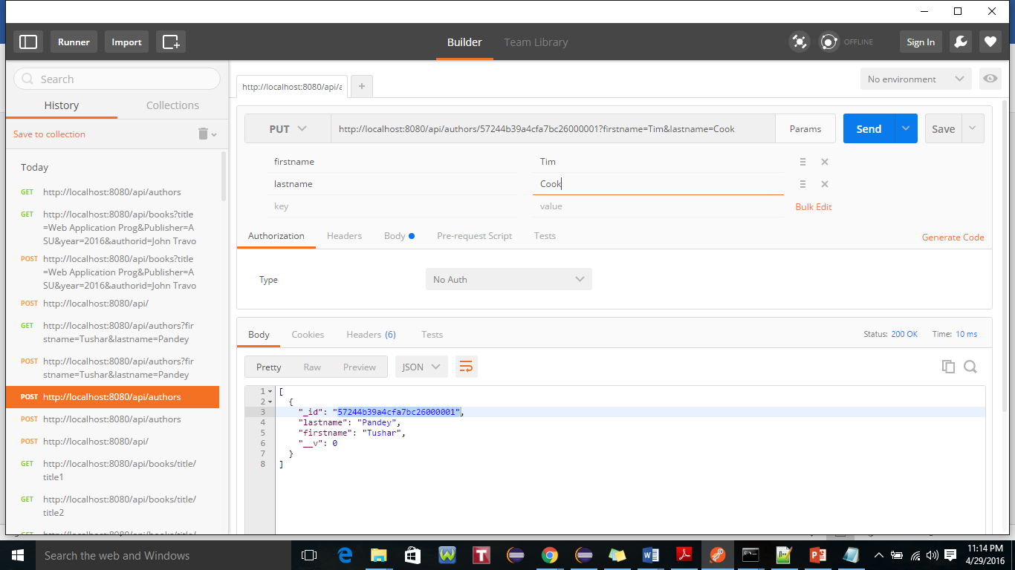

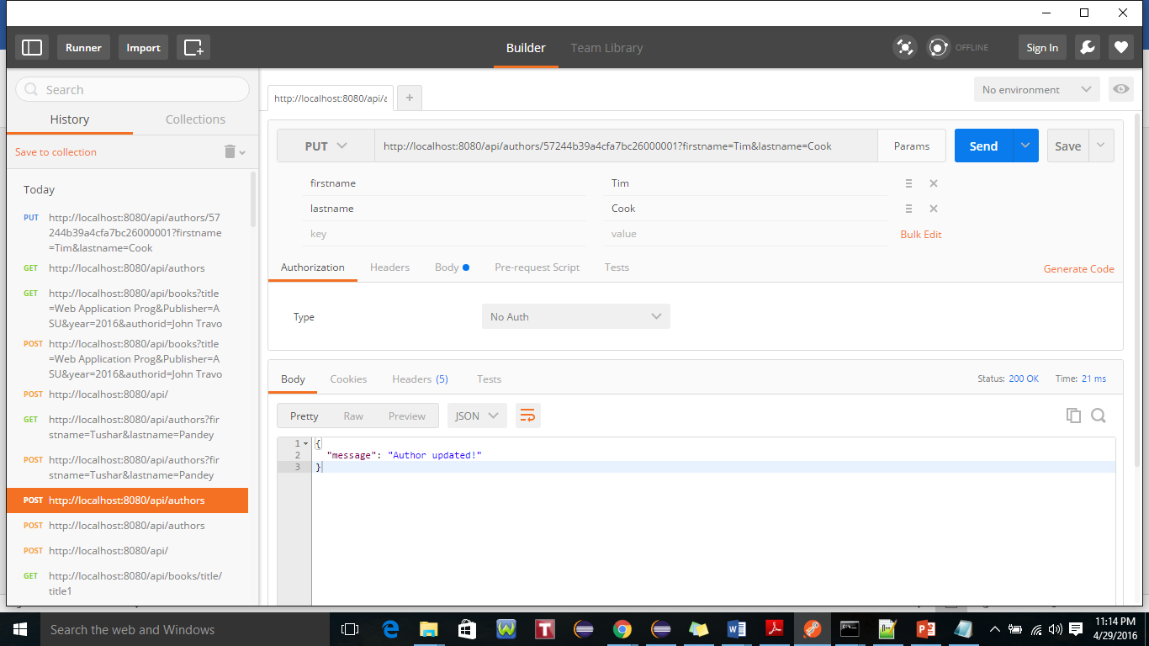

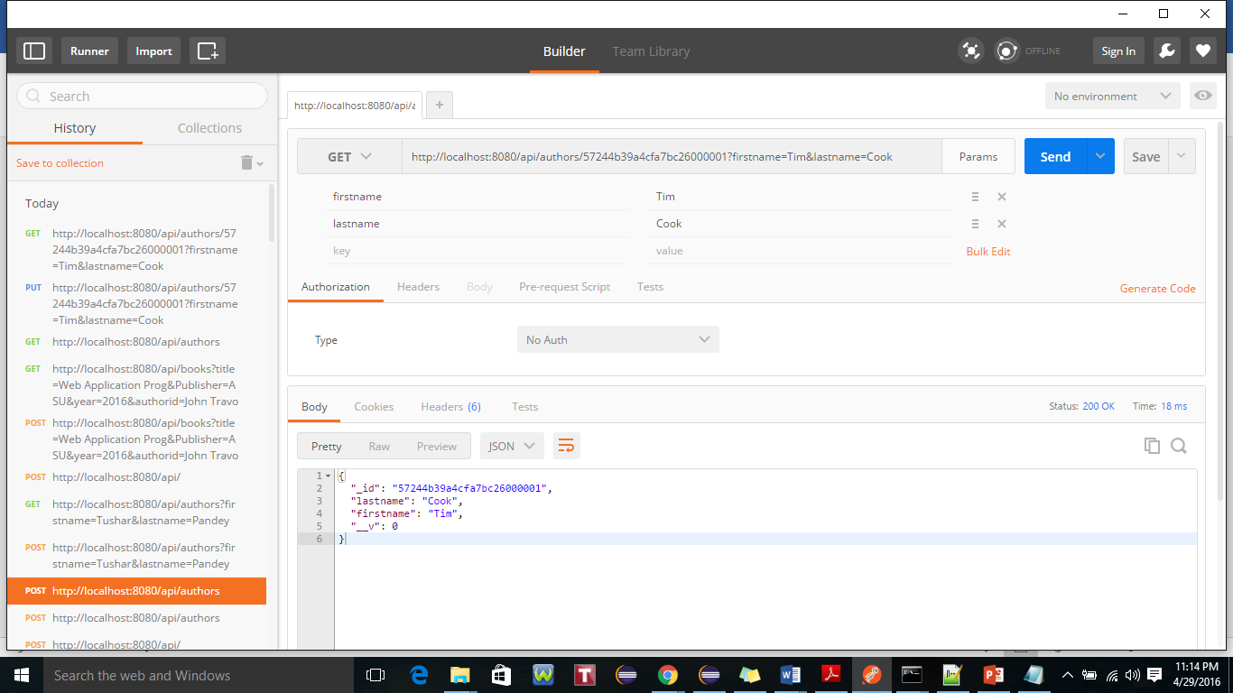

1. Update a Book’s publisher, title, or year

Fetch an existing book ID 57244c68a4cfa7bc26000002

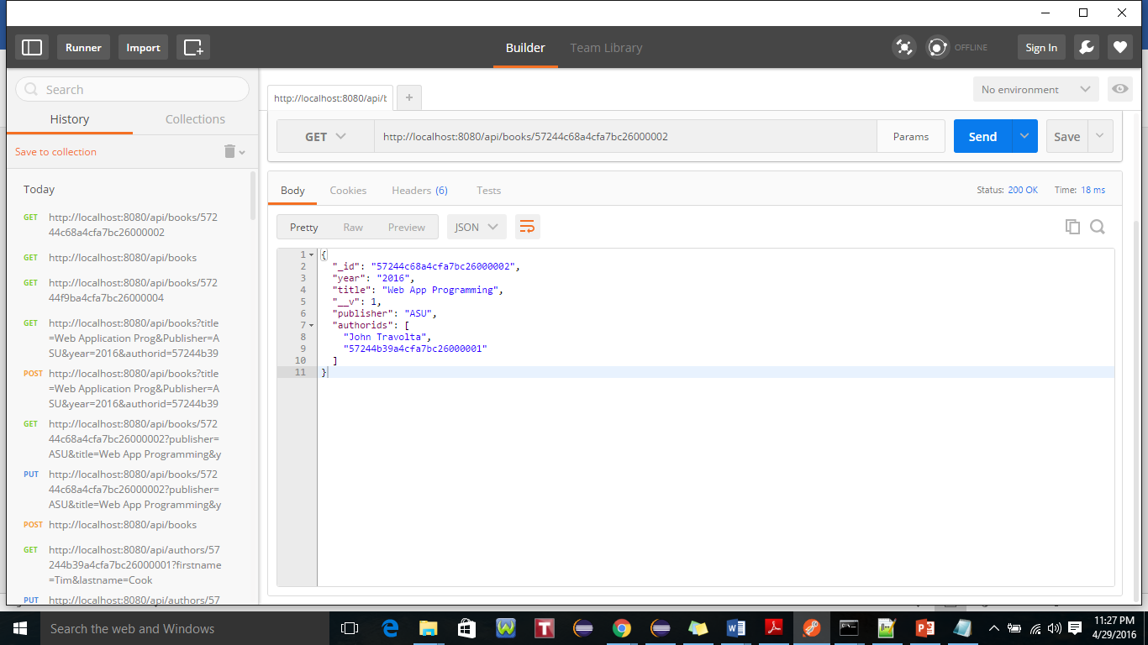

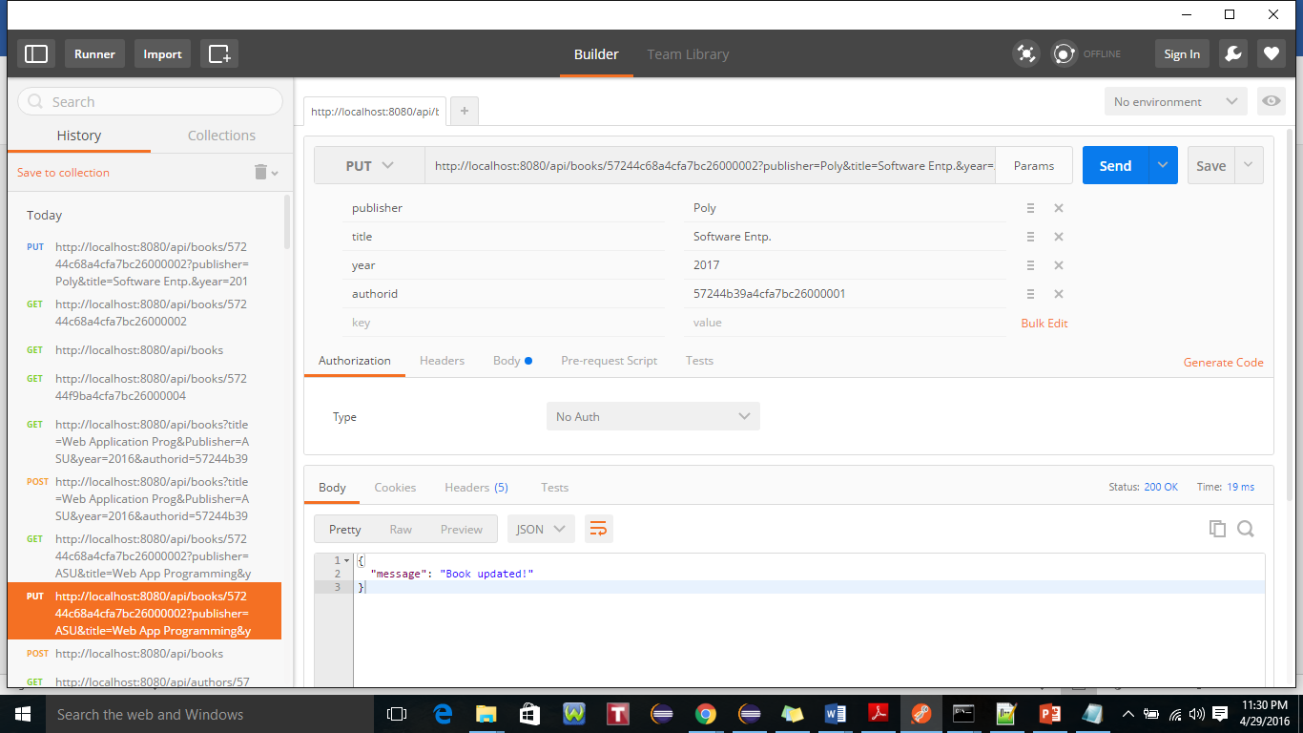

1. Add an Author to a Book

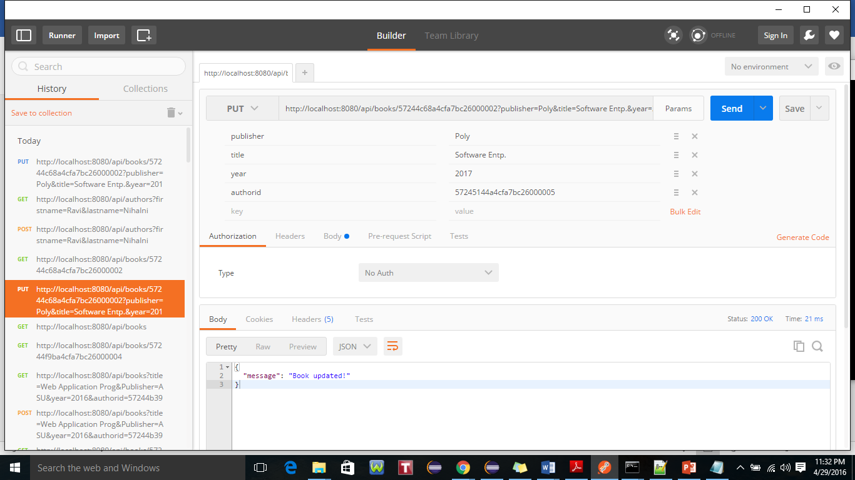

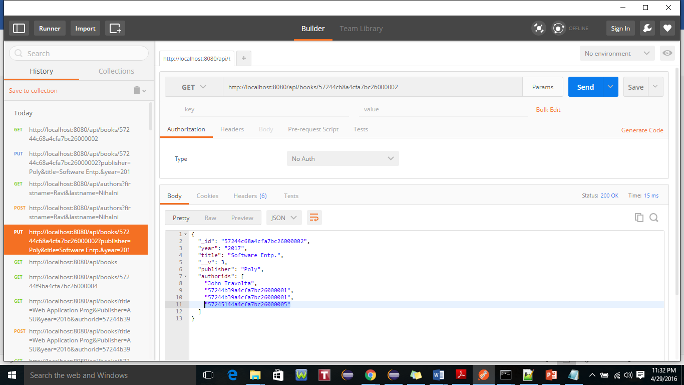

1. Delete a Book

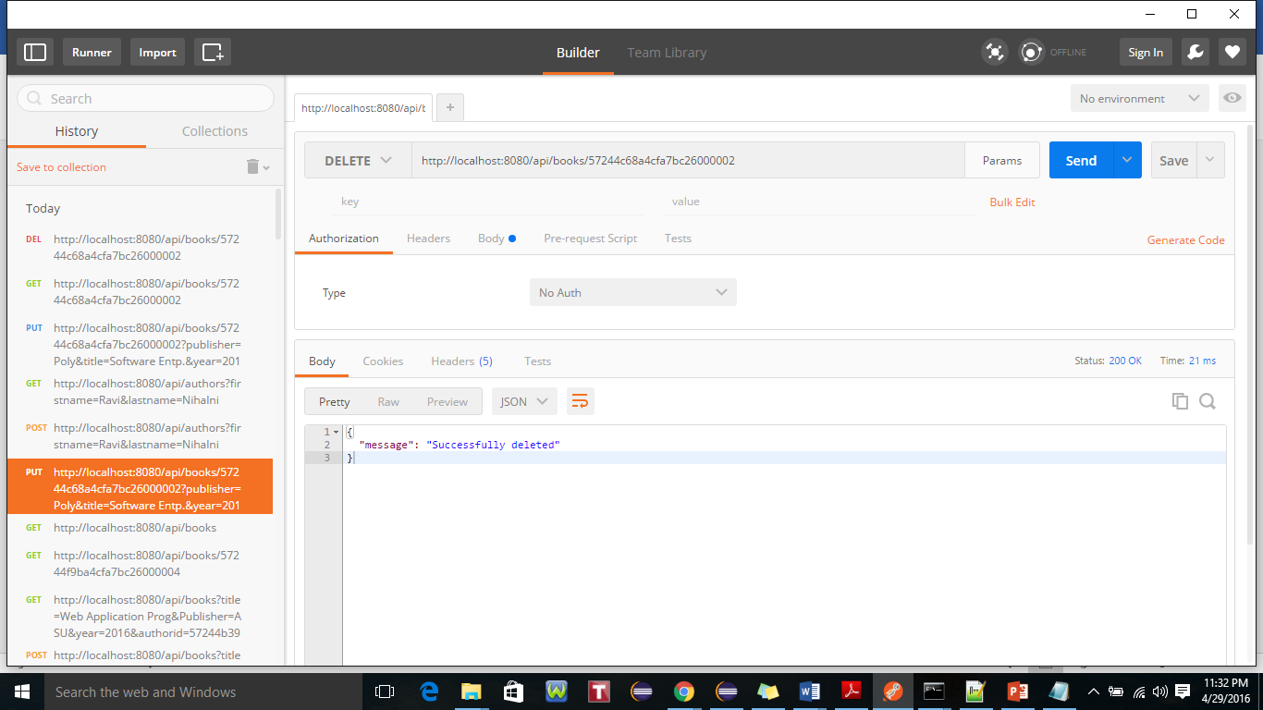

1. Delete an Author (only if no Book with that Author)

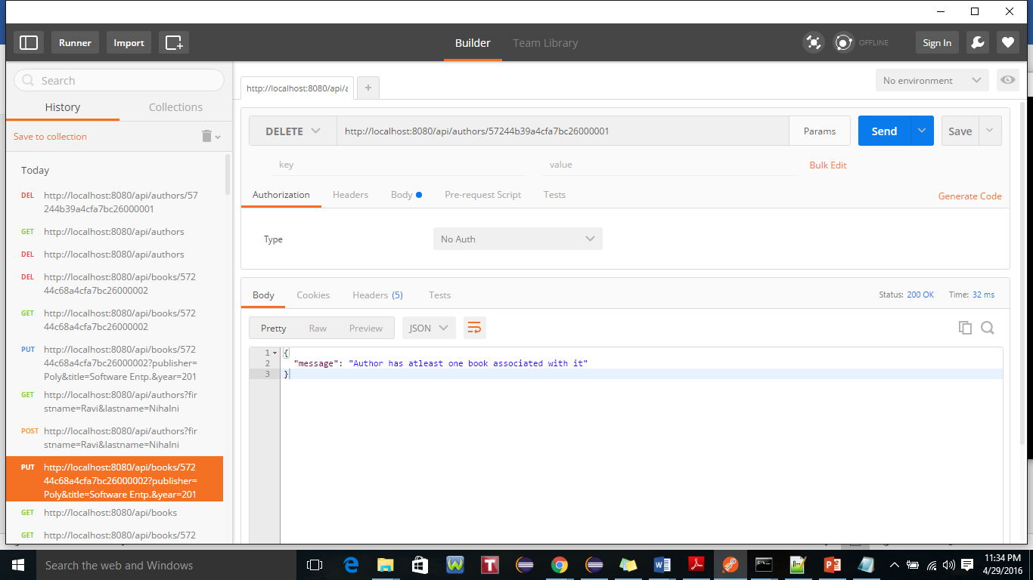

1. Retrieve an Author by ID

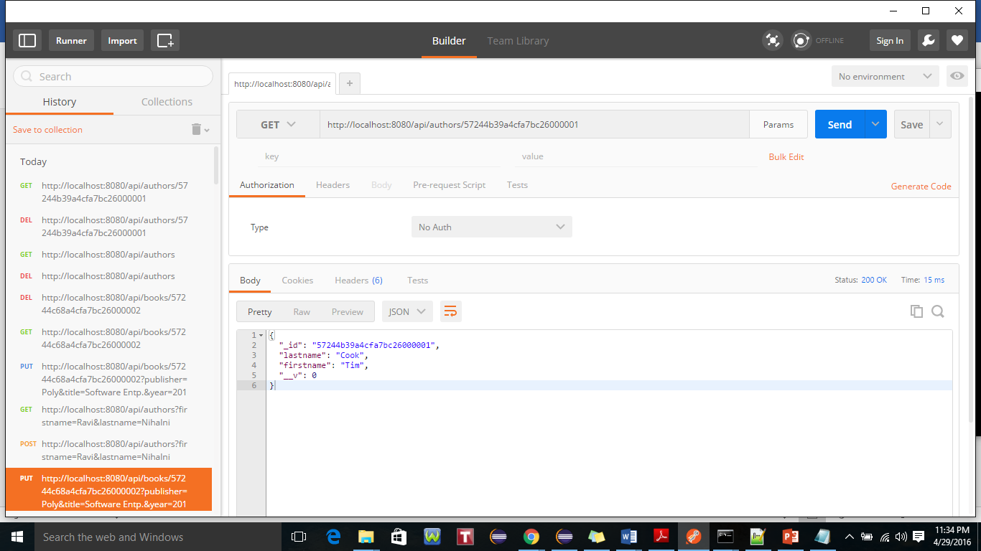

1. Retrieve a Book by ISBN

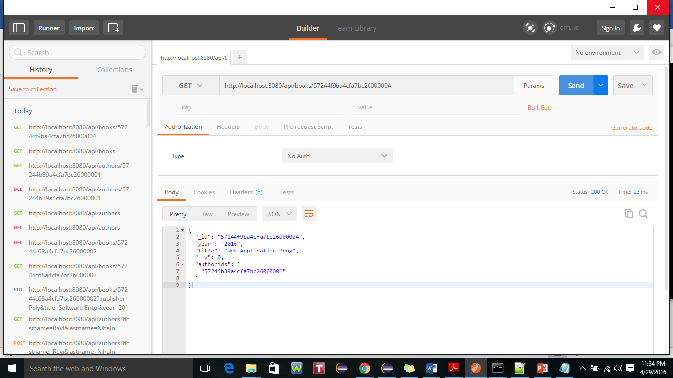

1. Retrieve a collection of Books by Title substring

