Benefit-Cost Analysis of Dam Construction Projects

Tushar Parimi

College of Professional Studies, Northeastern University

ALY 6050: Enterprise Analytics

June 6th, 2022

**Introduction**

Dams are a very powerful construction to enhance the usage of our water resource. The scenario is the analysis of construction of two dams. The project is a very real life like situation where there are a lot of construction projects available, but we can only select one because of various factors like time, budget, resource availability etc. This project will be a benefit cost analysis to select the best option out of the two dam construction projects provided. Each dam has set of six benefits that are improved navigation, hydroelectric power, fish and wildlife, recreation, flood control and commercial development. The annualized capital cost and operations and maintenance costs for both dams are also provided. The goal will be to select the best dam construction project out of the two options based on the benefit cost analysis ratio.

**Analysis**

In part 1 of the analysis,

we will perform 10000 simulations of the benefit cost ratio for both the dams based on the benefit and cost data given for each dam construction.

The benefits and cost estimates of the two construction projects were given to us in the form of minimum, maximum and the most repeated value (mode). Therefore, first 10000 random samples of each of the benefits and costs were generated. All the individual benefits in a particular sample were summed up to gets 10000 samples of total benefits. Similarly, 10000 samples were generated for total costs. Then the 10000 samples of benefit-cost ratio was generated for each dam by dividing the total benefits with total costs.

The 10000 benefit-cost ratio samples of both dams are as follows,

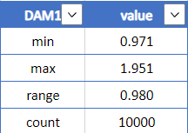 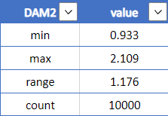

The frequency distribution of the two benefit-cost ratio samples for the two dam contruction projects are as follows,

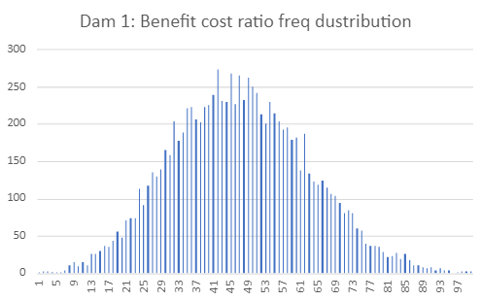

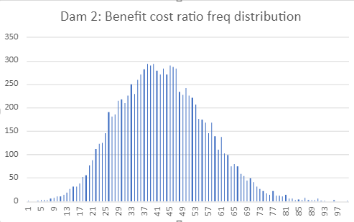

These frequency disstributions represent a distribution between a minimum and maximum values with one of the benefit-cost ratio having the most frequency. If we would want to make a guess then we would probably say it represents a triangular distribution.

Few results from the benefit-cost samples for the two dams are as follows,

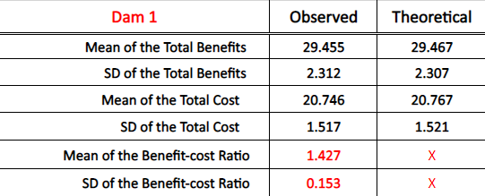 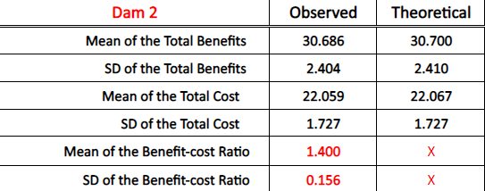

The observed and theoretical values of mean and stadard deviation of total benefits and total costs of each da are pretty similar.

In part 2 of the analysis,

We will conduct a chi-square goodness of fit test to check if the sample from dam1 represents a triangular distribution.

Null hypothesis: The benefit cost sample of dam1 represents a triangular distribution.

Alternate hypothesis: The benefit cost sample from dam1 does not represent a triangular distribution.

The results were as follows,



p-value is smaller than 0.05.

Therefore we reject the Null hypothesis.

Hence, the sample does not represent a triangular distribution.

**Results**

The results table is as follows,

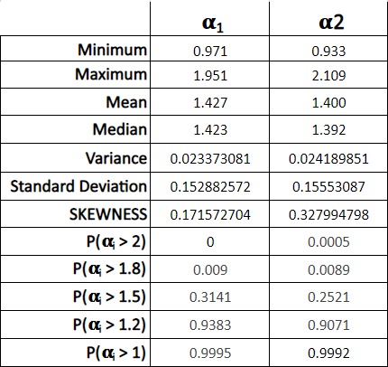

Here benefit cost analysis is represented as alpha1 and alpha2 for dam1 and dam2 respectively.

We can see that, dam1 does not have benefit-cost ratio greater than 2 where as there are some samples in dam2 that are greater than 2.



But as we can see that there is more probability of dam1 giving a greater benefit-cost ratio than dam2.

**Conclusion**

From the above analysis and results we can conclude that it would be better to go forward with the dam construction project 1 as the probability of the benefit cost ration of dam1 being higher than that of dam2 is greater than vice versa. This selection may not give us a chance of a very high benefit cost ratio i.e, >2 which is only seen in some samples of dam2 but will give us a fairly high ratio when compared to dam2.