A Prescriptive Model for Strategic Decision-making:

An Inventory Model

Tushar Parimi

College of Professional Studies, Northeastern University

ALY 6050: Enterprise Analytics

June 19th, 2022

**Introduction**

Inventory management is one of the most important areas to look after for an enterprise or industry. The industries try to follow a path where they can always keep up with the demand by maintaining enough inventory till the ordered products reach the warehouse. The total inventory costs are a summation of holding costs and ordering costs. This project is aimed at minimizing the total inventory costs for the inventory management model. The analysis will consist of finding the optimal solution for minimizing the total inventory costs and then a 1000 random numbers will be generated for the same for analysis purposes.

**Analysis**

Scenario,

Model parameters: Unit cost($80), Cost of placing order($220)

Uncontrollable variables: Demand(15000 units)

Controllable/Decision variable: Order Quantity

Objective: Minimize total inventory costs

Here,

Annual per unit carry cost=(18/100)*Unit cost =$14.40

Annual ordering costs= (Cost of placing order*Annual demand)/Order quantity

Annual carrying costs= (Annual per unit carry cost*Order quantity)/2

Total inventory costs= Annual ordering costs + Annual carrying costs

A data table was created with various values for order quantity and their total inventory costs were calculated. The Total costs vs order quantity plot is as follows,

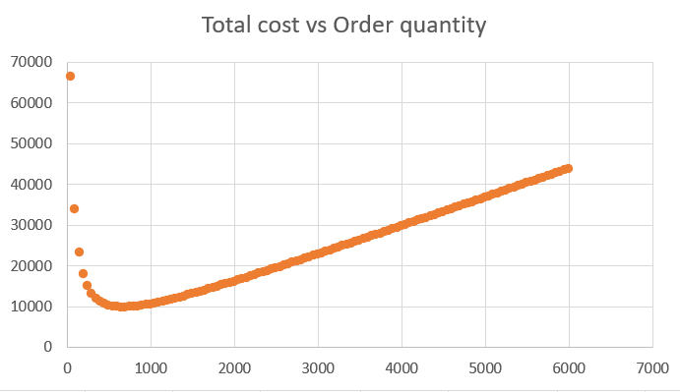

We can see that, the minimum total inventory costs is somewhere in the range of 600 to 700 order quantity.

The inventory model was then solved using Excel solver. The results were as follows,

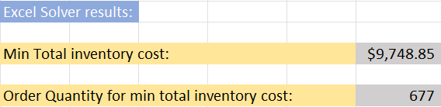

Then a Sensitivity/What-If analysis was conducted to check the response of increase in model parameter values,

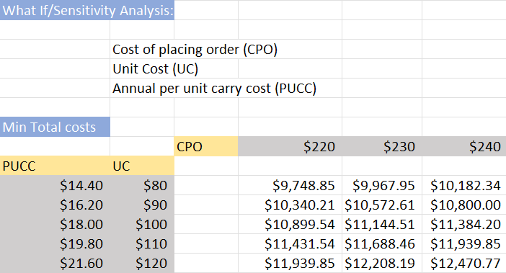

We can see that,

The minimum total cost increases with increase in either Unit cost or Cost of placing order.

Similar analysis was done in R to compare the results obtained from R and Excel,

The total costs vs order quantity was plotted in R and it is as follows,

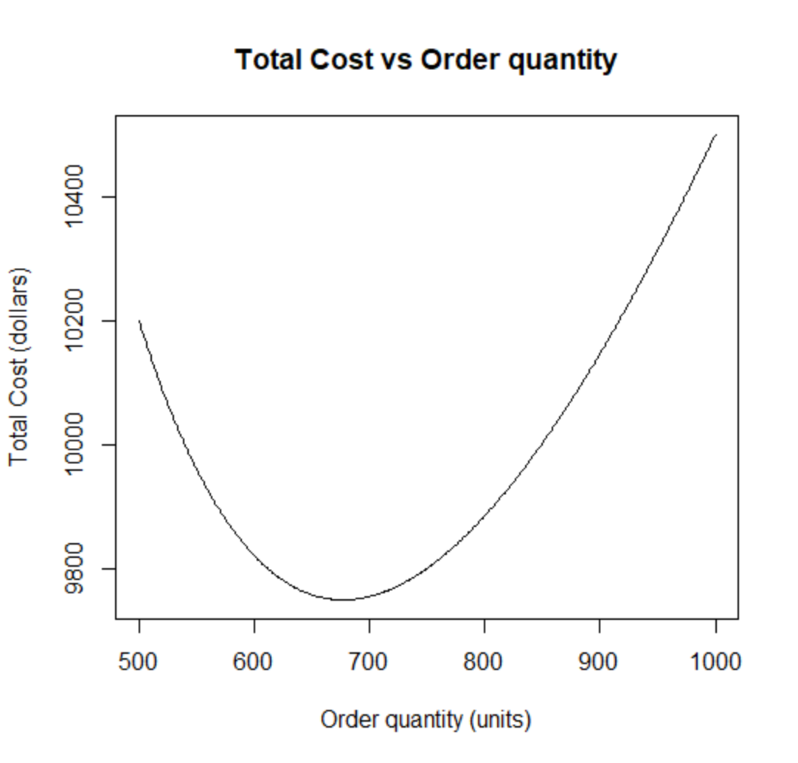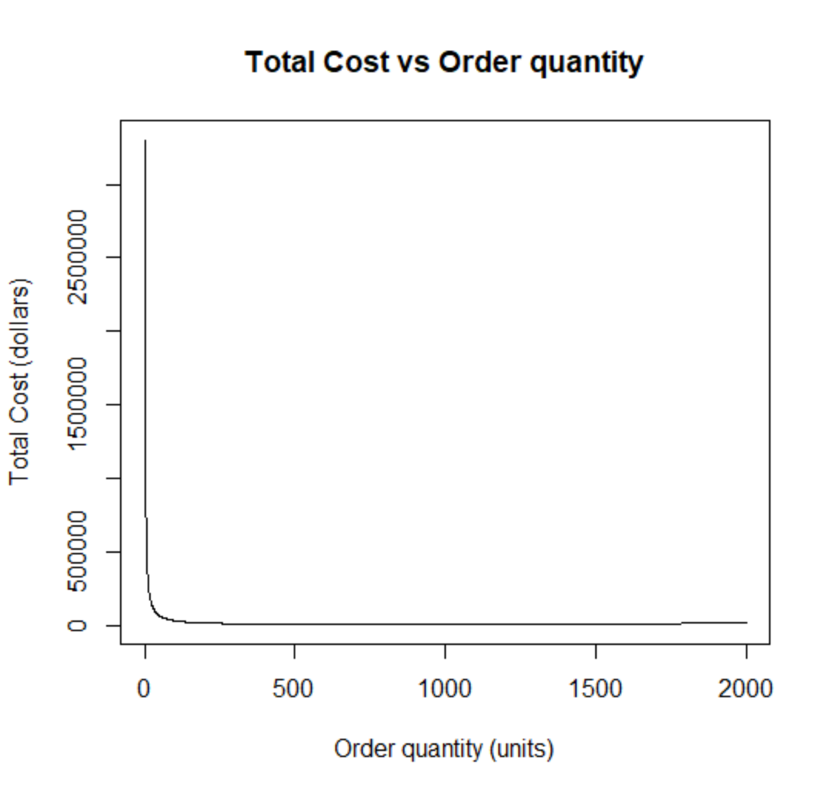

The left figure is the zoomed in version of the right figure. We can see that,

R also shows a approx. minimum between 600 and 700 order quantity.

The optimize function in R was used to get the global minimum and the results were as follows,





Therefore if we compare the results from R and Excel we can see that both results are approximately same.

In next part of the analysis the annual demand now was now considered not to be constant but a triangular distribution with min=13000, max=17000 and mode=15000.

A 1000 random number were generated for annual demand and the minimum total inventory costs and corresponding Order quantity, Annual number of orders were calculated.

**For Minimum total inventory costs,**

Estimate of expected value for 95% confidence was as follows,



The histogram was as follows,

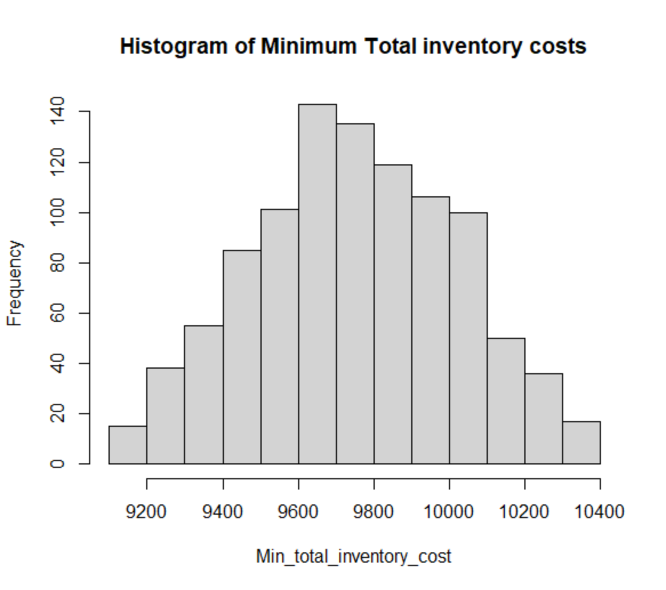

We can probably say that, The distribution seems to follow a normal distribution.

A Chi-square goodness of fit test was conducted to check the validity,

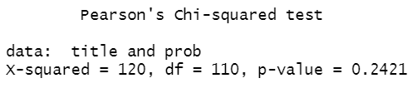

Since p value is greater than 0.05.

Therefore we cannot reject null hypothesis.

Hence Minimum total inventory costs comes from a normal distribution.

**For Order quantity corresponding to minimum total costs,**

Estimate of expected value for 95% confidence was as follows,



The histogram was as follows,

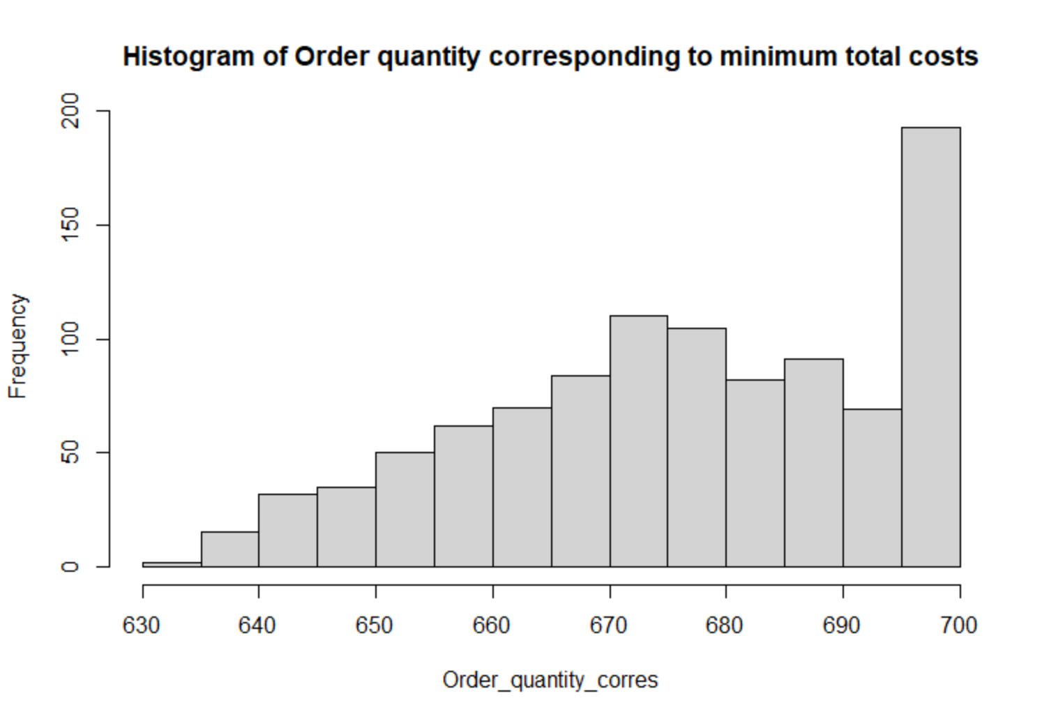

We can probably say that, The distribution seems to follow an exponential distribution.

A Chi-square goodness of fit test was conducted to check the validity,

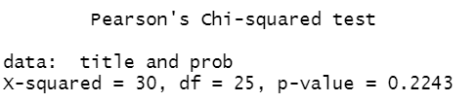

Since, p value is greater than 0.05

Therefore, we cannot reject null hypothesis.

Hence, Order quantity corresponding to min total costs comes from a exponential distribution.

**For Annual number of orders corresponding to minimum total costs,**

Estimate of expected value for 95% confidence was as follows,



The histogram was as follows,

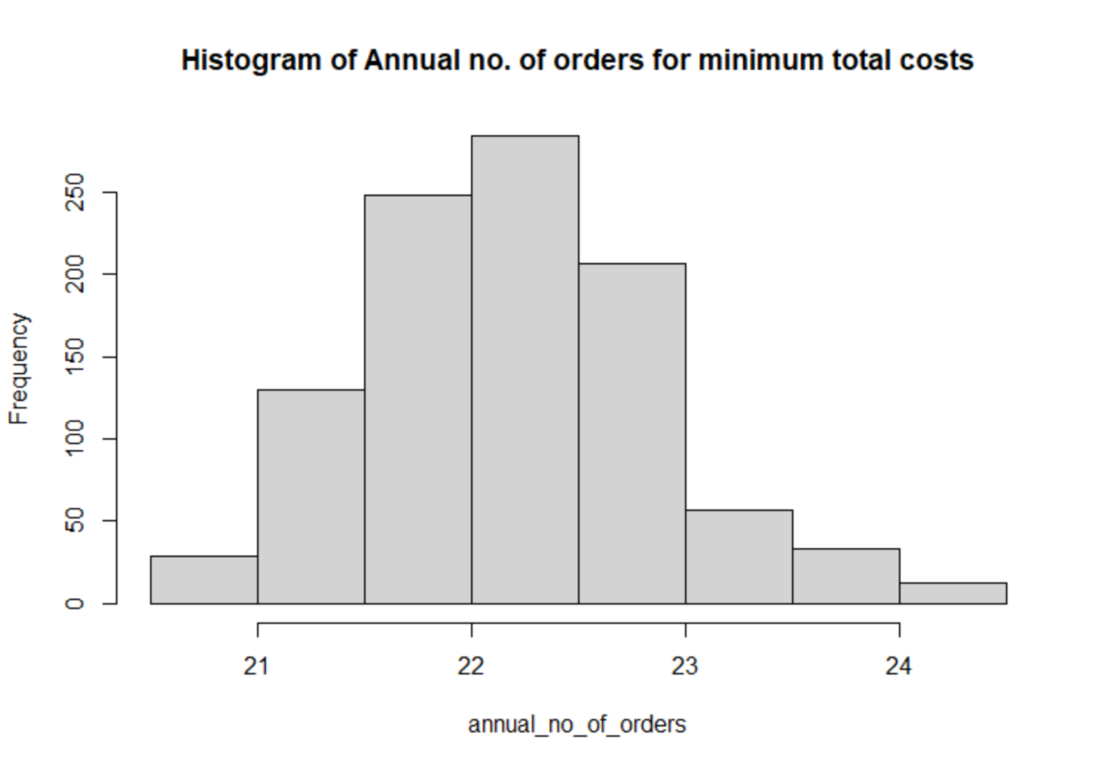

We can probably say that, The distribution seems to follow a lognormal distribution.

A Chi-square goodness of fit test was conducted to check the validity,

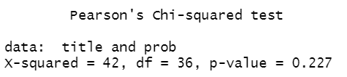

Since, p value is greater than 0.05

Therefore, we cannot reject null hypothesis.

Hence, Annual no. of orders corresponding to min total costs comes from a lognormal distribution.

**Conclusion**

The minimization model was successfully designed and implemented in both Excel and R. The Minimum total inventory cost was found to be 9748.8 dollars and the corresponding order quantity was 677 units. These results optimize the inventory management. Also, the minimum inventory costs, order quantity and annual no. of orders were validated for their respective distributions.