VITyarthi - Build Your Own Project

PROJECT REPORT ON:

Real-Time Face & Emotion Detection Using a Custom CN

NAME- TUSHAR KANTA PASAIT
REG.NOS-24BAI10844
COURSE-COMPUTER VISON

Abstract

In this project we made a face and emotion detection system which can detect a face from an image or video and then tell what emotion the person is showing. The system can detect seven emotions which are angry, disgust, fear, happy, sad, surprise and neutral. For detecting the face we used Haar Cascade and for emotion detection we trained a CNN model using the FER2013 dataset.The system also works with a webcam where it detects the face and shows the predicted emotion while the camera is running. We used different scripts for training the model, testing it and running the final system. During the project we worked on the dataset, trained the CNN model and checked how well it was performing. After that we used the trained model for real time detection. In this report we have explained the main steps of the project, the model used, training process, results and also some limitations that we noticed while working on it.

1. Introduction

Facial Expression Recognition (FER) is used in different areas like human computer interaction, driver monitoring systems, mental health screening and customer experience analysis. The main difficulty is that people do not show emotions in exactly the same way. The same emotion can have different intensity and sometimes it is even difficult for humans to tell the exact emotion. Things like lighting, face angle and if part of the face is covered can also make the recognition less accurate.

The aim of this project is to build a complete system which takes a video frame, detects the faces present in it and then predicts the most likely emotion for each face in real time. We use Haar Cascade for face detection and train our own CNN model from scratch using the FER2013 dataset. Instead of using a pretrained emotion recognition model, the classification model is trained as a part of our project.

2. Related Work
Facial expression recognition has been studied for many years and different datasets are available for this work, such as CK+, JAFFE and FER2013. In older methods, researchers used features like LBP and HOG and then classified them using SVM. With the FER2013 challenge, CNN models became more common for emotion recognition. Many different CNN architectures have been used, from simple models to bigger networks like VGG and ResNet. In our project, we followed the CNN approach but kept the model comparatively small. This is because the FER2013 dataset contains small 48 × 48 grayscale images, so using a very large pretrained network was not necessary for our implementation..

3. Dataset
The images are divided into seven different emotion classes. The dataset already has a predefined split using the Usage column.:
Split | Usage value | Approx. size | Purpose
Training | Training | 28,709 images | Model training
Validation | PublicTest | 3,589 images | Hyperparameter tuning / early stopping
Test | PrivateTest | 3,589 images | Final, held-out evaluation

4. Methodology

4.1 Face Detection
For detecting faces in our project, we used Haar Cascade from OpenCV. The file used here is haarcascade_frontalface_default.xml. We choose this method because it is simple and works fast for webcam also. There is no need to use another big deep learning model for just detecting the face, so it keeps the system quite light. When the face is detected, we crop that part from the video frame. After cropping, it is converted into grayscale and resized to 48 × 48 pixels. this is done because the CNN model is trained with images of this size. Finally, this processed face is given to the emotion model to predict which emotion it is showing..

4.2 Preprocessing
- Convert frame to grayscale for face detection.
- Crop the detected face region.
- Resize the crop to 48x48 pixels.
- Normalise pixel values to the [-1, 1] range (mean 0.5, std 0.5), matching the normalisation used during training.
- During training only: apply light data augmentation — random horizontal flip, random rotation (±10°), and random crop with padding — to reduce overfitting on the relatively small training set.

4.3 Model Architecture — EmotionCNN
We created our own CNN model called EmotionCNN for emotion classification. The model has three convolution blocks and a final classifier part.

Block | Layers | Output size
Input | Grayscale image | 1 x 48 x 48
Block 1 | Conv(32), BN, ReLU, Conv(32), BN, ReLU, MaxPool | 32 x 24 x 24
Block 2 | Conv(64), BN, ReLU, Conv(64), BN, ReLU, MaxPool | 64 x 12 x 12
Block 3 | Conv(128), BN, ReLU, MaxPool | 128 x 6 x 6
Head | Flatten, FC(256), ReLU, Dropout(0.4), FC(7) | 7 (logits)

Training Procedure

For training the model, we went with standard Cross-Entropy loss since there are 7 emotion classes to predict. We used the Adam optimizesetting the starting learning rate at 0.001 (1e-3) along with a weight decay of 1e-4 to help with regularization.

To keep the training smooth, we added a few tricks:

LR Scheduler: Used ReduceLROnPlateau which cuts the learning rate in half whenever the val accuracy stops improving for 3 epochs straight.

Early Stopping: The training automatically stops if validation accuracy doesn't get better after 7 epochs .

Model Checkpoint: We set it to save model weights only when val accuracy hits a new best.This ensures models/best_model.pt always holds our top performing epoch on validation set.

Batch Size: Maintained a batch size of 64, though this can be configured if needed.

5. Experimental Setup
Training and evaluation were run using the scripts in src/ (train.py, evaluate.py). Hardware and exact hyperparameters used for the reported run:
Hardware: CPU-based training was performed on a Windows system.
Dataset: FER2013 with 28,709 training images and 3,589 validation and 3,589 private-test images.
Batch size: 64
Optimizer: Adam
Initial learning rate: 0.001
Weight decay: 0.0001
Epochs: 40
Best validation accuracy: 64.95%.

6. Results

6.1 Training Curves

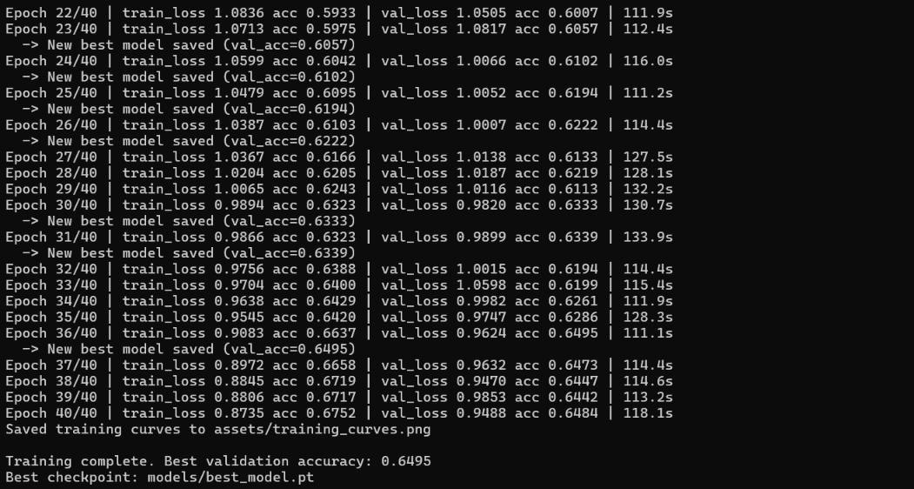

6.2 Test Set Performance
After running python -m src.evaluate on the PrivateTest split, record the overall accuracy and per-class precision/recall/F1 below.
Emotion | Precision | Recall | F1-score
Angry | 0.646 | 0.558 | 0.599
Disgust | 0.583 | 0.382 | 0.462
Fear | 0.529 | 0.413 | 0.464
Happy | 0.826 | 0.910 | 0.866
Sad | 0.506 | 0.574 | 0.538
Surprise | 0.765 | 0.745 | 0.755
Neutral | 0.627 | 0.671 | 0.648
Angry | 0.646 | 0.558 | 0.599

6.3 Qualitative Real-Time Results

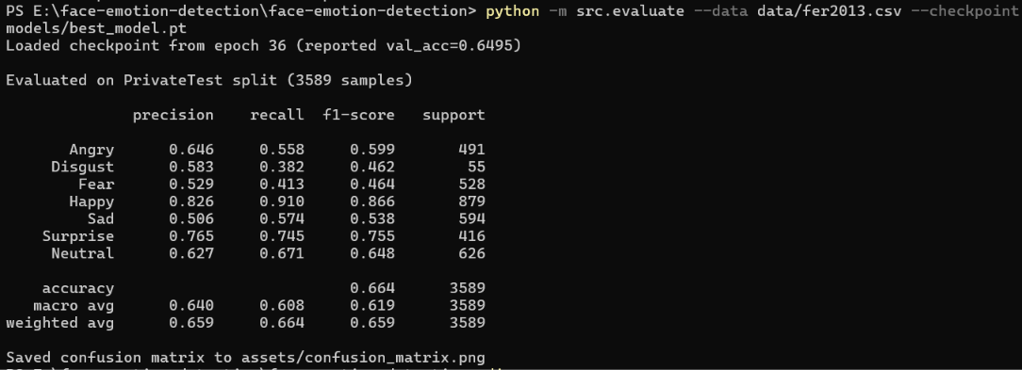

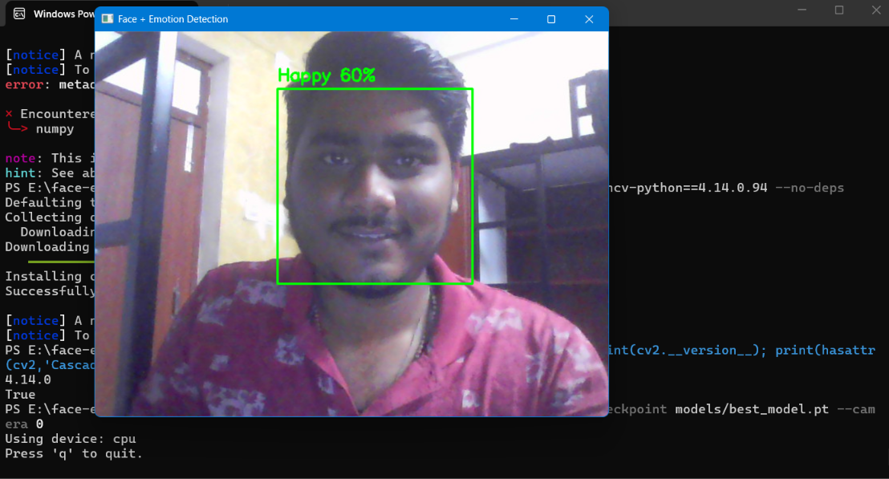

7. Discussion & Limitations

Noisy labels: Some FER2013 images may have incorrect or unclear labels.

Class imbalance: Disgust has fewer images, so it is harder to predict.

Face detection: Haar Cascade can miss faces in poor lighting or different poses.

Real videos: Real expressions can be different from the FER2013 images.

Prediction errors: The model may sometimes confuse similar emotions.

8. Conclusion & Future Work
In this project, we made a complete real time system for detecting faces and recognizing emotions. We trained our own CNN model using the FER2013 dataset and used it with images, videos and webcam input. The system is able to detect the face and predict one of the seven emotions. In future, the project can be improved by using a deep learning based face detector, adding more data for the classes which have less images and improving the model accuracy. We can also use predictions from multiple video frames together so that the emotion shown on the screen does not change too quickly.

9. References
1. Goodfellow, I. et al. "Challenges in Representation Learning: A Report on Three Machine Learning Contests." (FER2013 dataset origin), 2013.
2. Viola, P., Jones, M. "Rapid Object Detection using a Boosted Cascade of Simple Features." CVPR 2001. (Haar cascade face detection)
3. He, K. et al. "Deep Residual Learning for Image Recognition." CVPR 2016. (Architectural reference for CNN design choices)
4. PyTorch documentation: https://pytorch.org/docs/
5. OpenCV documentation: https://docs.opencv.org/

