**Background**

This project deals with popularity of online news. The internet age gives us both the need and opportunity to analyze factors that determine the number of shares a news article gets on the social media and predict the shares based on those factors for new news articles.

The data for this project is provided comes from the popular news sharing site [Mashable.com](http://mashable.com). Mashable presents news articles from various new and media outlets on many different topics. It even gives the number of shares on its news articles to indicate the popularity of the article.

The data set provided by Mashable was taken from UCI machine learning laboratory. For more information on the data, please check this [link.](https://archive.ics.uci.edu/ml/datasets/Online+News+Popularity)

1. **Data Description**

The data set obtained from UCI Machine learning laboratory contains 39,797 records with 59 quantified features related to the particular news articles. In addition, there is one column for the link to the news article itself, and one for the dependent variable, i.e. the number of shares the news article gets.

> head(onp1, 2) [39,797 x 59]

timedelta n_tokens_title n_tokens_content n_unique_tokens n_non_stop_words n_non_stop_unique_tokens num_hrefs

1 731 12 219 0.6635945 1 0.8153846 4

2 731 9 255 0.6047431 1 0.7919463 3

num_self_hrefs num_imgs num_videos average_token_length num_keywords data_channel_is_lifestyle

1 2 1 0 4.680365 5 0

2 1 1 0 4.913725 4 0

data_channel_is_entertainment data_channel_is_bus data_channel_is_socmed data_channel_is_tech data_channel_is_world

1 1 0 0 0 0

2 0 1 0 0 0

kw_min_min kw_max_min kw_avg_min kw_min_max kw_max_max kw_avg_max kw_min_avg kw_max_avg kw_avg_avg

1 0 0 0 0 0 0 0 0 0

2 0 0 0 0 0 0 0 0 0

self_reference_min_shares self_reference_max_shares self_reference_avg_sharess weekday_is_monday weekday_is_tuesday

1 496 496 496 1 0

2 0 0 0 1 0

weekday_is_wednesday weekday_is_thursday weekday_is_friday weekday_is_saturday weekday_is_sunday is_weekend

1 0 0 0 0 0 0

2 0 0 0 0 0 0

LDA_00 LDA_01 LDA_02 LDA_03 LDA_04 global_subjectivity global_sentiment_polarity

1 0.5003312 0.37827893 0.04000468 0.04126265 0.04012254 0.5216171 0.09256198

2 0.7997557 0.05004668 0.05009625 0.05010067 0.05000071 0.3412458 0.14894781

global_rate_positive_words global_rate_negative_words rate_positive_words rate_negative_words avg_positive_polarity

1 0.04566210 0.01369863 0.7692308 0.2307692 0.3786364

2 0.04313725 0.01568627 0.7333333 0.2666667 0.2869146

min_positive_polarity max_positive_polarity avg_negative_polarity min_negative_polarity max_negative_polarity

1 0.10000000 0.7 -0.35000 -0.600 -0.2

2 0.03333333 0.7 -0.11875 -0.125 -0.1

title_subjectivity title_sentiment_polarity abs_title_subjectivity abs_title_sentiment_polarity shares

1 0.5 -0.1875 0.0 0.1875 593

2 0.0 0.0000 0.5 0.0000 711

The data set is described below:

|  |  |
| --- | --- |
| 0. url | URL of the article |
| 1. timedelta | Days between the article publication and the dataset acquisition |
| 2. n_tokens_title | Number of words in the title |
| 3. n_tokens_content | Number of words in the content |
| 4. n_unique_tokens | Rate of unique words in the content |
| 5. n_non_stop_words | Rate of non-stop words in the content |
| 6. n_non_stop_unique_tokens | Rate of unique non-stop words in the content |
| 7. num_hrefs | Number of links |
| 8. num_self_hrefs | Number of links to other articles published by Mashable |
| 9. num_imgs | Number of images |
| 10. num_videos | Number of videos |
| 11. average_token_length | Average length of the words in the content |
| 12. num_keywords | Number of keywords in the metadata |
| 13. data_channel_is_lifestyle | Is data channel 'Lifestyle'? |
| 14. data_channel_is_entertainment | Is data channel 'Entertainment'? |
| 15. data_channel_is_bus | Is data channel 'Business'? |
| 16. data_channel_is_socmed | Is data channel 'Social Media'? |
| 17. data_channel_is_tech | Is data channel 'Tech'? |
| 18. data_channel_is_world | Is data channel 'World'? |
| 19. kw_min_min | Worst keyword (min. shares) |
| 20. kw_max_min | Worst keyword (max. shares) |
| 21. kw_avg_min | Worst keyword (avg. shares) |
| 22. kw_min_max | Best keyword (min. shares) |
| 23. kw_max_max | Best keyword (max. shares) |
| 24. kw_avg_max | Best keyword (avg. shares) |
| 25. kw_min_avg | Avg. keyword (min. shares) |
| 26. kw_max_avg | Avg. keyword (max. shares) |
| 27. kw_avg_avg | Avg. keyword (avg. shares) |
| 28. self_reference_min_shares | Min. shares of referenced articles in Mashable |
| 29. self_reference_max_shares | Max. shares of referenced articles in Mashable |
| 30. self_reference_avg_sharess | Avg. shares of referenced articles in Mashable |
| 31. weekday_is_monday | Was the article published on a Monday? |
| 32. weekday_is_tuesday | Was the article published on a Tuesday? |
| 33. weekday_is_wednesday | Was the article published on a Wednesday? |
| 34. weekday_is_thursday | Was the article published on a Thursday? |
| 35. weekday_is_friday | Was the article published on a Friday? |
| 36. weekday_is_saturday | Was the article published on a Saturday? |
| 37. weekday_is_sunday | Was the article published on a Sunday? |
| 38. is_weekend | Was the article published on the weekend? |
| 39. LDA_00 | Closeness to LDA topic 0 |
| 40. LDA_01 | Closeness to LDA topic 1 |
| 41. LDA_02 | Closeness to LDA topic 2 |
| 42. LDA_03 | Closeness to LDA topic 3 |
| 43. LDA_04 | Closeness to LDA topic 4 |
| 44. global_subjectivity | Text subjectivity |
| 45. global_sentiment_polarity | Text sentiment polarity |
| 46. global_rate_positive_words | Rate of positive words in the content |
| 47. global_rate_negative_words | Rate of negative words in the content |
| 48. rate_positive_words | Rate of positive words among non-neutral tokens |
| 49. rate_negative_words | Rate of negative words among non-neutral tokens |
| 50. avg_positive_polarity | Avg. polarity of positive words |
| 51. min_positive_polarity | Min. polarity of positive words |
| 52. max_positive_polarity | Max. polarity of positive words |
| 53. avg_negative_polarity | Avg. polarity of negative words |
| 54. min_negative_polarity | Min. polarity of negative words |
| 55. max_negative_polarity | Max. polarity of negative words |
| 56. title_subjectivity | Title subjectivity |
| 57. title_sentiment_polarity | Title polarity |
| 58. abs_title_subjectivity | Absolute subjectivity level |
| 59. abs_title_sentiment_polarity | Absolute polarity level |
| 60. shares | Number of shares (target) |

**2. Feature Selection**

It is clear from above that there are way too many features in the data set to be able to model this data without over fitting and making the models unnecessarily complicated. Moreover, there may be multicollinearity in the data.

Principal Component Analysis (PCA) did not seem particularly suitable as a feature selection technique as many of the variables are binary factors. Given the constraints, I took a more manual approach to feature selection. I used the rcorr() function to generate the correlation matrix along with the significance levels of each correlation. I start with studying only a subset of the variable pairs which have absolute correlations greater than 10% with significance levels of greater than 95% (P-value < 0.05). From each of these variable pairs, I select the variable that has a greater correlation with the dependent variable (no. of shares).

From the above analysis, it is obvious that the variable selections and rejections would not consistent and mutually exclusive across the board. To give an example, avg_positive_polarity is a choice variable between many comparisons, but between avg_positive_polarity and abs_title_sentiment_polarity, abs_title_sentiment_polarity gets chosen. So between avg_positive_polarity and abs_title_sentiment_polarity, which one should get chosen?

To resolve this, I devised an analysis strategy, which I have represented below in a flowchart form. The details of the scheme follow on the proceeding page.

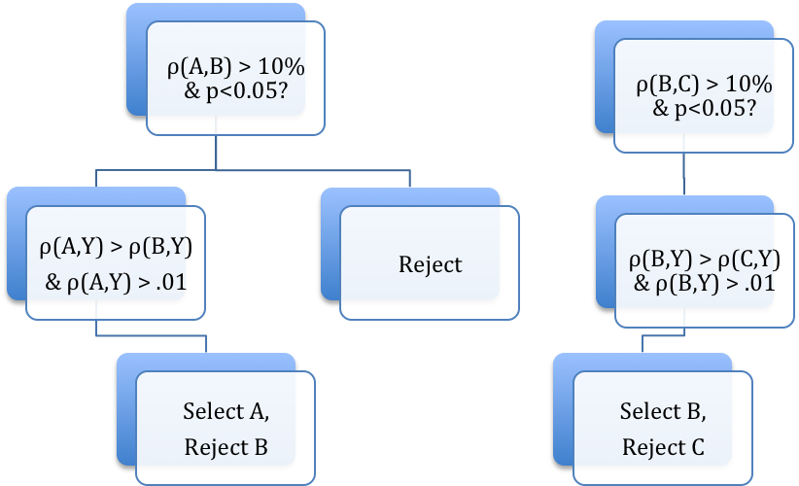

Yes

Yes

Yes

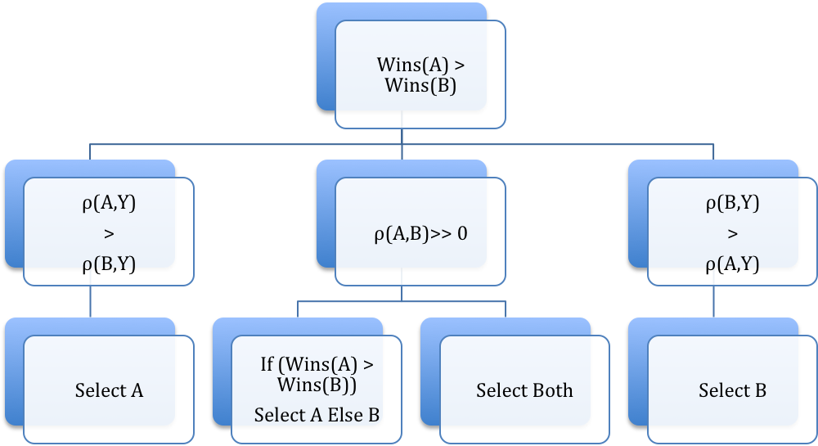

No =>

B preferred

No =>

A preferred

Yes

No

We start with first rejecting any winning variable that has less than 1% correlation with number of shares. If both have greater than 1% correlation, we check whether the number of wins of avg_positive_polarity is greater than the number of wins of abs_title_sentiment_polarity. We also check which among the two has a greater correlation with number of shares. If for these two tests, there’s a clear winner then we take that variable. If not, we check whether there’s significant correlation between these two variables themselves. If so, we select the one with greater number of wins. If not, we may select both and continue the analysis.

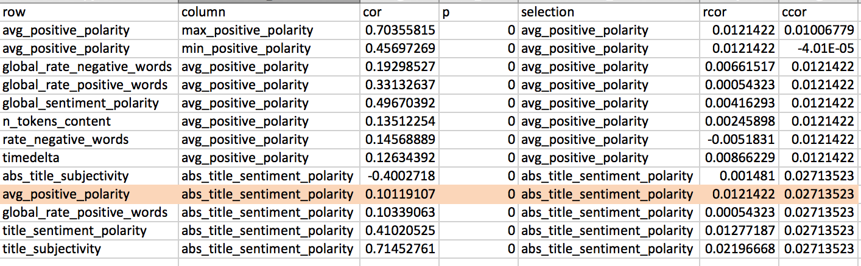

According to the scheme defined above, we observe that between avg_positive_polarity and abs_title_sentiment_polarity, avg_positive_polarity has the double the number of wins but abs_title_sentiment_polarity has double the correlation with number of shares. So there’s no clear choice. We then see whether correlation between avg_positive_polarity and abs_title_sentiment_polarity is significant. It is only 10%, our lower limit to even consider correlations between variables. Hence, we choose both and continue our analysis.

In such an analysis scheme, one of the two variables may get eliminated in another round of analysis. Following this scheme, I was able to reduce the significant features to 21 out of 60. On running these parameters in linear models, I eliminated another 3 which were not significant, leaving the set of selected features down to 18.

The following features made the final cut:

|  |  |
| --- | --- |
| 1 | num_hrefs |
| 2 | num_imgs |
| 3 | num_videos |
| 4 | average_token_length |
| 5 | data_channel_is_entertainment |
| 6 | data_channel_is_bus |
| 7 | kw_avg_min |
| 8 | kw_avg_max |
| 9 | kw_avg_avg |
| 10 | self_reference_avg_sharess |
| 11 | is_weekend |
| 12 | LDA_02 |
| 13 | LDA_03 |
| 14 | LDA_04 |
| 15 | global_subjectivity |
| 16 | avg_positive_polarity |
| 17 | title_subjectivity |
| 18 | title_sentiment_polarity |

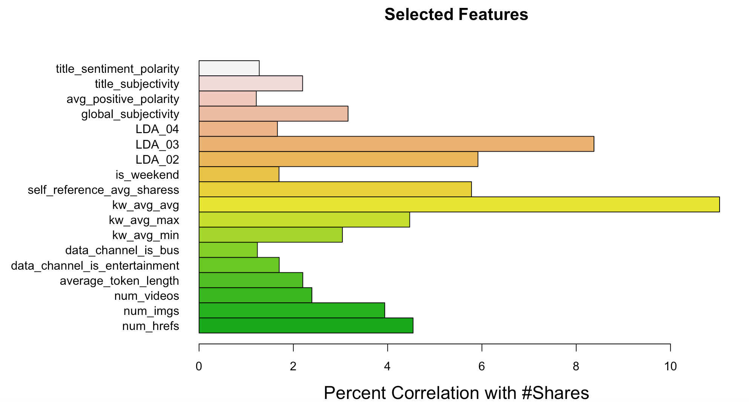

**3. Data Preparation**

**3.1 Capping**

Once the significant features are obtained, I removed the outliers by capping the data below 5% quantile to the 5% quantile value, and data above 95% quantile to the 95% quantile value. I did this for each of the columns except the first one which contains the actual news link.

**3.2 Scaling**

I centered and scaled all the continuous variables to bring all these variables on the same scale and make model coefficients intuitive and interpretable. The following variables were scaled:

1. shares

2. self_reference_min_shares

3. self_reference_avg_sharess

4. self_reference_max_shares

5. kw_avg_min

6. kw_avg_max

7. kw_avg_avg

A new variable “scaledy” is introduced above, which is nothing but scaled number of shares. Since number of shares is the dependent variable, we want to preserve the original variable for further use and keep it separate from it’s scaled version.

**3.3 Classification**

I intended to study this problem through both regression and classification. Hence I introduced two new variables for two-way classification. One is a binary classification between shares less than or equal to 1400 and greater than 1400. This is based on a 50-50 classification of data based on the quantiles of the number of shares.

> quantile(onp$shares, probs = c(0.1, 0.2, 0.3, 0.4, 0.5, 0.6, 0.7, 0.8, 0.9, 1))

10% 20% 30% 40% 50% 60% 70% 80% 90% 100%

708.0 870.6 1000.0 1200.0 1400.0 1800.0 2300.0 3400.0 6200.0 10800.0

I do another 30-30-20-20 classification based on the above quantiles. Hence the 4-class classification is between shares up to a 1000, greater than 1000 and less than or equal to 1800, greater than 1800 and less than or equal to 3400, and greater than 3400. I present the distribution of data in the two classes as below:

> table(onp$classes)

1 2 3 4

12424 12020 7392 7808

> table(onp$classes2)

0 1

20082 19562

**3.4 Factoring**

To be able to tell my regression or classification models that the above two variables are indeed classes, I converted them to factors. Moreover, there are three dependent binary variables among the one that we chose that need to be factorized:

1. data_channel_is_bus

2. data_channel_is_entertainment

3. is_weekend

**3.5 Splitting**

I split the data into training and test sets on a 70%-30% data split.

**4. Models and Results**

**4.1 Linear Regression**

I started with a linear regression model, using the selected features. I used *scaledy* as the dependent variable. The R-squared from this model was a low 0.09.

> summary(model1.lr)

Call:

lm(formula = scaledy ~ average_token_length + avg_positive_polarity +

factor(data_channel_is_bus) + factor(data_channel_is_entertainment) +

global_subjectivity + factor(is_weekend) + kw_avg_avg + kw_avg_max +

kw_avg_min + LDA_02 + LDA_03 + LDA_04 + num_hrefs + num_imgs +

num_videos + self_reference_avg_sharess + title_sentiment_polarity +

title_subjectivity, data = TrainONP)

Residuals:

Min 1Q Median 3Q Max

-1.7604 -0.5126 -0.2803 0.0913 3.6871

Coefficients:

Estimate Std. Error t value Pr(>|t|)

(Intercept) 0.5785775 0.0956935 6.046 1.50e-09 ***

average_token_length -0.1253167 0.0196303 -6.384 1.75e-10 ***

avg_positive_polarity -0.3010560 0.0705611 -4.267 1.99e-05 ***

factor(data_channel_is_bus)1 -0.1122887 0.0187793 -5.979 2.26e-09 ***

factor(data_channel_is_entertainment)1 -0.2475756 0.0156570 -15.812 < 2e-16 ***

global_subjectivity 0.3510964 0.0676835 5.187 2.14e-07 ***

factor(is_weekend)1 0.1754585 0.0142610 12.303 < 2e-16 ***

kw_avg_avg 0.2024007 0.0073263 27.627 < 2e-16 ***

kw_avg_max -0.0649528 0.0072084 -9.011 < 2e-16 ***

kw_avg_min 0.0120977 0.0058217 2.078 0.037713 *

LDA_02 -0.2846464 0.0272197 -10.457 < 2e-16 ***

LDA_03 -0.0658378 0.0254020 -2.592 0.009550 **

LDA_04 -0.0876990 0.0253116 -3.465 0.000531 ***

num_hrefs 0.0045111 0.0007031 6.416 1.42e-10 ***

num_imgs 0.0043067 0.0009602 4.485 7.30e-06 ***

num_videos 0.0156842 0.0036810 4.261 2.04e-05 ***

self_reference_avg_sharess 0.1136776 0.0050017 22.728 < 2e-16 ***

title_sentiment_polarity 0.0738561 0.0247527 2.984 0.002849 **

title_subjectivity 0.0408377 0.0158298 2.580 0.009889 **

---

Signif. codes: 0 ‘***’ 0.001 ‘**’ 0.01 ‘*’ 0.05 ‘.’ 0.1 ‘ ’ 1

Residual standard error: 0.9495 on 39625 degrees of freedom

Multiple R-squared: 0.09894, Adjusted R-squared: 0.09853

F-statistic: 241.7 on 18 and 39625 DF, p-value: < 2.2e-16

**4.2 Logistic Regression**

Next I performed a binomial logistic regression on the *classes2* variable, which is the binary classification variable.

> summary(PredONP.logit)

Call:

glm(formula = classes2 ~ average_token_length + avg_positive_polarity +

factor(data_channel_is_bus) + factor(data_channel_is_entertainment) +

global_subjectivity + factor(is_weekend) + kw_avg_avg + kw_avg_max +

kw_avg_min + LDA_02 + LDA_03 + LDA_04 + num_hrefs + num_imgs +

num_videos + self_reference_avg_sharess + title_sentiment_polarity +

title_subjectivity, family = binomial, data = TrainONP)

Deviance Residuals:

Min 1Q Median 3Q Max

-2.3258 -1.0509 -0.6618 1.0909 2.0412

Coefficients:

Estimate Std. Error z value Pr(>|z|)

(Intercept) 1.286594 0.213200 6.035 1.59e-09 ***

average_token_length -0.250468 0.043810 -5.717 1.08e-08 ***

avg_positive_polarity -0.926314 0.157781 -5.871 4.34e-09 ***

factor(data_channel_is_bus)1 -0.163933 0.041469 -3.953 7.71e-05 ***

factor(data_channel_is_entertainment)1 -0.779142 0.035168 -22.155 < 2e-16 ***

global_subjectivity 0.799267 0.151011 5.293 1.20e-07 ***

factor(is_weekend)1 0.814059 0.033249 24.483 < 2e-16 ***

kw_avg_avg 0.400066 0.016609 24.087 < 2e-16 ***

kw_avg_max -0.156352 0.016050 -9.742 < 2e-16 ***

kw_avg_min 0.071447 0.013023 5.486 4.11e-08 ***

LDA_02 -0.972450 0.060903 -15.967 < 2e-16 ***

LDA_03 -0.539889 0.057322 -9.419 < 2e-16 ***

LDA_04 0.039890 0.056310 0.708 0.478695

num_hrefs 0.012721 0.001583 8.035 9.36e-16 ***

num_imgs 0.007705 0.002153 3.579 0.000346 ***

num_videos 0.035740 0.008281 4.316 1.59e-05 ***

self_reference_avg_sharess 0.205558 0.011450 17.952 < 2e-16 ***

title_sentiment_polarity 0.307797 0.055531 5.543 2.98e-08 ***

title_subjectivity 0.017524 0.035420 0.495 0.620786

---

Signif. codes: 0 ‘***’ 0.001 ‘**’ 0.01 ‘*’ 0.05 ‘.’ 0.1 ‘ ’ 1

(Dispersion parameter for binomial family taken to be 1)

Null deviance: 54951 on 39643 degrees of freedom

Residual deviance: 50387 on 39625 degrees of freedom

AIC: 50425

Number of Fisher Scoring iterations: 4

Using the ROCR package, I calculated the area under the ROC curve and it is a decent 69.42%.

> print(paste("AUC =", round(performance(ROCRpred, "auc")@y.values[[1]], digits = 4)*100, "%"))

[1] "AUC = 69.42 %"

The accuracy for this model is also a decent 64.38%

> confusionM.logit = table(onp$classes2, predictONP.logit > 0.5)

> print(paste("Accuracy =", round(sum(diag(confusionM.logit))/sum(confusionM.logit),4)*100, "%"))

[1] "Accuracy = 64.38 %"

**4.3 CART Binary Classification Using Cross-Validation**

Following up logistic regression, I try a CART machine-learning model. I used *classes2* as the dependent variable for learning. I used cross-validation of get the ‘complexity parameter’ for the CART model. Training the model using cross-validation returns a complexity parameter of 0.01.

CART

39644 samples

18 predictor

2 classes: '0', '1'

No pre-processing

Resampling: Cross-Validated (10 fold, repeated 4 times)

Summary of sample sizes: 35680, 35678, 35680, 35680, 35679, 35680, ...

Resampling results across tuning parameters:

cp Accuracy Kappa

0.01 0.6169405 0.23274214

0.02 0.6153137 0.22934745

.

.

.

Accuracy was used to select the optimal model using the largest value.

The final value used for the model was cp = 0.01.

Next, I built the actual CART model using this parameter. The accuracy and AUC obtained from this model was lower than the logistic regression model.

> confusionM.cart = table(TestONP$classes2, predictONP.class)

> print(paste("Accuracy =", round(sum(diag(confusionM.cart))/sum(confusionM.cart),4)*100, "%"))

[1] "Accuracy = 61.94 %"

> print(paste("AUC =", round(performance(pred.class, "auc")@y.values[[1]], digits = 4)*100, "%"))

[1] "AUC = 62.53 %"

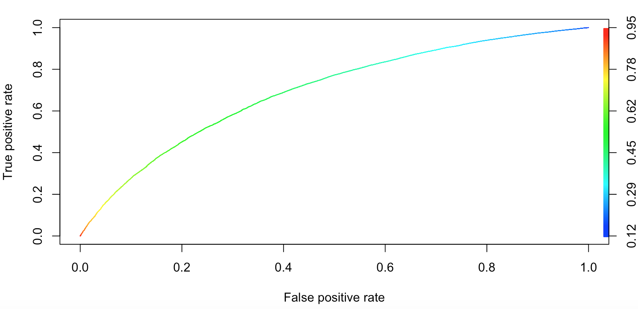

As we can see, accuracy is 61.94% and AUC is 62.53%.

**4.3 Random Forest Binary Classification**

Since CART model returned results less accurate than logistic regression, I tried the Random Forest machine-learning model for classification. Again, I used *classes2* variable as the dependent variable in this classification. I used 200 trees for this model with node size of 25. An error plot of the model shows that errors or both classes go down and stabilized around 200 trees mark. The results from this model were superior to all the previous models.

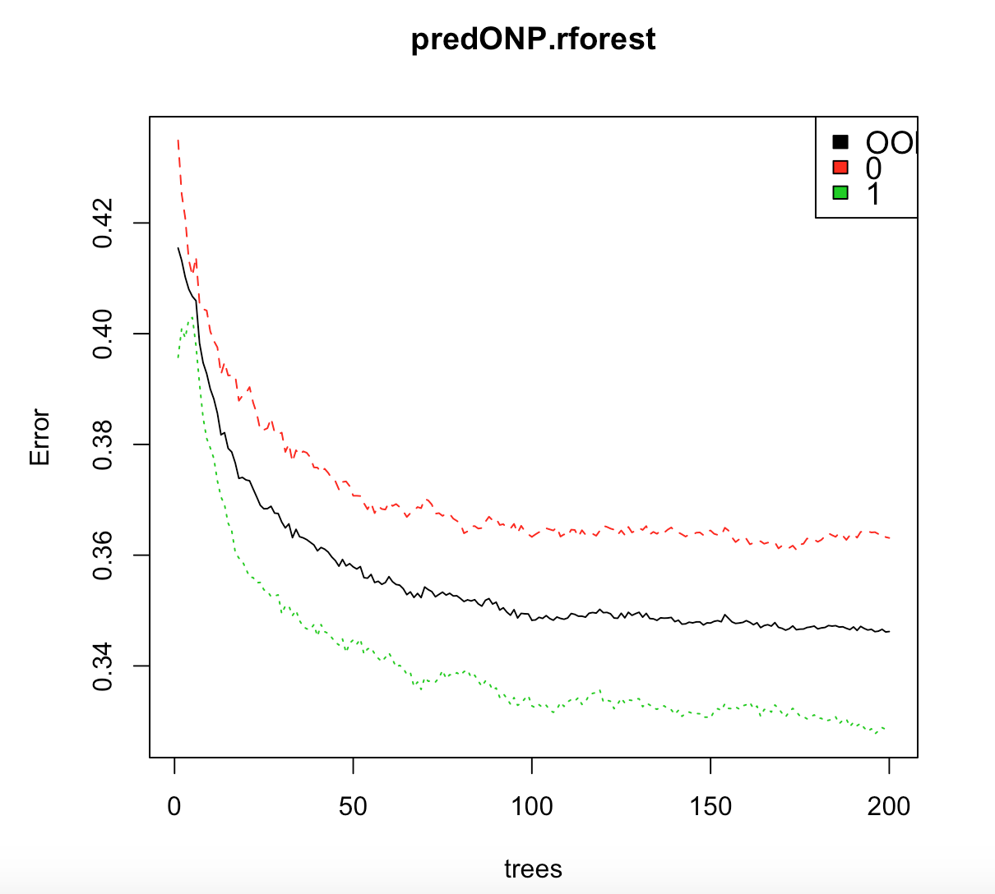

> confusionM.RF = table(TestONP$classes2, predictONP.forsest.2class)

> print(paste("Accuracy =", round(sum(diag(confusionM.RF))/sum(confusionM.RF),4)*100, "%"))

[1] "Accuracy = 83.75 %"

> print(paste("AUC =", round(performance(predrocr, "auc")@y.values[[1]], digits = 4)*100, "%"))

[1] "AUC = 92.19 %"

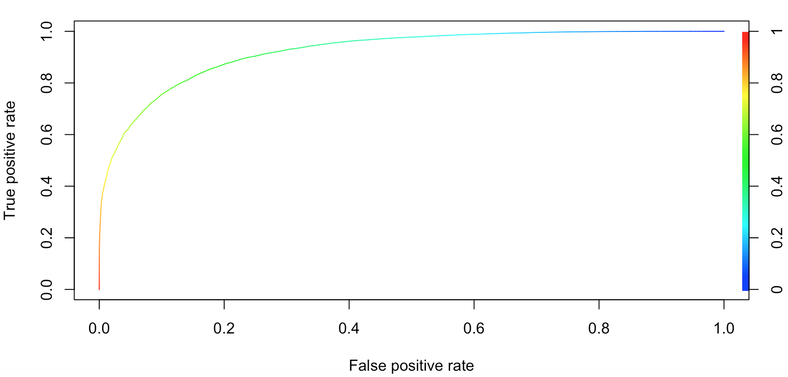

As we can see, accuracy for this model is 83.75% and AUC is 92.19%.

**4.4 Random Forest 4-class Classification**

Following the promising results from the previous Random Forest model, I tried to run this model on four classes instead of two. I used the *classes* variable as the dependent variable in this model, with 300 trees. As we can see from the plot below, error increases for class 3 with increasing number of trees with error for other classes and Out-of-Bag error decreasing. #00 tress offers the best compromise for accuracy and model simplicity.

> print(paste("Accuracy =", round(sum(diag(confusion.matrix))/sum(confusion.matrix),4)*100, "%"))

[1] "Accuracy = 68.7 %"

Even with four classes, this model gives a decent accuracy of 68.7%, calculated using the Exact Match Ratio method.

**5. Conclusion**