TensorFlow

TensorFlow is an open-source library which is used in Machine and Deep Learning fields like Computer Vision and Natural Language Processing and was developed by Google and released for public use in 2015. The advantage of using TensorFlow is that one does not need to do the back propagation manually while building a neural network. This back propagation step, often the trickiest step of building a neural network, has been generally implemented in TensorFlow and simply doing the forward propagation completes the job. Some advantages of using TensorFlow over any other framework include easy model building with the help of keras APIs, availability in many languages and a simple and fast architecture for powerful experimentation.

Transfer Learning

It is a method used in the field of machine learning where the output of a trained model is used as an input for some other model. Fixing the weights of the previously trained model and training on the weights of the new model produces accurate results and predictions. Some of the most accurate models like EfficientNet, ResNet, MobileNet, VGG are already in-built in TensorFlow for direct use.

Model Building

To localize a gun in an image, we have first trained a model to check whether a gun is present in the image or not. If a gun is present in the image, then the second model tries to draw a rectangle in the probable area where the weapon might be present.

To build the classifier on top of pre-built model, a set of 6000 images, half of which contained a weapon, was taken from Kaggle and weights were trained on this dataset. The model was run for 13(5+8) epochs and the cross categorical entropy loss was found to be less than 0.5.

In order to identify the object, a dataset of 3000 labelled images was taken from Kaggle, all of which contained a weapon and the co-ordinates of the weapon in the image were also given. The model was trained on this dataset for 10(5+5) epochs and was trained until the model started producing satisfactory results.

For the purpose of these tasks, we have used ResNetV2 model from TensorFlow which has been trained on the ImageNet data, attached a few fully connected dense layers to it and trained it with a learning rate of 0.00001. ResNet is convolutional neural network which produces state-of-the-art results over ImageNet dataset which consists of more than 1 million images organised in 1000 categories.

Testing the Model

Below is the code associated with identifying a gun in an image. The classifier model outputs 2 numbers, the second of which is the probability of a gun being present in the image. If the gun is present, the second model draws a rectangle around the gun, else the algorithm moves onto the next image.

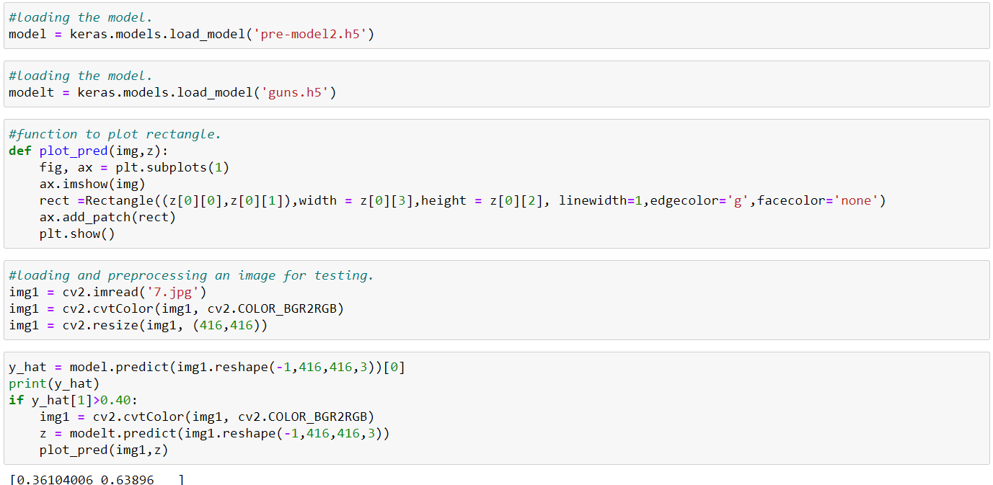

The output after running these cells. The predicted region where the gun might be present has been outlined in green.

