E-Commerce Sales Analytics
Project Report
Dataset: Superstore Sales (2015-2018) | Prepared using Python, MySQL, and Power BI
1. Project Overview
This project analyses an e-commerce sales dataset from 2015–2018 to understand sales performance, customer behaviour, product trends, and regional performance. The project follows a complete data analytics workflow using Python for data cleaning, MySQL for business analysis, and Power BI for dashboard creation. The goal is to turn raw sales data into useful business insights that support better decision-making.
Deliverables produced:
- Cleaned dataset: superstore_cleaned.csv (9,800 rows, 23 columns)
- Python notebook: E-commerce_Sales_Analytics.ipynb (data cleaning and preprocessing)
- SQL query file: business_query.sql (10 business questions, 20 queries)
- Power BI dashboard: E-commerce_Sales_Dashboard.pbix

2. Business Problem
The company wants a clear view of its sales performance. Different reports made it difficult to identify top products, valuable customers, sales trends, and regional performance. This project answers key business questions to help management make informed decisions.
10 business questions were set as the scope:
- Total sales, total orders, and average order value (AOV)
- Sales and order volume trends by month, quarter, and year
- Best- and worst-selling products and sub-categories
- Sales performance by region, state, and city
- Top customers by sales and order count
- Customer purchasing and spending behavior
- Seasonal sales trends
- Top 10 products for inventory planning
- Slow-moving products
- Top 5 products by sales contribution

3. Dataset
The dataset contains nearly 9,800 sales records from 2015 to 2018. It includes information about orders, customers, products, locations, shipping, and sales. Additional columns such as order year, month, quarter, and shipping days were created during data preparation.
Field group | Columns
Order info | row_id, order_id, order_date, ship_date, ship_mode
Customer | customer_id, customer_name, segment
Location | country, city, state, postal_code, region
Product | product_id, category, sub-category, product_name
Metric | sales
Derived (added during cleaning) | order_year, order_month, month_name, quarter, shipping_days

Key scale figures:
- 9,800 line items across 4,922 distinct orders
- 793 unique customers
- 3 segments (Consumer, Corporate, Home Office), 3 categories, 17 sub-categories
- 4 regions, 49 states, hundreds of cities
- Only one financial metric is present: sales. No profit, cost, or discount fields.

4. Methodology
The project was completed in four stages:
- Cleaned and prepared the data using Python.
- Loaded the cleaned data into MySQL.
- Used SQL to answer business questions.
- Built an interactive dashboard in Power BI to visualize the results.

5. Data Cleaning Process
Before analysis, the dataset was cleaned to improve data quality. Missing values were handled, date columns were converted to the correct format, column names were standardized, and new columns such as order year, quarter, and shipping days were created. The cleaned dataset was then exported for SQL analysis.
6. SQL Analysis
SQL was used to answer the business questions. Queries were written to calculate total sales, average order value, yearly sales trends, top-selling products, customer performance, regional sales, seasonal trends, and product rankings.
Business question | Query approach
Total sales, orders, AOV | SUM(sales), COUNT(DISTINCT order_id), and sales/orders in one query
Trends by month/quarter/year | Three separate GROUP BY queries using YEAR(), QUARTER(), MONTH()
Best/worst products & sub-categories | GROUP BY with ORDER BY ASC and DESC, run separately (no LIMIT on the full rankings)
Region/state/city performance | GROUP BY per geography level, ordered by total sales
Top customers | GROUP BY customer, sales and order count together
Purchase behavior | Per-customer spend, AOV, and order frequency
Seasonal trends | GROUP BY month name and quarter
Top 10 / slow-moving / top 5 products | Same ranking logic with LIMIT 10, LIMIT 10 ASC, LIMIT 5

7. Dashboard
An interactive Power BI dashboard was created to present the analysis. It includes KPI cards, sales trends, regional performance, customer analysis, product analysis, and filters that allow users to explore the data easily.
Based on the business questions in scope and the fields available in the data, the dashboard is expected to cover:
- KPI cards: total sales, total orders, average order value
- Time trend visuals: sales by year, quarter, and month (using order_year, quarter, month_name)
- Product performance: sales by category and sub-category, top/bottom products
- Geography: sales by region, state, and city, likely on a map visual
- Customer view: top customers by sales and order count
- Seasonality: monthly/quarterly sales pattern
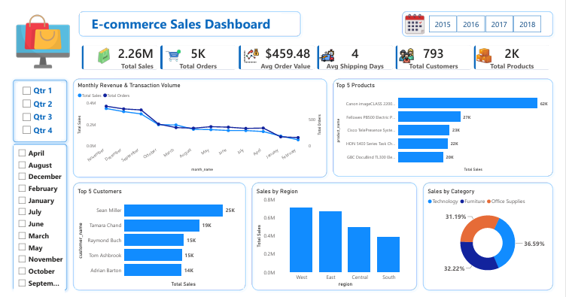

8. Insights

- Total sales exceeded $2.26 million from 2015–2018.
- Sales increased overall, with a temporary decline in 2016.
- Technology generated the highest sales among all categories.
- The West region recorded the highest sales, while the South had the lowest.
- Consumer customers contributed the largest share of revenue.
- Sales were highest during November and December, showing strong seasonal demand.
9. Recommendations
- Focus marketing efforts on the South region to improve sales.
- Increase inventory before the holiday season.
- Promote high-performing products and review low-selling products.
- Strengthen customer retention for the Consumer segment.
- Investigate the reasons behind the sales decline in 2016.
10. Conclusion

This project demonstrates an end-to-end data analytics workflow, from data cleaning to dashboard creation. Python was used for pre-processing, SQL for business analysis, and Power BI for visualization. The analysis identified sales trends, customer behaviour, product performance, and regional opportunities, providing insights that can support better business decisions.

