TELECOM CUSTOMER CHURN
ANALYSIS & PREDICTION

Project Report
End-to-End Data Analytics Project: SQL ETL, Power BI Dashboarding, and Machine Learning-Based Churn Prediction

Tools Used: SQL Server | Power BI | Python (scikit-learn) | Jupyter Notebook

1. Executive Summary
This project builds an end-to-end churn analytics solution for a telecom operator, covering data engineering, business intelligence reporting, and predictive modeling. Raw customer records were cleaned and loaded into a SQL Server database, summarized in an interactive Power BI dashboard, and used to train a Random Forest classifier that flags customers likely to churn.
Out of 6,563 existing customers, 1,727 have churned, a churn rate of 26.3%. The leading churn drivers are competitor activity, service attitude, and general dissatisfaction. A Random Forest model trained on this data reaches 85% overall accuracy and, when applied to 562 new/recently joined customers, flags 538 as high-risk instances requiring monitoring or retention outreach — meaning most new joiners currently carry a predicted at-risk profile.

Key Figures at a Glance
Metric | Value
Total customers | 6,563
Churned customers | 1,727
Overall churn rate | 26.3%
New customers (Joined status) | 561
Model accuracy (test set) | 85%
Model recall on churn class | 62%
Customers flagged at risk (prediction run) | 538

2. Project Objectives
The project was scoped around three goals, as defined in the project brief:
- Build an ETL pipeline to clean raw customer data and load it into a relational database.
- Create an interactive Power BI dashboard to analyze customers by demographics, geography, account details, payment methods, and subscribed services, and to surface churn patterns for retention and marketing use.
- Predict which existing customers are likely to churn using a machine learning model, so the business can act before the customer leaves.
Key metrics tracked throughout: Total Customers, Active Customers, Churned Customers, Churn Rate, and New Customers.

3. Data Understanding
The source dataset is a single customer-level table (customer_churn) with 6,563 records and 32 columns, spanning demographics, subscribed services, account/billing details, and churn outcome. Each row is one customer, keyed by Customer_ID.

3.1 Data Dictionary
Field | Description
Customer_ID | Unique key for each customer
Gender, Age, Married | Demographic attributes
State | Geographic location
Number_of_Referrals | Referrals made by the customer
Tenure_in_Months | How long the customer has been with the company
Value_Deal | Promotional deal, if any, attached to the account
Phone_Service / Multiple_Lines | Phone service subscription details
Internet_Service / Internet_Type | Internet subscription and connection type
Online_Security, Online_Backup, Device_Protection_Plan, Premium_Support | Add-on service subscriptions
Streaming_TV, Streaming_Movies, Streaming_Music, Unlimited_Data | Entertainment/data add-ons
Contract, Paperless_Billing, Payment_Method | Account and billing configuration
Monthly_Charge, Total_Charges, Total_Refunds, Total_Extra_Data_Charges, Total_Long_Distance_Charges, Total_Revenue | Financial fields
Customer_Status | Target field: Churned, Stayed, or Joined
Churn_Category, Churn_Reason | Reason codes recorded for churned customers

Customer_Status is the field the whole project is built around: it separates the base into Churned, Stayed, and Joined customers, which in turn defines the two working views used downstream.

4. Methodology: ETL Pipeline
Data was processed in SQL Server in four stages: database and table setup, null/quality checks, cleaning, and view creation for downstream consumption.

4.1 Database & Table Setup
A dedicated database (db_TeleChurn) was created and the raw file loaded into a customer_churn table for processing.

4.2 Data Quality Checks
Every one of the 32 columns was checked for nulls using a single diagnostic query (SUM(CASE WHEN ... IS NULL...)) run across the full column list. This confirmed which fields had missing values and needed a cleaning rule before the data could be trusted for reporting or modeling.

4.3 Cleaning & Standardization
A cleaned table, prod_churn, was built from customer_churn with COALESCE rules to replace nulls with meaningful defaults rather than dropping rows, preserving sample size. Examples:
- value_deal → 'None' where no deal applied
- multiple_lines, online_security, online_backup, device_protection_plan, premium_support, streaming_tv/movies/music, unlimited_data → 'No' where the customer had not subscribed to that service
- internet_type → 'None' where no internet service was active
- churn_category, churn_reason → 'Others' where the customer had not churned or the reason was unrecorded
Two SQL views were created on top of prod_churn to separate the data into the two populations the project needed:
- vw_ChurnData — customers with status Churned or Stayed (6,003 records). This is the historical, labeled set used for dashboard analysis and to train the prediction model.
- vw_JoinData — customers with status Joined (561 records). This is the newer customer base with no churn outcome yet — the set the trained model is applied to in order to generate forward-looking risk predictions.

4.4 Exploratory Distribution Checks
Before dashboarding, distribution queries were run directly in SQL to sanity-check the data — gender split, contract-type split, revenue share by customer status, customer count by state, and the distinct list of internet connection types. These queries validated that category values were clean and that state and contract fields were usable for slicing in Power BI.

5. Power BI Dashboard: Churn Summary
The summary page gives a single view of the churn base across demographic and account dimensions, with slicers for Monthly Charge Range and Married status so the business can filter to a specific segment.
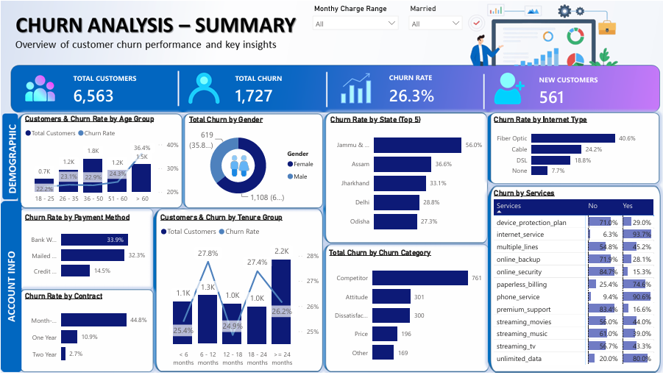
Figure 1 — Churn Analysis: Summary dashboard (Power BI).

5.1 Headline Metrics
Metric | Value
Total Customers | 6,563
Total Churn | 1,727
Churn Rate | 26.3%
New Customers | 561

5.2 Demographic Patterns
- Age: churn rate rises steadily with age — 22.2% for 18–25 year-olds versus 36.4% for customers over 60, the highest of any age band.
- Gender: of 1,108 total churned customers shown in the gender split, roughly 56% are female and 44% are male — churn is not concentrated in one gender, but skews slightly female.
- Geography: churn is heavily state-dependent. Jammu & Kashmir has the highest churn rate in the base at 56.0%, followed by Assam (36.6%), Jharkhand (33.1%), Delhi (28.8%) and Odisha (27.3%) — all well above the 26.3% national average.
- Internet type: Fiber Optic customers churn at 40.6%, far above Cable (24.2%), DSL (18.8%), and customers with no internet service (7.7%). This is counter-intuitive since fiber is the premium product, and points to a pricing or service-quality issue on that line rather than a demand problem.

5.3 Account & Contract Patterns
- Contract type is the single strongest churn driver visible on the dashboard: Month-to-month contracts churn at 44.8%, versus 10.9% for One Year and just 2.7% for Two Year contracts.
- Payment method: Bank Withdrawal (33.9%) and Mailed Check (32.3%) customers churn roughly 2–2.5x more often than Credit Card customers (14.5%).
- Tenure: churn is highest in the newest cohort (< 6 months, 25.4%) and rises again sharply in the ≥ 24 months cohort (27.4%), with the 12–18 month band the most stable (24.9%). Interestingly, tenure alone does not show the strongest or cleanest trend — contract type and internet type are more decisive.

5.4 Why Customers Leave
Total churn by category: Competitor (761), Attitude (301), Dissatisfaction (300), Price (196), Other (169). Competitive pressure is the single largest driver, accounting for 44% of all churn.
The detailed churn_reason breakdown (a subset of the full list) confirms this:
Churn Reason | Count
Competitor had better devices | 289
Competitor made better offer | 274
Competitor offered more data | 106
Competitor offered higher download speeds | 92
Attitude of support person | 208
Attitude of service provider | 93

Service-level churn rates (% of subscribers to a service who then churned) show internet_service (93.7%) and phone_service (90.6%) with very high churn-side percentages — but this reads high mainly because almost every customer has these base services, so the base rate dominates. The more actionable signals are the add-ons with a real 'No' population to compare against: customers without online_security churn far more than those with it (84.7% vs 15.3% split within that service), and the same holds for premium_support and device_protection_plan — customers without these add-ons are consistently the larger share of churners.

6. Predictive Modeling
The goal of the modeling stage is different from the dashboard: instead of explaining past churn, it predicts which of the 561 newly joined customers (vw_JoinData) are likely to churn next, using patterns learned from the 6,003 labeled historical records (vw_ChurnData).

6.1 Approach
Implemented in Python (Prediction.ipynb) using pandas for data handling and scikit-learn for modeling:
- Load vw_churndata (6,003 labeled records: Churned or Stayed) from the cleaned dataset.
- Drop identifier and outcome-explanation columns not available at prediction time: customer_id, churn_category, churn_reason.
- Label-encode 19 categorical fields (gender, married, state, contract, payment method, and all service flags) into numeric form.
- Encode the target Customer_Status as 0 = Stayed, 1 = Churned.
- Split into training and test sets (80% / 20%, random_state = 42 for reproducibility).
- Train a Random Forest Classifier (100 trees, random_state = 42).
- Evaluate on the held-out 20% test set using a confusion matrix and classification report, and rank feature importance.
- Apply the trained model and the same label encoders to vw_joindata (561 new customers with no known outcome) to generate predictions, then export every customer predicted as 'Churned' to Predictions.csv.

6.2 Why Random Forest
A Random Forest was chosen because the feature set is a mix of categorical and numeric fields, the relationship between features and churn is unlikely to be linear, and the model produces a feature-importance ranking directly — useful for turning the model into a business explanation, not just a black-box score.

6.3 Model Performance
On the 1,201-record test set:
Metric | Class 0 (Stayed) | Class 1 (Churned) | Overall
Precision | 0.86 | 0.83 | —
Recall | 0.95 | 0.62 | —
F1-score | 0.90 | 0.71 | —
Accuracy | — | — | 0.85

Confusion matrix (rows = actual, columns = predicted):
 | Predicted: Stayed | Predicted: Churned
Actual: Stayed | 811 | 44
Actual: Churned | 132 | 214

Read honestly, the model is strong at confirming customers who will stay (95% recall on that class) but materially weaker at catching churners — it misses 132 of 346 actual churners in the test set (38% miss rate). For a retention use case, that recall gap matters more than the headline 85% accuracy: accuracy is inflated by the majority 'Stayed' class, and a churn-prevention program built on this model will still let a meaningful share of true churners go unflagged. If missed churners are costly, this is the number to improve before relying on the model operationally — options include class-weighting, oversampling the churn class (e.g. SMOTE), or lowering the classification threshold to trade precision for recall.

6.4 Feature Importance
The notebook ranks all 27 remaining features by Random Forest importance to show which fields the model actually leans on. The chart output is available in the notebook; it is not reproduced numerically here because exact importance values were not captured in the saved notebook output. Re-running the notebook cell reproduces the ranked chart directly.

6.5 Applying the Model: At-Risk Customer List
The trained model and saved label encoders were applied to vw_joindata — 561 customers with status 'Joined' and therefore no churn outcome yet. Of these, the model flags 538 as predicted 'Churned', i.e. at risk. This is a very high flagged share (roughly 96% of the new-customer base), which should be read as a signal to prioritize by risk score or key drivers rather than treat all 538 as equally urgent — with recall at only 62% and this many positive flags, the model is casting a wide net, so pairing this list with a manual severity ranking (e.g. contract type, monthly charge, tenure) is advisable before acting on it.
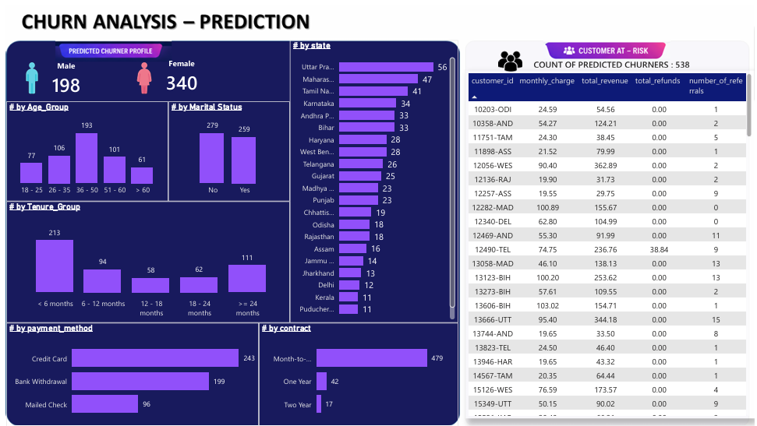
Figure 2 — Churn Analysis: Prediction dashboard, showing the predicted at-risk customer profile and list (Power BI).

6.6 Predicted Churner Profile
- Gender: 340 female vs. 198 male — the at-risk list skews female, consistent with the slightly higher female churn share seen in the historical dashboard.
- Age: concentrated in the 36–50 band (193 of 538), with the 18–25 and 51–60 bands roughly even (~100–106 each) and over-60 customers the smallest group (61).
- Marital status: fairly even — 279 unmarried, 259 married.
- Tenure: heavily weighted to under 6 months (213 of 538) — new customers are the largest single at-risk group, followed by ≥ 24 months (111).
- Contract: 479 of 538 (89%) are on month-to-month contracts, matching the historical pattern that month-to-month is the highest-churn contract type.
- Payment method: Credit Card leads (243), ahead of Bank Withdrawal (199) and Mailed Check (96) — a different order than the historical churn-rate ranking, worth reconciling before drawing conclusions from payment method alone.
- Geography: Uttar Pradesh (56), Maharashtra (47), and Tamil Nadu (41) have the largest at-risk counts by volume — note this tracks state population/customer volume in the new-joiner base rather than the churn-rate ranking seen in Section 5.2, so the two views should not be read as the same signal.
The exported list (Predictions.csv, 538 rows) includes each flagged customer's ID, monthly charge, total revenue, total refunds, and referral count, so the business can prioritize outreach — for example, higher-revenue customers with zero referrals are a natural first segment to target for retention.

7. Business Recommendations
- Target month-to-month contract holders first. This segment drives 44.8% of historical churn and 89% of the current at-risk list. Incentivizing a move to a one- or two-year contract (discount, bundled add-on) is the single highest-leverage lever available in this data.
- Investigate the Fiber Optic experience. Fiber customers churn at 40.6%, the highest of any internet type, despite being the premium product — this needs a root-cause check (pricing vs. reliability vs. support) rather than a marketing fix.
- Defend against competitor offers directly. Competitor-driven reasons account for 761 of 1,727 churns (44%) — better devices and better offers are the top two named reasons. A competitive device/pricing review is warranted, especially in Jammu & Kashmir, Assam, and Jharkhand where churn rates are far above average.
- Push adoption of protective add-ons. Customers without online security, premium support, or device protection churn disproportionately. Bundling these into new-customer onboarding, rather than selling them as later upsells, may reduce early-tenure churn.
- Treat the 538-name at-risk list as a starting point, not a final target list. Given the model's 62% recall on the churn class, layer a manual risk/value ranking on top (e.g. flag high monthly-charge, zero-referral, month-to-month customers within the list first) rather than running blanket outreach to all 538.
- Re-tune the model before scaling the program. If the business commits to using this model operationally, address the recall gap first — via class weighting, resampling, or threshold adjustment — since under the current settings more than a third of true churners are being missed.

8. Conclusion
This project delivers a working pipeline from raw data to actionable output: SQL-based cleaning and view creation, a Power BI dashboard that explains historical churn across demographic, geographic, and account dimensions, and a Random Forest model that scores new customers for churn risk. The dashboard makes a clear, consistent case that contract type, internet type, and competitor pressure are the dominant churn drivers. The predictive model is directionally useful and correctly surfaces the same high-risk segments (month-to-month, new tenure) — but its 62% recall on churners is a real limitation, not a footnote, and should be addressed before the flagged list is used as the sole basis for a retention campaign.

9. Appendix: Tools & Files
Component | Tool / File
Database & ETL | SQL Server — Create_Database.sql, Create_Table.sql, data_exploration_check_null.sql, data_exploration_remove_null.sql, data_exploration_views.sql, data_distribution.sql
Dashboarding | Power BI — Churn_Analysis.pbix
Predictive modeling | Python (pandas, scikit-learn, seaborn) — Prediction.ipynb
Model input data | Prediction_data.xlsx (vw_churndata, vw_joindata sheets)
Model output | Predictions.csv (538 flagged at-risk customers)
Raw source data | Customer_Data.csv (6,563 records, 32 fields)

