**AZURE FILE SYNC**

**INDEX**

1. Creating the Storage Account
2. Creating the Azure File Sync
3. Configuring the Server Endpoints
4. Creating the Sync Group

**AZURE FILE SYNC**

Microsoft Azure has an offering called Azure File Sync, which allows the synchronization of on-premises file servers with Azure Files supported by Storage Accounts.

There are several benefits of using this approach — it could be used for transition between on-premises and cloud, backup, and disaster recovery.  
  
**STEPS TO BE FOLLOWED -  
  
1. Creating the Storage Account**

Before creating the Azure File Sync, we need to prepare a **Storage Account that will receive all data from the File Servers on-premises**.

From the design perspective, it is highly recommended to use a **GRS** (Geo-Redundant Storage which uses the **three local replicas + three additional replicas** in another region) to make sure that all data that is being synchronized to the cloud does not have a single point of failure.  
  
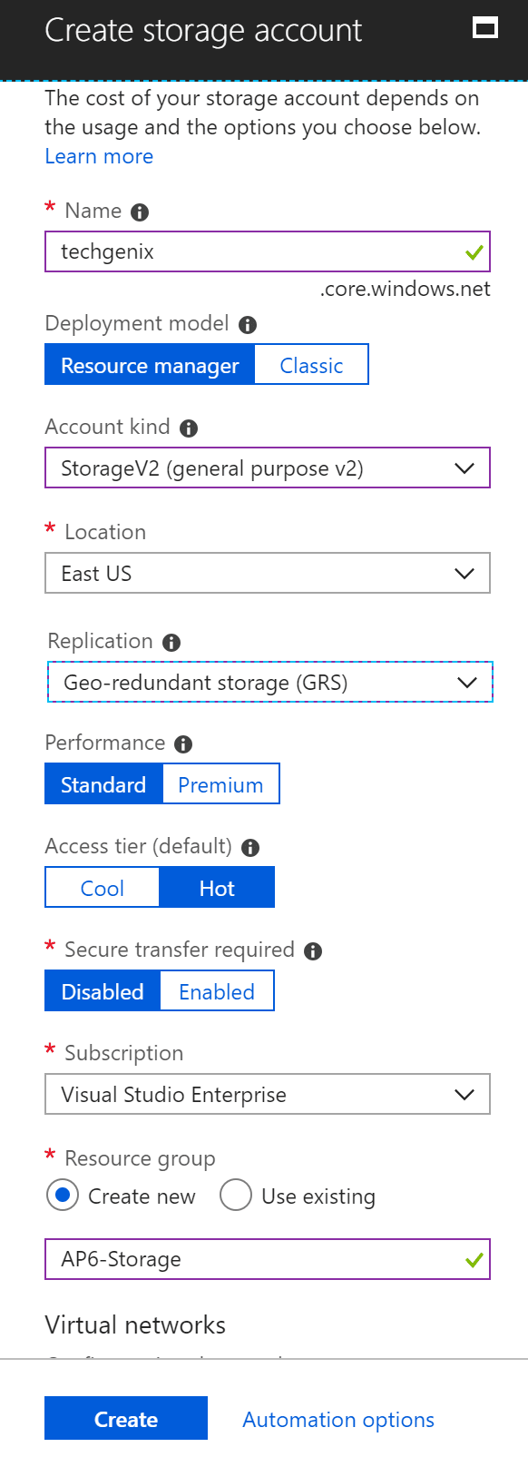  
  
  
After creating the Storage Account to support the upcoming Azure File Sync, our next step is to **replicate the share structure that we have on-premises in the Storage Account/Files.**

Based on our scenario, we will be replicating a shared folder called Public and we will be creating a **Shared Folder called public and we will set the Quota to 4096GB.**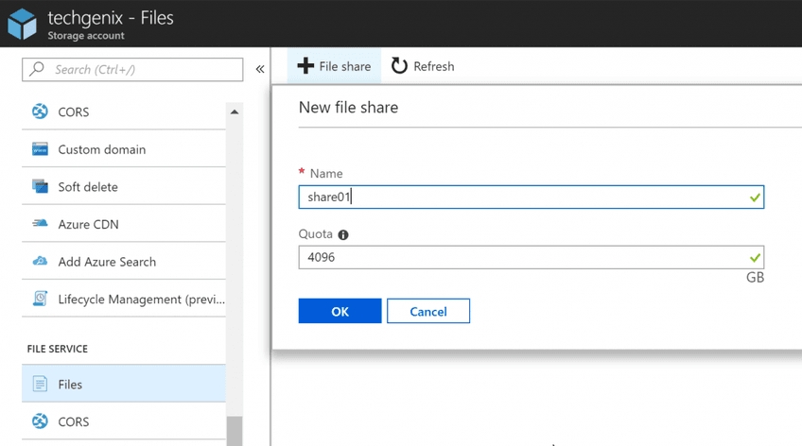

**2. Creating the Azure File Sync**

Logged on the **Azure Portal,** click on **New Resource,** and **type in File Sync,** and select **Azure File Sync** from the list. In the initial blade, a short summary of the service will be described, click on Create.  
  
  
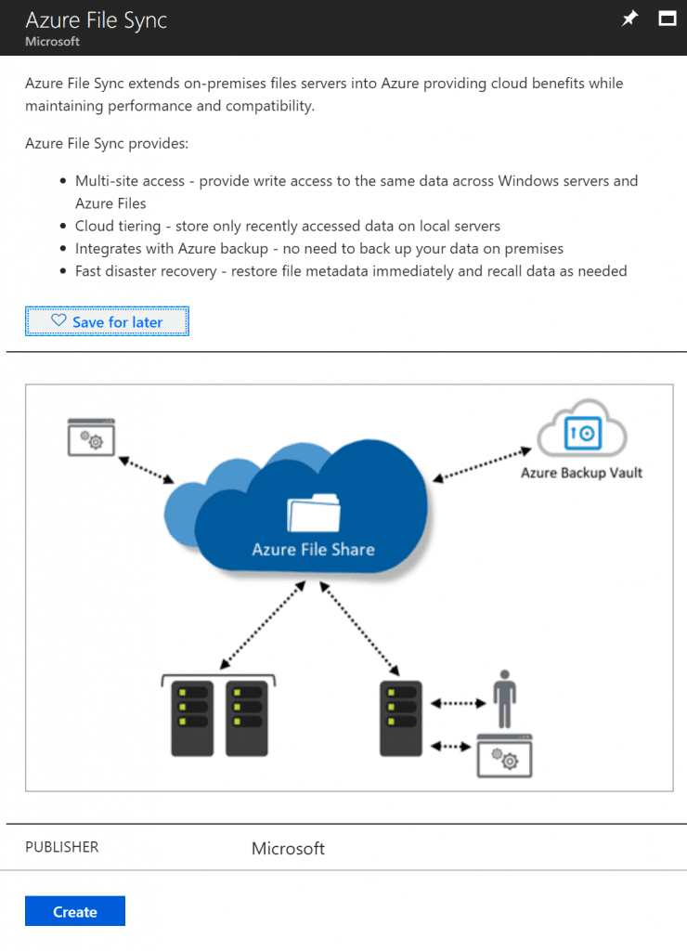

Click on **Create**. In the new blade, we need to **define** the name for the **Azure File Sync, Resource Group, and location.** After making the decision, click on **Create** button to complete the process and wait for the provision to be completed.

**3. Configuring the Server Endpoints**

The first step on the server where we are going to install the Storage Sync Agent is to make sure that the **AzureRM module** is installed. Using the following **PowerShell** cmdlet we can install the module.

**Install-module AzureRM**

If the AzureRM is already present on your server, run **Update-Module AzureRM** just to confirm that the latest modules are in place.  
  
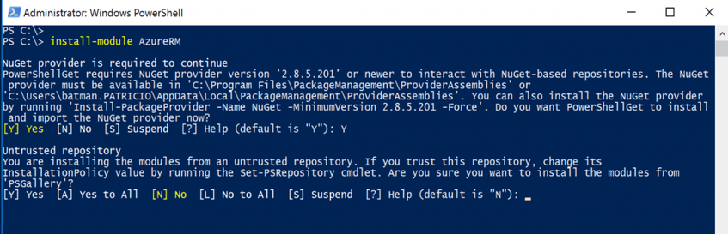

The second step is to **download and install** the **Storage Sync Agent**, which can be retrieved from **Registered Servers item** of Azure Sync Service in the Azure Portal.

After the installation is complete, in the Sign in and register this server page, click on **Sign in** button and provide your credentials to access Microsoft Azure.

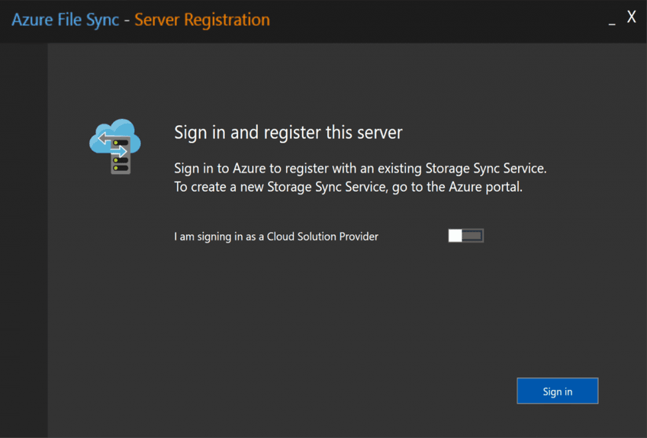

In the Choose a Storage Sync Service page, we need to select the subscription, resource group, and Storage Account and we will use the ones that we have just created in the previous step. If everything goes well, a Registration Successful! page will be displayed. Click on OK.

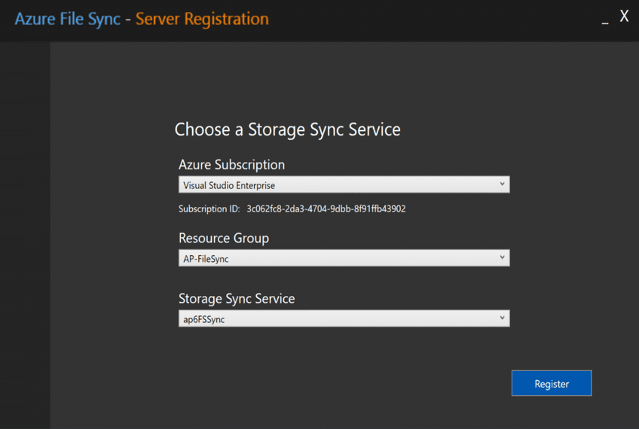

The result of that operation will be **the server showing up on the Registered Servers in the File Sync service**, as depicted in the image below.

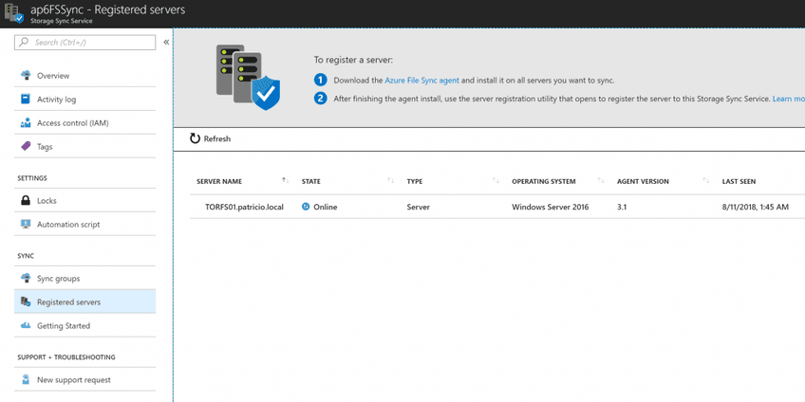

**4. Creating a Sync Group**

So far we **created the requirements on both sides of the fence**: on-premises and Azure to support the file synchronization. What **glues them together is the Sync group** where we define **server endpoints** and **cloud endpoints**, and after that is just matter of time to let them replicate and keep the synchronization.

**Open the Azure File Sync** resource in Microsoft Azure portal, **click on Sync group**s, and to start the creation of a new one click on **+ Sync Group** button located at the top of the new blade on the right side. In the new blade, define a **name** for the Sync Group, and **define the cloud endpoint**, which is comprised of the **Subscription, Storage Account, and File Share** (which was created prior to this wizard).

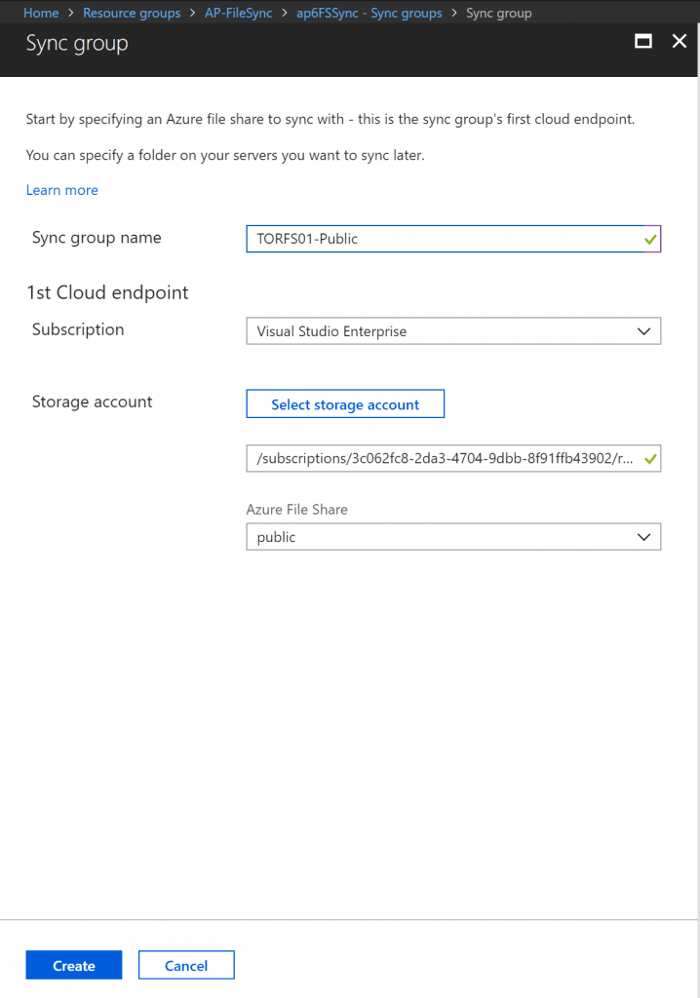

After creation, we will have a Sync Group with one cloud endpoint that we have just configured, and our **next task is to add server endpoints**, and we can do that by hitting the **Add server endpoint button**. **Select the registered server and the path from where we want to synchronize the data**. Click on **Create**.

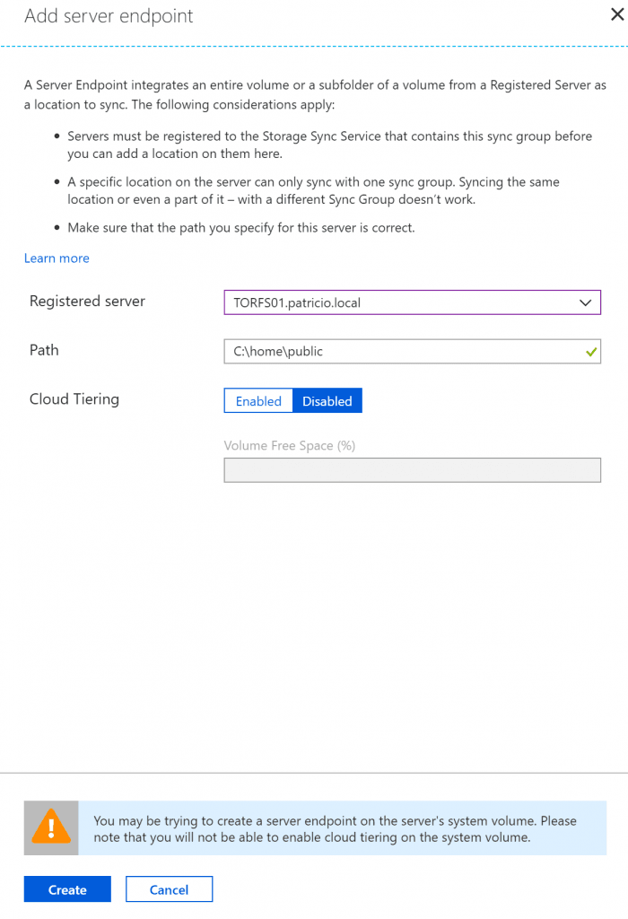



The result will be a Sync Group with one cloud endpoint and one server endpoint and its **status**, in our case shows health, which is a good sign.

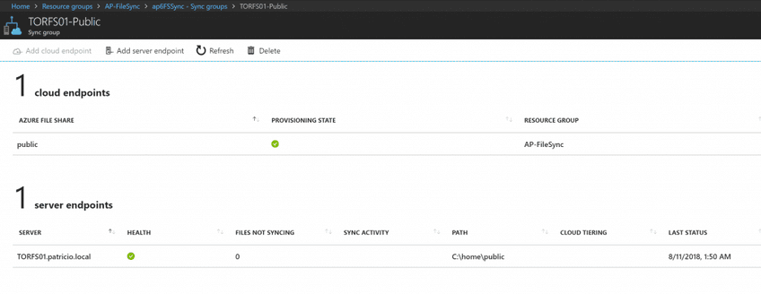

After getting a **health status**, we can check the Storage Account, and under the File Share that we created to support the synchronization, we can validate that all data that we have on-premises is being synchronized.

