**WORK OFFER**

*Ref. No.*

BO-2019-AX-02

**Employer Information**



IAESTE BOLIVIA, IB

|  |  |  |
| --- | --- | --- |
| *Employer:* | AXON Srl | Website: www.axon.com.bo |
|  | Calle Gualberto Villarroel No. 390  Santa Cruz  Bolivia | Location of placement: Santa Cruz, Bolivia Nearest airport:  Working hours per week: 40.0  Working hours per day: 8.0 |

*Number of employees: 65*

*Business or products: ERP Software Development, Core Banking, AML Systems*

# Student Required

|  |  |  |
| --- | --- | --- |
| *General Discipline:* 11-COMPUTER AND INFORMATION SCIENCES | *Completed years of study:* | 4 |
| *Field of Study:* 11.0101-Computer and Information Sciences, General.  11.0103-Information Technology.  11.0104-Informatics.  11.0202-Computer Programming, Specific Applications. | *Language required:* | English Good And  Spanish Fair Or  Portuguese Good |
| *Required Knowledge and Experiences:* | *Other requirements:* |  |

Solid knowledge of Java, app develpment tools. Encryption Algorithms.

Digital Signatures.

Experience with mobile app development with Android.

At work, Spanish language is not necessary, communication in English would be fine. But a fair Spanish language is recommended for regular activities outside the office.

# Work Offered

Development of payment system prototype in a mobile app under Android to issue payment orders digitally signed, for which it is required to develop a safe storage of private keys and digital certificates.

The app will interact, in a safe connection, with a server from which the payment requests will come and to which the payment orders will be delivered. Previous experience preferred.

|  |  |  |  |  |  |  |
| --- | --- | --- | --- | --- | --- | --- |
| *Number of weeks offered:* | 6 - 12 | | *Working environment:* | | Research and development | |
| *Within the months:* | 03-DEC-2018 - 31-DEC-2019 | | *Gross pay:* | | 4,000 BOB / Month | |
| *Or within:* | - | | *Deduction to be expected:* | | 0 | |
| *Holidays:* | | - | | *Payment method / frequency:* / | |  | |
| **Accomodation**  *Canteen at work:* | | Yes | |  | |  | |
| *Expected type of accommodation:* Student dormitory | | | | *Estimated cost of lodging:* | | 1,700 BOB / Month | |
| *Accommodation will be arranged by:* IAESTE | | | | *Estimated cost of living incl. lodging:* | | 4,000 BOB / Month | |
| **Additional Information**  In case of acceptance, we expect an offer in return in AC 2019. | | | |  | |  | |

# Nomination Information

*Deadline for nomination:* 15-JAN-2019 *Please send nominations by* Exchange Platform

*Date:* 02-OCT-2018 *On behalf of receiving country:* Patricia Pagani de Gasser

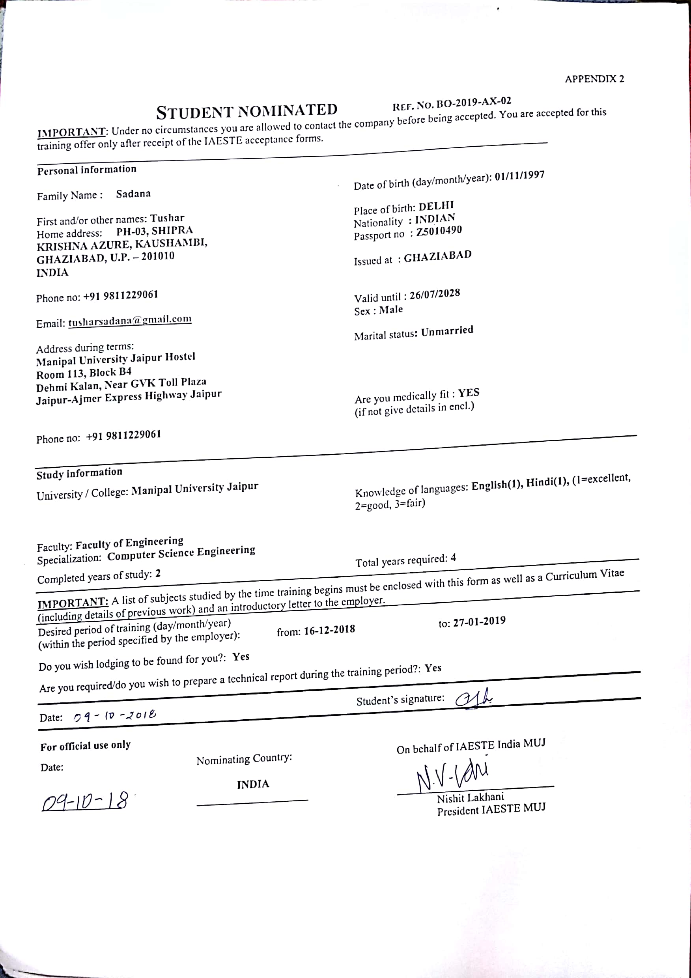

**Cover Letter**

Respected Sir/Ma’am,

I was a twelve-year-old awe-struck kid fascinated by watching the aura of the computer, always tried to process the whole working of this in my head. For me this was a phenomenon which was out of reach, but later I realized all of this is achievable. This was the point where I decided to build my future in this domain. It was too early to decide but I never bothered, I wanted to dig deep and deep into computers, I decided to learn from wherever I could. I took multiple online course in several domains under the umbrella of computers exploring the depths of Website Development which expanded his knowledge in HTML, CSS, SQL, PHP, JavaScript, Vue.js and Firebase After learning all this I began focusing upon Android application development. I began to learn all over this again, his interest in this deepened learned the basics of Java. Learning Java changed his perspective about programming, I explored more languages like C and Python. Python was the one which attracted my eye, and I enjoyed learning and solving questions related to python, I slowly became very proficient in it. After so much of analysis I easily drew the conclusion of choosing a career in Computer Science and I got selected at Manipal University Jaipur with the course of my choice. Here I came across the term “Machine Learning”. When I saw the applications of this concept and I spent days and nights studying about it, I explored all its dimensions from supervised learning to unsupervised, I dug deeper and learned about linear modules which included linear regression and logistic regression, polynomial model.

I have maintained an excellent academic track record throughout my academic career. I achieved 10 CGPA in grade 10 and 95.2% in grade 12. My college track record has been similarly immaculate so far, with a CGPA of 9.4 out of 10 in 4 semesters. I have also achieved the highest possible grade of A+ in the critical subjects of Object Oriented Programming in Java, Relational Database Management Systems and Data Structures, and am currently studying Design and Analysis of Algorithms. I aim and aspire to leverage my technical acumen for the betterment of society. Another application I have already created in this direction is the IoT BASED NAVIGATION FOR BLIND PEOPLE, which navigates safe pathways for them to take based on Ultrasonic Sensors and Gyroscope.

I have extensive experience in Android App Development, having developed 3 applications on Android so far. The most salient of these is an Anti-Human Trafficking app which I have developed for the Rajasthan police.

As a part of my summer internship in NUS, Singapore, I was part of a team involved in a 5-day hackathon on Kaggle. At the end of the first day, my team and I ranked eleventh out of fifteen teams. However, I am unable to settle for anything less than the very best, and the fact that we were ranked so low was not at all alright with me. From the start of the second day, we literally worked day and night until the very end. By the end of the third day we were ranked fifth, and only a couple of minutes before the deadline, my team achieved the first rank in the contest and won it. As a person, throughout my life, I have never settled for second best, and believe in giving my 100% to any and everything I do to ensure I am at its very peak.

I believe that, apart from everything, my most essential and defining trait is my insatiable hunger to learn more. I believe that throughout life, and most importantly at this stage of my life, I must learn as much as I possibly can. I have always prioritised learning over everything else, and actively sought out new and diverse opportunities where I can develop. In one such instance, I learned a new programming language, PHP overnight and erected a website using the same by the next morning. This is just one of the many instances where I have gone out of my way and out of my comfort zone to learn something new and exciting. The internship opportunity being offered to me will be another such challenging platform for me to learn so much more, all the while gaining essential international exposure. This is why, chiefly, I consider myself the perfect candidate for the internship offer.

As of now, I’m the chairperson of the most prominent technical club of my college, MUJ ACM-SCHAP which has close to 550 students enrolled and a working committee of 80 people.

Having moved around during my life I have an ability to adapt to different living conditions and make the best of where I am. I don’t have any problem in adjusting to new surroundings and providing my absolute best output. I have an instinct to lead but that is accompanied with an equal thirst to learn from people more experienced and better skilled than me. I would face no problem in communicating with anyone because I am well versed in English.

If I get the chance to work in your prestigious corporation, it will give me a chance to help me gain experience which will help boost my career. My ability to not shy away from hard work and my excellent work ethics will also, in my humble opinion be an asset to your organization.

I thank you for your time to peruse my CV.

Yours Sincerely,

Tushar Sadana

(+91) 981-122-9061

[tusharsadana@gmail.com](mailto:tusharsadana@gmail.com)