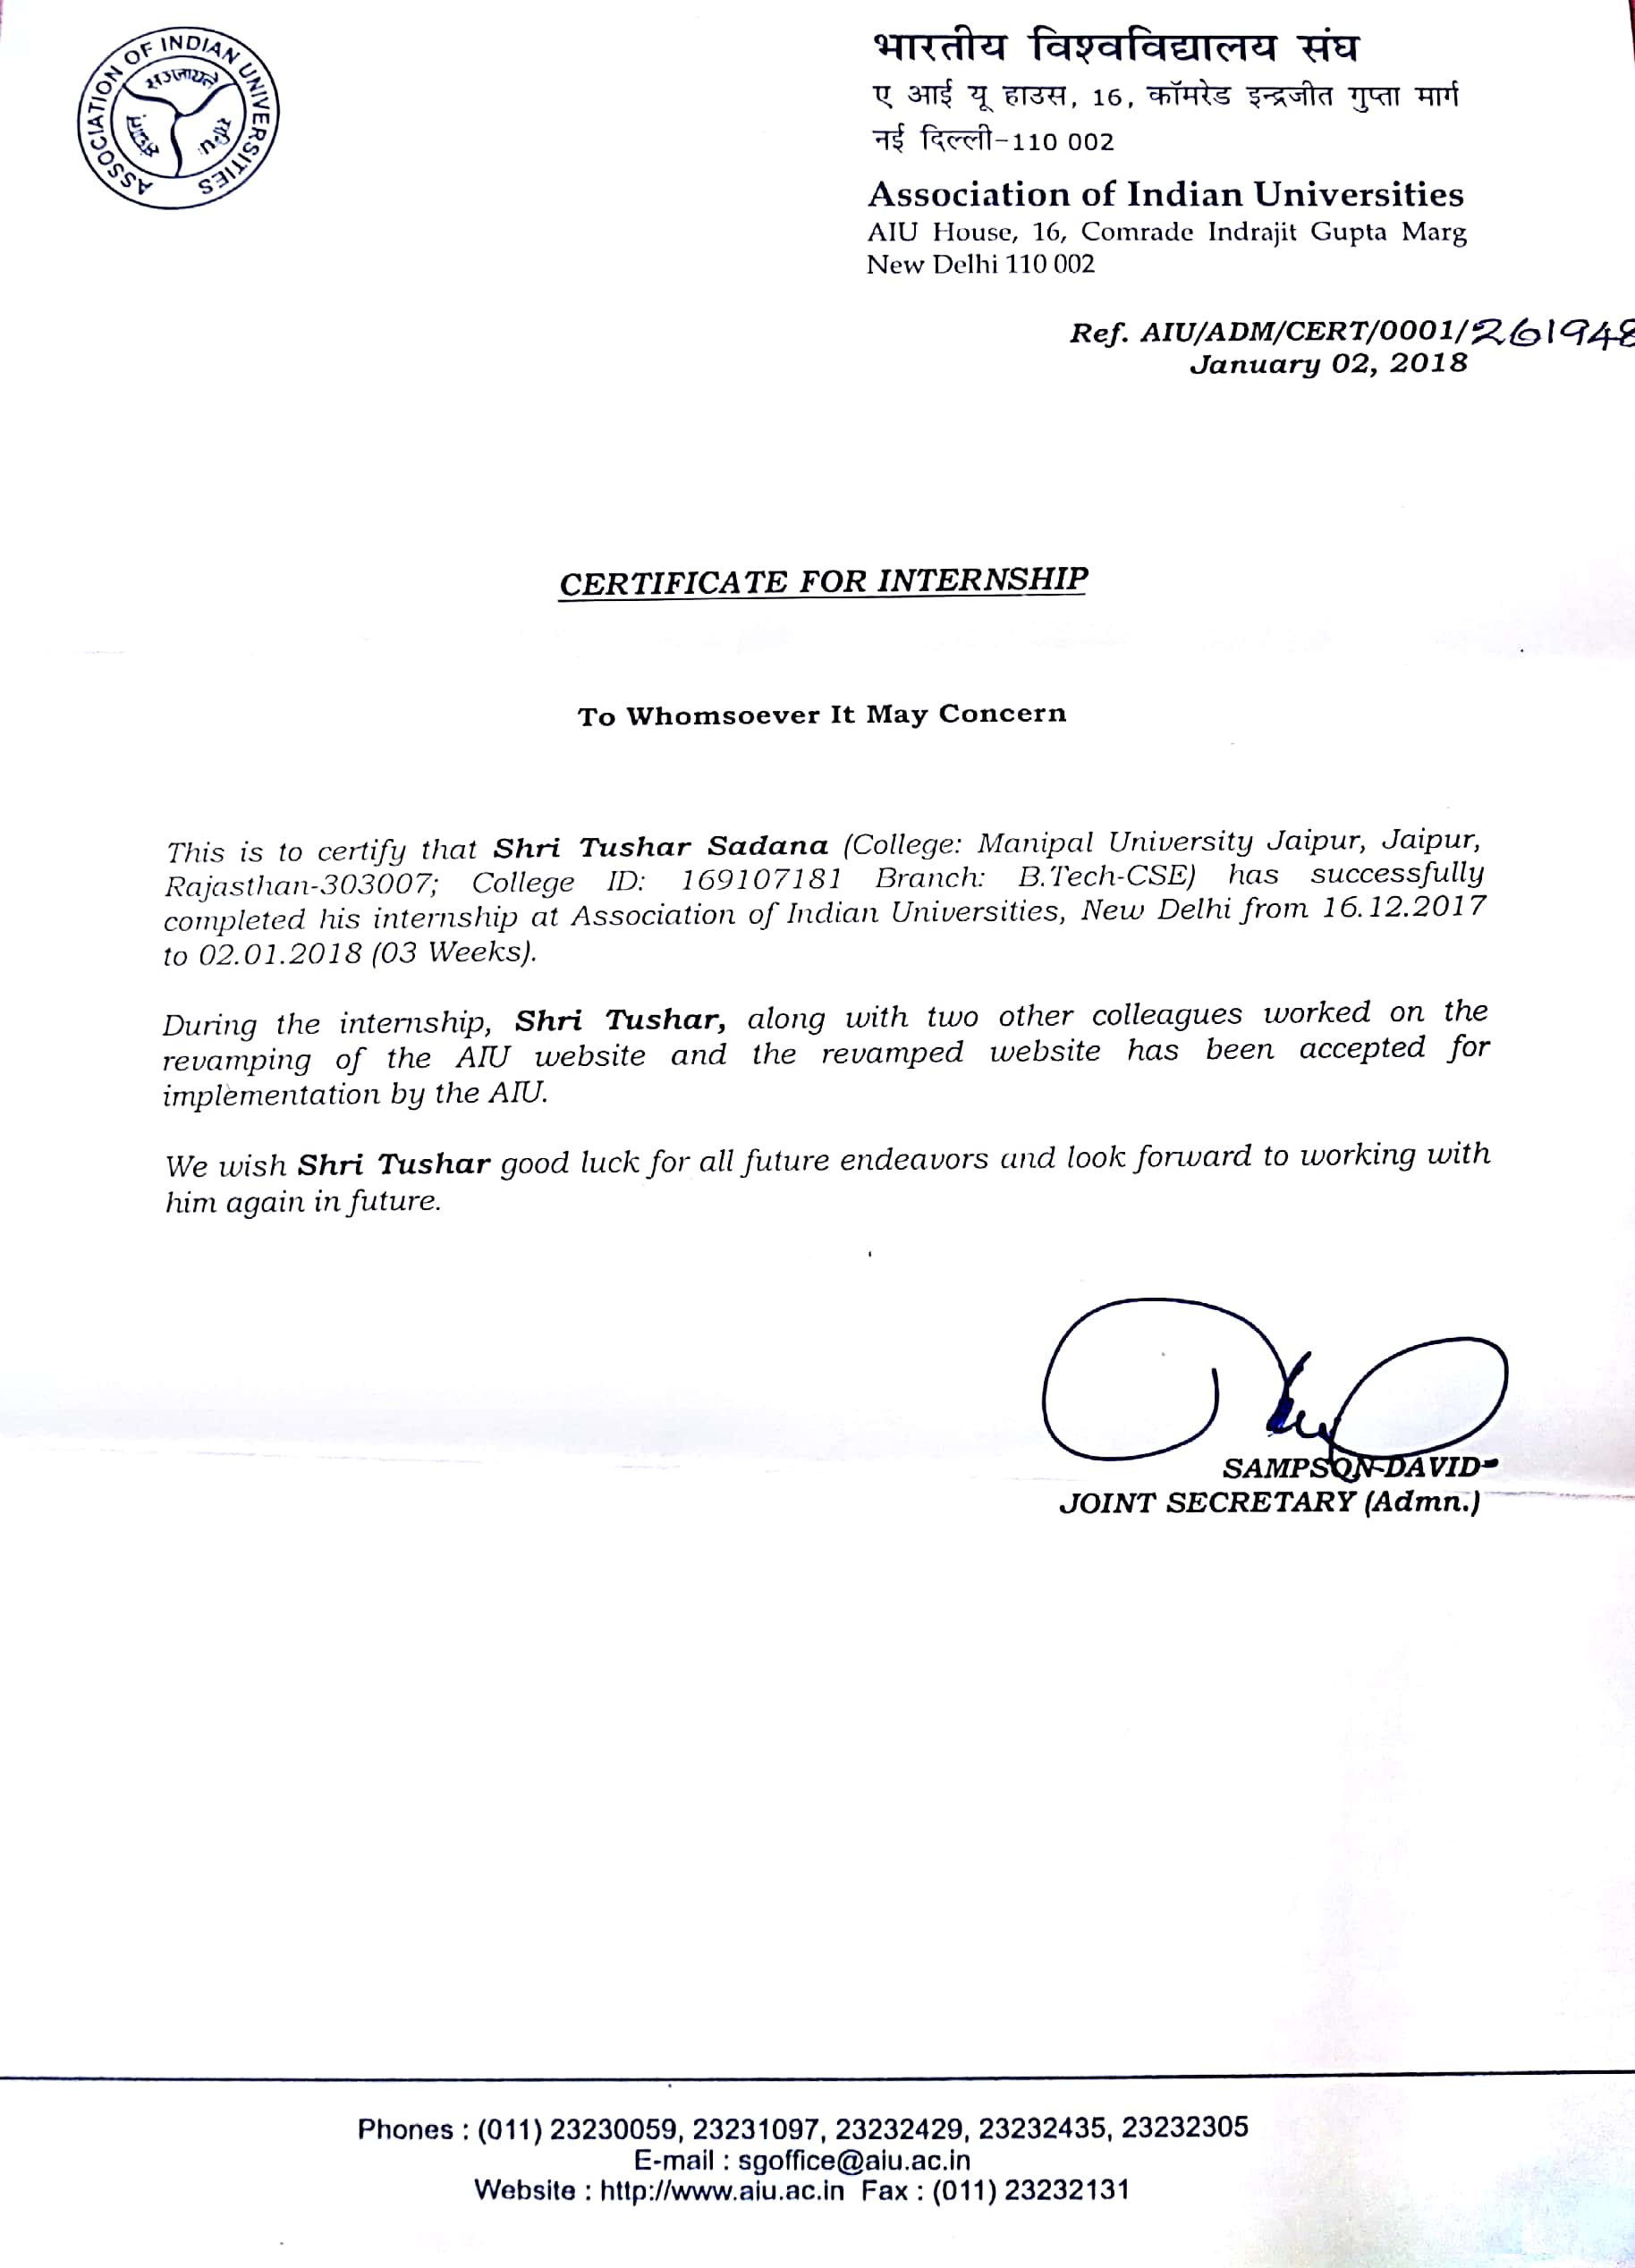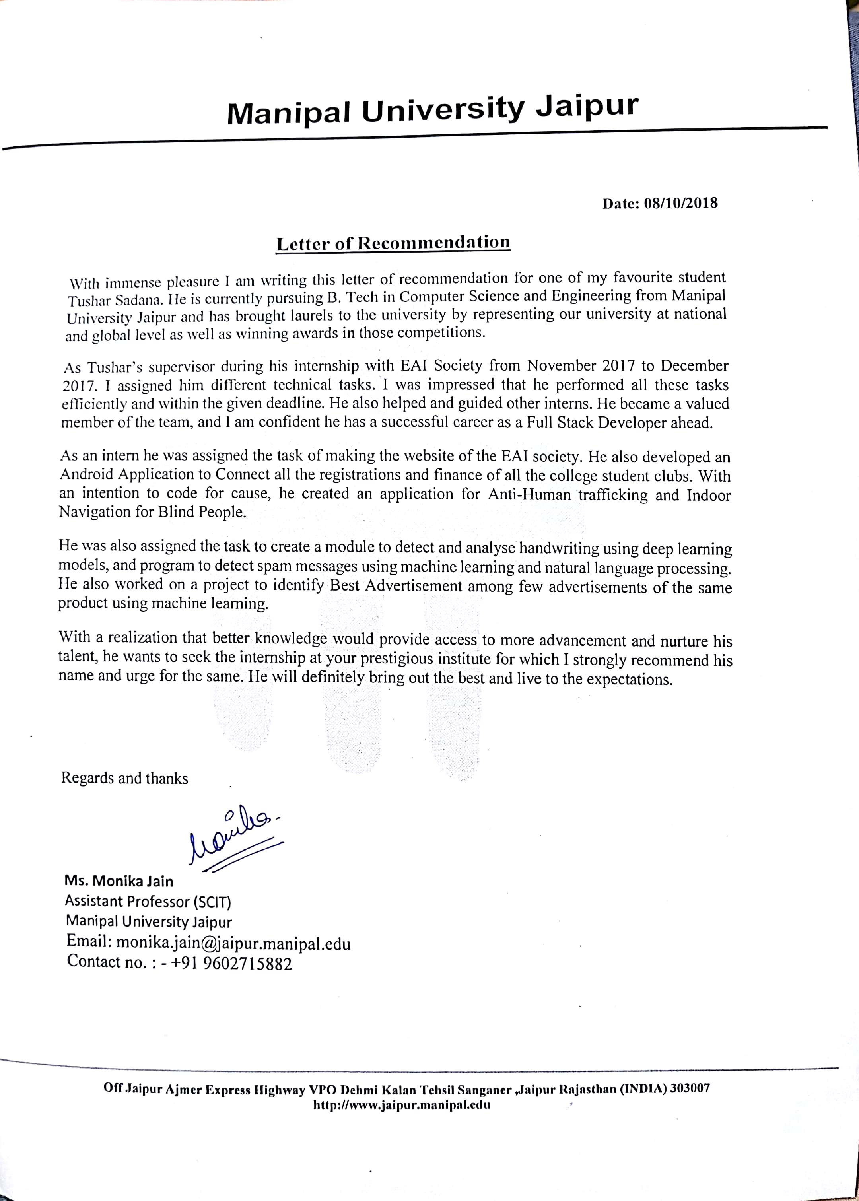

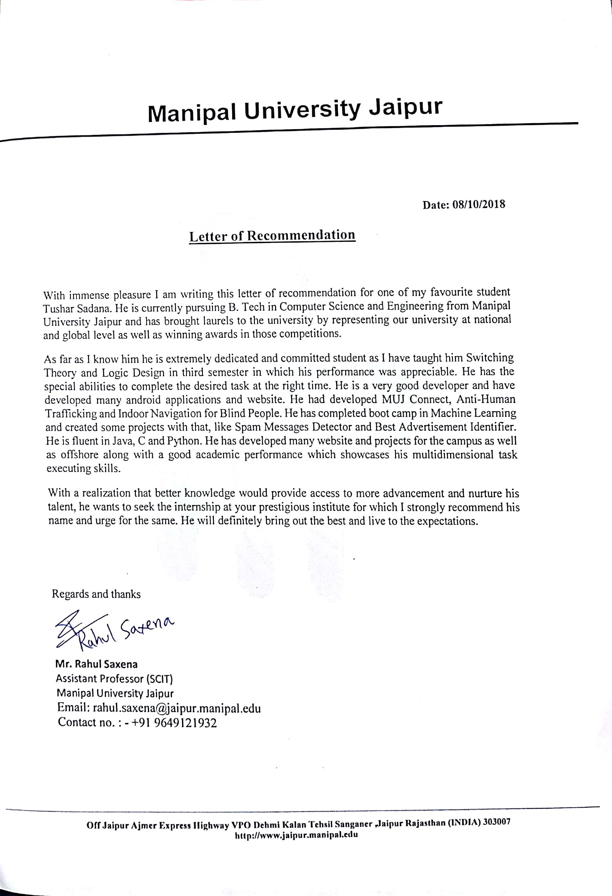

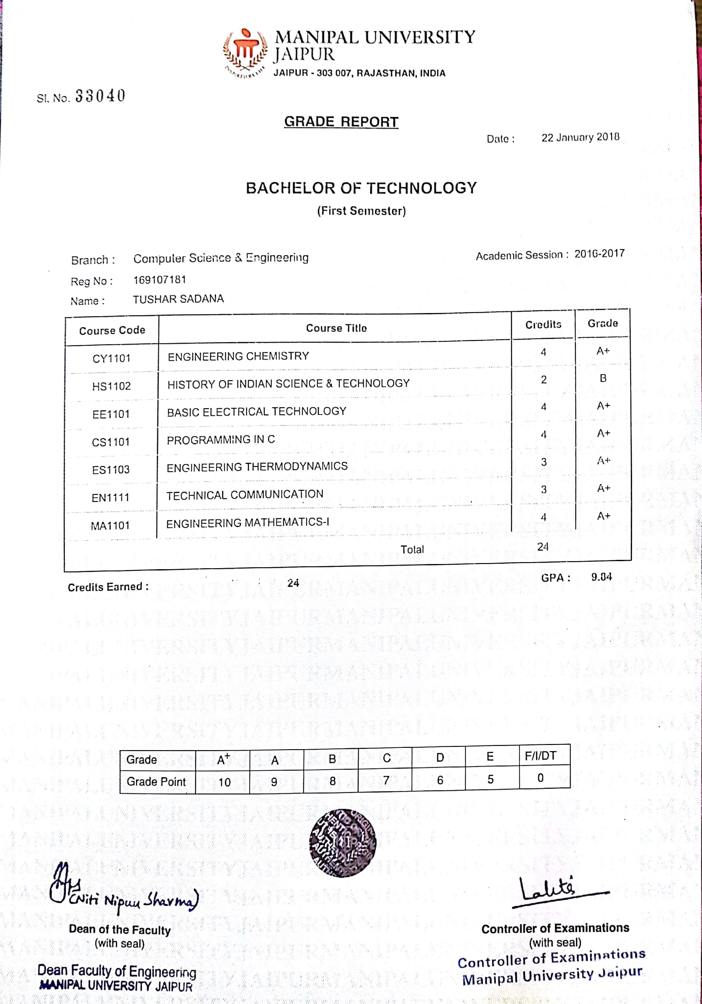

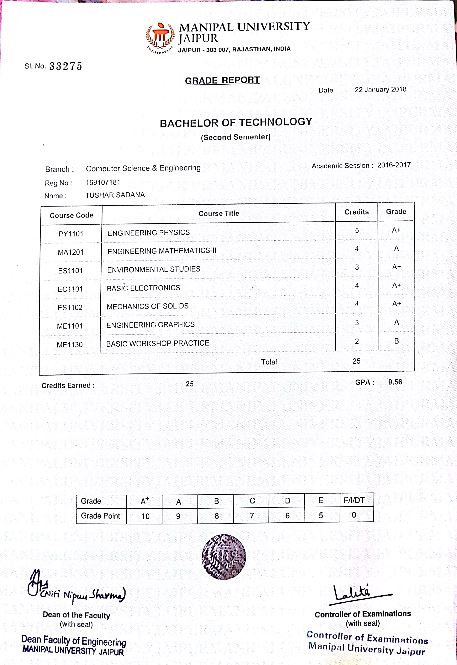

SEMESTER 3

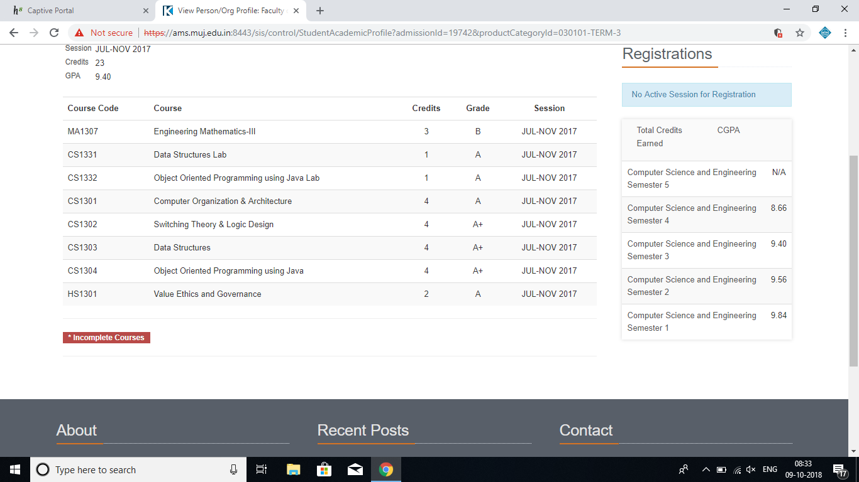

SEMESTER 4

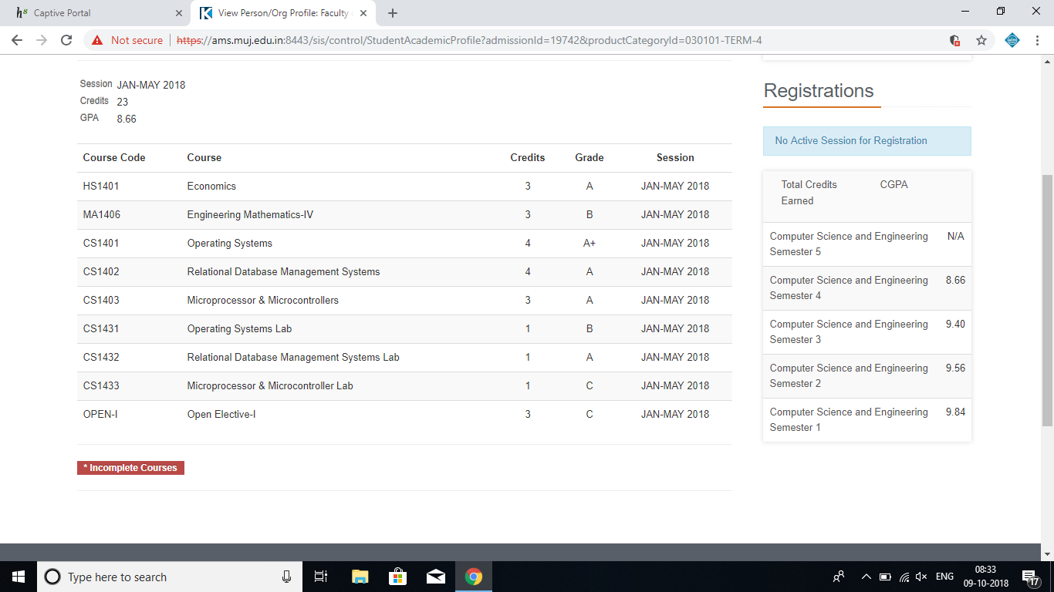

**LIST OF COURSES TAKEN**

SEMESTER 1

|  |  |
| --- | --- |
| **Course** | **Credits** |
| ENGINEERING CHEMISTRY | 4/4 |
| BASIC ELECTRICAL TECHNOLOGY | 4/4 |
| Programming in C | 4/4 |
| Engineering Thermodynamics | 3/3 |
| Technical Communication | 3/3 |
| ENGINEERING MATHEMATICS-I | 4/4 |
| History of Indian Science & Technology | 2/2 |

SEMESTER 2

|  |  |
| --- | --- |
| **Course** | **Credits** |
| Engineering Physics | 5/5 |
| Engineering Mathematics-II | 4/4 |
| Environmental Studies | 3/3 |
| Basic Electronics | 4/4 |
| Mechanics of Solids | 4/4 |
| Engineering Graphics | 3/3 |
| Basic Workshop Practice | 2/2 |

|  |  |
| --- | --- |
|  |  |
|  |  |
| SEMESTER 3 |  |
|  |  |
| |  |  | | --- | --- | | **Course** | **Credits** | | Engineering Mathematics-III | 3/3 | | Data Structures Lab | 1/1 | | Object Oriented Programming using Java Lab | 1/1 | | Computer Organization & Architecture | 4/4 | | Switching Theory & Logic Design | 4/4 | | Data Structures | 4/4 | | Object Oriented Programming using Java | 4/4 | | Value Ethics and Governance | 2/2 | |  |
|  |  |
| SEMESTER 4   |  |  | | --- | --- | | **Course** | **Credits** | | Economics | 3/3 | | Engineering Mathematics-IV | 3/3 | | Operating Systems | 4/4 | | Relational Database Management Systems | 4/4 | | Microprocessor & Microcontrollers | 3/3 | | Operating Systems Lab | 1/1 | | Relational Database Management Systems Lab | 1/1 | | Microprocessor & Microcontroller Lab | 1/1 | | Financial Markets (Open Elective-I) | 3/3 | |  |
|  |  |
|  |  |

SEMESTER 5

|  |  |
| --- | --- |
| **Name** | **Credits** |
| [Design & Analysis of Algorithms](https://ams.muj.edu.in/sis/control/courseContent?productId=CSE074) | Ongoing |
| [Software Engineering](https://ams.muj.edu.in/sis/control/courseContent?productId=CSE075) | Ongoing |
| [Data Communications](https://ams.muj.edu.in/sis/control/courseContent?productId=CSE076) | Ongoing |
| [Automata & Compiler Design](https://ams.muj.edu.in/sis/control/courseContent?productId=CSE077) | Ongoing |
| [PYTHON PROGRAMMING](https://ams.muj.edu.in/sis/control/courseContent?productId=CSE091) | Ongoing |
| [FUNDAMENTALS OF IMAGE PROCESSING](https://ams.muj.edu.in/sis/control/courseContent?productId=OPBT5N0009) | Ongoing |
| [Design & Analysis of Algorithms Lab](https://ams.muj.edu.in/sis/control/courseContent?productId=CSE114) | Ongoing |
| [Software Engineering Lab](https://ams.muj.edu.in/sis/control/courseContent?productId=CSE115) | Ongoing |
| [Automata & Compiler Design Lab](https://ams.muj.edu.in/sis/control/courseContent?productId=CSE116) | Ongoing |

The educational process at Manipal University Jaipur uses a Credit-Based System wherein the course content is expressed in number of Credits. M.U.J. has been using the Credit-Based System since the year 2011. The present system, applicable to me incorporated several modifications and is known as “Revised Credit System”. The course content of individual subjects-theory

as well as practical-is expressed in terms of certain number of credits. The number of credits assigned to a subject depends on

the number of contact hours per week. Normally, in case of theory subjects, the number of credits is equal to the number of contact hours per week, while in case of labs, one credit is assigned for every three contact hours per week.

