# Medical Drug Identification Using Blockchain(Supply Chain)

Lalit Barad

*Department of Computer Engineering*

*St. John College of Engineering and*

*Management,*

*Palghar, India*

[lalitb@sjcem.edu.in](mailto:lalitb@sjcem.edu.in)

Dhruv Jha

*Department of Computer Engineering*

*St. John College of Engineering and*

*Management*

Palghar, India

dhruvj@sjcem.edu.in

Sunny Sall (Mentor)

*Department of Computer Engineering*

*St. John College of Engineering and*

*Management,*

*Palghar, India*

sunnys@sjcem.edu.in

Ritesh Yadav

*Department of Computer Engineering*

*St. John College of Engineering and*

*Management*

Palghar, India

riteshy@sjcem.edu.in

Clyde Dsouza

*Department of Computer Engineering*

*St. John College of Engineering and*

*Management*

*Palghar, India*

clyded@sjcem.edu.in

*Abstract*—*Counterfeit medicines are a major concern because the current system is opaque, making it difficult for consumers to determine the true cost of their medicines. This is compounded by the challenges of investigating potential illegal or unethical practices within the supply chain. To address this issue, we propose using blockchain technology, which provides a secure and transparent means of recording transactions between parties. By utilizing the decentralization, transparency, and immutability of blockchain, we aim to combat counterfeit medicines. Our proposed solution involves the use of smart contracts to track the transfer of each product within the supply chain and verify its authenticity. Our experimentation with the React Framework, Ganache, Web3.js, and Truffle frameworks has demonstrated the feasibility and enhanced security of this solution compared to existing systems., Drug counterfeiting.*

Keywords - Ganache, Web3.js, Blockchain, React

Framework, Web3.js, DAPP.

# Introduction

The intricate pharmaceutical supply chain network, which involves numerous phases that can take months or even longer in different regions of the world, is vital in the distribution of prescription pharmaceuticals to patients. It is challenging to track the sources and flow of medicines because of this network, which includes suppliers, manufacturers, shippers, wholesalers, distributors, and retailers, among others. With estimates indicating that up to 30% of pharmaceuticals used in underdeveloped nations are fake, the prevalence of counterfeit drugs is a serious concern on a worldwide scale and can have serious negative health effects. Customers find it difficult to identify the exact cost of items and to look into alleged unlawful or unethical acts inside the supply chain due to the lack of transparency in the current system, which creates a rift between vendors. This inefficiency results in a disconnect between entities such as vendors, suppliers, and customers, making it challenging to determine who needs what, when, and how. Blockchain technology provides a solution to these issues by offering a decentralized, transparent, and immutable ledger that can securely record transactions between parties. Through the use of smart contracts, transactions between entities in the supply chain can be tracked and recorded on the blockchain. The proposed solution was tested using the React Framework, Ganache, Web3.js, and Truffle frameworks.

# REVIEW OF LITERATURE

Jamil et al. [1] proposed a user service framework-based application that uses smart contracts and a distributed ledger as middleware. The proposed system is built on a permissioned blockchain, which allows only valid participants to join and participate in the blockchain network, distinguishing it from other blockchain-based systems. The proposed smart contract-based application executes several queries, updates the ledger state by appending transaction blocks, and returns the updated result as a response to the application.technology.  
  
A.S. K. Pathan, R. R. Jadhav and P. S. Karde, [2] proposes the use of blockchain technology to create a traceability system for the supply chain of counterfeit medicines. The authors highlight the serious issue of counterfeit medicines, which can be harmful to consumers and the industry, and suggest that blockchain can provide a secure, decentralized and immutable way to track the supply chain. The paper describes the architecture of the proposed system, which includes the use of smart contracts and a distributed ledger to record transactions and ensure transparency. The authors also discuss the challenges and limitations of implementing such a system, including the need for collaboration among stakeholders and the difficulty of verifying the authenticity of drugs in the supply chain. Overall, the paper presents an interesting application of blockchain technology to address a critical problem in the pharmaceutical industry.  
  
The article "Traceability and Detection of the Counterfeit Medicine Supply Chain Through Blockchain" [3]proposes the use of blockchain technology to address the issue of counterfeit medicines in the supply chain. The authors describe the architecture of the proposed system, which includes the use of smart contracts and a distributed ledger to create a secure and transparent supply chain. The article highlights the benefits of using blockchain, such as enhanced traceability and detection of counterfeit medicines, and discusses the challenges of implementation.

[4] The paper proposes a solution for the governance of the drug supply chain using blockchain technology, specifically the Gcoin blockchain. The proposed system is designed to enhance the transparency and security of the drug supply chain and prevent the distribution of counterfeit drugs. The system utilizes smart contracts to enforce rules and regulations and ensure the authenticity of drugs at every stage of the supply chain. The authors conducted a simulation of the proposed system and found that it performed well in terms of transaction speed, security, and efficiency.

[5]The paper provides an introduction to blockchain technology and its potential applications in the healthcare sector. The author discusses the challenges faced by the healthcare industry, such as data security, privacy, and interoperability, and explains how blockchain technology can address these challenges. The paper also provides examples of how blockchain can be used in healthcare, such as secure data sharing, clinical trial management, and supply chain management. The author concludes that blockchain has the potential to transform the healthcare industry by improving data security, interoperability, and efficiency.  
  
[6] The paper discusses the potential of blockchain technology in the healthcare sector. The author provides an overview of blockchain technology, including its features such as decentralization, immutability, and transparency, and explains how it can address some of the challenges faced by the healthcare industry, such as data security, privacy, and interoperability. The author also provides examples of how blockchain can be used in healthcare, such as secure data sharing, patient identity management, and drug supply chain management. The paper concludes that blockchain has the potential to revolutionize the healthcare industry by improving data security, reducing costs, and enhancing patient outcomes.

[7] The paper discusses the issue of counterfeit drugs in the online pharmaceutical trade and its impact on public safety. The authors explain how counterfeit drugs are produced and distributed, and the risks they pose to consumers, including serious health complications and even death. The paper also provides an overview of the global trade in counterfeit drugs and the challenges faced by law enforcement in combating this trade. The authors conclude that there is a need for greater awareness and collaboration among governments, law enforcement agencies, and the pharmaceutical industry to address this growing threat.

[8] D.S. Kim, Y.C. Kim, and S.H. Kim, "A Blockchain-based System for Traceability of Pharmaceuticals Supply Chain Management," in Proceedings of the 2020 10th International Conference on Ubiquitous and Future Networks (ICUFN), 2020, pp. 773-777. The authors propose a blockchain  
[9] R. Kamal, A. Dhanasekaran, and N. Kumar in their paper "A Secure Blockchain-Based Drug Supply Chain Management System," [9] present a secure blockchain-based system for managing the drug supply chain. They aim to tackle the problems of counterfeiting, unauthorized distribution and contamination, and lack of transparency in the current drug supply chain management. They also highlight the role of blockchain in ensuring secure data sharing and tracking of drugs from the manufacturer to the end-user.

# Proposed system.

#### The decentralized network underlying the proposed anti-counterfeit drug supply chain system is designed to connect different participants in the supply chain, including suppliers, manufacturers, transporters, distributors, and retailers. Each of these participants acts as a node on the blockchain network and uses an Ethereum account to authenticate their identity and participate in the system. By leveraging this distributed architecture, the proposed system aims to promote transparency, traceability, and security in the drug supply chain, ultimately helping to reduce the incidence of counterfeit drugs.

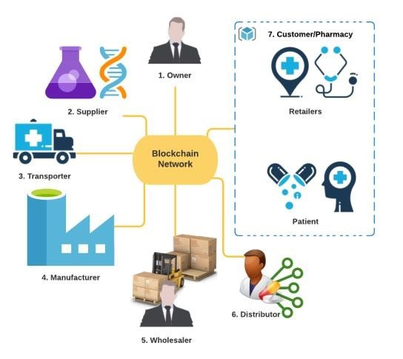

**Fig. 1** - Overview of the Proposed Architecture

1.The proposed blockchain-based system has specific roles assigned to different entities.

2.The Owner can manage the users on the chain, including creating new users, updating their roles, and deleting them if necessary.

3. The Transporter is responsible for verifying the package and delivering it to the destination while ensuring the safety of the product.

4. The Supplier can create raw materials and retrieve their addresses.

5. The Manufacturer receives raw materials from the supplier through the transporter and uses them to create new medicines, ensuring the authenticity of the source.

6.The Wholesaler verifies the source of the medicine and transfers the ownership of the product to the Distributor. 7.The Distributor, in turn, verifies the source of the medicine and transfers ownership to the Customer.

The proposed system is built on a network of smart contracts that govern different aspects of the drug supply chain. The Supply Chain Contract, deployed by the chain owner, provides a framework for managing various entities in the supply chain and includes Solidity events to facilitate real-time communication with the front-end. The Raw Material Contract, deployed by the supplier, allows the addition of raw materials to the chain and captures key information such as the Ethereum address of the supplier and transporter, and the current status of the raw material. Similarly, the Medicine Contract, deployed by the manufacturer, enables the addition of medicines to the chain and captures relevant information such as the Ethereum address of the raw material used to create the medicine, and the current status of the medicine. Finally, the Transaction Contract, automatically deployed by the Raw Material and Medicine contracts, stores transactional information and enables entities to verify the authenticity of products in the supply chain.

* Product Traceability and Source Verification

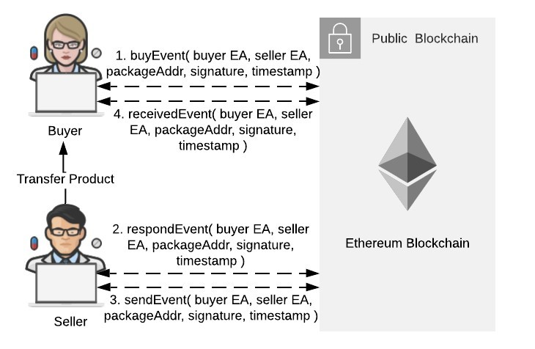

Fig. 2, Event Request Response Mechanism

1.The supply chain contract's buy Event() event is triggered when the buyer makes a purchase request. The request's timestamp, the buyer's private key signature, the address of the raw material or medicine to be purchased, and the seller's and buyer's Ethereum addresses are all included in the event In order to verify the parties' identities and the legitimacy of the request, the signature is used. Due to the indexing of the seller addresses, each seller can get records using their Ethereum address.

2. Using their Ethereum address, the Seller retrieves log entries that are pertinent to them and checks the signature of the events.. if the check is successful, the seller triggers the respond Event() event to reply to the buyer's request, including a signature signed with the seller's private key.

3.The Seller then ships the product to the buyer via the Transporter, triggering the send Event() event to demonstrate that the raw materials/medicines have been shipped. The product address, a signature created with the seller's private key, the timestamp of the product transfer, and the seller's and buyer's Ethereum addresses (Seller EA and Buyer EA) are all included in the event.

4. After receiving the items and verifying their receipt, the buyer initiates the received Event() event.As an example, let's consider a scenario where a manufacturer needs a raw material to produce a new medicine. In this scenario, the supplier that provides the raw material serves as the seller and the producer serves as the buyer. After the above procedure is finished, the Supplier modifies the transaction details in the relevant Transaction Contract based on the product address, and the raw material contract is changed to reflect the new raw material recipient. The system makes the assumption that the transaction's specifics won't be altered until all parties to the transaction truly trigger the aforementioned events, hence validating the product's source.

# IMPLEMENTATION

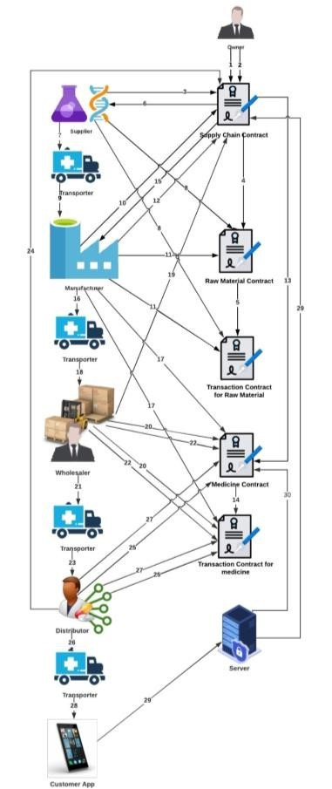

1.The Ethereum Blockchain receives smart contracts from the owner.

2.Chain entities are registered and authenticated by the owner.

3.Supplier registers new Raw Material.

4.Raw Material Contract

deployed for the newly

created raw material.

5.Corresponding Transaction

Contract deployed for the

newly created raw material.

6.Raw material registered

successfully.

7.Supplier transfers raw

material to the Transporter.

8.Supplier updates product

status and creates

Transaction in Transaction

Contract.

9.Transporter transfers raw

Fig3. Process Flow Diagram material to the manufacturer.

10.Manufacturer verifies source of raw material.

11.Manufacturer updates product status and creates

Transaction in Transaction Contract.

12.Manufacturer registers new medicine.

13.Medicine Contract deployed for the newly created

medicine.

14.Corresponding Transaction Contract deployed for the

newly created medicine.

15.Medicine registered successfully.

16.Manufacturer transfers raw material to the Transporter.

17.Manufacturer updates product status and creates

Transaction in Transaction Contract.

18.Transporter transfers raw material to the Wholesaler.

19.Wholesaler verifies source of raw material.

20.Wholesaler updates product status and creates

Transaction in Transaction Contract.

21.Wholesaler transfers raw material to the Transporter.

22.Wholesaler updates product status and creates

Transaction in Transaction Contract.

23.Transporter transfers raw material to the Distributor.

24.Distributor verifies source of raw material.

25.Distributor updates product status and creates

Transaction in Transaction Contract.

26.Distributor transfers raw material to the Transporter.

27.Distributor updates product status and creates

##### V.Results

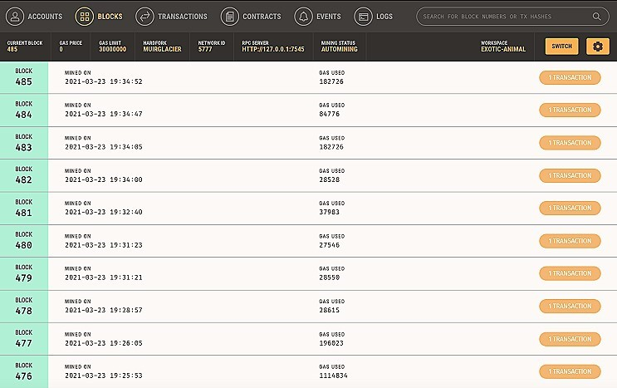

**Fig. 4 – Analysis of local blockchain on Ganache GUI**

An evaluation of the performance of the blockchain was conducted by analyzing the throughput and latency of the blocks that were mined. The results of this analysis provided valuable insights into the efficiency and effectiveness of the blockchain system. shown in Fig. 4.

In evaluating the performance of the system on the Ethereum network, it is essential to consider not only the TPS, but also other factors such as network latency, transaction confirmation times, and scalability. While TPS can provide a good measure of the system's transaction processing capacity, it may not necessarily reflect the real-world performance of the system under different scenarios and workloads. Therefore, it is crucial to conduct comprehensive testing and analysis to understand the strengths and limitations of the system fully. On average, the TPS is between 0.01 to 0.209.

𝑇ℎ𝑟𝑜𝑢𝑔ℎ𝑝𝑢𝑡 = 𝑐𝑎𝑝𝑎𝑐𝑖𝑡𝑦 = 𝑇𝑃𝑆 = (𝑏𝑙𝑜𝑐𝑘 𝑠𝑖𝑧𝑒) ∗ (𝑏𝑙𝑜𝑐𝑘𝑡𝑖𝑚𝑒)  
(1) 𝑇𝑃𝑆 = (𝑡𝑟𝑎𝑛𝑠𝑎𝑐𝑡𝑖𝑜𝑛𝑠 𝑝𝑒𝑟 𝑏𝑙𝑜𝑐𝑘) ∗ (𝑏𝑙𝑜𝑐𝑘 𝑝𝑒𝑟 𝑠𝑒𝑐𝑜𝑛𝑑)  
  
The block time can be described as the interval between the mining of two consecutive blocks on the blockchain network. The block time plays a crucial role in determining the efficiency and speed of the blockchain network. On average, users can expect to wait from 0.01 seconds to 1.07 seconds. The contracts run on a local blockchain provided by Ganache and the client app is connected to the blockchain through Web3.js. A raw material is created by the Supplier and its details are added to the blockchain and given a unique address. A new transaction contract is then deployed, and its address is saved in the Raw Material smart contract.

# VI. Conclusion and future work

This paper proposes a novel approach to addressing the problem of counterfeit drugs in the supply chain by combining blockchain technology. The proposed solution uses smart contracts to ensure that each product transfer is recorded on an immutable ledger, allowing for seamless product tracking as it moves through the supply chain. Furthermore, consumers can help to maintain the system by providing useful product information. The proposed system's decentralised nature eliminates the risk of data tampering, ensuring the accuracy and integrity of the data. The proposed solution is easily accessible due to its implementation as a DApp using Ganache's popular Truffle framework and local blockchain, as well as a user-friendly web app interface.

##### References

[1] Jamil, F.; Hang, L.; Kim, K.; Kim, D. "A Novel Medical Blockchain Model for Drug Supply Chain Integrity Management in a Smart Hospital". Electronics 2019. 8. 505.

[2] A.S. K. Pathan, R. R. Jadhav and P. S. Karde, "Traceability of counterfeit medicine supply chain through Blockchain," 2019 11th International Conference on Communication Systems & Networks (COMSNETS), Bengaluru, India, 2019, pp. 534-537, doi: 10.1109/COMSNETS.2019.8711418.

[3] P. S. Pokharkar, M. B. Pokharkar and P. S. Prachi, "Traceability and detection of the counterfeit medicine supply chain through Blockchain," in Jaihind Journal of Engineering, vol. 21, no. 8, pp. 277-282, Nov. 2019, doi: 10.5281/zenodo.3510208.  
  
  
[4] Jen-Hung Tseng, Yen-Chih Liao, Bin Chong, and Shih-wei Liao, "Governance on the Drug Supply Chain via Gcoin Blockchain," in IEEE Access, vol. 8, pp. 189491-189500, 2020, doi: 10.1109/ACCESS.2020.3038824.  
  
[5] M. A. Engelhardt, "Hitching Healthcare to the Chain: An Introduction to Blockchain Technology in the Healthcare Sector," in IEEE Potentials, vol. 36, no. 5, pp. 14-17, Sept.-Oct. 2017, doi: 10.1109/MPOT.2017.2709058.

[6] M. Mettler, "Blockchain technology in healthcare: The revolution starts here," in Proceedings of the 2016 IEEE 18th International Conference on e-Health Networking, Applications and Services (Healthcom), Munich, Germany, 14-17 September 2016, pp. 1-3, doi: 10.1109/HealthCom.2016.7749462.  
  
[7] A. O'Hagan and A. Garlington, "Counterfeit drugs and the online pharmaceutical trade, a threat to public safety," Forensic Research & Criminology International Journal, vol. 6, no. 3, pp. 191-193, 2018, doi: 10.15406/frcij.2018.06.00208.

[8]   
  
[9] R. Kamal, A. Dhanasekaran, and N. Kumar, "A Secure Blockchain-Based Drug Supply Chain Management System," in 2021 International Conference on Advances in Computing, Communications and Informatics, 2021, pp. 454-459.