REPORT  
 On

WEB

DEVELOPMENT

**E-COMMERCE WEBSITE**



**Submitted by: Submitted to:**

TUSHAR SAXENA Mr. Anand Prakash Gupta

(171500361) Computer Science Department

RIYA NARAIN

(171500264)

# INTRODUCTION OF THE **IDEA**

We know that the [growth of online business](https://360.shiprocket.in/blog/ecommerce-growth-india-market-research-stats/) worldwide is significantly faster and higher as compared to traditional businesses. The success of eCommerce businesses has been so impacting that even established business houses have started online selling as a complementary effort in their business.

Similarly, we thought of a business idea and wanted to start directly from the web. And through web development and marketing on the platform, we wanted to design a eCommerce website.

This website will aim at the general ecommerce website services, that is connecting suppliers/vendors and customers but at the same time it’ll offer the users an efficient way to order tgeir products!Also we will provide a massdrop service from time to time according to users interest.

[](https://pixabay.com/vectors/positive-thinking-creative-brain-3616556/)

TECHNOLOGIES USED

1. HTML
2. CSS
3. JAVASCRIPT
4. PHP
5. SQL

COMPONENTS OF WEBSITE

* E-Commerce website/portal
* Sign-up/login with customer database
* Products, interests according to user
* Sales/Orders/Shipments page
* Coupons/discount management
* Page details/blogs/sponsors

# TARGET AUDIENCES:

Target audience will be based upon interests, products marketed, advertisements, emails which will direct the audience to our website. Audiences will also be targeted through sales and coupons. We will be also including a payment gateway on our website for conversions.

# FUTURE SCOPE:

The website will be collecting data according to user interest through which we will improve our feature of mass drop. We will also be linking it to Google Analytics which will provide us with a complete analysis of the website along with the implemented funnels, conversion rate, bounce rate etc which will help us improve the website.

# PROBLEM DEFINITION

We see websites making money by just showing how they can sell products a lower costs.

The base reason behind this is that these companies give huge orders to the manufacturers that in turn gift them the low cost price that these sellers sell on their own terms and prices at what they want.

This website allows the customer to efficiently buy at a cheap rate and hence they are benefitted from our services.

# **OBJECTIVE**

The war for lower price for customers ends. Customers decide the price for the product. The more orders results manufacturer to lower their selling prices and hence lower cost to the customers. The main objective of the ideology of the website is to provide options to customers to allow them to make bold choices and get product on a much lower prices.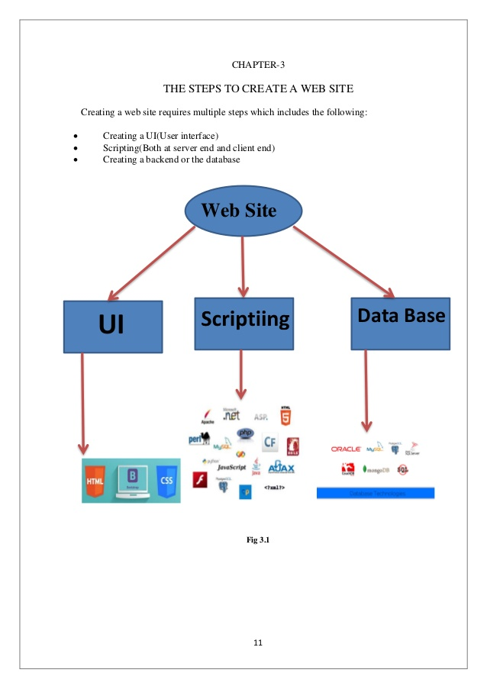

# 

# 

UI Development:

<HTML 5>:

**Hypertext Markup Language** (**HTML**) is the standard [markup language](https://en.wikipedia.org/wiki/Markup_language) for creating [web pages](https://en.wikipedia.org/wiki/Web_page) and [web applications](https://en.wikipedia.org/wiki/Web_application). With [Cascading Style Sheets](https://en.wikipedia.org/wiki/Cascading_Style_Sheets) (CSS) and [JavaScript](https://en.wikipedia.org/wiki/JavaScript) it forms a triad of cornerstone technologies for the [World Wide Web](https://en.wikipedia.org/wiki/World_Wide_Web). [Web browsers](https://en.wikipedia.org/wiki/Web_browser) receive HTML documents from a [webserver](https://en.wikipedia.org/wiki/Webserver) or from local storage and render them into multimedia web pages. HTML describes the structure of a web page [semantically](https://en.wikipedia.org/wiki/Semantic) and originally included cues for the appearance of the document.

[HTML elements](https://en.wikipedia.org/wiki/HTML_element) are the building blocks of HTML pages. With HTML constructs, [images](https://en.wikipedia.org/wiki/Img_(HTML_element)) and other objects, such as [interactive forms,](https://en.wikipedia.org/wiki/Fieldset) may be embedded into the rendered page. It provides a means to create [structured documents](https://en.wikipedia.org/wiki/Structured_document) by denoting structural [semantics](https://en.wikipedia.org/wiki/Semantics) for text such as headings, paragraphs, lists, [links](https://en.wikipedia.org/wiki/Hyperlink), quotes and other items. HTML elements are delineated by tags, written using [angle brackets](https://en.wikipedia.org/wiki/Bracket" \l "Angle_brackets). Tags such as <img /> and <input /> introduce content into the page directly. Others such as <p>...</p> surround and provide information about document text and may include other tags as sub-elements. Browsers do not display the HTML tags, but use them to interpret the content of the page.

HTML can embed programs written in a [scripting language](https://en.wikipedia.org/wiki/Scripting_language) such as [JavaScript](https://en.wikipedia.org/wiki/JavaScript) which affect the behavior and content of web pages. Inclusion of CSS defines the look and layout of content. The [World Wide Web Consortium](https://en.wikipedia.org/wiki/World_Wide_Web_Consortium) (W3C), maintainer of both the HTML and the CSS standards, has encouraged the use of CSS over explicit presentational HTML since 1997.

HTML markup consists of several key components, including those called tags (and their attributes), character-based data types, character references and entity references. HTML tags most commonly come in pairs like <h1> and </h1>, although some represent empty elements and so are unpaired, for example <img>. The first tag in such a pair is the start tag, and the second is the end tag (they are also called opening tags and closing tags).

Another important component is the HTML [document type declaration](https://en.wikipedia.org/wiki/Document_type_declaration), which triggers [standards mode](https://en.wikipedia.org/wiki/Standards_mode) rendering.

The following is an example of the classic [Hello world program,](https://en.wikipedia.org/wiki/Hello_world_program) a common test employed for comparing [programming languages](https://en.wikipedia.org/wiki/Programming_language), [scripting languages](https://en.wikipedia.org/wiki/Scripting_language) and [markup languages](https://en.wikipedia.org/wiki/Markup_language). This example is made using 9 [lines of code](https://en.wikipedia.org/wiki/Lines_of_code):

### General Syntax of HTML

<!DOCTYPE html>

<html>

<head>

<title>This is a title</title>

</head>

<body>

<p>Hello world!</p>

</body>

</html>

(The text between <html> and </html> describes the web page, and the text between <body> and </body> is the visible page content. The markup text "<title>This is a title</title>" defines the browser page title.)

The Document Type Declaration <!DOCTYPE html> is for HTML5. If a declaration is not included, various browsers will revert to "[quirks mode](https://en.wikipedia.org/wiki/Quirks_mode)" for rendering.

Css:

**Cascading Style Sheets** (**CSS**) is a [style sheet language](https://en.wikipedia.org/wiki/Style_sheet_language) used for describing the [presentation](https://en.wikipedia.org/wiki/Presentation_semantics) of a document written in a [markup language](https://en.wikipedia.org/wiki/Markup_language). Although most often used to set the visual style of [web pages](https://en.wikipedia.org/wiki/Web_page) and user interfaces written in [HTML](https://en.wikipedia.org/wiki/HTML) and [XHTML](https://en.wikipedia.org/wiki/XHTML), the language can be applied to any [XML](https://en.wikipedia.org/wiki/XML) document, including [plain XML](https://en.wikipedia.org/wiki/Plain_Old_XML), [SVG](https://en.wikipedia.org/wiki/Scalable_Vector_Graphics) and [XUL](https://en.wikipedia.org/wiki/XUL), and is applicable to rendering in [speech](https://en.wikipedia.org/wiki/Speech_synthesis), or on other media. Along with HTML and [JavaScript](https://en.wikipedia.org/wiki/JavaScript), CSS is a cornerstone technology used by most websites to create visually engaging webpages, user interfaces for [web applications](https://en.wikipedia.org/wiki/Web_applications), and user interfaces for many mobile applications.

CSS is designed primarily to enable the separation of presentation and content, including aspects such as the [layout](https://en.wikipedia.org/wiki/Page_layout), [colors](https://en.wikipedia.org/wiki/Color), and [fonts](https://en.wikipedia.org/wiki/Typeface). This separation can improve content [accessibility](https://en.wikipedia.org/wiki/Accessibility), provide more flexibility and control in the specification of presentation characteristics, enable multiple HTML pages to share formatting by specifying the relevant CSS in a separate .css file, and reduce complexity and repetition in the structural content.

Separation of formatting and content makes it possible to present the same markup page in different styles for different rendering methods, such as on-screen, in print, by voice (via speech-based browser or [screen reader](https://en.wikipedia.org/wiki/Screen_reader)), and on [Braille-based](https://en.wikipedia.org/wiki/Braille_display) tactile devices. It can also display the web page differently depending on the screen size or viewing device. Readers can also specify a different style sheet, such as a CSS file stored on their own computer, to override the one the author specified.

Changes to the [graphic design](https://en.wikipedia.org/wiki/Graphic_design) of a document (or hundreds of documents) can be applied quickly and easily, by editing a few lines in the CSS file they use, rather than by changing markup in the documents.

The CSS specification describes a priority scheme to determine which style rules apply if more than one rule matches against a particular element. In this so-called cascade, priorities (or weights) are calculated and assigned to rules, so that the results are predictable.

The CSS specifications are maintained by the [World Wide Web Consortium](https://en.wikipedia.org/wiki/World_Wide_Web_Consortium) (W3C). Internet media type ([MIME type](https://en.wikipedia.org/wiki/MIME_media_type)) text/css is registered for use with CSS by [RFC 2318](https://tools.ietf.org/html/rfc2318) (March 1998). The W3C operates a free [CSS validation service](https://en.wikipedia.org/wiki/W3C_Markup_Validation_Service" \l "CSS_validation) for CSS documents.

#### **Types of CSS:**

* Inline CSS:

In this CSS is applied in between the tags

* Internal CSS:

Eg: <tag style=”styling”>Hello World</tag>

In this Thecss code is defined inside the style tag in the head section of the HTML page.

#### **General Syntax:**

<html>

<head>

<style>

<! -- CSS STYLING -- >

</style>

</head>

</html>

* External CSS:

In this the CSS code is written on another page and is linked to the HTML page. It is advantageous to use this type of styling as we can use the same file to style various HTML pages.

External CSS uses the extension .css and is applied using the following syntax

<html>

<head>

<link relation=”stylesheet” type=”css” href=”url to the page”>

</head>

</html>

All the CSS style types are important but can be used in different situations.

* Inline CSS is used when only small changes are to be done to the HTML tag and the changes are to be reflected only to that specific tag
* Internal CSS is used when the individual HTML pages have to be designed differently. This also slows the page load system if the internal styling is long.
* External CSS files are maintained to design multiple pages and use common styles over various pages. It is useful as it helps in managing the resources in an easy manner.

*Both HTML and CSS are used to create a UI but CSS behaves like a makeup on the face of an actress which makes her look even more beautiful than she is in reality.*

Screenshots



