Digital Design Verification & Simulation Report
Implementation, Trace Analysis & Waveform Verification
Section 1: 4-Request Round-Robin Arbiter
Arbitration manages shared resource access when multiple masters request access simultaneously. Fixed-priority schemes often cause starvation for lower-priority requesters. A round-robin arbiter fixes this by shifting priority after every granted request, giving every master equal access over time.
Operation & State Machine Mechanics
The design monitors 4 active-high request lines, req[3:0], and drives a 4-bit one-hot grant vector, gnt[3:0]. Only one requester gets granted per clock cycle.
1. Combinational Grant Evaluation: A 2-bit priority register points to the current top-priority requester (0 to 3). The grant block checks requests starting at this priority index and grants the first active request found.
2. Priority Rotation: When a grant is issued, the priority register updates on the next positive clock edge to point to the position right after the granted index. For example, granting requester 1 sets priority to 2 for the next cycle.
Simulation & Waveform Verification
The simulation (captured in rra.vcd) verifies two primary behaviors:
- Exhaustive Combination Search: Evaluates all 16 request states (from 4'b0000 to 4'b1111) to confirm valid one-hot output generation.
- Priority Cycling under Heavy Load: With all requests held high (req = 4'b1111), gnt cycles continuously through 4'b0001 -> 4'b0010 -> 4'b0100 -> 4'b1000. Priority updates smoothly every clock cycle without lockups or skipped steps.
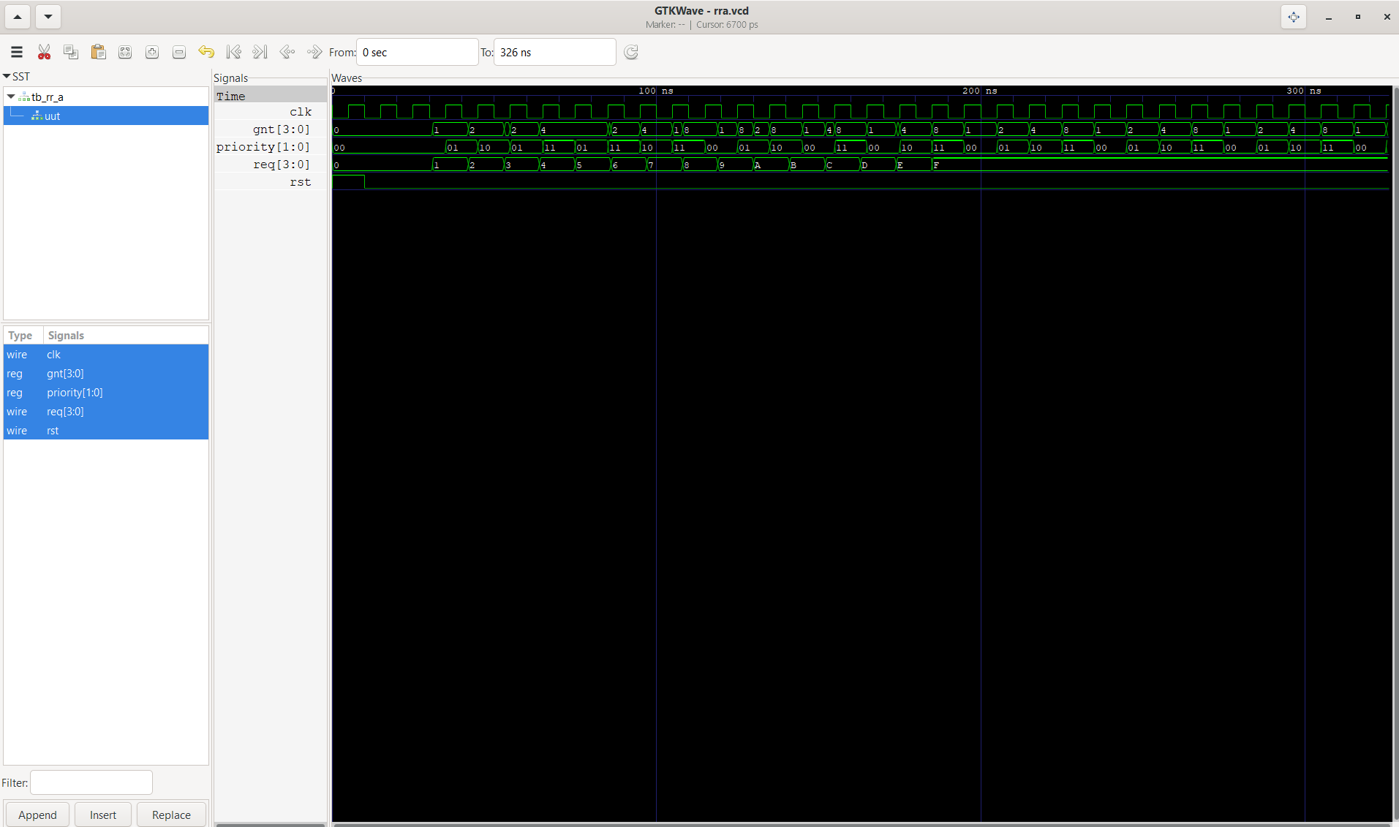
Section 2: Optimized Multiplier
Standard shift-and-add multipliers use an accumulator alongside separate registers for the multiplicand and multiplier. This architecture optimizes area by storing the partial product sum and the remaining multiplier bits inside a single combined register, CAQ.
Architectural Details
For 4-bit operands (M and Q):
- CAQ Register (9-bit): {C (1 bit), A (4 bits), Q (4 bits)}.
- At reset, A is cleared to 0, Q gets the multiplier, and C is set to 0.
- Each cycle checks CAQ[0] (the lowest bit of Q). If it is 1, M is added to A, and the combined {C, A, Q} vector shifts right by 1 bit. If it is 0, no addition occurs and {C, A, Q} simply shifts right.
- After 4 clock cycles, the 8-bit result is ready in the {A, Q} fields, and a done flag goes high.
Manual Trace Computations
Computation 1: 11 x 7 = 77 (M = 1011, Q = 0111)
Cycle | Step / Action | C | A | Q | Operation Description
Init | Reset State | 0 | 0000 | 0111 | Load Q=0111 (7), M=1011 (11)
1 | Add & Shift | 0 | 0101 | 1011 | Q[0]=1 -> A+M=1011 -> Shift right
2 | Add & Shift | 0 | 1000 | 0101 | Q[0]=1 -> A+M=1100 -> Shift right
3 | Add & Shift | 0 | 1001 | 1010 | Q[0]=1 -> A+M=1011 -> Shift right
4 | No Add, Shift | 0 | 0100 | 1101 | Q[0]=0 -> Shift right -> Final P = 01001101 (77)

Computation 2: 6 x 9 = 54 (M = 0110, Q = 1001)
Cycle | Step / Action | C | A | Q | Operation Description
Init | Reset State | 0 | 0000 | 1001 | Load Q=1001 (9), M=0110 (6)
1 | Add & Shift | 0 | 0011 | 0100 | Q[0]=1 -> A+M=0110 -> Shift right
2 | No Add, Shift | 0 | 0001 | 1010 | Q[0]=0 -> Shift right
3 | No Add, Shift | 0 | 0000 | 1101 | Q[0]=0 -> Shift right
4 | Add & Shift | 0 | 0011 | 0110 | Q[0]=1 -> A+M=0110 -> Shift right -> Final P = 00110110 (54)
Simulation & Waveform Verification
The opt_mult.vcd simulation verifies these step-by-step traces. In GTKWave, CAQ shifts every clock edge, count increments from 0 to 4, and done pulses high on completion while P displays the expected product output.
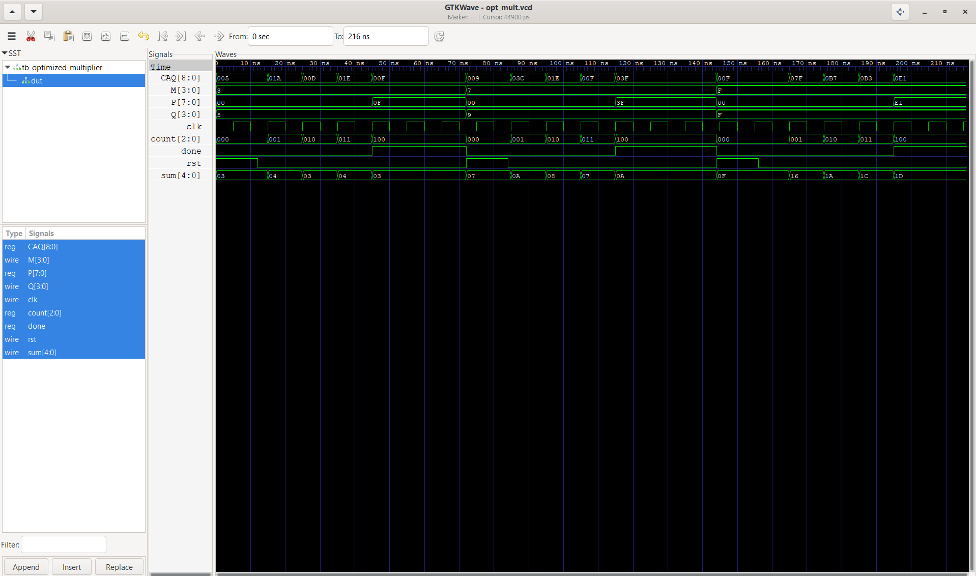
Section 3: Configurable 128-bit SIMD Add/Sub Unit
SIMD (Single Instruction, Multiple Data) architectures increase throughput by processing multiple data lanes in parallel using a wide datapath. This design implements a configurable 128-bit execution unit that handles additions and subtractions across flexible lane widths.
Supported Configurations
- 8-bit mode (mode = 2'b00): Splits the 128-bit datapath into 16 parallel 8-bit sub-units.
- 16-bit mode (mode = 2'b01): Splits the 128-bit datapath into 8 parallel 16-bit sub-units.
- 32-bit mode (mode = 2'b10): Splits the 128-bit datapath into 4 parallel 32-bit sub-units.
Saturating Arithmetic Mechanism
Standard fixed-width operations wrap around on overflow or underflow. This module uses saturating logic instead:
- Overflow on Addition (op = 0): If the sum exceeds the lane width max (0xFF, 0xFFFF, or 0xFFFFFFFF), the output clamps to that maximum value.
- Underflow on Subtraction (op = 1): If the result drops below zero, the output clamps to 0x0 instead of wrapping around to a large value.
Simulation & Waveform Verification
The simd.vcd waveform capture shows correct output across all test cases:
- Mode 00 (8-bit): Clamps to 8'hFF on addition overflow and 8'h00 on subtraction underflow across all 16 lanes.
- Mode 01 (16-bit): Clamps to 16'hFFFF on addition overflow and 16'h0000 on subtraction underflow across all 8 lanes.
- Mode 10 (32-bit): Clamps to 32'hFFFFFFFF on addition overflow and 32'h00000000 on subtraction underflow across all 4 lanes.
