Resume
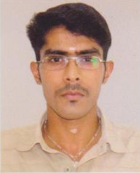
Personal data:
Name: Sarath P Mohan
Birth date: 31 of May 1990
Birth place: Kerala, India
Marital status: Single
Address: Lekshmi Nivas, Punnassery, Bharathannoor.
Bharathannoor P.O
Thiruvananthapuram District,
Kerala, India.
PIN CODE: 695609
Means of contact:
Mob: 9833847241
E-mail: spmaeronautics@gmail.com

Academic Qualifications:

• Passed high school from Higher Secondary School GHSS KALLARA in India.

• Under Graduate degree in Aeronautical Engineering from the Aeronautical Society of India with First Class

• Pursuing M. Tech in Aerospace in propulsion specialization with cpi of 7.85

Supporting Courses:
• Computer Aided Three Dimensional Interactive Application Version 5 (CATIA )
Part Design /Assembly / W.F / SM / INT.D /GSM. Analysis up to 2.5 L
Nodes / FEM / 2D and 3D Solid / Surface Meshing.

• Has undergone training in ANSYS Structural / Thermal.
Familiarization with element choice Meshing / Transient Analysis.

Communication Skills:

• Well versed in Native and Regional languages. Good oral and written skills in
English.

Extra-Curricular Activities:
- Play Cricket, Foot Ball.
- Worked in Tech Fest.
- Volunteer in Entrepreneurship cell.

