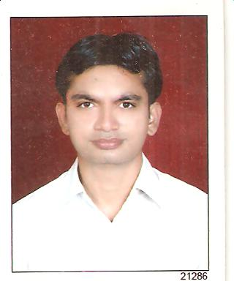
PUNIT KUMAR

E-mail: kumar.puniteck@gmail.com
Mobile: +91-9413731691
+91-9680698636

OBJECTIVE

To learn and function effectively in an organization and be able to deliver to the bottom-line. To constantly upgrade my knowledge and skills and make a difference in whatever I do.

ACADMIC DETAIL

Examination | University/Board | Institute | Stream | Year of Passing | Percentage of Marks (%) Aggregate
B.E | University of Rajasthan, Jaipur | Engineering College, Kota | Electronic Instrumentation & Control Engineering | 2005-2009 | 64.45
Intermediate/+2 | Board of Secondary Education, Rajasthan | Govt. Sr. Sec.School Loonkaransar,Bikaner Rajasthan | Science Math’s | 2003 | 62.77
Matriculation | Board of Secondary Education, Rajasthan | Govt. Sr. Sec. School Loonkaransar,Bikaner Rajasthan | -------- | 2001 | 61.83

TECHNICAL SKILLS

- PLC PROGRAMING
- MATLAB
- MS OFFICE, C,C++ LANGAUGE
- OPRATING SYSTEM :- Windows

PROJECT AND TRAINING UNDERTAKEN

PROJECT
- Design of Optimal Fuzzy PID Controller using MAT LAB

TRAINING
Site : SHRIRAM RAYONS, KOTA
Duration : 40 days (20 Jul 2008 – 30 AUG 2008)
Description : Industrial application of Instrumentation & Control engineering

Site : QUICK LOGIC CONTROL, PUNCHKULA
Duration : 30 days (June 2007 to July 2007)
Description : Basics of PLC and Industrial Automation

EXTRACURRICULAR ACTIVITY

Organizational Participation
- Student volunteer “Annual function” in I st year of engineering
- Student Coordinator of an event on “Share market” in IIIrd year of engineering
- Committee Head of ‘Day Events’ in “Annual Function” in Final year of Engineering

Social
- Blood donated Three times
Presentation
- Paper presentation on Biodiesel

PERSONAL DETAIL

Father’s Name : Mr. Ruparam Verma
Date of Birth : DEC 10, 1987
Nationality : Indian
Sex : Male
Marital status : Single
Languages Know : English, Hindi.
Hobbies : Reading Newspaper, Photography, Traveling
Strength : Team member, Quick learner.
Weakness : Over Optimistic, Restless
Like : Responsible about works, Communicate with everyone, Honesty
Dislike : Irresponsibility about work, Dishonesty.
Permanent add. : Roop Auto Electric Works
Near Bus Stand, NH-15
Loonkaransar, Bikaner
Rajasthan

DECLARATION

I do here by declare that the particulars of information and facts stated herein above are true, correct and complete to the best of my knowledge and belief.

PLACE: BIKANER Punit Kumar
DATE: ___________

