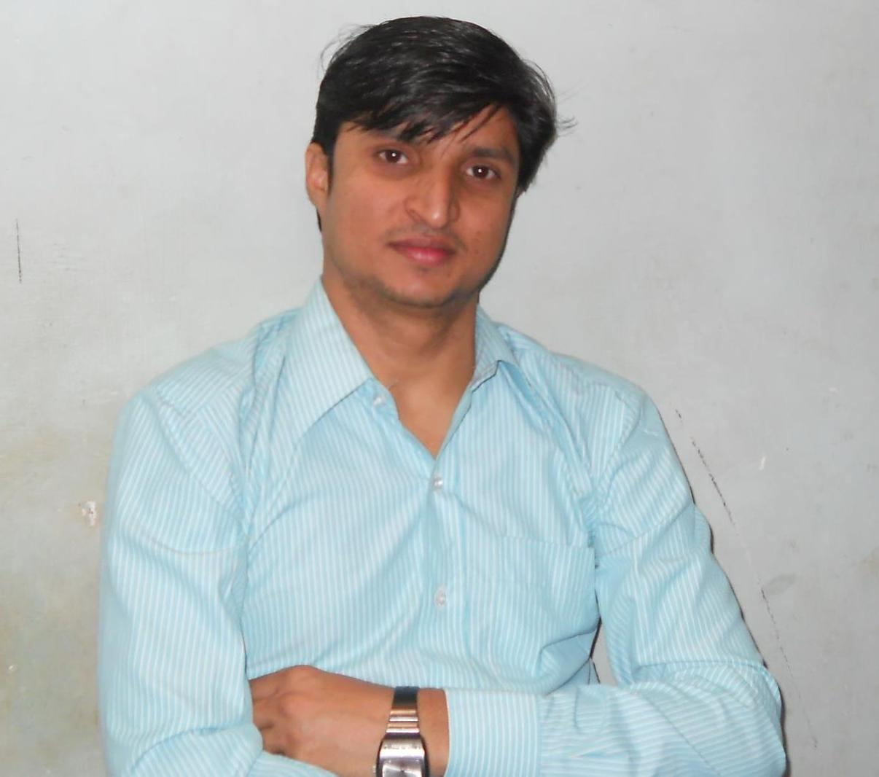
Vijay Bhan Sharma
M-09757417682 E-mail-: vb.sharma87@gmail.com
D.O.B-: 15.08.1987
Objective
Seeking a position, where I can utilise the knowledge, skills, and abilities that I have developed so far and can be an important part in the growth of the organization

Academic Achievements
EXAMINATION | UNIVERSITY | YEAR OF PASSING | %/CPI
M.Tech(MEMS) | IIT Bombay | 2012 | 8.42
PGDBA(Marketing) | SCDL, Pune | 2010 | 60.30
M.Sc.(Chemistry) | Univ. of Rajasthan | 2007 | 65.00
B.Sc. | Univ. of Rajasthan | 2005 | 69.11
12th | RBSE Ajmer | 2002 | 71.08
10th | RBSE Ajmer | 2000 | 69.33

INDUSTRIAL EXPERIENCE
Hindustan Zinc limited (Vedanta Pvt. Ltd. Co.) at CLZS Chittorgarh Rajasthan (Dec, ‘06- Jul ‘10)
- Certificate training course: Birla Institute of Technology and Science(BITS), Pilani (Feb, 2007)
- Title of course: -Academic development program in basic process engineering
- Modules in course: -Management principle, Financial and Managerial Accounting, Maintenance Management, Workshop practice
- Worked as Process Associate in the Department of Melting & Casting under Cell House SBU
- Handling shift operations, controlling process parameters using DCS to optimise production
- Effective use of 3M, 4P, and 14 management principle to manage the shift operations
- Active member in commissioning team for the construction of 1.7 lac tonnes per annum capacity Zinc plant
- Very good performance grade was awarded in 2009-2010 financial year
POSITIONS OF RESPONSIBILITY
- Coordinator: - Student Alumni Relation Cell (SARC), IIT Bombay (Since Aug, 2011)
- Organiser: - Material Research Symposium (MR 11) (May, 2011)
- Class representative: - Corrosion Science and Engineering, IIT Bombay (2010-2011)
- Membership: - National Association of Corrosion Engineer (NACE) (Since 2010)
- Workshop: -Environmentally Assisted Cracking (Sep, 2010)
AWARDS AND ACHIEVEMENTS
- Rewarded for excellent commitment and dedicated contribution in the commissioning of 1.7 lac tonnes per Annum capacity zinc expansion project at Hindustan Zinc Limited (Jan, 2008)
- Teaching experience: AVVM Sen.secondary school Bharatpur Rajasthan (Jul., 2006-Jul., 2007)
Intellectual Property Right (IPR) workshop (Sep-Oct, 2011)
- Completed Intellectual Property Right (IPR) workshop conducted by Shailesh J. Mehta School of Management IIT Bombay
- Achievements of course: Patent searching and drafting, Copyright, and Trade Design.
KEY ACADEMIC ENDEAVORS
M.Tech Project: Development of thin films for FPDs and sensors using Carbon Nano Tubes (CNTs) and polymer via dip coating and spin coating method (Ongoing)
- Objective: The project aims at generating alternative coating layers of thin film using CNT and polymer by layer by layer (LBL) method
- Methodology: Method involves sequential deposition of alternating layers of CNT and polymer on substrate. Synthesis of some samples of LBL films has been done
- Result: The spatial uniformity, optical transparency and electrical properties of LBL films are to be improved by use of modifiers.
OTHER INFORMATIONS
- Computer proficiency: -SAP, C
- Hobbies: Photography, singing, social services, outdoor games

