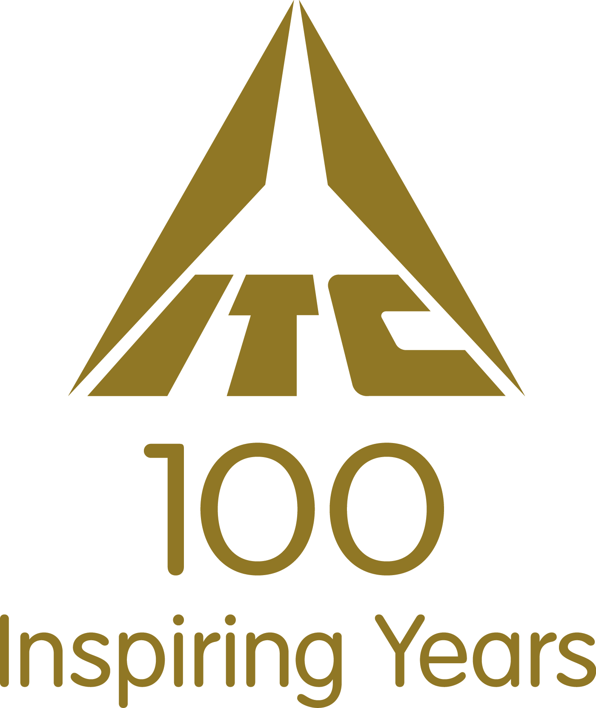

Application form for

SUMMER

PROGRAMME

2013
technical campus

INTERNSHIP

Name: Aditya Jadhav
Date of Birth: Gender: Male
Institute: IIT Bombay Branch: Electrical Engineering Btech/Dual: Dual
Mobile Number:
Permanent Address:4th floor, Gulmohar Building
IIT Bombay
Powai, Mumbai 400076
India
Telephone Number:022-25723548
E-mail ID: training@iitb.ac.in
JEE Rank: 151*

 | Institution/College | Board | Month & Year of passing | %
Class X | IES Manik Vidyamandir | Maharashtra State Board | June 2007 | 89.37
Class XII | D.G.Ruparel College of Science | Maharashtra State Board | June 2009 | 89

Semester | Month & Year of Passing | SPI/SGPA
1 | November 2010 | 7.24/10 | GRE Score
2 | April 2011 | 5.67/10 | CAT Score
3 | November 2011 | 6.25/10 | GMAT Score
4 | April 2011 | 7.03/10
5
6
7
8
CPI/CGPA

Projects/Summer Internships:
Technical Projects :
- Micromouse : Lead a team of 12 batchmates in designing a 2D graphical simulation of a path finding robot game called the Micromouse using C++. (guide: Prf.Dr.D.B.Phatak)
- Spy Bug: Designed a compact very low power FM receiver+transmitteer kit for spying applications.
- Snakes & Ladders : The popular game realised on an 8x8 LED array using only basic logic gates.
- Data analysis by running PCA/ICA simulations on yeast multiplaction.
- Summer Intership at AISEC Mumbai. (April 2011-June 2011)

Extra Curricular Activities:
- Music : Well versed in classical vocals, piano & guitar with numerous awards at school level competitions. Part of the winning band (Hindi & Western both) at Freshiezza 2010
- Debate : Part of the IIT Bombay Speakers' Club & the Debating Club. Awarded certificate of merit at the IIT Bombay Antional Debate consecutively in 2011 & 2012
- Sports : Participated in Football & Badminton throughout school life. Part of the winning football team (Hostel 5) in the inter hostel football championship.

Positions of Responsibility:
- Presently serving as the head of the Mentorship Programme at the Student Alumni Relations Cell of IIT Bombay :
      - Leading a team of six 2nd year students in managing a database of 50,000+ alumni. Contacted over 1500 alumni to enlist their participation in the mentorship programme.
      - Increased student participation from 287 in 2011 to 486 in 2012

2.Coordinator at Techfest 2012 (Hospitality) : Managed the food arrangements for the overseas guests at three different venues during the event.

What are your short term and long term objectives? (Max. 150 Words)

Short Term goals :
1. To improve my CPI
- To gain work exposure at an industry level to better prepare myself & clear my mind of perceptions about working at an established FMCG/Non core company.
- 3. To have a clear idea of the career path I have chosen

Long Term goals :
1. To be the best at what I do

Why do you want to do your summer internship with ITC? (Max 150 Words)

I firmly believe that guidance is the key driving force behind giving a sense of direction & purpose to one's career & life in general. Therefore, having interacted with a broad spectrum of people from my seniors to elders it has come to my knowledge that ITC is a company that invests heavily in its people making them world class professionals in their respective fields managerial or otherwise. After, two years at IIT & having gained experience at relevant positions of responsibility I find myself inclined towards the managerial & people centric areas of an event or organisation. Considering the fairly good people skills & capability of clearly expressing my opinions I have to offer, I believe that working with ITC will give me the right kind of exposure & impetus I seek in my professional life. Hopefully, the benefits will be mutual to both parties.

What do you think is your most significant achievement? Please give reasons for the same. (Max. 150 words)

My younger sister looks up to me & tries to follow my footsteps. I think, doing the best I can to be a good role model for her & inspiring her to better my own academic distinctions is my most significant achievement.

Give an instance where you put Mind Over Matter. (Max. 150 Words)
I think the one time I put mind over matter was when I failed to clear the JEE on my first attempt, but despite the negativity pulled myself up worked hard & achieved my dream
of getting into IIT.

Have you engaged with the community through development activities addressing social or environmental concern? Tell us more about it. (Max. 150 Words)

In general I have a tendency to be forthright about my social opinions. Therefore, throughout school we had campaigns to distribute free necessities like soaps, toothpaste old clothes etc to the Fr.Agnel Ashram at Bandra, Mumbai.
Also, I have worked with Knowledge Academy a non profit JEE coaching centre for economically underprivileged aspirants at Dadar in Mumbai.
Also, at IIT I have been a active campaigner to highlight the health hazards posed by Cell Phone Tower radiation under Prof.Girish Kumar.

KITES – Knowledge, Initiative & Talent Excellence Series is the Summer Internship Programme of ITC Limited, designed to provide budding leaders of tomorrow a stepping board to success

