OBJECTIVE .

To be a successful person and a leader in my discipline and to serve my organization as well as my nation, through my commitment dedication and hard work.

ACADAMIC RECORDS .

UNDER GRADUATION

Course : B.E. Mechanical Engineering.
University : Anna University, Chennai.
College : Erode Sengunthar Engg College,
.
Stream : Regular.
Percentage : 87 % (Gold Medalist)
(Univ. Rank Holder)

H.S.C. : Passed in First class (80.20 %),
Nirmal Vidhyalaya (CGBSE)
Jagdalpur, Chattisgarh.

S.S.L.C : Passed in First class (78.50 %),
Nirmal Vidhyalaya (CGBSE)
Jagdalpur, Chattisgarh.

COMPUTER PROFICIENCY .

Iron CAD
Pro-E
Solid works ( basics)

FIELD OF INTEREST .

Heat Transfer.
Thermodynamics
Design of machine elements.
Strength of Materials.
Theory of Machines

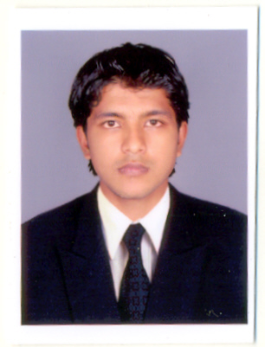
PERSONAL DETAILS

Name : S.Sumeet Jain Father’s Name : Shri Suresh Jain
Mother’s Name : Smt. Meena Jain
Date of Birth : 19-04-1987
Age : 22
Nationality : Indian
Languages Known : Hindi, English & Tamil
Permanent Address

S/O Suresh Jain,
Sagar stores
Main road, Jagdalpur-494 001
Chattisgarh.

Mobile : 09843326301,094255 95911
E-Mail : sureshsumeet@gmail.com

CO-CURRICULAR ACTIVITIES
Presented a paper at International Conference at Indian Institute of science center, Bangalore, entitled
Property analysis of aluminum alloys.
Presented a paper at Rajiv Gandhi memorial college of tech.(A.P.) and won the first prize.
Presented a paper at Adhiyaman Engineering College entitled SWACS and won the second prize.
Presented a paper at S.C.S.V.Mahavidhyalaya, Kaanchipuram entitled Eco-friendly a/c system.
Presented a poster at Kumaraguru College of Tech. entitled sea water a/c system.
Presented a paper at Institute of road and Transport Technology entitled LM6 aluminium property enhancement.
Attended a 3 day Entrepreneurship Awareness Camp at IRTT Erode.
Attended a Workshop on Recent Trends in Energy Conservation at Velalar Engg. College.

PROJECT

Design and fabrication of mechanical type of paper mandrel used in the equipment of CRM at salem steel plant (SAIL).
Design and fabrication of Multiple Drilling Jig.
Design and Analysis of Sea Water Air conditioning system.

EXTRA CURRICULAR ACTIVITIES

Participated in NCC camp conducted at Dharampura, Jagdalpur, with NCC ‘B’ certificate.
Active member of Mech. Engg. Association at ESEC (comparing team)
Active member of Renewable Energy Club.
Member of Indian Institute of Production engineering (student chapter).
Class Committee Member
INPLANT TRAINING

Underwent Training for 17 days in GODLINE TEXTILE PROCESS, Tirupur.

REFERENCE

Mr. R. KUMARAVELAN M.E., Ph.D
Head of the Department
Mechanical Engineering
Erode Sengunthar Engineering College
Erode - 57.

DECLARATION

I hereby declare that the details furnished above are true to the best of my knowledge.

Date : Signature,
Place :. ( )

