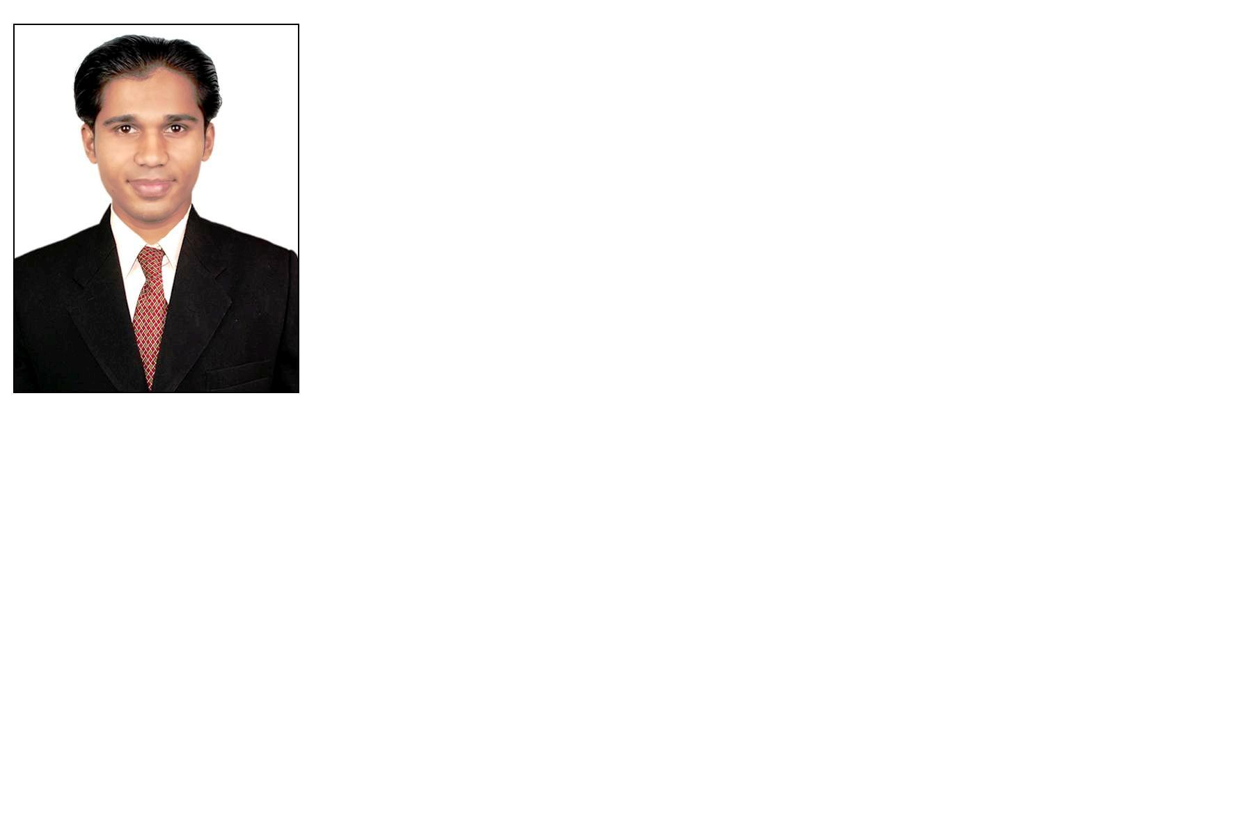
Curriculum Vitae

Carrier Objective:
I want to grow with honesty & dedication to build my carrier in professional field and also want to play a constructive role in the society and nation.

Personal Profile:
Name : Chauhan Mehulkumar Jagubhai
Father’s Name : Chauhan Jagubhai R.
Address : 195-Shreejinagari, Ugat, Jahangirabad, Morabhagal, Rander,
Surat 395005
Telephone No : Mo. +91 8879387394, +919574994074.
E-Mail Address : mehulthemehul@gmail.com
Date of Birth : 21th April 1986
Sex : Male
Marital Status : Single
Nationality : Indian
Languages Known : English, Hindi and Gujarati

Educational Qualification: METALLURGICAL & MATERIALS ENGINEERING Institute: Indus Institute of Technology & Engineering

Qualification | University/Board | Month-Year | Percentage
Metallurgical Engg. & Materials Science (MEMS) Department - Materials Science (MM-1) | IIT Bombay |  | Running study ( 1st year)
B.E. Metallurgical & Materials Engineering | Gujarat University | July -2011 | 66.81 %
Diploma In Metallurgy | T.E.B. | May- 2007 | 65.38 %
S.S.C | G.S.E.B. | March 2001 | 66.86%

SCHOLATIC ACHIEVEMENTS:

Secured All India Rank 131 in GATE-2011 rank with a percentile of 94.28 in final year.

Computer Skills:
I have done Certificate Course in Front Office Management Using Microsoft Office.

Industrial Training:
- Organization : ESSAR STEEL LTD., HAZIRA at Surat
Profile / Details : In Hot Briquetted Iron (HBI) Plant.
Training Duration : 15 days 15th December, 2006 to 31st March, 2007

- Organization : BABULAL KARSANDAS & CO. Vatva, at Ahmadabad
Profile / Details : In Hot Rolling Mill plant
Training Duration : 29th June, 2010 to 16th July, 2010.

Project:
I have done project of “case hardening” &
I have done project of “Heat treatment of EN 31 grade required HRC (60-62)”.

Seminar:
I have done seminar of “Chemical Vapor Deposition."

Workshops:
I have attained workshop on Corrosion.

Model Company:
Essar steel Ltd.

Soft Skills:
Good communication, listening, etiquettes, language skills; positive work ethics, good attitude, personal integrity, desire to learn and be trained and most importantly urge to improve constantly.

Co-curricular Activities and Achievements:
Reiki, Mind power, Chess & Cricket, Etc

Hobbies:
Listening Music, Travelling, Playing Cricket & chess,

Date: 19-Aug-2012
Place: Bombay
Yours faithfully
Mehul J Chauhan.

