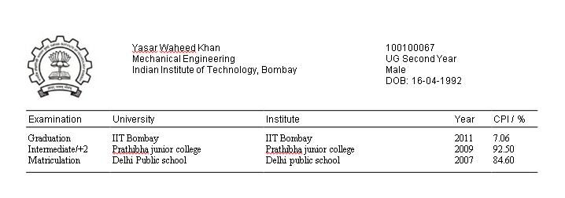

**ACHIEVEMENTS (According to me)**

* Secured All India **Rank 303** in **IITJEE2010.**
* Secured All India Rank **1020** in **AIEEE 2010**.
* Pursuing minor**\*** in the Aerospace engg. Department.
* Worked on the **Hydrogen bubble experiment** during the summer 2011 under **Prof. Amit Agarwal** of Mechanical engg. Department.

**THINGS AND TOPICS I FIND INTERESTING**

* Fluid Mechanics: especially related to air vehicles.
* Engineering drawing: 3D modeling and solid mechanics.
* Programming of mobile and computer apps.
* Quantum mechanics and relativity.
* Air vehicles and its future.
* Playing computer games like CS, DOW, etc.