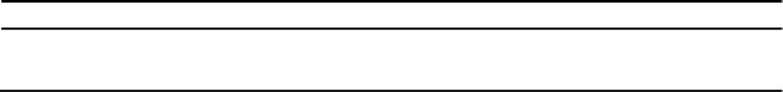

|  |  |  |  |  |
| --- | --- | --- | --- | --- |
| **Examination** | **University** | **Institute** | **Year** | **CPI/%** |
| Graduation | IIT Bombay | IIT Bombay | 2012 | 7.8 |
| Intermediate/+2 | Delhi Public School, RKL | CBSE | 2011 | 84% |
| Matriculation | Delhi Public School, RKL | CBSE | 2009 | 90% |



**OBJECTIVE**

**Tushar Ranjan 110020071**

**Chemical Engineering U.G. Second Year B.Tech. Institute of Technology, Bombay E-mail :** [**tushar.ranjan@iitb.ac.in**](mailto:110020056@iitb.ac.in) **Phone: +919167462655 D.O.B. : 27/09/1993**

• Seeking an internship to augment my engineering knowledge and skills through practical application

**SCHOLASTIC ACHIEVEMENTS**

**ENTRANCE EXAMS**

* Secured **All India Rank 879** in **IIT-JEE 2011** (out of 4.85 lakh students that appeared).
* Secured **All India Rank 1309** in **AIEEE 2011**(out of 11 lakh students that appeared)

**OLYMPIAD**

* Qualified for **Final Round** of **NTSE**
* 4th and 5th National Cyber Olympiad (NCO) by SOF **AIR 158** and **AIR 24** respectively.
* Orissa State Talent Scholarship Exam - **Won gold medal** at school level.
* 8th National Science Olympiad (NSO) by SOF **AIR 75**.
* Unified Cyber Olympiad (UCO) **AIR 19**.
* recd. merit certificate of Merit for being in statewise **TOP 1%** in National Standard Examination in Chemistry (NSEC) organised by association of Chemistry Teachers

**CURRENT**

* Pursuing a minor in **Energy Science And Technology**.

**KEY PROJECTS UNDERTAKEN**

**Technical Projects**

**Remote Controlled Bot [** Autumn 2011]

*Electronics Club Project*

* **Built a robot** which can be controlled by **wireless remote**.
* Studied the function of various IC’s

**Attended PyCon 2011 [**December 2011]

* Attended talks by famous personality in the field of Python
* Attended **Advanced Python Workshop**.
* **Learnt Image Processing** using Python.

**Industrial Training at “Rashtriya Chemicals and Fertilizers Ltd.”** [Jan- Feb 2012]

* Studied the design and working of Sulphuric Acid successfully completed the training programme on **Sulphuric Acid Technology** in Mumbai.
* Created a **report** on the sulphuric acid plant vist.

**RELEVANT COURSES**

Calculus, Transport Phenomenon ,Chemical Engineering Thermodynamics, Energy Economics and Environment, Differential Equations, Solid Mechanics , Data Analysis and Interpretation, Complex Analysis, Modern Physics, Economics, C/C++ Programming

**POSITION OF RESPONSIBILITY**

**Organiser, Techfest 2012**

*Media*

• **Contacted repoters** from renowned newspapers and magazines.

• Escorted reporters and **helped them cover the highlights of techfest**.

**EXTRA CURRICULAR ACHIEVEMENTS**

**Technical Events**

* Actively took part in workshops and events conducted by WnCC (Web and Coding Club) and Elec Club at IIT Bombay.

**Sports**

* Won **medals** in Inter City Swimming Competion
* Was **Captain** of School Basketball Team

**Cultural**

* Took part in **All India Invitational Karate Championship** in Kata/Kumite event organised by Japan karate Association of India.
* Took a course under **NSO** (National Sports Organization) of **Violin** and got a passing grade
* Was a part (prod making) of winning **PAF 2012**(IITB event).

**SOFTWARE SKILLS**

**Programming Languages :** C/C++,HTML, CSS, Javascript ,Python ,JQuery ,SQL

**Software :** Scilab, MS-Office ,Solidworks

**Worked In:** Windows, Linux

**INTERESTS**

* Programming
* Robotics
* Web Design/Development
* Animation/Graphic Design

**Hobbies**

* Basketball
* Swimming
* Table Tennis
* Violin
* Football