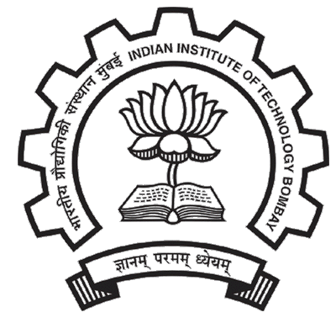 **Indian Institute of Technology, Bombay**

Urvesh Dinesh Patil 11D070008

Electrical Engeneering UG Second Year

Dual Degree(Btech + Mtech) Male

Specialisation: Microelectronics DOB- 06/04/1992



**ACAMADIC DETAILS**

**Examination University Institute Year CPI/%**

Graduation IIT Bombay IIT Bombay 2011 7.45

2012 8.35

(2nd Sem)

Total 1st year 7.91

Intermidate/+2 CBSE DAV Public School,New Panvel 2010 81.4

Matriculation CBSE DAV Public School,New Panvel 2008 92.2

**SCHOLASTIC ACHIEVEMENTS**

* Secured an **AIR 1650 in IIT-JEE '11** given by about 4,85,000 aspirants
* Secured an **AIR 1323 in AIEEE '11** given by 11,18,000 aspirants
* Received **Certificate of Merit** in **Dr. Homi Bhabha Balvaidnyanik Competition**

**PROJECT ACCOMPLISHMENTS**

* **IIT Bombay Racing** [August 2012-Till date]
* **Junior Design Engineer,** electronics. Working towards designing and manufacturing of **Electric Formula One car for Formula Student UK 2013**
* Working under **Sensors and Data Acquisition Subsystem** which involves data logging for car testing and tuning using different sensors. The data is filtered and processed using Microcontroller and wirelessly relayed to a remote laptop
* **Communication Using LASER** [May 2012-June2012]
* Developed a system to transmit data using LASER as a part of Institute Technical Summer projects
* File and real time transmission of data was achieved which was tested over a distance of 40 meters
* Auto adjustment of receiver laser and sensor using servo motors
* It was developed using Arduino and Processing



**TECHNICAL SKILLS**

* Coding: **C++,** Arduino, Processing
* OS: Windows 9x to 7, Linux (Ubuntu)
* Others: EAGLE, LTspice, Solid Works (elementary), Matlab (elementary), Sony Vegas, Adobe Photoshop, MS Office



**POSITIONS OF RESPONSIBILITY**

* **Technical Mentor** under Student Technical Activity Body (STAB) for freshmen
* Guided freshmen in making their bots for technical competitions organised by STAB
* **Co-ordinator** for Mood Indigo '12, Asia’s largest cultural festival: [May '12 - Till Date]
* Active member of the organizing team for the Street Performances
* In talks with various international escape artists
* **Co-ordinator** for Techfest '12, Asia’s largest technical festival: [Dec '11 - Jan '12]
* Actively involved in organizing **Exhibitions**
* In talks with various exhibitors



**EXTRA CURRICULAR ACTIVITIES**

* **Technical Activities**
* Designed and fabricated an **autonomous line following bot** for the event organized by the Electronics Club of IIT Bombay
* Designed and fabricated a **remote controlled car** for the ‘Tech one’ event organized by the Robotics Club of IIT Bombay
* **Literary and Cultural Activities**
* Passed 1st three out of seven exams by Gandharva mahavidyalay in Tabla
* Represented school in various national level quizzes
* **Others**
* Other interests include literature, Music
* Volunteered in **National Service Scheme** in Events from July 2011 to April 2012
* Secured second position in shortput at district level



**COURSES** (I would have completed following course by the end of Spring 2012)

* **Core Courses**
* Introduction to electrical systems
* Introduction to electronics
* Electronic devices
* Network theory
* Electronic Devices Lab
* **Non-Core Courses**
* Chemistry, Electricity and Magnetism, Linear Algebra, Differential Equations, Calculus, Economics, Mathematical Structures for Systems and Controls, Measurements Lab, Computer Programming and Utilisation