Submitted TO: Submitted by:

Mohammed Hussain Tushar Singh

Infosys

Introduction
The Grievance Management System is a dynamic and user-friendly platform designed to address and resolve grievances effectively within an organization or institution. The system aims to simplify the process of submitting, tracking, and resolving grievances by providing a structured workflow and ensuring accountability at every stage. It caters to the needs of users, administrators, and managers, promoting transparency and trust through systematic grievance handling.
In today’s fast-paced environment, grievances can often be overlooked or delayed due to manual handling. This system digitizes and automates the process, reducing the time taken to resolve issues and ensuring that no grievance goes unnoticed.

Objectives
- Efficient Grievance Submission: Allow users to submit grievances with relevant details effortlessly.
- Role-Based Management: Provide specific roles and functionalities for users, administrators, and managers.
- Tracking and Updates: Enable users to track the status of their grievances in real time.
- Transparency and Accountability: Build trust by maintaining clear communication between users and administrators.
This system is especially beneficial for organizations where large volumes of grievances are reported, ensuring that every issue is addressed promptly.

Significance
The Grievance Management System significantly improves grievance resolution processes in organizations. It ensures:
- Timely Resolutions: Automated workflows reduce delays in addressing grievances.
- Enhanced User Experience: A streamlined process makes it easier for users to lodge and track grievances.
- Organizational Growth: The system promotes fairness and enhances employee or customer satisfaction, leading to better organizational outcomes.
By implementing this system, organizations can foster a culture of openness and responsiveness, addressing the concerns of their stakeholders efficiently.

Project Scope
The Grievance Management System was designed to address the needs of organizations that require an efficient, transparent, and automated way to manage grievances submitted by users. The system aims to provide users, administrators, and managers with a structured platform for handling grievances, ensuring that issues are resolved in a timely and transparent manner.

Included in the Project:
- User Registration and Authentication:
  - A secure registration and login system where users can create accounts, authenticate, and access the platform based on their roles (user, admin).
  - Password recovery functionality to assist users who forget their login credentials.
- Grievance Submission:
  - Users can submit grievances with detailed descriptions, priority levels, and attachments (if necessary).
  - Grievances can be categorized (e.g., technical issues, service complaints, etc.).
- Role-Based Access Control (RBAC):
  - Users, administrators, and managers have specific roles and permissions, ensuring data security and privacy.
  - Admins can view and manage all grievances, update statuses, and assign issues to managers for resolution.
  - Managers can update grievance statuses and add comments regarding the progress of resolutions.
- Grievance Tracking:
  - Real-time tracking of grievance statuses by users, providing updates on the progress and resolution timelines.
  - Notification system for users to receive alerts when their grievance status changes or if additional information is required.
- Admin Dashboard:
  - Admins have access to a comprehensive dashboard to manage users, grievances, and overall system settings.
  - Provides analytical tools for admins to view statistics such as the number of grievances, the time taken for resolution, and status breakdowns.
- Grievance Resolution Workflow:
  - A structured workflow that guides grievances from submission to resolution. Each grievance moves through stages, such as "Open," "In Progress," and "Resolved."
  - Resolution notes are added by administrators or managers, and users are notified once their grievance is resolved.
- Reporting and Analytics:
  - Admins can generate reports based on grievance data, such as unresolved grievances, grievance type analysis, and average resolution times.
  - Statistical analysis of grievance trends to help improve organizational processes and identify recurring issues.
- Data Security:
  - Ensuring that sensitive data, such as user information and grievance details, are securely stored and managed.
  - Adherence to encryption standards and secure authentication mechanisms to protect user privacy.

Excluded from the Project:
While the project covers essential grievance management functionalities, several features were excluded from its scope due to time and resource constraints:
- Mobile Application:
  - A mobile version of the platform for iOS/Android was excluded. The system is currently web-based, with no plans for native mobile applications.
- AI-Powered Grievance Categorization:
  - While future enhancements may include AI to automatically categorize grievances, this functionality was not included in the initial version.
- Advanced Analytics and Machine Learning:
  - Predictive analytics or machine learning models to assess grievance patterns and predict future issues were not part of the project scope.
- Multiple Language Support:
  - Although the platform could benefit from multilingual capabilities, this feature was not developed in the current iteration, limiting access to users who speak different languages.
- Complex Workflow Automation:
  - Automation of certain complex workflows, like auto-routing grievances to different departments based on keywords or severity, was not included.

- Real-Time Chat Support:
  - Integration of a real-time chat feature for users to directly communicate with support staff was excluded from the project.

- Third-Party Integrations:
  - The system does not integrate with other external platforms (e.g., CRM systems, email services) in this version.

Limitations and Constraints:
- Limited User Roles
  - The system supports basic user roles: Users, Admins, and Managers. However, in a larger organization with more specific roles (e.g., departments), the system may require further role customization.
- Scalability:
  - Although the system is designed to handle moderate amounts of data, scalability was not a primary focus. The system may face performance issues when handling a significantly larger user base or a high number of grievances.
- Internet Dependency:
  - The platform requires an active internet connection for accessing and submitting grievances. Offline functionality is not supported in this version.
- Limited Notification System:
  - The notification system is limited to email notifications only. In future versions, it would be ideal to implement push notifications or SMS alerts for real-time updates.
- Security Considerations:
  - Although the system follows industry-standard security practices, future development may include more advanced features such as two-factor authentication (2FA) for enhanced security.
- User Interface Customization:
  - The system does not offer extensive customization options for users or administrators. It provides a fixed set of features and UI design elements.
- Support for External Grievance Reporting Channels:
  - Currently, grievances can only be submitted via the platform's web interface. Integration with external reporting channels, such as social media or email, was not implemented.

Requirements
The Grievance Management System has been designed to meet both functional and non-functional requirements, which are crucial for its successful implementation and operation. These requirements ensure that the system serves its intended purpose of efficiently managing grievances while providing a smooth and reliable experience for its users.

Functional Requirements:
- User Registration and Authentication:
  - FR1: Users must be able to register on the platform by providing their personal details (name, email, password).
  - FR2: Users should be able to log in using their registered credentials (email and password).
  - FR3: Password recovery functionality must be implemented, allowing users to reset their password through their registered email.
  - FR4: Admins should have the ability to manage user accounts, including the ability to deactivate or activate user accounts.
- Grievance Submission:
  - FR5: Users should be able to submit grievances via an online form with fields for grievance category, description, priority, and relevant attachments.
  - FR6: The grievance form should allow users to select predefined categories (e.g., Technical Issue, Service Complaint) to classify their issues.
  - FR7: A field for a detailed description must be available for users to provide necessary context or details regarding the grievance.
  - FR8: Users should be able to upload supporting documents or screenshots as attachments to their grievance.
- Role-Based Access Control (RBAC):
  - FR9: The system must support three roles: User, Admin, and Manager, each with specific permissions.
  - FR10: Admins can view and manage all grievances, including assigning grievances to managers or other admins.
  - FR11: Managers can update the status of grievances (e.g., In Progress, Resolved) and provide resolution notes.
  - FR12: Users can only view and track their own grievances, but they should be able to see their grievance status and resolution history.
- Grievance Tracking:
  - FR13: Users should be able to track the status of their grievances (e.g., Open, In Progress, Resolved).
  - FR14: The system must notify users about status updates through email.
  - FR15: Admins and managers should have a dashboard that displays all grievances and their current statuses.
- Admin Dashboard:
  - FR16: Admins should have access to a comprehensive dashboard to view and manage grievances, users, and system settings.
  - FR17: The dashboard should include filters to view grievances by date, category, priority, or status.
  - FR18: Admins should be able to generate reports on grievance statistics (e.g., number of unresolved grievances, average resolution time).
- Grievance Resolution Workflow:
  - FR19: Grievances must follow a structured workflow: Submitted → Assigned → In Progress → Resolved → Closed.
  - FR20: Each status change should be documented, including timestamps and user comments.
  - FR21: Resolved grievances should be marked as “Closed” after confirmation from the user.
- Notifications:
  - FR22: The system must send email notifications when a grievance’s status changes, such as when it is resolved or when further information is required.
  - FR23: Admins should receive notifications for new grievance submissions and unresolved issues.

Non-Functional Requirements:
- Performance:
  - NFR1: The system should support up to 1,000 concurrent users without performance degradation.
  - NFR2: The system should have a response time of less than 3 seconds for 95% of user interactions.
- Scalability:
  - NFR3: The system should be scalable to handle an increasing number of users and grievances. Future enhancements may include distributed databases to handle larger loads.
- Security:
  - NFR4: User data should be securely stored using encryption methods (e.g., bcrypt for password storage).
  - NFR5: Sensitive data such as user information and grievance details must be protected through HTTPS and secure session management.
  - NFR6: The system should implement role-based access control to ensure that users can only access the data and features that are relevant to their role.
- Usability:
  - NFR7: The user interface must be intuitive and user-friendly to allow seamless navigation.
  - NFR8: The system should be mobile-responsive, allowing users to access the platform via smartphones and tablets.
- Availability:
  - NFR9: The system should maintain an uptime of 99.5% or higher to ensure users can access it without disruptions.
- Reliability:
  - NFR10: The system should have a backup mechanism to prevent data loss in case of system failure.
  - NFR11: Error messages should be clear and provide users with actionable steps to resolve issues (e.g., invalid login credentials).
- Maintainability:
  - NFR12: The system should be easy to maintain, with modular code architecture to support updates and bug fixes.
  - NFR13: The system should support logging for debugging and audit purposes.

User Stories:
- As a user, I want to register and log in to the system so that I can submit grievances and track their resolution.
  - Acceptance Criteria: The system allows registration, email verification, and password recovery.
- As a user, I want to submit a grievance, providing a detailed description and attaching relevant documents, so that the admin or manager can review and address the issue.
  - Acceptance Criteria: The grievance form captures relevant information, including description, category, and attachments.
- As an admin, I want to assign grievances to the appropriate manager, so that they can resolve the issue in a timely manner.
  - Acceptance Criteria: Admins can view all grievances, assign them to managers, and track their progress.
- As a manager, I want to update the status of grievances and add resolution notes, so that the user is kept informed of the progress.
  - Acceptance Criteria: The manager can update the grievance status, add comments, and notify the user.
- As a user, I want to track the status of my grievances, so that I know when the issue has been resolved.
  - Acceptance Criteria: The system displays real-time updates on grievance statuses.
- As an admin, I want to generate reports to track the performance of grievance resolutions, so that I can ensure the system is functioning efficiently.
  - Acceptance Criteria: The admin can generate reports on grievance statistics and resolution times.

Use Cases
- Use Case 1: User Grievance Submission
  - Actors: User
  - Description: A user logs in to the system, submits a grievance form, and waits for it to be reviewed and resolved.
  - Preconditions: The user is registered and logged into the system.
  - Postconditions: The grievance is successfully submitted, and the user receives a confirmation email.
- Use Case 2: Admin Grievance Management
  - Actors: Admin
  - Description: An admin views all grievances, assigns them to managers, and monitors their progress.
  - Preconditions: Admin has logged into the system.
  - Postconditions: The grievance is assigned to the appropriate manager, and the admin can track its status.
- Use Case 3: Manager Grievance Resolution
  - Actors: Manager
  - Description: A manager reviews a grievance, updates the status, and resolves it.
  - Preconditions: The manager is assigned a grievance.
  - Postconditions: The grievance status is updated, and the user is notified of its resolution.

Technical Stack
The Grievance Management System is built using a variety of modern technologies that ensure a secure, scalable, and efficient platform for managing grievances. Below is a breakdown of the programming languages, frameworks/libraries, databases, and tools/platforms used in the development of the system.

Programming Languages:
- Python:
  - Primary Language: Python is the primary programming language used to build the backend of the Grievance Management System. Python was chosen for its simplicity, ease of learning, and strong community support.
  - Why Python: Python's clear and readable syntax makes it an ideal choice for backend development. Additionally, its robust libraries and frameworks, such as Django and Django REST Framework, allow for rapid development of secure and maintainable web applications.
  - Key Features:
    - Object-Oriented Programming (OOP) features to organize code in a modular way.
    - Large number of built-in libraries to handle various utility operations, like JSON manipulation, data formatting, and logging.
- JavaScript:
  - Purpose: JavaScript is used for client-side scripting, enhancing the interactivity and dynamic behavior of the frontend.
  - Why JavaScript: JavaScript allows for client-side form validation, dynamic content updates, and enhances the user experience.
  - Key Features:
    - DOM manipulation to create interactive interfaces.
    - AJAX for asynchronously submitting forms and fetching data.

Frameworks/Libraries:
- Django:
  - Purpose: Django is a high-level Python web framework used for backend development. It provides an efficient and scalable way to manage user authentication, handle databases, and render web pages dynamically.
  - Why Django: Django was chosen due to its built-in features such as authentication, an admin interface, ORM (Object-Relational Mapping), and its robust security measures. It follows the MVT (Model-View-Template) architecture, which promotes the separation of concerns.
  - Key Features:
    - MVT (Model-View-Template) architecture for clean and modular code.
    - Built-in user authentication system for secure login, registration, and password management.
    - Advanced security features to protect against common web vulnerabilities such as SQL injection and cross-site scripting (XSS).
- Django REST Framework (DRF):
  - Purpose: Django REST Framework is a powerful and flexible toolkit for building Web APIs in Django. It is used to create RESTful APIs for managing grievances, complaints, and other data.
  - Why DRF: DRF simplifies the creation of API endpoints, handling serialization, authentication, and permissions. It is essential for building the backend logic that supports the frontend interface.
  - Key Features:
    - Serializers to convert complex data types, such as model instances, into Python data types that can then be rendered into JSON.
    - Built-in support for authentication, permissions, and viewsets to manage API endpoints.
    - Comprehensive tools for managing API responses, such as pagination, filtering, and ordering.
- DRF-YASG:
  - Purpose: DRF-YASG is a library that generates an interactive API documentation for Django REST Framework-based projects. It uses the Swagger specification to provide an easy-to-navigate, interactive API interface.
  - Why DRF-YASG: This tool helps developers and users easily explore the API, view endpoints, and test API calls, which is crucial for managing and debugging API-related issues.
  - Key Features:
    - Automatic generation of Swagger UI and OpenAPI documentation.
    - Provides interactive API testing directly from the documentation.
    - Integrates seamlessly with Django REST Framework and helps in documenting endpoints, models, and serializers.
- Jazzmin:
  - Purpose: Jazzmin is a Django admin interface customization library that provides a modern and aesthetically pleasing interface for managing the backend of Django applications.
  - Why Jazzmin: Jazzmin is used to improve the user experience of the Django admin interface by providing a more modern, intuitive, and customizable design. It simplifies the process of managing models and administrative tasks.
  - Key Features:
    - Customizable themes and layouts for the Django admin interface.
    - User-friendly design with a cleaner look and feel.
    - Enhanced navigation and search capabilities for models and data.
- Django Extensions:
  - Purpose: Django Extensions is a collection of custom extensions for the Django framework, providing additional management commands, database functions, and other utilities that extend the default capabilities of Django.
  - Why Django Extensions: This library was used to enhance the development process with additional tools and features such as shell-plus, graph models, and others, making development and debugging easier.
  - Key Features:
    - shell-plus for an enhanced Django shell experience with automatic imports.
    - graph_models to visualize the database schema in graphical form.
    - Useful commands for database management and migrations.

Databases:
- PostgreSQL:
  - Purpose: PostgreSQL is the primary database used to store all data for the Grievance Management System, such as user information, grievances, and system configurations.
  - Why PostgreSQL: PostgreSQL is a powerful, open-source, object-relational database that supports complex queries, large data sets, and is fully ACID-compliant. It ensures data integrity and reliability.
  - Key Features:
    - ACID-compliant, ensuring safe and reliable transactions.
    - Support for complex data types, full-text search, and other advanced features.
    - Scalable, high-performance database suitable for handling large volumes of data.
- SQLite (for development):
  - Purpose: SQLite is used as a lightweight, file-based database during development and testing.
  - Why SQLite: SQLite simplifies the setup during development by not requiring a separate database server. It is a serverless, self-contained database engine that allows for quick prototyping.
  - Key Features:
    - Serverless and zero configuration.
    - Portable file-based storage.

Tools/Platforms:
- Visual Studio Code (VS Code):
  - Purpose: VS Code is the main code editor used for developing the Grievance Management System.
  - Why VS Code: VS Code offers an efficient and feature-rich development environment, with extensions for Python, Django, JavaScript, and more. It integrates seamlessly with Git, Docker, and other tools.
  - Key Features:
    - Integrated terminal for running commands and scripts.
    - Extensions for Python, Django, and Git integration.
    - Lightweight and fast, making it easy to use for both frontend and backend development.
- Git & GitHub:
  - Purpose: Git is used for version control, and GitHub is used to host the code repository.
  - Why Git: Git allows developers to track changes in the codebase, collaborate efficiently, and revert to previous versions if needed. GitHub provides a cloud-based platform for sharing and collaborating on the code.
  - Key Features:
    - Branching and merging to manage parallel development.
    - Remote repository management and collaboration features.
    - Pull requests for code review and integration.
- Heroku (for Deployment):
  - Purpose: Heroku is used for deploying and hosting the Grievance Management System.
  - Why Heroku: Heroku allows for quick and easy deployment of Django applications with built-in support for PostgreSQL and other necessary add-ons.
  - Key Features:
    - Cloud-based platform with automatic scaling.
    - Integration with Git for seamless deployments.
    - Provides a variety of add-ons for databases, monitoring, and more.
- Trello (Project Management):
  - Purpose: Trello is used to manage tasks and track project progress.
  - Why Trello: Trello provides an intuitive, visual way to manage tasks, assign responsibilities, and track the project's milestones.
  - Key Features:
    - Kanban-style task boards for efficient task tracking.
    - Easy-to-use interface for creating and assigning tasks.
    - Real-time updates for team collaboration.

Architecture/Design
The Grievance Management System (GMS) is designed using a multi-tier architecture, where different components interact to provide a seamless, user-friendly experience for handling grievances. Below is an overview of the system’s architecture, the high-level components involved, and how they interact with one another.

System Architecture Overview:
The system architecture follows the Model-View-Controller (MVC) design pattern, leveraging Django's built-in Model-View-Template (MVT) architecture. This separation of concerns ensures a clean, modular, and scalable system. The key components of the system are:
- Frontend (User Interface):
  - Purpose: The frontend is responsible for rendering the user interface, allowing users to interact with the system.
  - Technology Used: HTML, CSS, JavaScript, and Django templates.
  - Interaction: The frontend communicates with the backend via RESTful APIs (exposed through Django REST Framework). It handles user interactions such as submitting grievances, managing accounts, and viewing responses.
  - Components:
    - User Dashboard: Displays the list of grievances, their status, and options to submit new ones.
    - Grievance Form: Allows users to submit a new grievance.
    - Admin Interface: Enables administrators to manage grievances, respond to them, and close tickets.
- Backend (Server-Side):
  - Purpose: The backend is responsible for handling the business logic, user authentication, data management, and communication with the database.
  - Technology Used: Django, Django REST Framework (DRF), Django ORM.
  - Components:
    - Views and API Endpoints: Handle the logic for user actions such as submitting grievances, viewing grievance details, and managing user profiles.
    - Business Logic: This layer processes the data, implements workflows (e.g., grievance approval or closure), and ensures smooth interactions between the database and user interface.
    - Authentication and Authorization: Ensures users and admins can securely log in, submit grievances, and view appropriate data based on their roles.

- Database Layer:
  - Purpose: The database layer is responsible for storing and retrieving data such as user information, grievances, responses, and other system configurations.
  - Technology Used: PostgreSQL, Django ORM.
  - Components:
    - Grievance Model: Stores grievance details, including description, status, category, and user ID.
    - User Model: Stores user information such as usernames, passwords, and role (user/admin).
    - Response Model: Stores the responses given by the admin to a grievance.
- Admin Panel:
  - Purpose: The Django admin panel allows system administrators to manage users, grievances, and the overall system.
  - Technology Used: Django Admin Interface (customized using Jazzmin for a more modern look and feel).
  - Components:
    - Grievance Management: Admins can view all grievances, change their status, and provide responses.
    - User Management: Admins can add, remove, or modify user roles and permissions.

High-Level Components and Their Interactions:
- User Interaction:
  - Action: A user logs into the system and submits a grievance through a web form.
  - Interaction: The data entered by the user is sent to the backend via an API endpoint. The backend validates the input and stores the grievance in the database.
  - Database: The grievance details are saved in the Grievance table, and the grievance status is initially set to "Submitted."
- Admin Interaction:
  - Action: An admin views the grievances from the dashboard, reviews the details, and provides a response.
  - Interaction: The admin updates the grievance status and writes a response through the admin interface. This interaction triggers an API call to the backend to update the grievance record in the database.
  - Database: The Grievance record is updated with the response and status change, and the admin’s response is stored in the Response table.
- User Feedback:
  - Action: After an admin response, the user receives a notification, and they can view the status of their grievance.
  - Interaction: The frontend communicates with the backend to fetch the grievance details and display the updated status and response.
  - Database: The system retrieves the updated grievance and response details from the database and displays them on the user dashboard.

UML Diagrams:
- Use Case Diagram:
  - Purpose: Visualize the interactions between the actors (User, Admin) and the system (Grievance Management System).
  - Actors:
    - User: Submits grievances, views status, and views responses.
    - Admin: Reviews grievances, provides responses, and closes grievances.
Submit_Grievance:
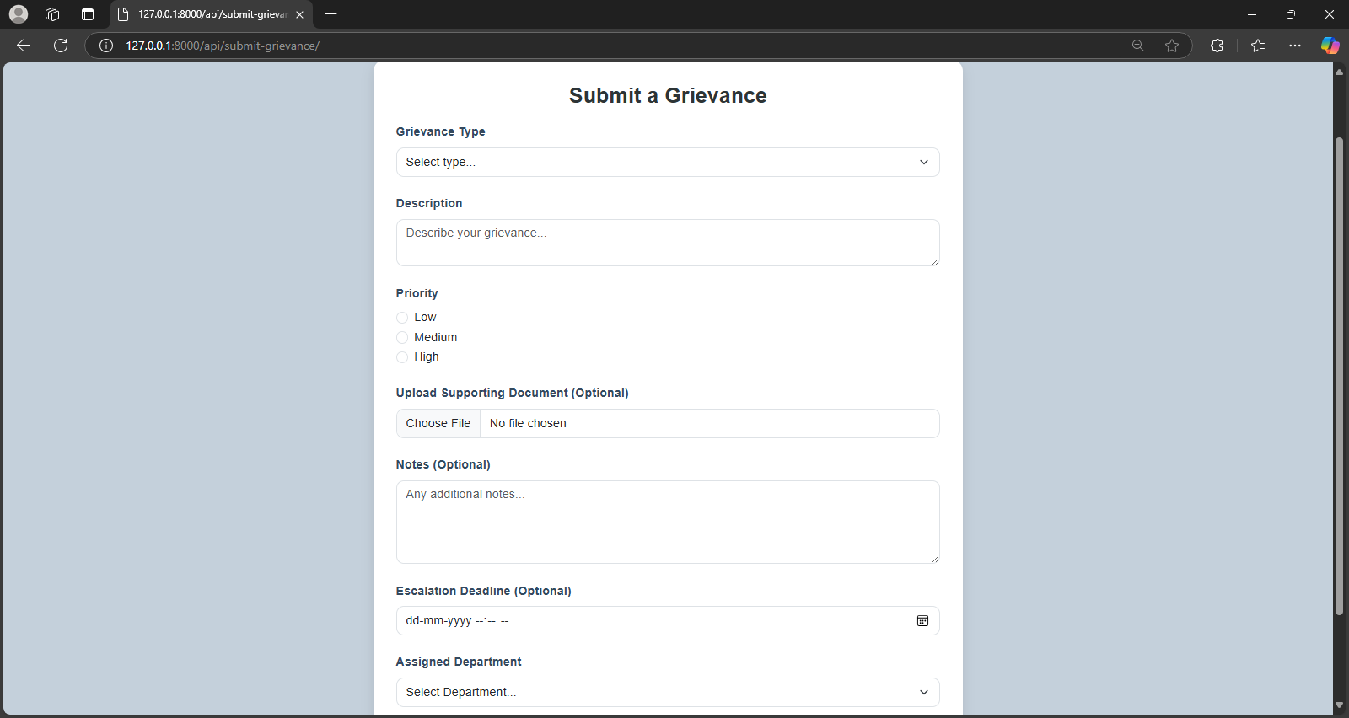
User_dashbnoard:
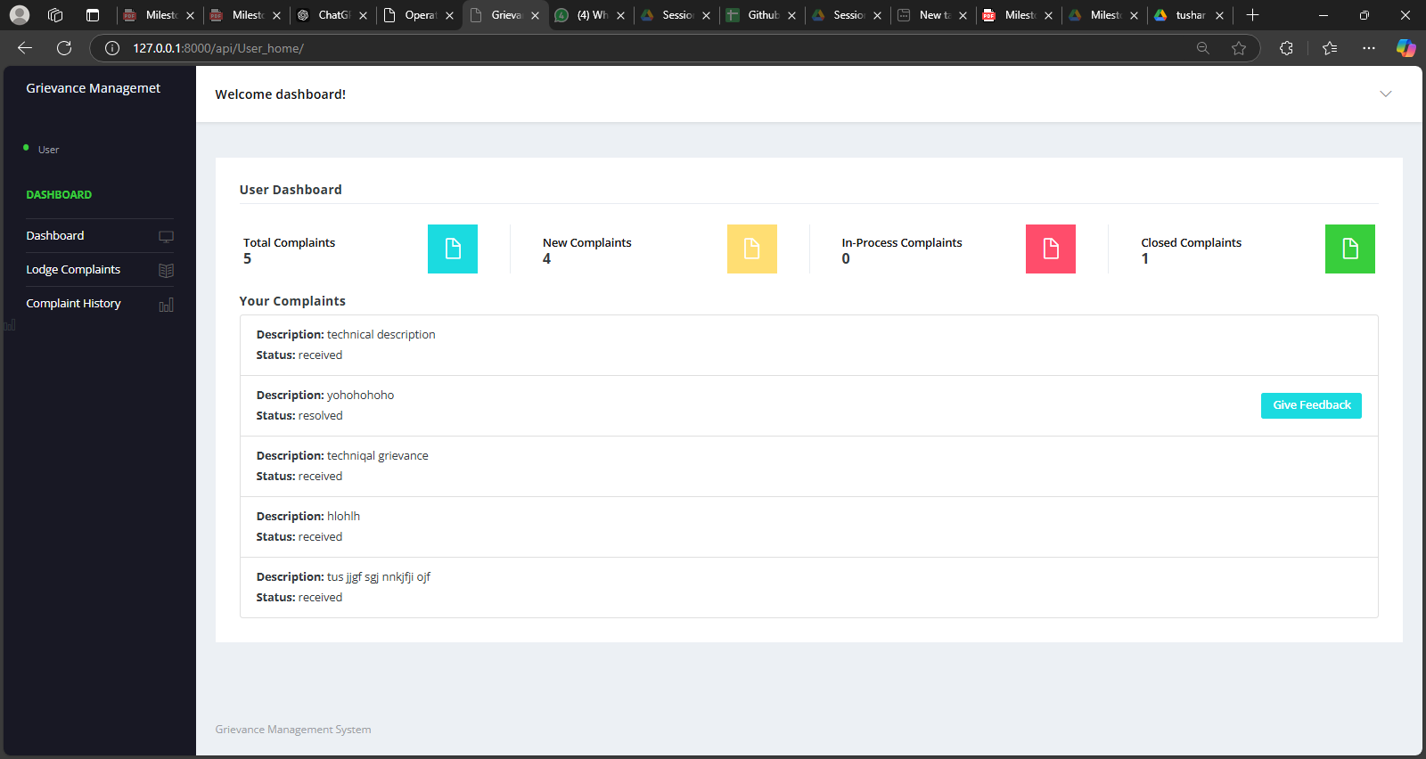
Admin_dashboard
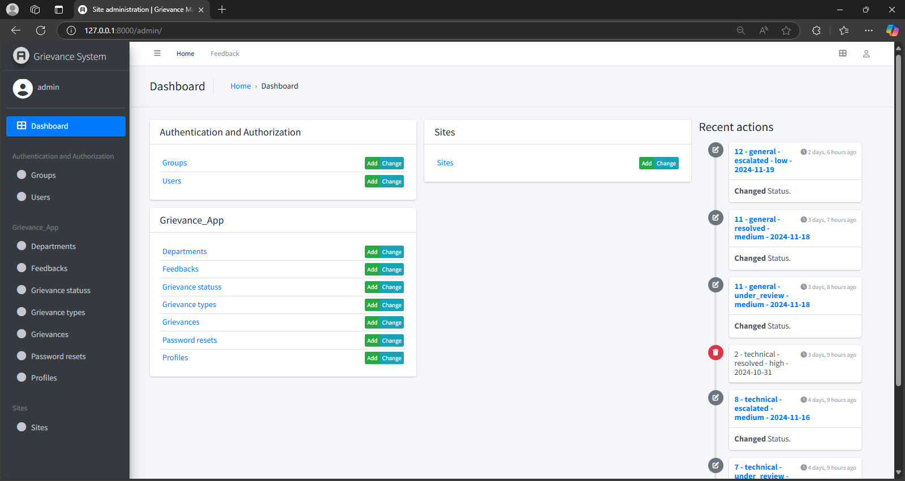
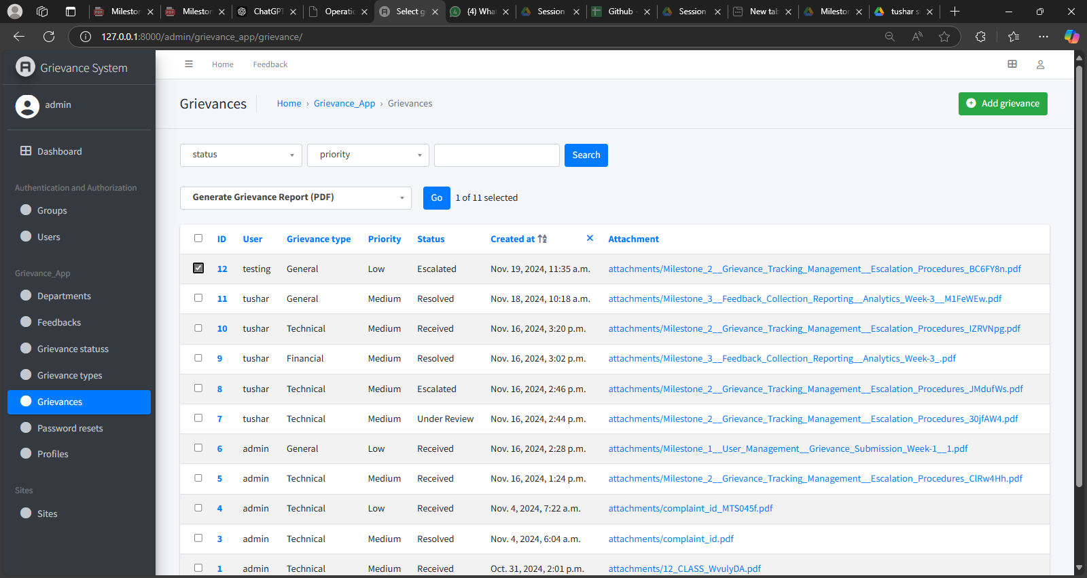
- Class Diagram:
  - Purpose: Represent the static structure of the system, showing the classes involved and their relationships.
  - Classes:
    - User: Manages user data, login, registration, etc.
    - Grievance: Represents grievance data, including status, category, and description.
    - Response: Represents responses given by admins.
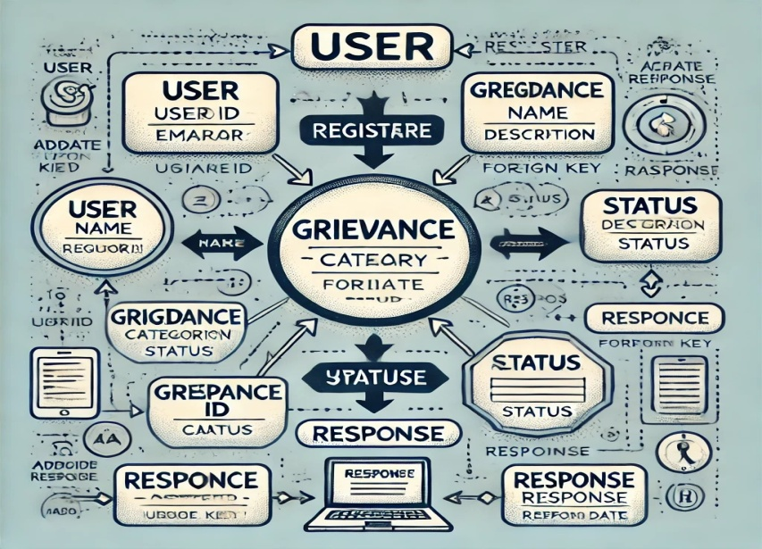
Sequence Diagram:
  - Purpose: Show the sequence of interactions between components for a specific use case, such as submitting a grievance.

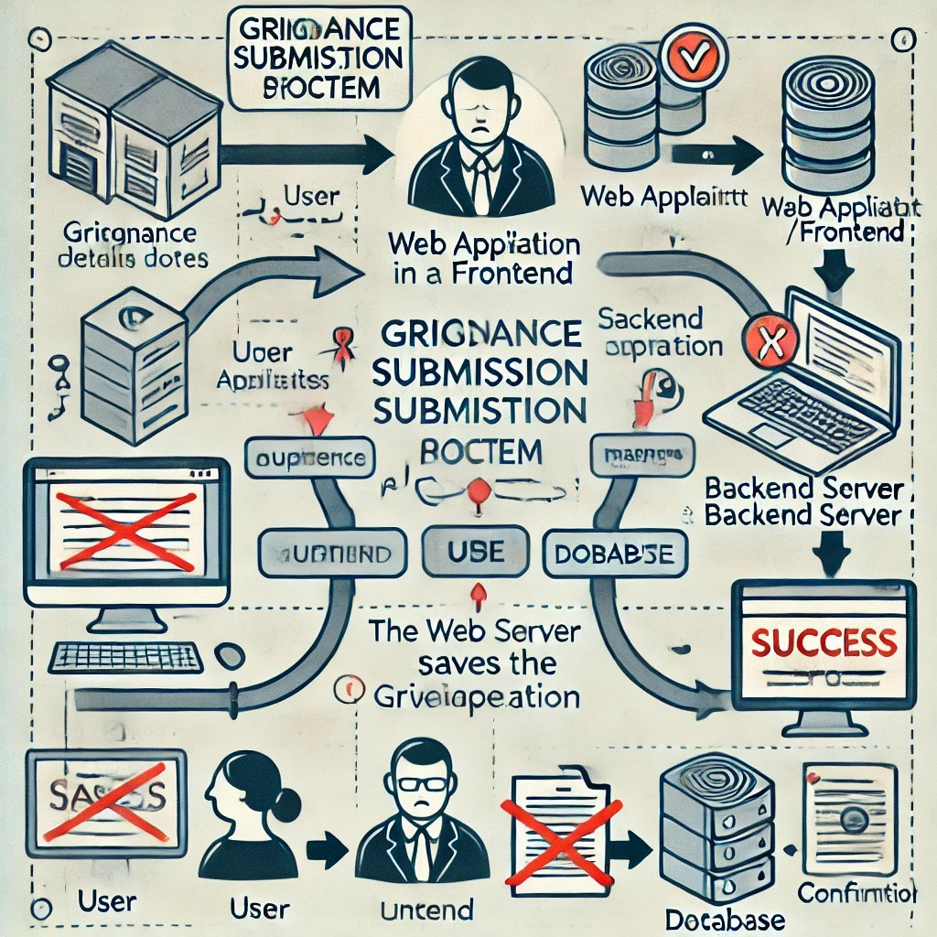

System Flow:
The overall flow of the Grievance Management System is illustrated below:
- User Logs In:
  - The user enters credentials on the login page.
  - If authenticated, the user is redirected to the dashboard.
- User Submits Grievance:
  - The user fills out a grievance form, providing details like the category, description, and priority.
  - The data is sent via API to the backend, where it is processed and stored in the database.
- Admin Reviews Grievance:
  - Admin views all submitted grievances in the admin panel.
  - The admin responds to the grievance, updating its status and providing feedback.
- User Views Response:
  - The user is notified when a response is available.
  - The user can view the response and status update on their dashboard.

Design Decisions:
- MVC (Model-View-Controller) / MVT (Model-View-Template) Architecture
  - Decision: The decision to use Django’s Model-View-Template (MVT) architecture was made based on its robustness and suitability for web-based applications. Django’s structure offers clear separation between data management, business logic, and presentation, making it ideal for the GMS.
    - Model: Represents the system’s data structure. Django’s ORM makes database interactions seamless and abstracted, which simplifies the handling of complex data models like grievances and user profiles.
    - View: Responsible for managing user input and presenting the results. It communicates directly with the database and updates the model when needed.
    - Template: The frontend that renders the data returned by the view, ensuring a clean user interface for both users and administrators.
  - Reasoning: This architecture allows clear division of concerns and modularizes the application, enabling easier maintenance and updates. It also supports Django’s extensive tooling for fast development and deployment.
- RESTful API for Communication
  - Decision: The Grievance Management System uses Django REST Framework (DRF) to expose APIs for communication between the frontend and backend.
    - Reasoning: DRF allows the creation of efficient and scalable APIs that are easy to consume from any frontend technology (in this case, HTML, CSS, and JavaScript). RESTful APIs also ensure statelessness and separation of the client-side and server-side, which simplifies both development and maintenance.
    - Benefits:
      - Decouples the frontend from the backend, making it easy to switch or scale either part independently.
      - Enables future integration with mobile applications or external systems via APIs.
- User Roles and Permissions (RBAC - Role-Based Access Control)
  - Decision: Implementing Role-Based Access Control (RBAC) was essential for managing different user interactions within the system.
    - Reasoning: The GMS involves multiple types of users with different levels of permissions (Users and Admins). RBAC ensures that users have access to only what they need while keeping administrative controls secure.
    - Benefits:
      - Simple and effective access control.
      - Ease of adding new roles or permissions as the system evolves.
- Django Admin Customization
  - Decision: We decided to customize Django's built-in admin interface using Jazzmin, which provides a modern UI for administrative tasks.
    - Reasoning: Django’s admin panel provides a lot of out-of-the-box functionality, but it needed a more visually appealing and user-friendly interface for admins to effectively manage grievances.
    - Benefits:
      - Customizable, responsive interface tailored to the needs of administrators.
      - Improved usability for admin tasks such as managing grievances, responding to users, and monitoring system health.
- PostgreSQL Database
  - Decision: The database for the Grievance Management System was chosen to be PostgreSQL, an open-source relational database.
    - Reasoning: PostgreSQL is highly scalable, provides ACID compliance, and is well-suited for complex queries and large datasets, making it ideal for this system which might need to handle large numbers of grievances and responses.
    - Benefits:
      - Robust and reliable performance.
      - Built-in support for data integrity and complex query processing.
- Django Extensions and DRF YASG for API Documentation
  - Decision: The use of django_extensions and drf_yasg for database schema visualization and automatic generation of Swagger-based API documentation.
    - Reasoning: Both tools provide helpful utilities that save time for the development team. django_extensions allows for better debugging and code inspection, while drf_yasg automates the process of generating clean, accessible API documentation.
    - Benefits:
      - Auto-generates Swagger docs for the API, improving the ease of understanding and using the system for both internal and external developers.
      - Facilitates testing and debugging through better schema management and documentation.

Trade-offs and Alternatives Considered
- Design Pattern: MVC vs. MVVM (Model-View-ViewModel)
  - Alternative: Another pattern that was considered during the design phase was MVVM (Model-View-ViewModel), especially for frontend frameworks like Angular or React. In MVVM, the ViewModel acts as an intermediary between the Model and the View, providing better state management.
  - Trade-off: While MVVM could have been beneficial for handling complex UI state, the MVC/MVT architecture provided a simpler and more appropriate structure for the Django framework, especially with Django’s built-in support for models and views. The chosen MVT design minimizes the complexity of introducing an additional layer (ViewModel) that could have made the system harder to maintain.
- Use of a Single Database vs. NoSQL Database
  - Alternative: Initially, a NoSQL database (such as MongoDB) was considered, particularly for storing dynamic data like grievance descriptions, comments, and feedback.
  - Trade-off: NoSQL databases offer flexibility and scalability, but Django's ORM and PostgreSQL’s relational nature provided a better structure for maintaining consistent data, supporting complex queries, and handling relationships (like linking grievances to users and admin responses). The decision to use a relational database (PostgreSQL) ensures better data integrity and consistency, which is crucial for managing grievances and responses.
- Direct Database Queries vs. Django ORM
  - Alternative: Writing direct SQL queries was considered for complex data interactions, especially for filtering and joining large datasets related to grievances and users.
  - Trade-off: While direct SQL could provide performance benefits for certain complex queries, Django ORM provides a more maintainable, readable, and developer-friendly approach. Django ORM's abstraction allows the development team to focus more on business logic, without worrying about low-level database interactions. The ORM also ensures that the system can easily be migrated or extended in the future.
- Monolithic vs. Microservices Architecture
  - Alternative: Initially, the system could have been designed using a microservices architecture, where different parts of the grievance management (like user management, grievance submission, and resolution) would run as separate services.
  - Trade-off: While microservices offer better scalability and isolation of concerns, the complexity and overhead of setting up and managing multiple services outweighed the benefits for this specific project. A monolithic MVT-based design was chosen for simplicity, faster development, and easier maintenance, as the scale of the application did not require the overhead of a microservices approach.

Development
The development phase of the Grievance Management System (GMS) involved the use of various technologies, frameworks, and tools. The goal was to create a user-friendly, scalable, and secure platform for both users and administrators. Below is a detailed description of the technologies used, the coding standards followed, and the challenges encountered during the implementation phase, along with the strategies used to address them.

Technologies and Frameworks Used:
- Django
  - Role: Django is the core framework used for developing the backend of the Grievance Management System. It is a high-level Python web framework that allows rapid development of secure and maintainable websites.
  - Reason for Use: Django was chosen because of its comprehensive features such as built-in authentication, admin interface, ORM (Object-Relational Mapping) for easy database manipulation, and robust security features. Its simplicity and flexibility allowed the team to focus on business logic while Django handled repetitive tasks like user authentication, form handling, and database connections.
- Django REST Framework (DRF)
  - Role: DRF is used to build RESTful APIs for the system. These APIs allow communication between the frontend and the backend, enabling actions such as submitting grievances, viewing grievance statuses, and managing user profiles.
  - Reason for Use: DRF simplifies the creation of RESTful APIs by providing powerful tools to handle authentication, serialization, and query filtering. The choice to use DRF enables a clean, decoupled architecture, making it easier to develop both the frontend and backend independently.
- Jazzmin
  - Role: Jazzmin is used to enhance and customize the default Django Admin interface, providing a more modern, user-friendly look and feel for administrators managing the grievances.
  - Reason for Use: Jazzmin offers a more polished and user-friendly experience than the default Django admin interface. This tool was essential in making administrative tasks easier and more intuitive.
- PostgreSQL
  - Role: PostgreSQL serves as the relational database used to store and manage all data related to grievances, users, and administrative actions.
  - Reason for Use: PostgreSQL was chosen because it is a powerful, open-source, relational database management system that supports complex queries, data integrity, and scalability. It is well-suited for handling large datasets and provides strong ACID compliance.
- drf_yasg
  - Role: drf_yasg is used to generate interactive and user-friendly Swagger documentation for the RESTful APIs.
  - Reason for Use: drf_yasg automatically generates documentation that helps frontend developers, as well as external developers and users, understand and interact with the APIs. It saves time and ensures that the documentation is always up-to-date with the codebase.
- Django Extensions
  - Role: Django Extensions provides additional utilities, such as database schema visualization and enhanced shell capabilities, to support the development process.
  - Reason for Use: Django Extensions was included to make development and debugging easier, especially when working with the complex database structure and ensuring smooth interaction between the components of the system.
- Bootstrap 4
  - Role: Bootstrap is used to create a responsive and mobile-friendly frontend for the Grievance Management System.
  - Reason for Use: Bootstrap allows for quick prototyping and ensures that the system’s user interface (UI) is consistent across different devices. It provides a wide variety of pre-styled components, making it easier to create an attractive and functional UI.

Coding Standards and Best Practices Followed:
- PEP 8 Compliance
  - Description: PEP 8 is the official style guide for Python code, and it was strictly followed throughout the development process. This includes proper indentation, use of spaces, function and variable naming conventions, and commenting.
  - Reasoning: Following PEP 8 ensures that the code is clean, readable, and maintainable. It also promotes consistency across the development team, making it easier to collaborate.
- DRY (Don't Repeat Yourself) Principle
  - Description: One of the key principles followed during development was the DRY principle, which emphasizes minimizing redundancy in the codebase.
  - Reasoning: This principle helps improve the maintainability and clarity of the code by ensuring that each piece of logic is written only once. This minimizes the potential for errors and simplifies future updates or modifications.
- Modular Design
  - Description: The code was divided into modules, each responsible for specific functionality (e.g., handling grievances, managing user profiles, etc.).
  - Reasoning: Modular design promotes separation of concerns, making the system easier to understand and maintain. It allows developers to focus on specific parts of the system without needing to understand the entire codebase.
- Version Control (Git)
  - Description: Git was used for version control to track changes in the codebase, collaborate with the team, and manage the deployment process.
  - Reasoning: Git ensures that developers can work on different features concurrently without conflict, provides a history of changes for debugging, and allows for easy rollback if necessary.
- Code Reviews
  - Description: Code reviews were conducted regularly to ensure code quality, identify potential issues, and share knowledge across the team.
  - Reasoning: Code reviews improve the overall quality of the code, catch bugs early, and ensure that all team members are aligned with coding standards and best practices.
- Testing
  - Description: Automated testing was emphasized, including unit tests, integration tests, and API tests. Django’s built-in testing tools were used for writing test cases.
  - Reasoning: Testing ensures that the system functions as expected, helps identify bugs early in the development process, and ensures that future changes don’t break existing functionality.
- API Documentation
  - Description: API documentation was automatically generated using drf_yasg to ensure that it stays in sync with the backend code.
  - Reasoning: Auto-generated API documentation allows developers to easily understand and interact with the system’s APIs. It also reduces the need for manual documentation updates.

Challenges Encountered and How They Were Addressed:
- Handling Complex User Roles and Permissions
  - Challenge: The system required robust handling of multiple user roles, each with different levels of access. Implementing role-based access control (RBAC) without creating confusion or errors was a significant challenge.
  - Solution: Django’s built-in permission system was extended to define custom permissions for different roles. The django-guardian package was used to implement object-level permissions, allowing fine-grained control over who can access and modify specific resources (e.g., grievance submissions).
- Optimizing Database Queries
  - Challenge: The application required querying large datasets, especially when retrieving lists of grievances based on various filters (status, type, etc.). This led to concerns about performance and query efficiency.
  - Solution: Database indexing and query optimization techniques were employed, such as using select_related and prefetch_related to reduce the number of queries made to the database. Additionally, caching was used for frequently accessed data to reduce load on the database.
- API Rate Limiting and Security
  - Challenge: The API needed to be secure and prevent abuse, such as excessive requests from the same user or malicious actors trying to perform unauthorized actions.
  - Solution: Django REST Framework’s built-in support for authentication and permissions was leveraged, alongside throttling and rate-limiting to prevent abuse. JWT (JSON Web Tokens) were used for user authentication, ensuring secure communication between the client and server.
- Cross-browser Compatibility Issues
  - Challenge: Ensuring that the frontend was compatible with multiple browsers and devices was difficult, especially when dealing with responsive design.
  - Solution: Bootstrap 4 was used for its mobile-first and responsive design capabilities. Browser compatibility was tested regularly, and minor issues were addressed by writing custom CSS to fix layout problems in specific browsers.
- Integrating Third-Party Tools for Documentation
  - Challenge: Automatically generating and maintaining up-to-date API documentation with external tools like drf_yasg proved to be complex initially.
  - Solution: Extensive documentation and community resources for drf_yasg were used to integrate it properly into the project. Regularly updating the Swagger documentation ensured that the API documentation reflected the changes made during development.

User Guide
The Grievance Management System (GMS) is a web-based platform designed to help users easily submit and track grievances, while also enabling administrators to manage and resolve them efficiently. This guide will walk you through the steps to use the application, provide instructions for setting up the system, and offer troubleshooting tips for common issues you may encounter.

1. Setup and Configuration:
Step 1: Installation of the Application
To begin using the Grievance Management System, follow these installation instructions:
- Clone the Repository: Download the project from the repository by running the following command:
bash
Copy code
git clone https://github.com/your-repository/grievance-management-system.git
- Create a Virtual Environment: It is recommended to set up a virtual environment to manage the project’s dependencies. Run the following commands to create and activate the environment:
bash
Copy code
python -m venv venv
source venv/bin/activate # On Windows: venv\Scripts\activate
- Install Dependencies: Once the virtual environment is activated, install the required packages using the following command:
bash
Copy code
pip install -r requirements.txt
This will install all the necessary Python packages, including Django and Django REST Framework, among others.
- Set Up the Database: Configure your database by editing the settings.py file in the project directory to connect to your preferred database (e.g., PostgreSQL).
For PostgreSQL, you will need to have a database set up and enter the connection details such as:
python
Copy code
DATABASES = {
'default': {
'ENGINE': 'django.db.backends.postgresql',
'NAME': 'your_database_name',
'USER': 'your_database_user',
'PASSWORD': 'your_database_password',
'HOST': 'localhost',
'PORT': '5432',
}
}
- Migrate the Database: After setting up the database, apply migrations to create the necessary tables. Run the following commands:
bash
Copy code
python manage.py migrate
- Create a Superuser (for Admin Access): To access the Django admin interface, create a superuser account by running:
bash
Copy code
python manage.py createsuperuser
Follow the prompts to enter the username, email, and password for the superuser account.
- Run the Development Server: To start the application and test it locally, run the following command:
bash
Copy code
python manage.py runserver
The application will be accessible at http://127.0.0.1:8000/.

2. Using the Application:

User Interface (UI)
The Grievance Management System has a simple and intuitive user interface, allowing users to interact with the system effectively. Here’s a breakdown of the key sections:
- User Registration and Login:
  - To access the system, users must first create an account by clicking on the "Sign Up" button and entering their personal details.
  - Once registered, users can log in with their credentials to access the dashboard.
- Submitting a Grievance:
  - After logging in, users can click on the "Submit Grievance" button to open the grievance submission form.
  - They must provide a title, description, and category for their grievance. They may also attach any supporting files (e.g., images, documents).
  - After completing the form, users click "Submit" to send their grievance for processing.
- Tracking Grievance Status:
  - Once a grievance is submitted, the user can track its status. On the dashboard, users can view a list of their submitted grievances along with the current status (e.g., "In Progress," "Resolved").
  - Users can also update the grievance if they wish to provide additional information or clarification.
- Admin Panel:
  - Admins can log in to the system through the Django admin panel at http://127.0.0.1:8000/admin/.
  - From the admin panel, admins can view and manage all grievances, assign them to appropriate departments or personnel, and mark grievances as resolved.

Key Features and Actions
- View Grievances: Users can view the list of grievances they’ve submitted and filter them by status.
- Search: The application allows users to search for specific grievances based on keywords, category, or status.
- Grievance Updates: Both users and admins can add updates to grievances, ensuring that the system reflects the latest developments.
- Notifications: Users receive notifications when their grievances are resolved or updated by the admin.

3. Troubleshooting Tips
Below are some common issues users may encounter while using the Grievance Management System, along with their potential solutions:

Issue 1: Unable to Submit Grievance
- Cause: This issue may occur if the required fields (title, description, or category) are left empty.
- Solution: Ensure that all required fields are filled out before submitting the grievance. The system will display an error message if any fields are missing.

Issue 2: Cannot Log In
- Cause: Users may not be able to log in if they enter incorrect credentials.
- Solution: Double-check the username and password. If forgotten, users can reset their password by clicking on the "Forgot Password" link and following the instructions.

Issue 3: Grievance Status Not Updating
- Cause: Grievance statuses may not be updating correctly if there is a delay in backend processing or database syncing.
- Solution: Try refreshing the page. If the problem persists, contact the system administrator to investigate any potential issues with the database or backend logic.

Issue 4: Admin Panel Not Accessible
- Cause: Admin access may be blocked if there is a misconfiguration or missing superuser privileges.
- Solution: Ensure that the superuser account was created correctly. If not, run the createsuperuser command again in the Django environment to create a valid admin account.

Issue 5: Application Running Slowly
- Cause: Slow performance could be due to a large number of grievances or heavy database queries.
- Solution: Consider optimizing the database queries, adding indexing where necessary, and using caching mechanisms. Additionally, check the server’s resources and ensure the environment is properly configured.

Issue 6: File Uploads Not Working
- Cause: File uploads may fail if the server configuration limits the file size or if there are issues with the file storage settings.
- Solution: Verify the file upload size limit in the Django settings file (settings.py). Increase the DATA_UPLOAD_MAX_MEMORY_SIZE and ensure that the server has enough disk space to store uploaded files.

Issue 7: API Errors
- Cause: If you're using the system's APIs and receive an error, the issue may be related to authentication, permission, or incorrect endpoints.
- Solution: Verify that you're using the correct API endpoint. Ensure your API request includes a valid token for authentication. If you're unsure about the request format, refer to the Swagger documentation generated by drf_yasg for guidance.

Conclusion
The Grievance Management System (GMS) project has successfully met its primary objective of providing an efficient, user-friendly platform for users to submit grievances and for administrators to manage and resolve these complaints. The project has enabled seamless grievance submission, real-time tracking, and management, enhancing the communication between users and administrators.

Summary of the Project's Outcomes and Achievements:
- Effective Grievance Submission: Users are able to easily submit grievances through a well-designed form, which allows for detailed descriptions, categorization, and attachment of relevant files. This ensures that the grievances are clearly communicated and can be properly handled by administrators.
- Real-Time Grievance Tracking: The system enables users to monitor the status of their grievances, providing transparency and reducing the number of follow-up inquiries. This feature also enhances user satisfaction by ensuring that grievances are addressed in a timely manner.
- Admin Control Panel: The admin panel gives administrators full control over grievance management. They can categorize, assign, resolve, and track grievances efficiently, which streamlines the workflow and allows for faster resolution times.
- Notifications and Updates: The system automatically notifies users about the status of their grievances, keeping them informed about important updates. This ensures a proactive approach to grievance management.
- Security and Authentication: The use of Django’s built-in authentication mechanisms, combined with secure login and role-based access control, ensures that only authorized personnel can access sensitive information or manage grievances.
- Customization and Extensibility: With features like the ability to upload files, flexible grievance categorization, and easy-to-use tracking, the system can be customized and scaled to fit the specific needs of different organizations or institutions.

Reflections on Lessons Learned:
Throughout the development process, the team learned valuable lessons that can be applied to future projects:
- Importance of User-Centered Design: One of the key takeaways from the project was the significance of focusing on the user experience (UX). Designing the application with the user in mind, providing clear instructions, intuitive navigation, and a simple submission process, significantly improved the system’s usability.
- Database Optimization: Initially, the database queries were not optimized, causing delays when retrieving large amounts of data. Through iterative testing and profiling, the team was able to identify and resolve these performance bottlenecks, improving the system’s speed.
- Testing and Debugging: The project highlighted the need for rigorous testing, especially for critical functionality such as grievance submission and status tracking. Automated tests were incorporated to ensure the integrity of the system during future changes and updates.
- Team Collaboration: Effective communication and collaboration among team members were crucial for the successful completion of the project. Each member brought their expertise to different aspects of the project, whether in the frontend, backend, or system design.
- Scalability: While the system was designed to meet the current needs of a small to medium-sized organization, the experience highlighted the importance of planning for scalability. Future versions of the project can be improved by considering load balancing, caching, and distributed systems to handle a larger number of users and grievances.

Areas for Improvement in Future Projects:
- Mobile Compatibility: Although the system was designed for web access, creating a mobile-responsive version or a native mobile application could improve accessibility for users who prefer to submit grievances on the go.
- Advanced Analytics and Reporting: Adding detailed analytics, such as grievance trends, resolution times, and department-wise statistics, would provide valuable insights for administrators. This data can help in identifying recurring issues and improving the overall grievance management process.
- AI-Powered Grievance Categorization: Implementing AI or machine learning algorithms to automatically categorize grievances based on their content could significantly reduce manual intervention and expedite the grievance handling process.
- Multi-language Support: To cater to a wider range of users, implementing multi-language support would make the system more inclusive, allowing users from different regions and backgrounds to interact with the system in their preferred language.
- Integration with External Systems: Future versions of the system could benefit from integrating with other organizational systems (e.g., HRMS, ITSM) for a more streamlined experience. This could allow grievances to be linked to employee records or IT issues, improving cross-functional collaboration.

