Install and get the Elastic Beanstalk Command Line Interface (EB CLI) running by referring this link: <https://docs.aws.amazon.com/elasticbeanstalk/latest/dg/eb-cli3-install.html>

Follow these steps for deploying to AWS Elastic Beanstalk:

1. Clean and rebuild the code.

gradlew clean bootJar

2. Go inside cloned project directory and execute below cmd. Keep default values or enter values as per your wish.

eb init

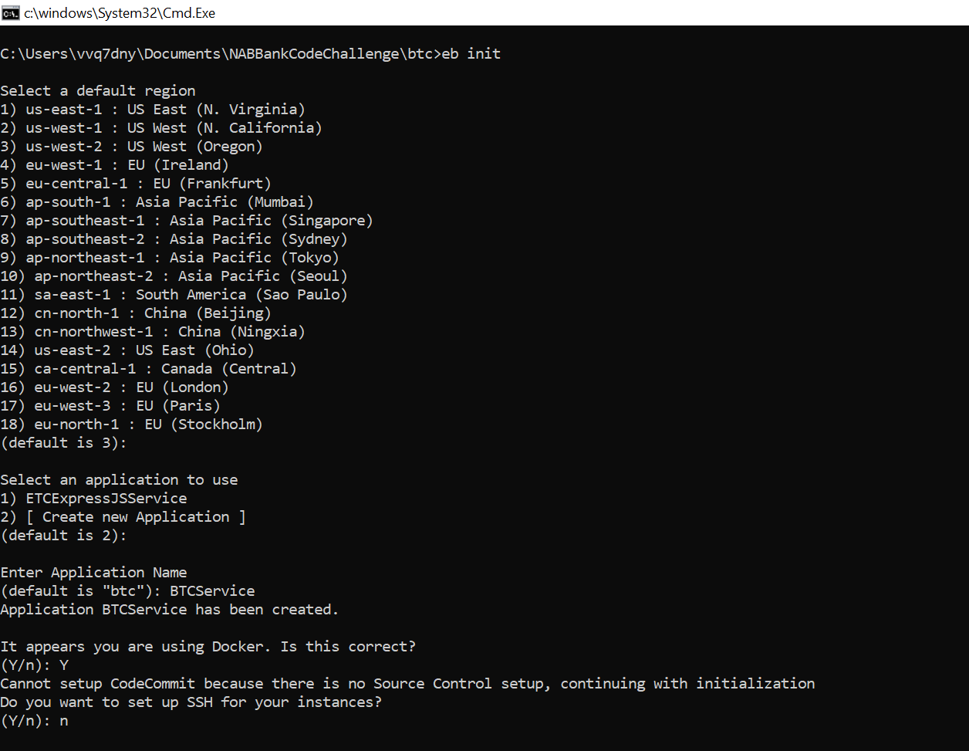

3. Create an environment by executing below cmd.

eb create btc-service

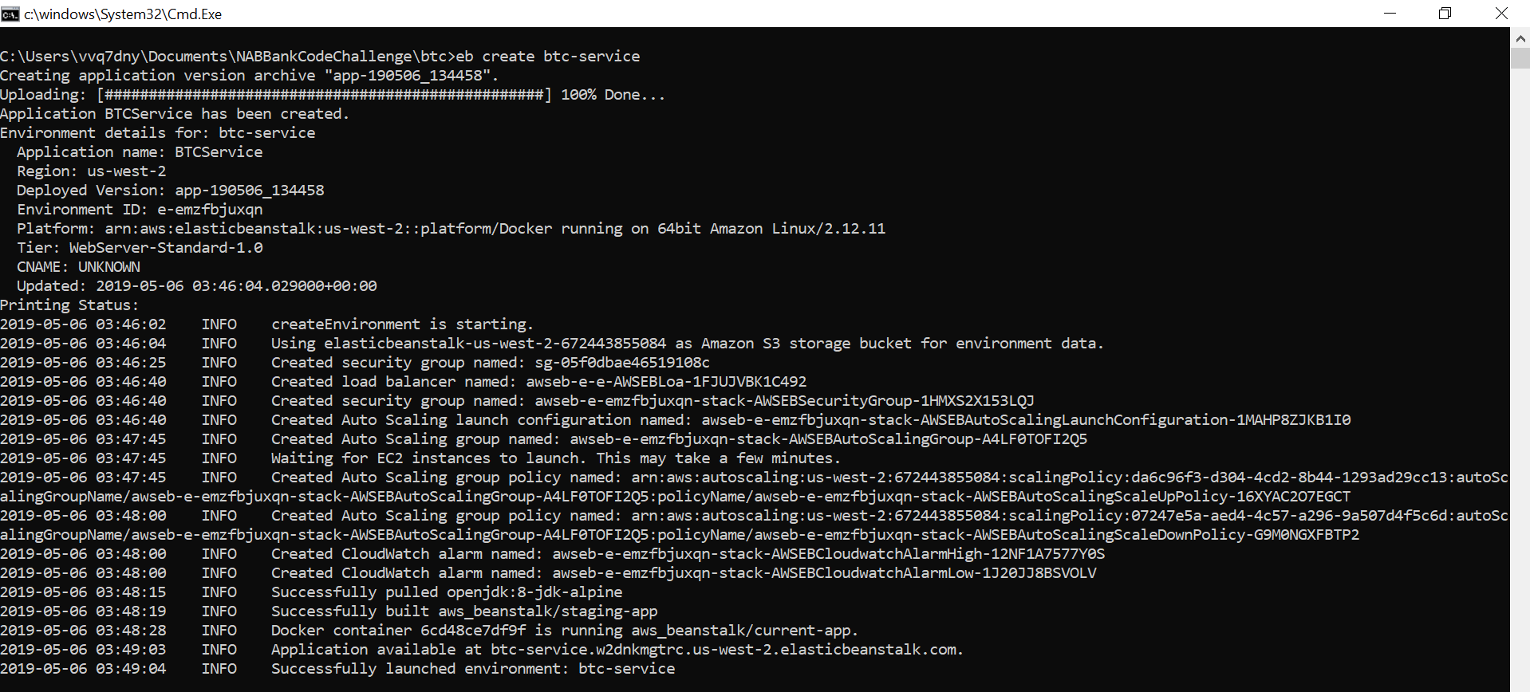

4. In case any changes are made, please commit the changes and then deploy / update the environment by executing below cmd.

eb deploy

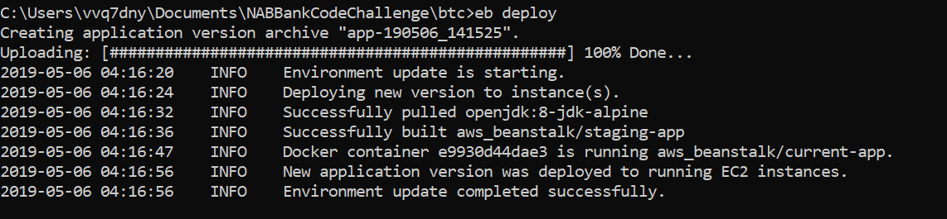

5. Access the API using link like below.

<http://btc-service.w2dnkmgtrc.us-west-2.elasticbeanstalk.com/btc?inputDate=05/08/2019>

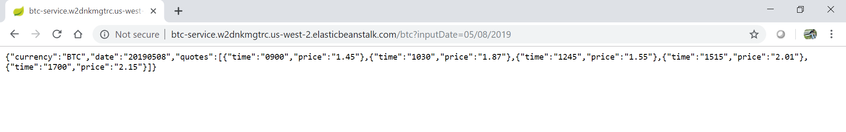

6. EBS provisions all the required resources for running a node application in AWS. Go to AWS Console under Elastic Beanstalk service section and view the above created application.

