Build the code and deploy to AWS S3 and AWS Cloudfront

The deployment steps will require access to AWS Console and AWS CLI (<https://aws.amazon.com/cli/> ) installed and configured. For configuring AWS CLI, please refer <https://docs.aws.amazon.com/cli/latest/userguide/cli-chap-configure.html#cli-quick-configuration> link.

1. Build the cloned project using below cmd.

ng build –prod

2. Configure AWS CLI as below after getting the user access key and secret key from AWS IAM Console.

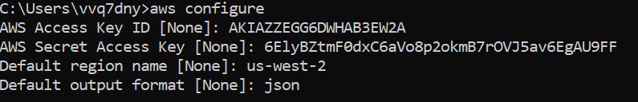

3. Create bucket using AWS CLI as below:

aws s3 mb s3://nab-profit-calculator

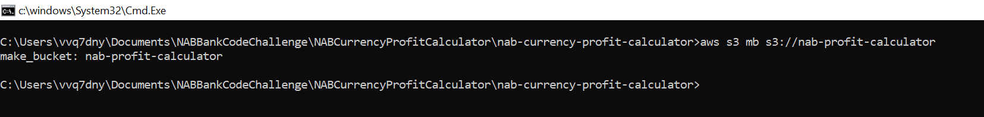

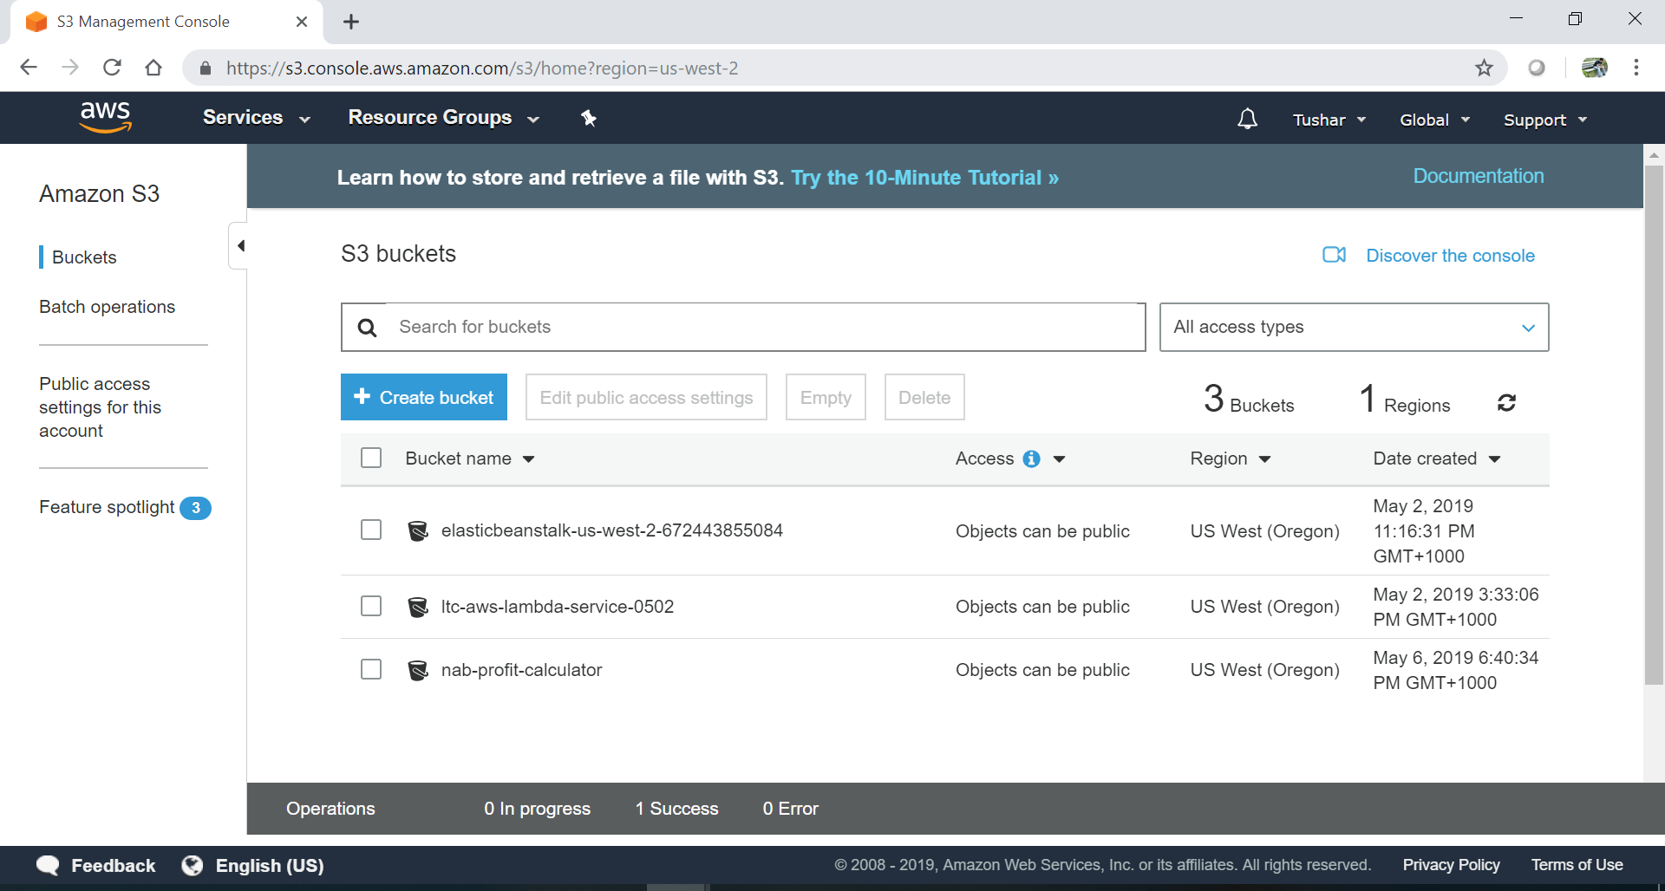

4. Copy the dist folder created at the project root to S3 with the help of AWS CLI as below:

aws s3 cp ./dist s3://nab-profit-calculator --recursive --acl public-read

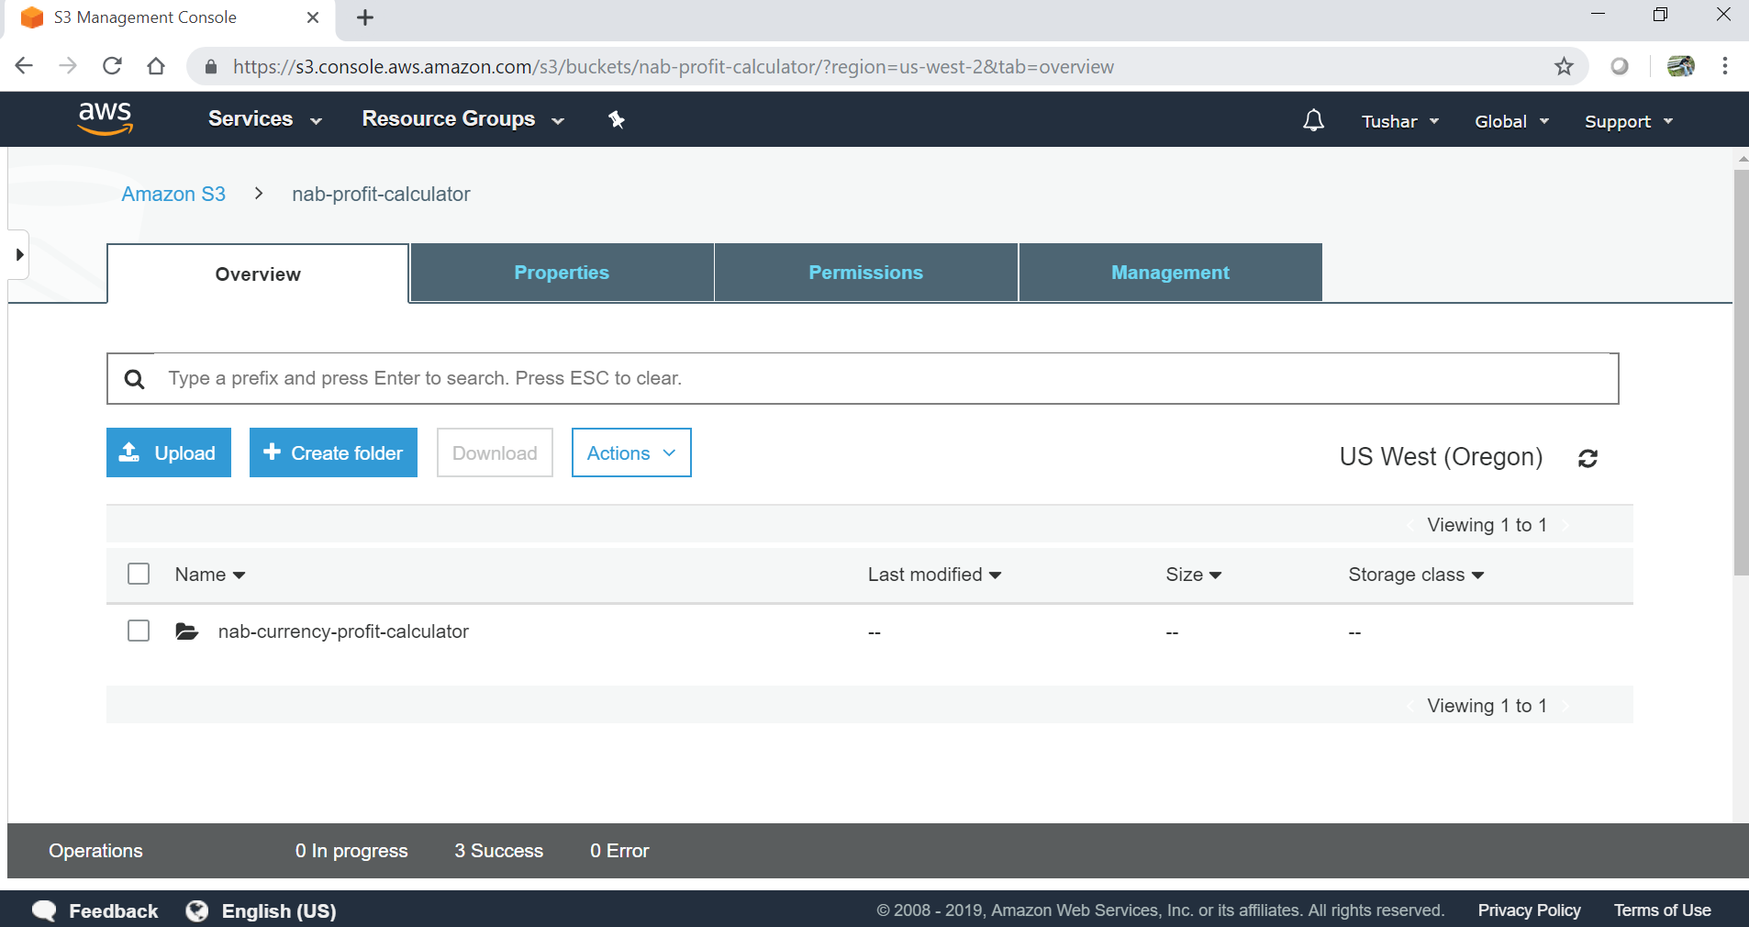

5. Login to AWS S3 console and configure the above created bucket as below:

Enable static website hosting

Index document: index.html

Error document: error.html

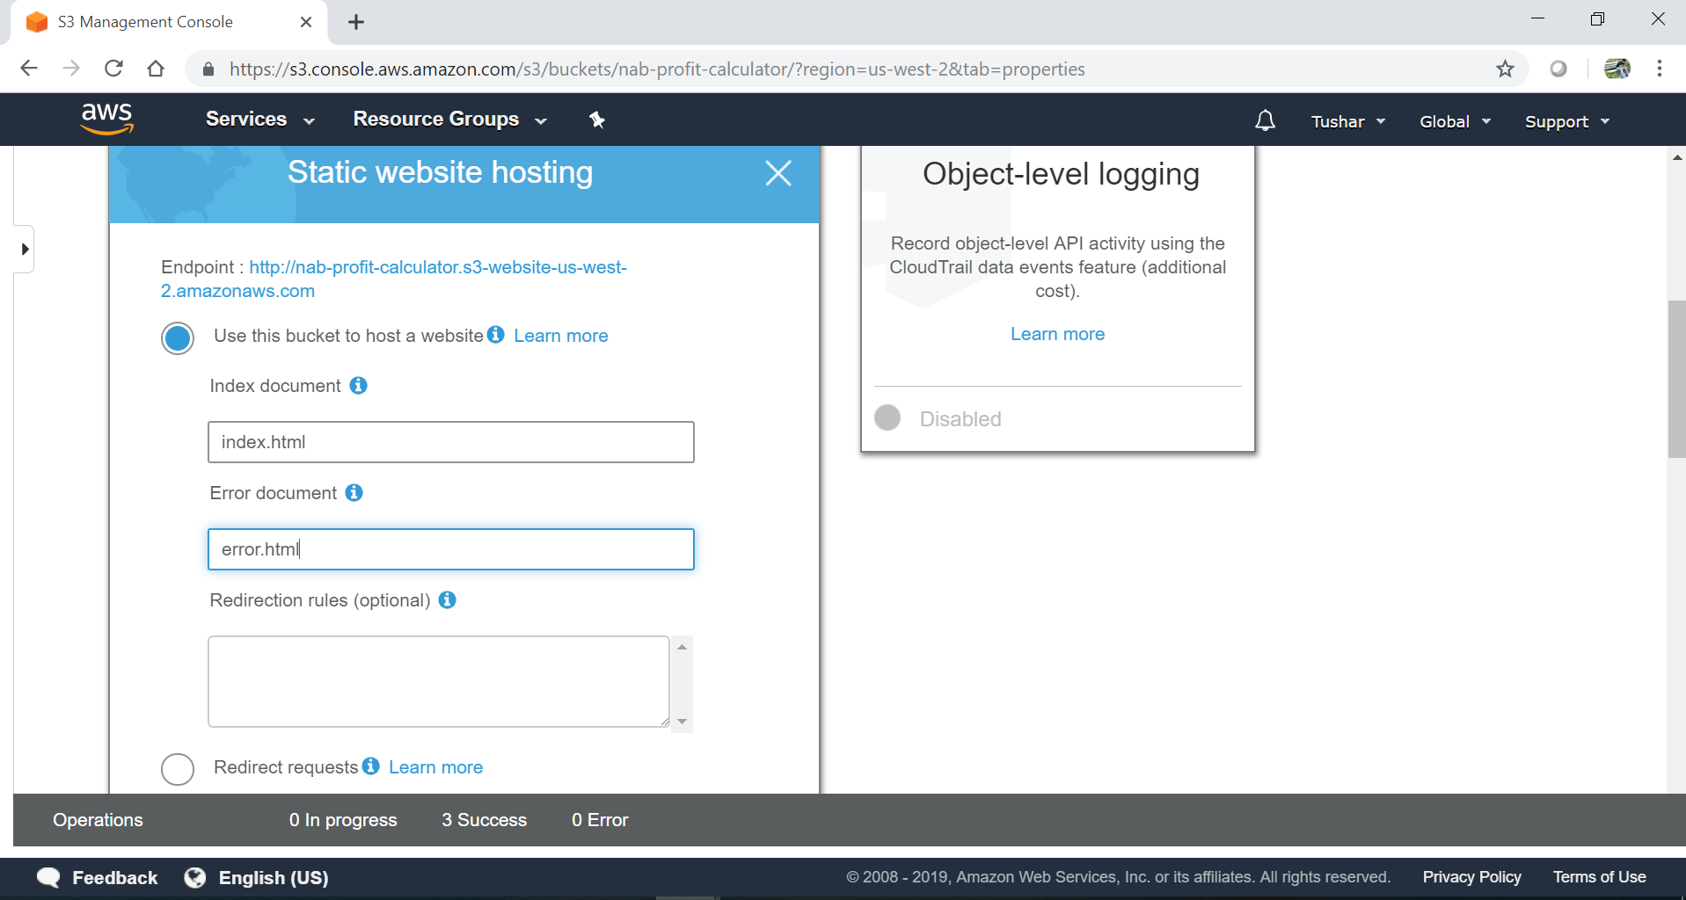

6. Make the uploaded application files public as below:

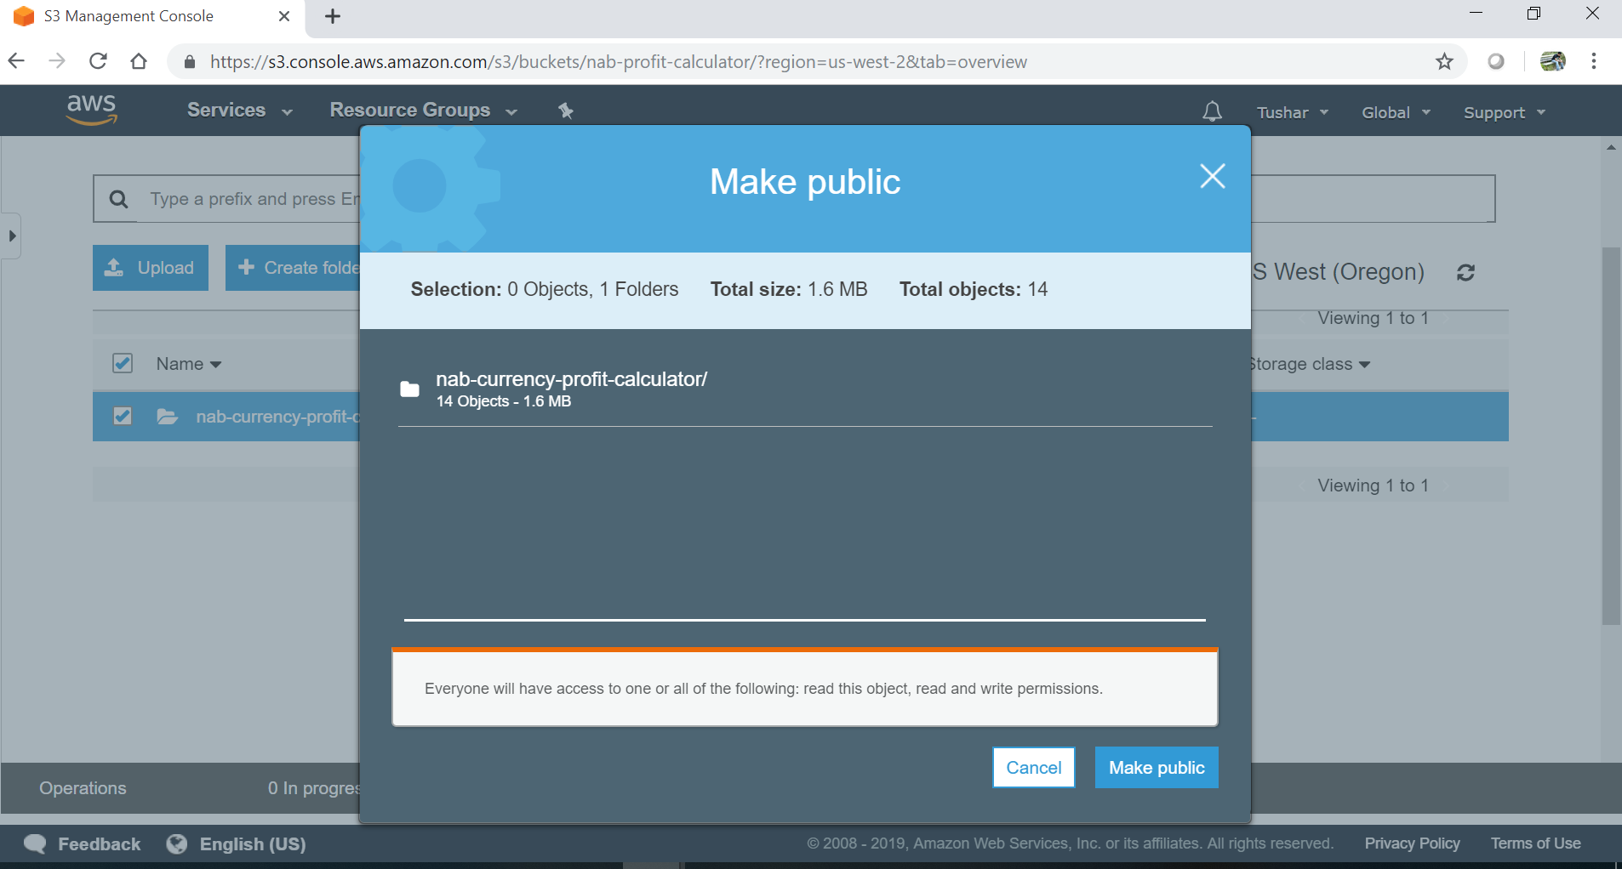

7. Update bucket policy as below. Use AWS policy generator if required.

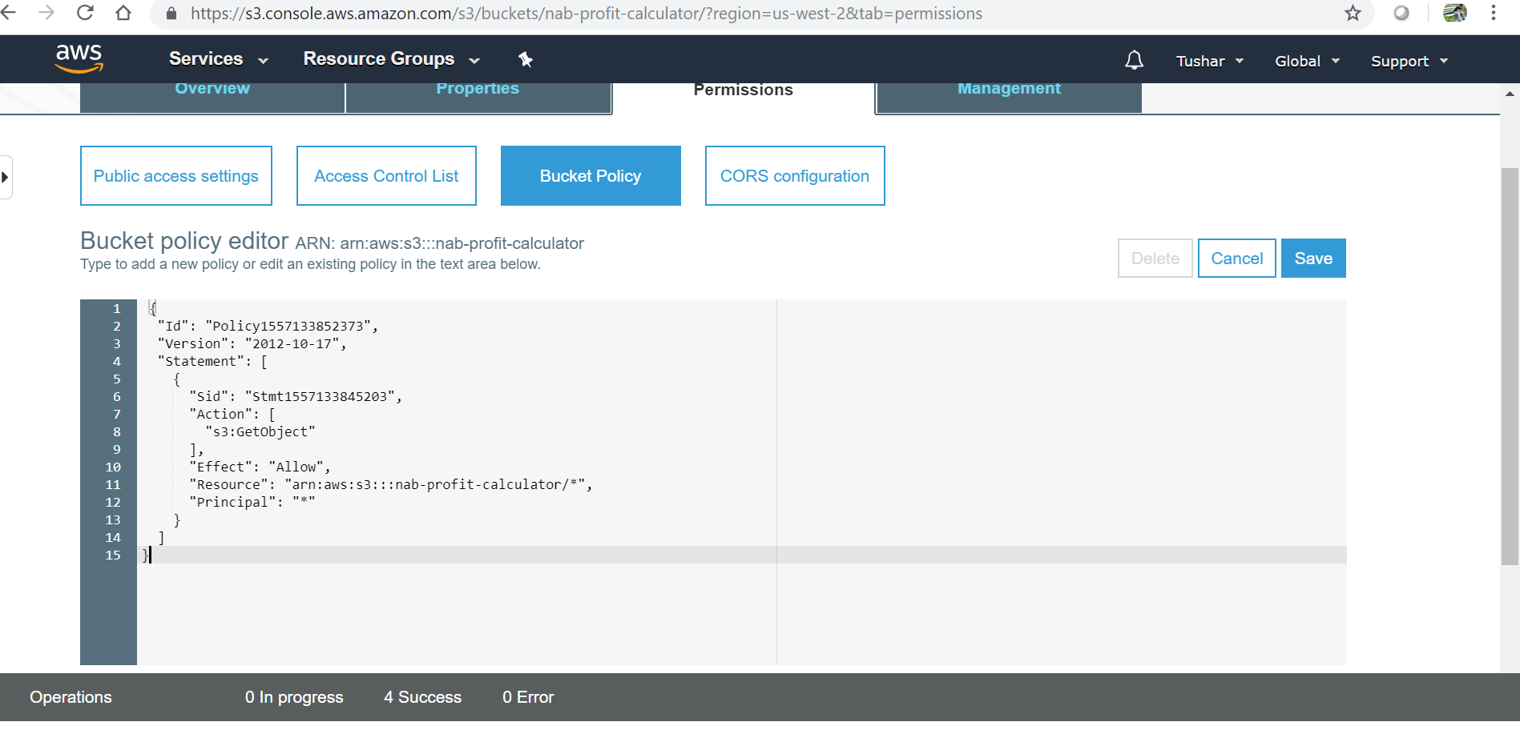

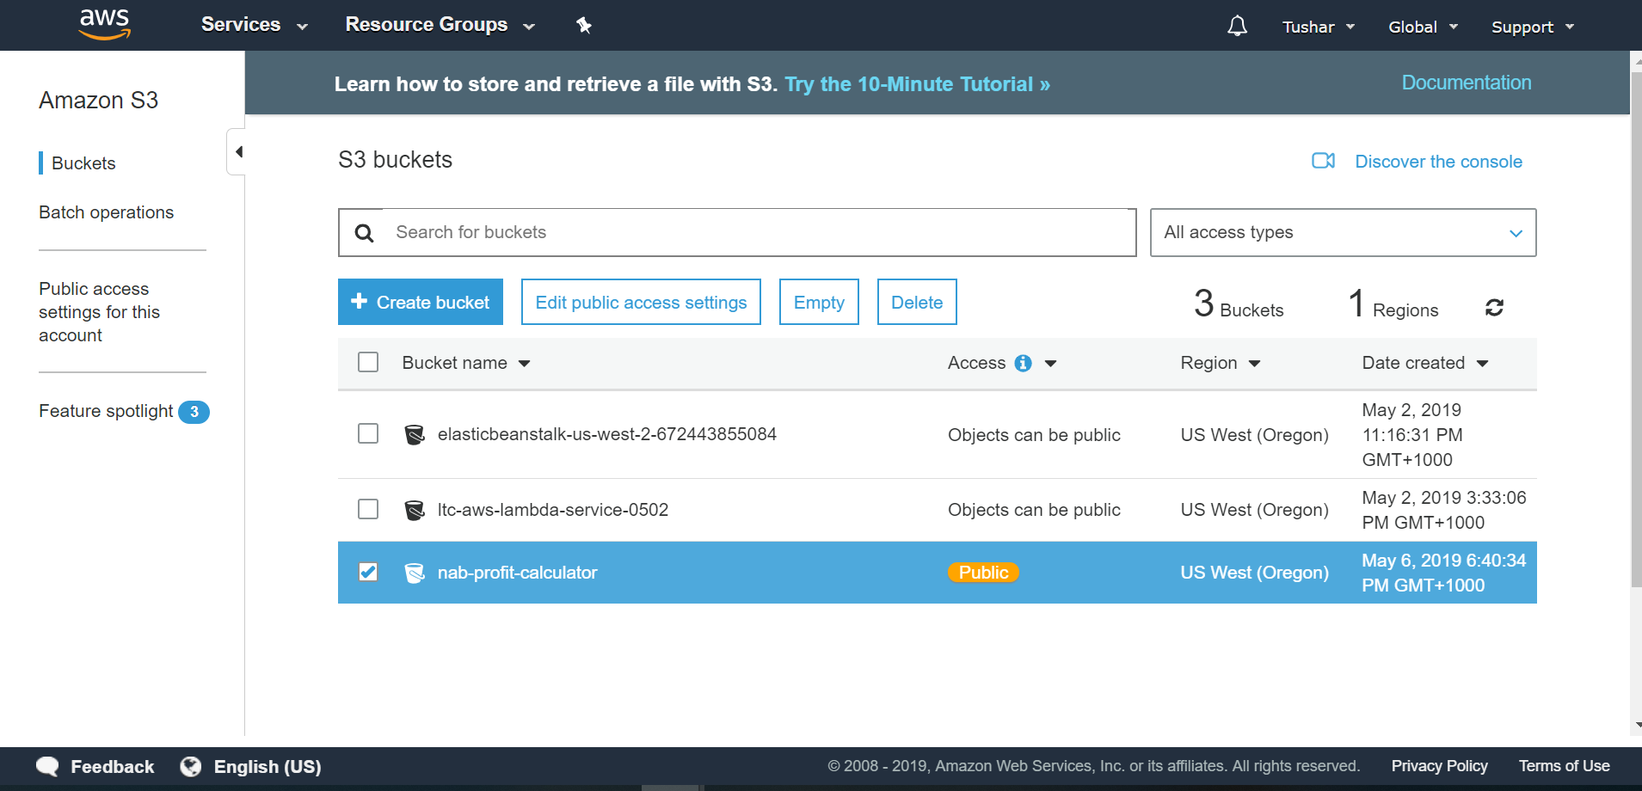

8. Go to Cloudfront console. Create a new Web Distribution as below:

Origin Domain Name: nab-profit-calculator.s3.amazonaws.com

Origin Path: /nab-currency-profit-calculator

Default Root Object: index.html

Rest all the values can be kept default.

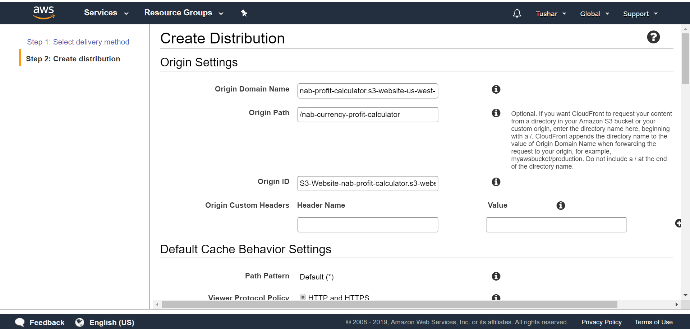

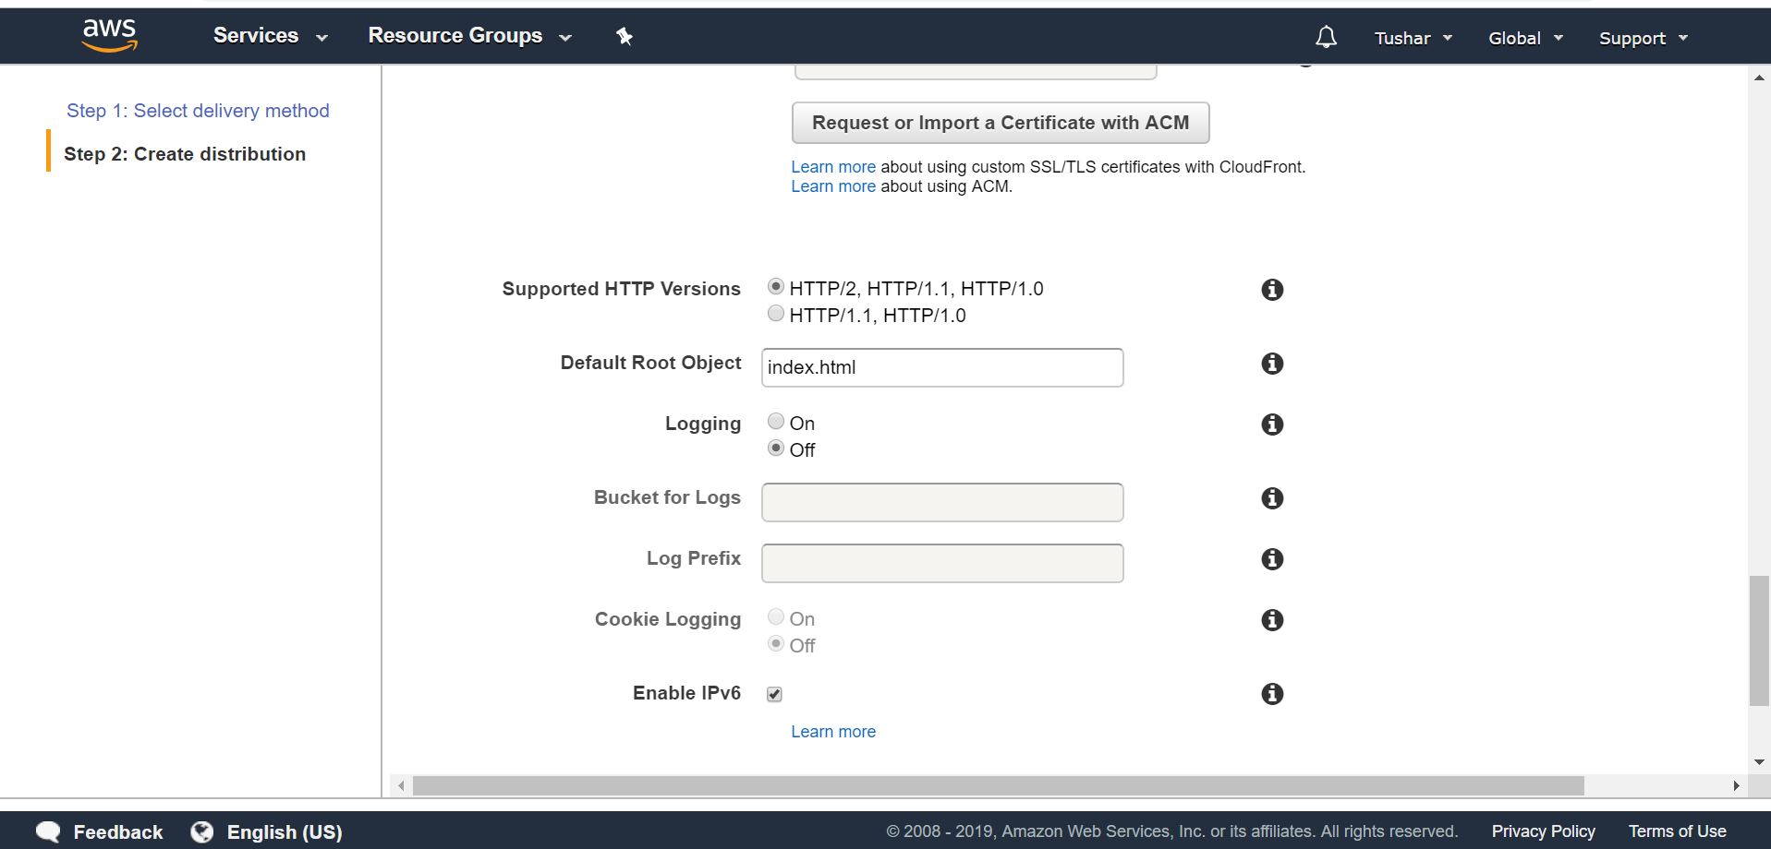

9. Create custom error responses for 403 and 404 as below:

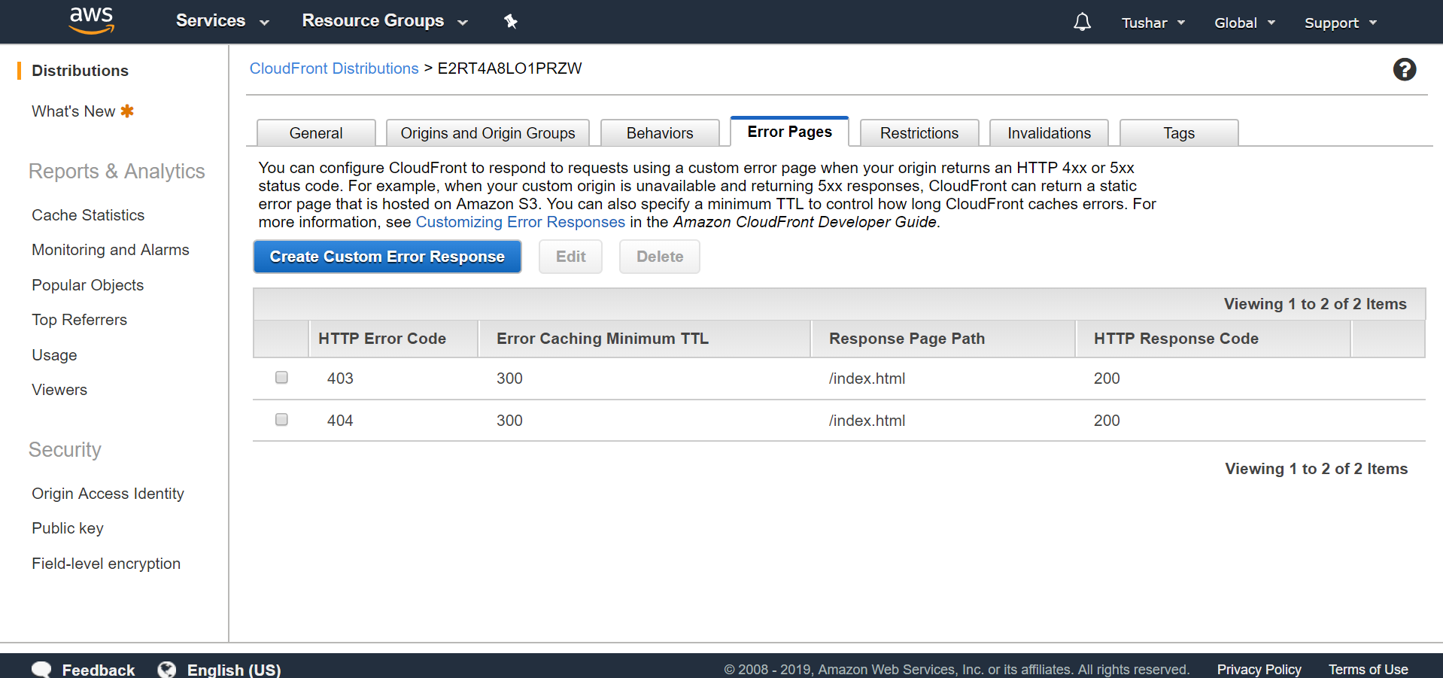

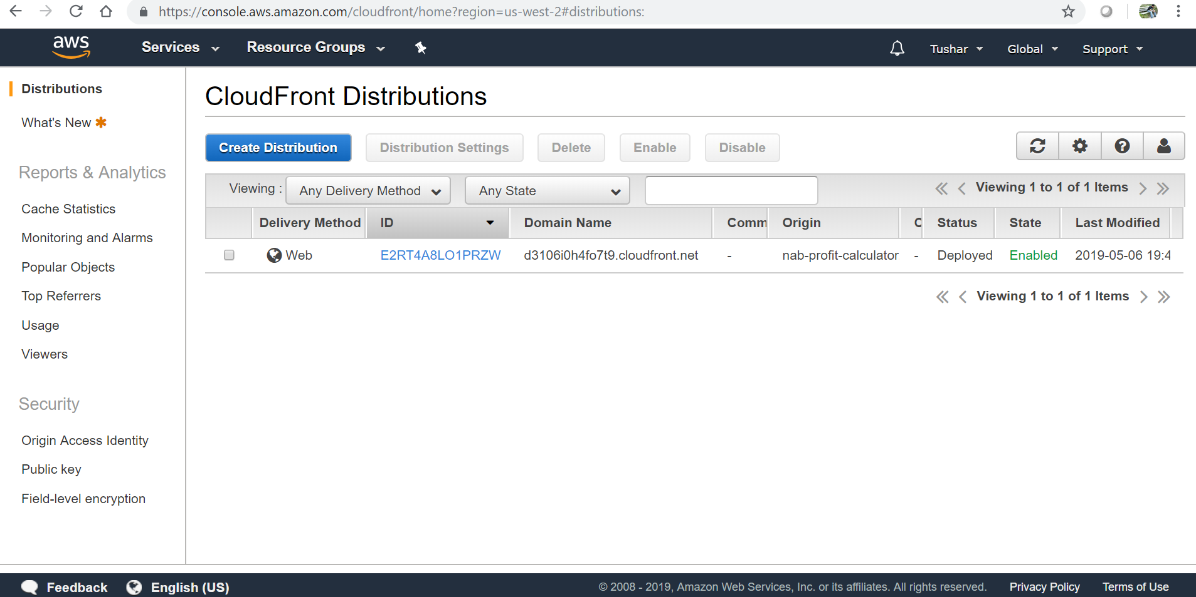

10. Access the application using Cloudfront URL as below:

d3106i0h4fo7t9.cloudfront.net

