This ETC MicroService is built using ExpressJS and is deployed on AWS Elastic Beanstalk.

Install and get the Elastic Beanstalk Command Line Interface (EB CLI) running by referring this link: <https://docs.aws.amazon.com/elasticbeanstalk/latest/dg/eb-cli3-install.html>

Follow these steps for deploying to AWS Elastic Beanstalk:

1. Go inside cloned project directory execute below cmd. Keep default values.

eb init

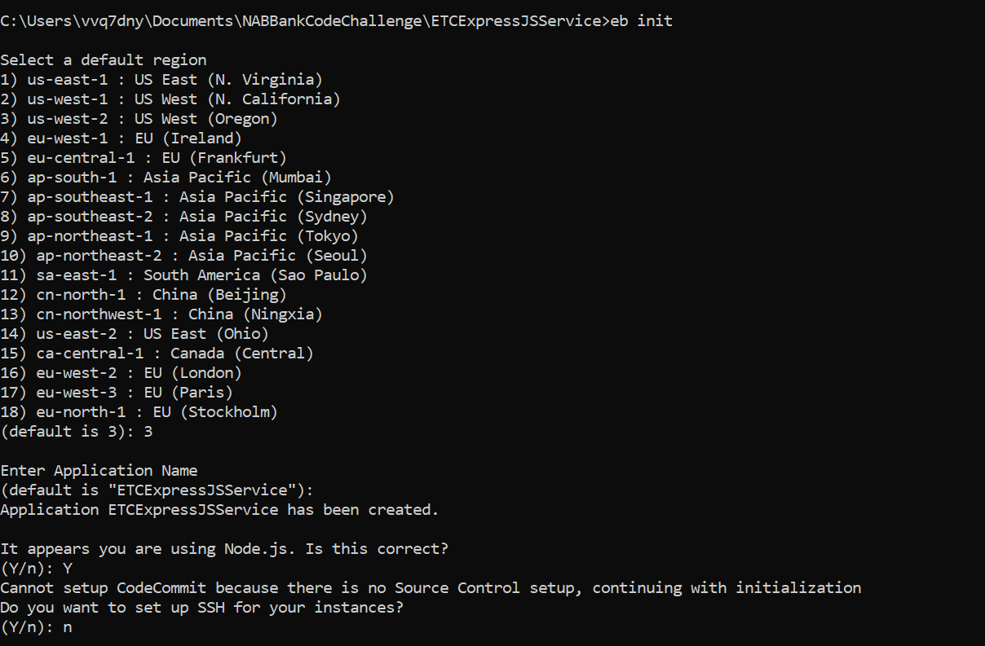

2. Create an environment by executing below cmd.

eb create etc-service

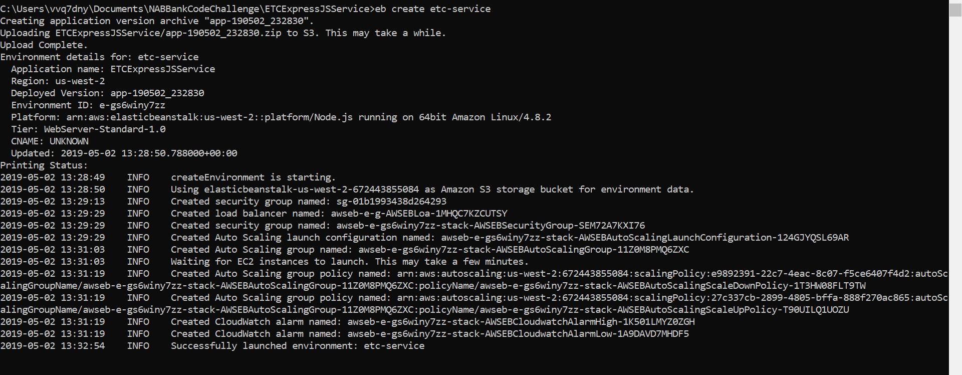

3. Deploy / Update the environment by executing below cmd.

eb deploy

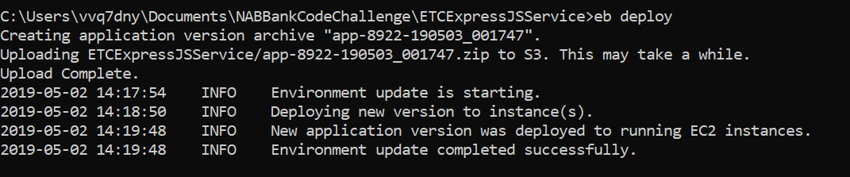

4. Access the API using link like below.

http://etc-service.tthmedhjhb.us-west-2.elasticbeanstalk.com/etc?inputDate=05/07/2019

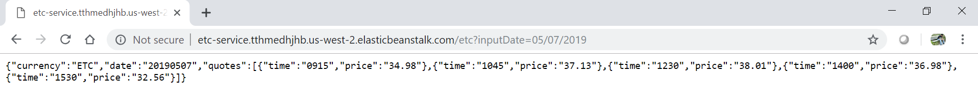

5. EBS provisions all the required resources for running a node application in AWS. Go to AWS Console under Elastic Beanstalk service section and view the above created application.

