Follow these steps for deploying to LTC Service to AWS Lambda:

The deployment steps will require Maven and AWS CLI (<https://aws.amazon.com/cli/> ) to be installed and configured. For configuring AWS CLI, please refer <https://docs.aws.amazon.com/cli/latest/userguide/cli-chap-configure.html#cli-quick-configuration> link.

1. Configure AWS CLI as below after getting the user access key and secret key from AWS IAM Console.

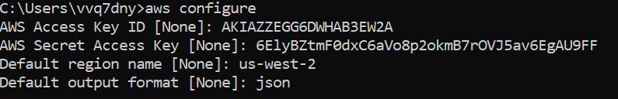

2. Clean and rebuild the code as a shaded jar, not as a Spring Boot jar.

mvn clean package

3. Create an S3 bucket to hold the application code. This bucket name must be unique across S3, so adjust for your use in the next two steps.

aws s3 mb s3://ltc-aws-lambda-service-0502



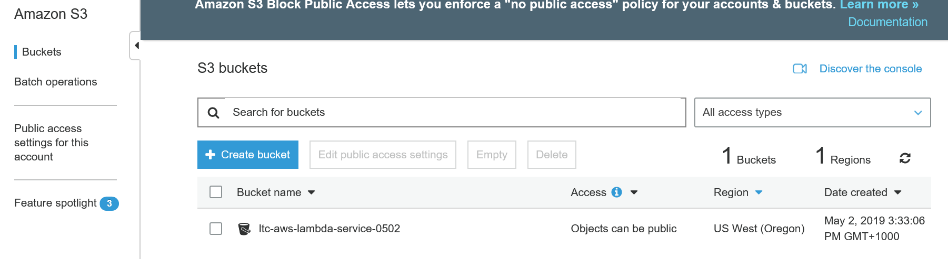

4. Copy the jar file to the S3 bucket and update the information into a SAM template.

aws cloudformation package --template-file sam.yaml --output-template-file target/output-sam.yaml --s3-bucket ltc-aws-lambda-service-0502

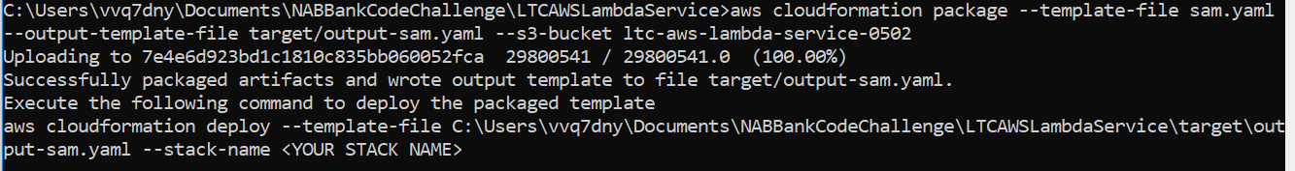

5. Deploy a Cloudformation stack from the SAM template.

aws cloudformation deploy --template-file target/output-sam.yaml --stack-name ltc-aws-lambda-service --capabilities CAPABILITY_IAM

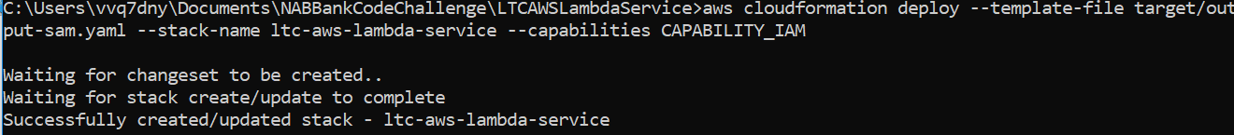

6. Describe the stack, which will display the URL of the API in the outputs.

aws cloudformation describe-stacks --stack-name ltc-aws-lambda-service

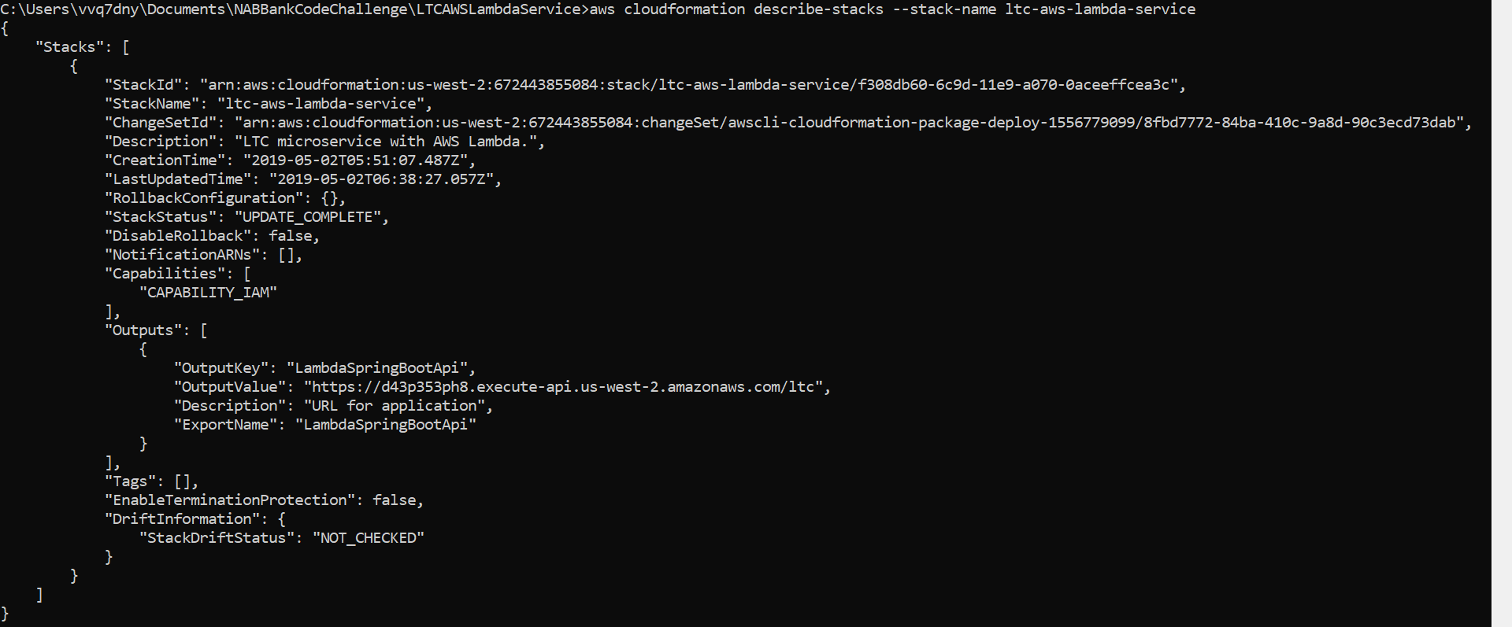

7. Go to AWS Lambda Console and verify the created lambda application as below:

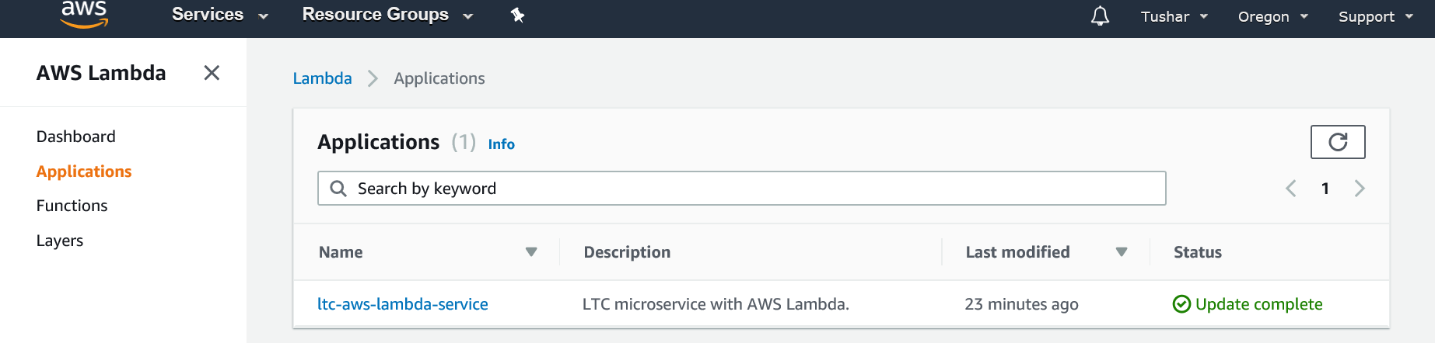

8. Go to AWS API Gateway Console and verify the created API as below:

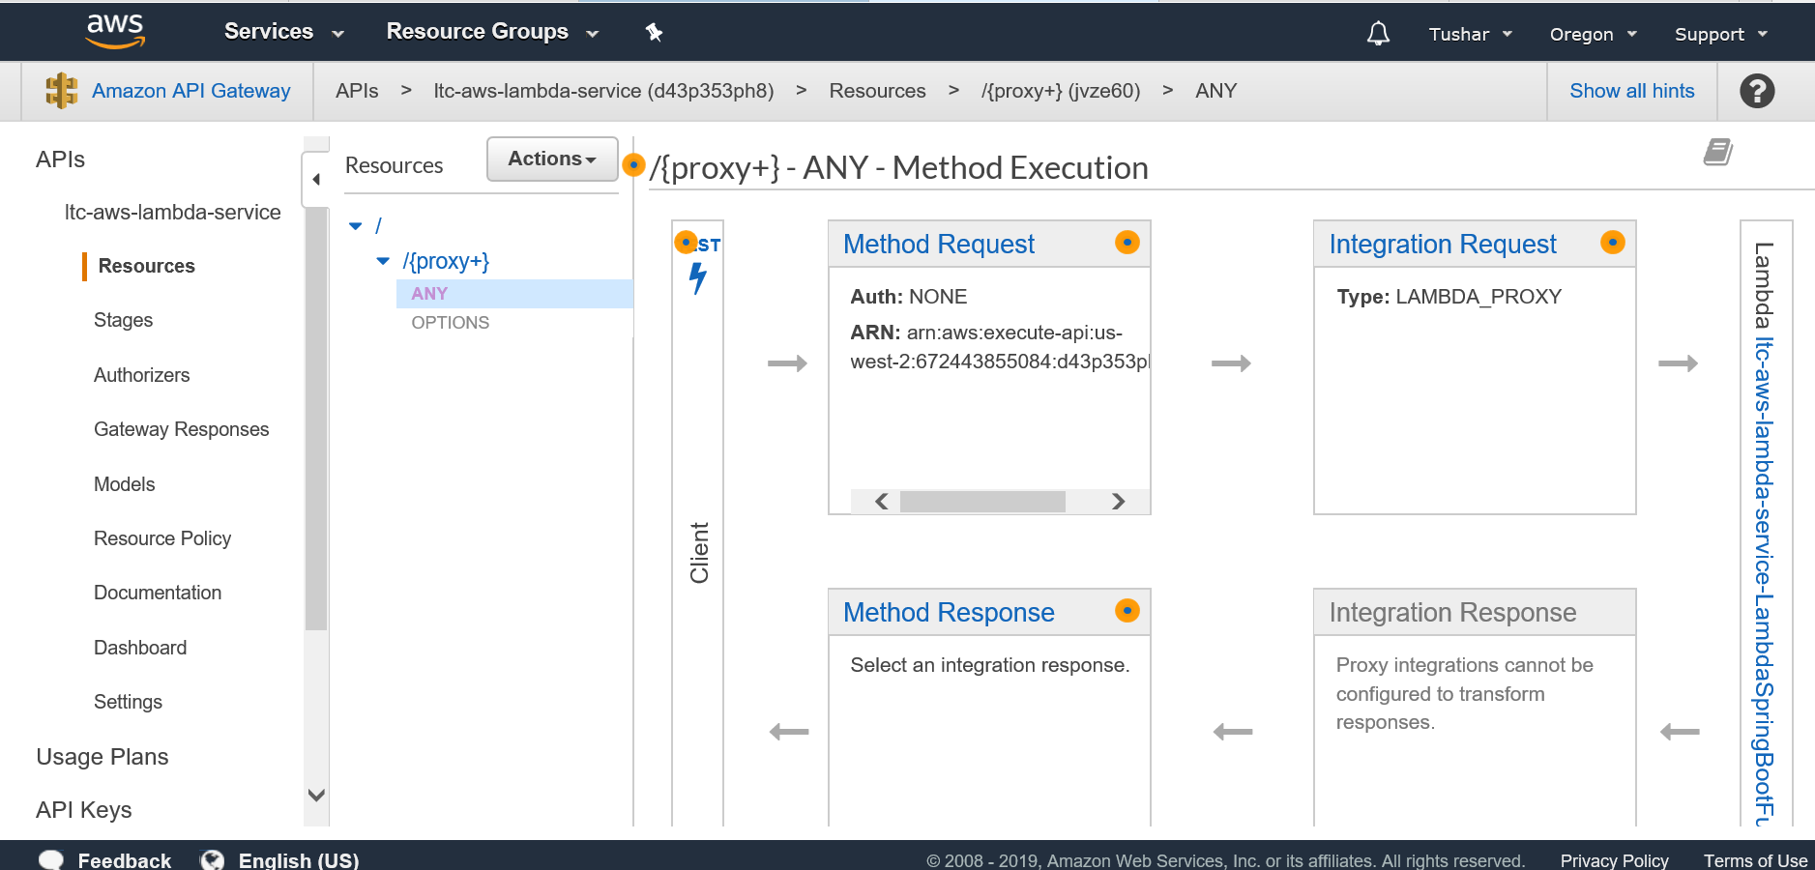

9. The API can be accessed with URL like below:

<https://d43p353ph8.execute-api.us-west-2.amazonaws.com/Prod/ltc?inputDate=05/09/2019>

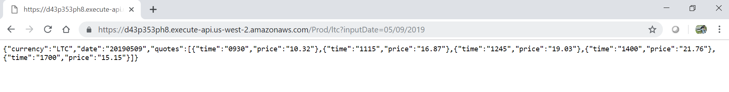

10. Monitor AWS Lambda dashboard for function metrics as below: