**Q-1** What is RDBMS?

**Ans**: - The software used to store, manage, query, and retrieve data stored in a relational database is called a relational database management system (RDBMS).

* The RDBMS provides an interface between users and applications and the database, as well as administrative functions for managing data storage, access, and performance.
* Relational Database Management System (RDBMS) is a more advanced version of a DBMS system that allows access to data in a more efficient way. It is used to store or manage only the data that are in the form of tables.

**Example**: Oracle, SQL Server.

**Q-2** What is SQL?

**Ans**:- **SQL** stands for Structured Query Language.

SQL is a standard language for storing, manipulating and retrieving data in databases. SQL allows you to access and manipulate the databases. To use SQL in: MySQL, SQL Server, MS Access, Oracle, Sybase, Informix, Postgres, and other database systems.

**Q-3** Write SQL Commands.

**Ans**:- 1) DDL-data definition language

2)DQL-data query language

3)DML-data manipulation language

4)DCL-data control language

5)TCL-transaction control language

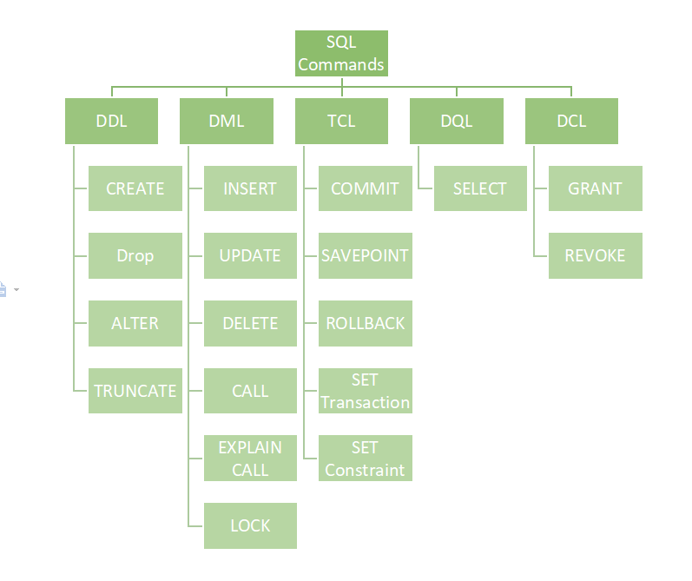

**Software Testing (Database)**

**Q-4** What is join?

**Ans**:- SQL Join statement is used to combine data or rows from two or more tables based on a common field between them.

**Q-5** Write type of joints.

**Ans**:-

* INNER JOIN
* LEFT JOIN
* RIGHT JOIN
* FULL JOIN

1. **Inner Join**:-The INNER JOIN keyword selects all rows from both the tables as long as the condition is satisfied. This keyword will create the result-set by combining all rows from both the tables where the condition satisfies i.e value of the common field will be the same.
2. **Left Join**:- This join returns all the rows of the table on the left side of the join and matches rows for the table on the right side of the join. For the rows for which there is no matching row on the right side, the result-set will contain null. LEFT JOIN is also known as LEFT OUTER JOIN.
3. **Right Join**:-RIGHT JOIN is similar to LEFT JOIN. This join returns all the rows of the table on the right side of the join and matching rows for the table on the left side of the join. For the rows for which there is no matching row on the left side, the result-set will contain null. RIGHT JOIN is also known as RIGHT OUTER JOIN.
4. **Full Join**:-FULL JOIN creates the result-set by combining results of both LEFT JOIN and RIGHT JOIN. The result-set will contain all the rows from both tables. For the rows for which there is no matching, the result-set will contain NULL values.

**Q-6** How many constraints and describes itself.

**Ans**:- constraints are used to specify rules for the data in a table.

Constraints can be column level or table level. Column level constraints apply to a column, and table level constraints apply to the whole table.

**Constraints:-**

**NOT NULL** - Ensures that a column cannot have a NULL value

**UNIQUE** - Ensures that all values in a column are different

**PRIMARY KEY** - A combination of NOT NULL and UNIQUE. Uniquely identifies each row in a table

**FOREIGN KEY** - Prevents actions that would destroy links between tables

**CHECK** - Ensures that the values in a column satisfies a specific condition

**DEFAULT** - Sets a default value for a column if no value is specified

**CREATE INDEX** - Used to create and retrieve data from the database very quickly

**Software Testing (Database)**

**Examples**:-

1. **Not Null:**-

Create TABLE Employee

(

Emp_id int,

F_name text Not Null,

L_name text Not null,

Age int

);

1. **UNIQUE:-**

CREATE TABLE Employee

(

ID int NOT NULL UNIQUE,

F_Name varchar(255) NOT NULL,

L_Name varchar(255),

Age int

);

1. **PRIMARY** **KEY:**-

CREATE TABLE Employee

(

ID int NOT NULL PRIMARY KEY,

F_Name varchar(255) NOT NULL,

L_Name varchar(255),

Age int

);

1. **FOREIGN KEY:-**

create table Course

(

cid int PRIMARY key,

cname text,

cost int,

rates int

);

create table student

(

sid int,

sname text,

cid int,

primary key(sid),

FOREIGN KEY(cid) REFERENCES course(cid)

);

1. **CHECK:-**

CREATE TABLE Persons

(

ID int NOT NULL,

LastName varchar(255) NOT NULL,

FirstName varchar(255),

Age int CHECK (Age>=18)

);

**Software Testing (Database)**

1. **DEFAULT :-**

CREATE TABLE Persons

(

ID int NOT NULL,

LastName varchar(255) NOT NULL,

FirstName varchar(255),

Age int,

City varchar(255) DEFAULT 'Sandnes'

);

1. **CREATE INDEX:-**

CREATE INDEX idx

ON STUDENTS (NAME);

SELECT * FROM STUDENTS USE INDEX (idx);

**Q-7** Difference between RDBMS and DBMS

**Ans:-**

|  |  |
| --- | --- |
| **RDBMS** | **DBMS** |
| 1) Data stored is in table format. | 1) Data stored is in the file format. |
| 2) RDBMS supports multiple users. | 2) DBMS supports a single user. |
| 3) The software and hardware requirements are higher. | 3) The software and hardware requirements are low. |
| 4) **Example**: Oracle, SQL Server. | 4) **Example**: XML, Microsoft Access. |

**Q-8** what is an SQL alias?

**Ans:-** SQL aliases are used to give a table, or a column in a table, a temporary name. Aliases are often used to make column names more readable. An alias only exists for the duration of that query.An alias is created with the AS keyword.

**SELECT C.Cust_ID, C.Customer_Name, E.Emp_No, E.Emp_Name FROM Customer C, Employee E**

**WHERE C.Emp_No=E.Emp_No;**

**Q-9** Write a query to create a table in structured query language?

**Ans:-**

**CREATE TABLE Employee**

**(**

**Emp_No int,**

**Emp_Name varchar(50),**

**Salary int**

**);**

**Q-10** write a query to insert data into table?

**Ans:-**

**INSERT INTO Employee VALUES (101,’Tushar’, 50000);**

**Software Testing (Database)**

**Q-11** writes a query to update data into a table with validation.

**Ans:-**

**UPDATE Employee SET Salary=25000 WHERE Emp_Name='Dhara';**

**Q-12** writes a query to delete data from table with validation.

**Ans:-**

**DELETE FROM Employee WHERE Emp_No=104;**

**Q-13** write a query to insert new column in existing table.

**Ans:-**

**INSERT INTO Employee VALUES (101,’Tushar’, 50000);**

**Q-14** write a query to drop table and database.

**Ans:-**

**DROP TABLE Employee;**

**Q-15** write a query to find max and min value from table**.**

**Ans:-**

**SELECT MIN(Salary) AS Minimum_Salary FROM Employee;**

**Output :**

**Minimum_Salary**

**15000**

**SELECT MAX(Salary) AS Maximum_Salary FROM Employee;**

**Output :**

**Maximum_Salary**

**55000**

**Q-16** Create a table named seller and product apply foreign key in product table fetch data from both using different joins.

Ans:-

**create table seller**

**(**

**sel_ID int PRIMARY KEY,**

**sel_Name varchar(30),**

**Description text**

**);**

**insert into category values(1, 'raj', 'Soft drinks, coffee, tea');**

**insert into category values(2, 'rohan', 'Milk, buttermilk, curd, butter, cheese');**

**insert into category values(3, 'jack', 'ketch-up, mayo');**

**Software Testing (Database)**

**create table Product**

**(**

**Pro_id int,**

**Pro_name varchar(30),**

**sel_ID int,**

**Price int,**

**PRIMARY KEY (Pro_id),**

**FOREIGN KEY (Cat_ID) REFERENCES**

**category(sel_ID)**

**);**

**insert into Product values(1, 'Pepsi', 1, 90);**

**insert into Product values(2, 'Real Jiuce', 1, 50);**

**insert into Product values(3, 'Red Bull', 1, 125);**

**insert into Product values(4, 'Amul Butter', 2, 158);**

**insert into Product values(5, 'Go Cheese', 2, 178);**

**insert into Product values(6, 'Maggie Spicy', 3, 230);**

**insert into Product values(7, 'Kissan Sweet', 3, 199);**

**Inner join:-**

**Select product.pro_id, product.Pro_name, category.sel_Name from product INNER JOIN category on**

**product.sel_ID=category.sel_ID;**

**Left join:-**

**Select category.sel_Name, product.Pro_name from category LEFT**

**OUTER JOIN product on product.sel_ID = category.sel_ID;**

**Right join:-**

**Select category.sel_Name, product.Pro_name from category RIGHT**

**OUTER JOIN product on product.sel_ID = category.sel_ID;**

**Full join:-**

**Select category.sel_Name, product.Pro_id from category FULL JOIN product on product.sel_ID=category.sel_ID;**

**Software Testing (Database)**

**Q-17** What is API Testing?

**Ans: -** API is a Software Interface that allows two applications to interact with each other without any user intervention.

The purpose of API Testing is to check the functionality, reliability, performance, and security of the programming interfaces.

**Q-18** Types of API Testing?

**Ans**: - **Open API**: These types of APIs are publicly available to use like OAuth APIs from Google. It has also not given any restriction to use them. So, they are also known as Public APIs.

**Partner API**: Specific rights or licenses to access this type of API because they are not available to the public.

**Internal API**: Internal or private. These APIs are developed by companies to use in their internal systems. It helps you to enhance the productivity of your teams.

**Q-19** What is Responsive Testing?

**Ans: -** To check the responsiveness of our website on multiple devices is simply called responsive testing. The goal of responsive testing is to ensure that the website or web application can be used effectively on various devices, including desktops, laptops, tablets, and smartphones.

**Q-20** Which types of tools are available for Responsive testing?

**Ans**:-

* **LT Browser**
* **Lambda Testing**
* **Google Resizer**
* **am I responsive**
* **Pixel tuner**

**Q-21** What is full form of .ipa, .apk

**Ans**: - .ipa-------- **iOS International Phonetic Alphabet**

.apk------ **Android Package Kit**

**Q-22** How to create steps to open the developer option mode on?

**Ans: -** **Step 1**: Go to Settings >my Phone.

**Step 2**: Tap Software Info > Build Number.

**Step 3**: Tap Build Number seven times. After the first few taps, you should see the steps counting down until you unlock the developer options. You may also have to tap in your PIN for verification.

**Step 4**: Once developer options are activated, you will see a message that reads, you are now a developer.

**Step 5**: Go back to the Settings pane, where you will now find Developer options as an entry.

**Step 6**: Tap it and toggle (USB debugging) the switch on if it is not already, and from there, you can proceed to make adjustments to your phone.