**Q-1** what is exploratory Testing?

**Ans:-**  Exploratory testing is a concurrent process where Test design execution and logging happen simultaneously.

Explore the app features and in an unstructured method, find the defect.

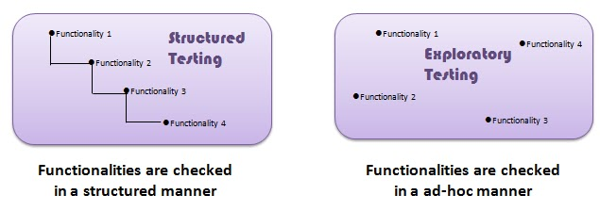

**Q-2** What is a traceability matrix?

**Ans**:- Test conditions should be able to be linked back to their sources in the test basis, this is known as traceability. A software process should help you keep the virtual table up-to-date. To find out the cause of the defect. To ensure the complete coverage of testing.

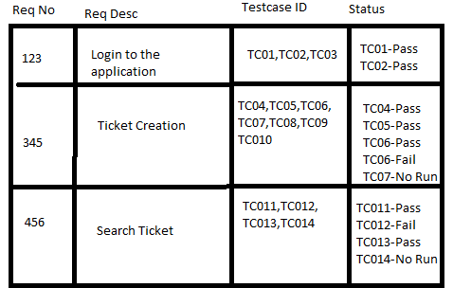

**Q-3** What is Boundary value testing?

**Ans :-** The method refines the EP method, where

we can just analyze the boundary to get the valid range.

Boundary value analysis is a methodology for designing test cases that concentrates software testing effort on cases near the limits of valid ranges.

|  |  |  |
| --- | --- | --- |
| **Boundary Value Analysis(Age accepts 18 to 56)** | | |
| Invalid  (min-1) | Valid  (min, min + 1, nominal, max – 1, max) | Invalid  (max + 1) |
| 17 | 18, 19, 37, 55, 56 | 57 |

**Q-4** Equivalence partitioning testing?

**Ans**:- We are checking a range of numbers by this method.

In this method, Divide the range by equivalence partitions, then

select one representative value from each partition to test the whole

partition as pass(in range) or fail(out of range).

Aim is to treat groups of inputs as equivalent and to select one

representative input to test them all.

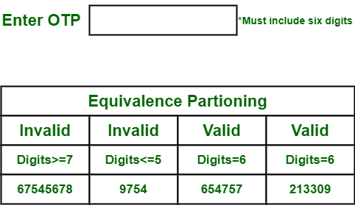

**Q-5** what is integration testing?

**Ans**:- Integration Testing is a level of the software testing process

where individual units are combined and tested as a group.

Either Developers themselves or independent Testers perform

Integration Testing.

**Q-6** what is determines level of risks?

**Ans:- Types of Risk:**

1) Project Risk

-Can be arised before manufacturing of the product.

(before open to the market)

2) Product Risk

-Can be arised after manufacturing of the product.

(after open to market)

**Q-7** What is alpha Testing?

**Ans:-** Alpha Testing is deﬁnitely performed and carried out at the developing organizations location with the involvement of developers. Alpha Testing is not open to the market and public It is always performed within the organization.Alpha testing on "Project". It is performed in a virtual environment.It is a combination of Black Box Testing & white box testing.

**Q-8** What is beta Testing?

**Ans:-** It is always performed by the customers at their own site.It is only performed by Independent Testing Team.Beta Testing is always open to the market and public.Beta testing on "Product" It is performed in Real Time Environment.It is only a kind of Black Box Testing.

**Q-9** What is component testing?

**Ans:-**Component Testing – The testing of individual software components.

A unit is the smallest testable part of an application like functions/procedures, classes, interfaces.The goal of unit testing is to isolate each part of the program and show that the

individual parts are correct.

**Examples**:-

**username**

**password**

**email**

(username & password both are integrated and tested together always)

**Q-10** What is functional system testing?

**Ans** :- Testing the attributes of the system that are directly affected to the functionalities of the system.

**Example:-**  to check the accuracy, functions, Interoperability

Functional Testing Examples :

-----------------------------------------------------------------------

-Check OTP for any transaction

-To check the score for every gaming level.

**Q-11** What is non-functional testing?

**Ans**:-Testing the attributes of the system that are not directly affected to the functionalities of the system.

**Example:-** performance, load, GUI, security, usability

Non- Functional Testing Examples :

-----------------------------------------------------------------------

In mobile , automatically will switch oﬀ without any reason.

**Q-12** What is GUI testing?

**Ans:-** Graphical User Interface (GUI) testing is the process of testing the system’s GUI of the System under Test. GUI testing involves checking the screens with the controls like menus, buttons, icons, and all types of bars – toolbar, menu bar, dialog boxes and windows etc.

**Q-13** What is Ad-hoc testing?

**Ans:-** Adhoc testing is an informal testing type with an aim to break the system.if the knowledge of testers in the system under test is very high.Main aim of this testing is to ﬁnd defects by random checking. Adhoc testing can be achieved with the testing technique

called Error Guessing.The Error guessing is a technique where the experienced and good testers are encouraged to think of situations in which the software may not be able to cope.

**Q-14** What is load testing?

**Ans**:-Stability + response time + applying load (app will with stand with designed no. of users)

**Example:-** app will handle 1000 users at every 5 sec.

You have to check 1000 or <=1000 users with your app.

**Q-15** What is stress testing?

**Ans**:- System is stressed beyond its specifications to check how and when it fails. Performed under heavy load like putting large number beyond storage capacity, complex database queries, continuous input to system or database load.

Example:- app will handle 1000 users at every 5 sec.

You have to check 1000 or >=1000 users with your app.

**Q-16** what is white box testing? And list the types of white box testing?

Ans:- White Box Testing: Testing based on an analysis of the

internal structure of the component or system.

Also known as "Glass box testing" or "Open box testing".

**Example:-**  When we debug the code when we writing.

knowledge about OS, programming language. technology.

|  |
| --- |
| Input  Output |

**list the types of white box testing:-**

* Statement / segment coverage
* Decision / branch coverage
* Condition coverage

**Q-17** What is a black box testing? What are the different black box testing?

**Ans**:-The technique of testing without having any knowledge of the

the interior workings of the application is Black Box testing.

Directly executing the executable code without source code.

The testers have no knowledge of how the system or component is

structured inside the box.

A tester will interact with the system's user interface by

providing inputs and examining outputs without knowing how

and where the inputs are worked upon.

**Different black box testing:-**

1. Equivalent Partitioning
2. Boundary Value Analysis
3. Decision Table
4. State Transition Tech
5. Use-case Testing

**Q-18** What is bigbang testing?

**Ans**:- In Big Bang integration testing all components or modules is

integrated simultaneously, after which everything is tested as

a whole.

all components are integrated together at once, and then tested.

**Pros :**

-Easy for a smaller system.

**Cons :**

-Fault identification is diﬃcult.

-there should be chance to miss out to test any module or component

for integration.

-testing team will have less time for execution in the testing because

tested as a whole.

-all modules are tested at once, high risk for module isolation

**Q-19** What is the purpose of exit criteria?

**Ans** :- How do we know when to stop testing?

* Running out of time.
* Run out of budget.
* The business tells you it went live last night.
* Boss says stop.
* All defects have been fixed.
* When our exit criteria have been met.

**Q-20** When should “regression testing” be performed?

**Ans:-** To test all the testcases whether they are positive or negative.

Like there is some change in code for the previous build like insert, delete or updating any functionality or bug fixing should not affect the current functionalities.

Test cases need to be rechecked repeatedly.

Regression Testing Tools

-------------------------------------

-QTP (Quick Test Professional)

-Selenium

**Q-21** What is 7 key principles? Explain in detail?

**Ans** :-

1. Testing shows presence of Defects
2. Exhaustive Testing is Impossible!
3. Early Testing
4. Defect Clustering
5. The Pesticide Paradox
6. Testing is Context Dependent
7. Absence of Errors Fallacy
8. **Testing shows presence of Defects** **:-** Testing can show that defects are present, but cannot prove that there are no defects.

Testing reduces the probability of undiscovered defects remaining in the software but, even if no defects are found, it is not a proof of correctness. We test to find Faults.However Testing cannot prove that there are no defects present.

1. **Exhaustive Testing is Impossible! :-** Testing everything including all combinations of inputs and preconditions is not possible.So, instead of doing the exhaustive testing we can use risks and priorities to focus testing efforts.That is we must Prioritise our testing effort using a Risk Based Approach.
2. **Early Testing :- T**esting activities should start as early as possible in the software or system development life cycle, and should be focused on defined objectives.Testing activities should start as early as possible in the development life cycle These activities should be focused on defined objectives – outlined in the Test Strategy.
3. **Defect Clustering :-** A small number of modules contain most of the defects discovered during pre-release testing, or are responsible for the most operational failures. Defects are not evenly spread in a system .They are ‘clustered’.
4. **The Pesticide Paradox :-** If the same tests are repeated over and over again, eventually the same set of test cases will no longer find any new defects. As software improves the effectiveness of previous tests erodes.
5. **Testing is Context Dependent :-** Therefore we must learn, create and use new tests based on new techniques to catch new bugs.
6. **Testing is Context Dependent :-** Different kinds of sites are tested differently.Testing is basically context dependent.Testing is done differently in different contexts.

**Q-22** Difference between QA v/s QC v/s Tester.

**Ans** :-

|  |  |  |
| --- | --- | --- |
| **QA** | **QC** | **Tester** |
| 1. It is a Process oriented activities. | 1. It is a Product oriented activities. | 1. It is a Product oriented activities. |
| 1. It is a Preventive activities.. | 2) It is a corrective process | 2) It is a preventive process. |
| 1. It is a subset of the Software Test Life Cycle (STLC). | 3) QC can be considered as the  subset of Quality Assurance. | 3) Testing is the subset of  Quality Control. |
| 1. Focuses on processes and   procedures rather than conducting  actual testing on the system. | 4) Focuses on actual testing by  executing Software with intend  to identify bug/defect through  implementation of procedures  and process. | 4) Focuses on actual testing. |

**Q-23** difference between smoke and sanity testing.

**Ans** :-

|  |  |
| --- | --- |
| **Smoke testing** | **Sanity testing** |
| 1. After receiving software build, smoke testing will be performed to check the critical(mandatory) functionalities of the app. | 1. After receiving a software build, with minor changes in code, or functionality, Sanity testing is performed to check that the bugs have been ﬁxed and no further issues are introduced due to these changes. |
| 1. Smoke testing is also called subset of acceptance testing. | 2) Sanity testing is also called subset of regression testing. |
| 1. Smoke testing is performed by either developers or testers. | 3) Sanity testing is normally performed by testers. |
| 1. Smoke testing is used to test all over function of the system/product. | 4) Sanity testing is used in the case of only  modified or defect functions of system/products. |
| 1. Smoke testing is documented | 5) Sanity testing isn’t documented. |

**Q-24** difference between verification and validation.

**Ans:**-

|  |  |
| --- | --- |
| **Verification** | **Validation** |
| 1. Verification is a process which is performed at development level. | 1. Validation is a process which is performed at testing level. |
| 1. Verification phases are :  * Business Requirement Analysis * System Design/ System Requirement * Architectural Design (Technical Specification) * Module Design (Program Specification) | 2) Validation Phases are :   * Unit Testing * Integration Testing * System Testing * Acceptance Testing |
| 1. Verification activities are Reviews and Inspections. | 3) Validation activity is Testing. |

**Q-25** Explain types of performance testing?

**Ans**:- 1)  **Load testing:-** Load testing is performance testing that measures how well a system can handle a high amount of traffic or user interactions. It's important to ensure that a website, [web app](https://www.globalapptesting.com/blog/web-app-testing), or application can handle [real-world](https://www.globalapptesting.com/challenge/real-device-testing) usage without crashing or slowing down.

**Example**

1. Send 100 simultaneous GET requests to the endpoint.
2. Track response times, throughput, and errors.

2) **Stress testing**:- Stress testing measures how well a system can handle a high amount of stress or extreme conditions. Unlike load testing, which focuses on testing a system's performance under expected loads, stress testing pushes a system beyond its limits to see how it responds under extreme conditions.

**Example**

1. Identify when the system starts to degrade or exhibit abnormal behavior.
2. Analyze any performance bottlenecks, errors, or failures encountered during stress testing.

3) **Scalability testing:-** Scalability testing evaluates a system's ability to handle increased workloads as the number of users or transactions grows. This testing is crucial because it ensures the system can perform effectively even under high-traffic conditions**.**

**Example**

1. Upgrade existing resources (e.g., CPU, memory) to assess the system's ability to scale vertically.
2. Evaluate the system's scalability characteristics and determine any bottlenecks or limitations encountered during testing.

4) **Volume testing:-** Volume testing measures how well a system can handle extensive data and aims to identify how it responds when a large amount of data is loaded. This type of testing is important for databases and other data-heavy systems to ensure that they remain functional and performance even under heavy data loads.

**Example**

1. Load the generated data into the database system, ensuring it reaches maximum capacity.
2. Execute various database queries on the voluminous dataset, including read, write, update, and delete operations.

5) **Soak testing:-**Soak testing is a type of testing that measures how well a system performs under sustained use over an extended period. Soak testing aims to identify performance issues that may not be visible during shorter stress or load tests but can occur over a more extended period of use

**Example**

1. Run the test for 24 hours to simulate continuous usage.
2. Continuously monitor system performance, resource utilization, and error rates.
3. Identify any degradation, memory leaks, or other issues over time.

6) **Spike testing**:- Spike testing is a type of testing that measures how well a system can handle sudden and extreme increases in traffic or usage. It aims to identify how a system responds to sudden spikes in usage, such as when a website goes viral, or an application experiences a sudden surge of user interactions

**Example**

1. Suddenly increase the number of concurrent users or requests.
2. Generate a significant and rapid surge in traffic to stress the system.

**Q-26** What is Error, Defect, Bug and failure?

**Ans** :-

* 1) Error :- error in coding and programming that is called error.
* 2) Defect :- error found by a Tester that is called Defect.
* 3) Bug :- defect accepted by developer and developer team that is called bug.
* 4) failure :- build does not meet requirement and expectation that is called failure.

**Q-27** Difference between priority and severity

**Ans**:-

|  |  |
| --- | --- |
| Priority | Severity |
| 1)Defect Priority has defined the order in which the developer should resolve a defect. | 1)Defect Severity is defined as the degree of impact that a defect has on the operation of the product. |
| 2) Priority is categorized into three types   * Low * Medium * High | 2)Severity is categorized into five types   * Critical * Major * Moderate * Minor * Cosmetic |
| 3)Priority is driven by business value. | 3)Severity is driven by functionality. |

**Q-28** what is Bug Life cycle?

**Ans**:-

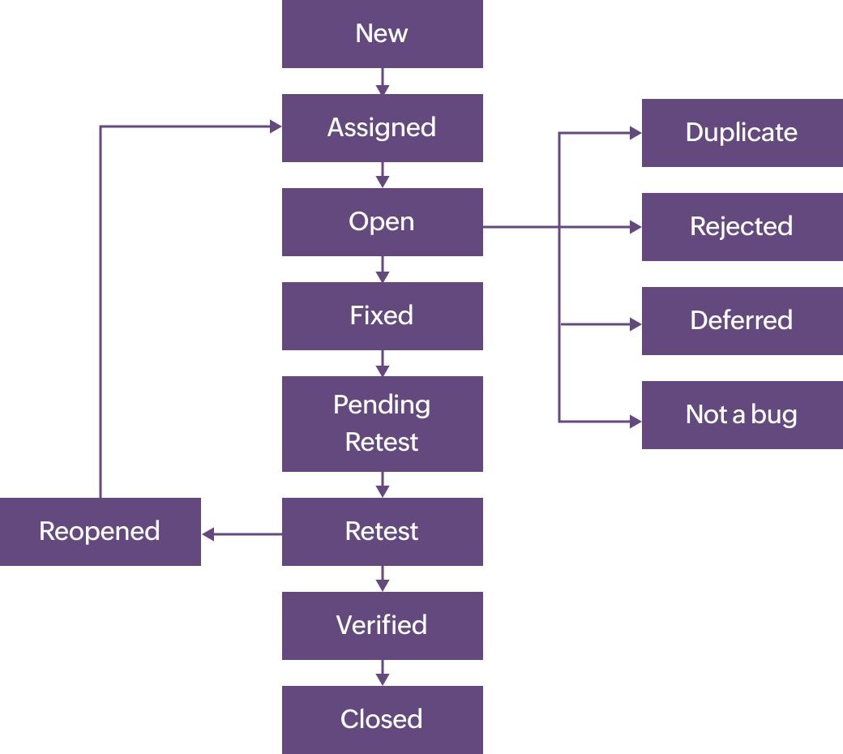

The duration or timespan between the first time defect found and the time when defect closed, rejected, deferred or postponed is called defect life cycle.

1. **NEW**:- Defect raised by TE (Test Engineer)
2. **Assigned**:- Defect posted by TE & assigned to DEV
3. **Open**:- DEV works on defect fixing
4. **Fixed** :- DEV changes and verifies the code as fixed.
5. **Pending retest**:- DEV gives the particular code to TE for re-testing
6. **Retest** :- TE retests that code to check, a bug is fixed or not.
7. **Verified** :- TE retest that code & make sure the bug is fixed by DEV.
8. **Closed** :- A bug no longer exists, said by TE.
9. **Re opened**:- Again bug raised after fixing it by the DEV. TE reopens it.

**Duplicate** : Defect repeating twice.

**Rejected**: DEV feels defect is not genuine.

**Differed**: Present bug not having prime priority. Defect can be fixed in next release.

**Not a bug**: Defect does not affect the functionality of an app.

**Q-29** explain the difference between functional and non functional testing?

**Ans**:-

|  |  |  |
| --- | --- | --- |
| **No** | **Functional testing** | **Non functional testing** |
| 1 | Functional testing is performed using the Non-Functional functional specification provided by the client and verifies the system against the functional requirements. | Testing checks the Performance,reliability, scalability and other non-functional aspects of the software system. |
| 2 | Functional testing is executed first | Non functional testing should be performed  after functional testing |
| 3 | Manual testing or automation tools can be used for functional testing | Using tools will be effective for this testing |
| 4 | Types of Functional testing are  ∙ Unit Testing  ∙ Smoke Testing  ∙ Sanity Testing  ∙ Integration Testing  ∙ White box testing  ∙ Black Box testing  ∙ User Acceptance testing  ∙ Regression Testing | Types of Nonfunctional testing are  ∙ Performance Testing  ∙ Load Testing  ∙ Volume Testing  ∙ Stress Testing  ∙ Security Testing  ∙ Installation Testing  ∙ Penetration Testing  ∙ Compatibility Testing  ∙ Migration Testing |

**Q-30** difference between STLC and SDLC.

**Ans**:-

|  |  |
| --- | --- |
| STLC | SDLC |
| 1)Focused on software testing. | 1. Focused on software development. |
| 1. Helps to make software defects free. | 2) Helps to develop good quality software. |
| 1. QA team defines the test plan. | 3) Coders create a well-organized development plan. |

**Q-31** What is the difference between test case and test scenario and test script?

**Ans** :-

|  |  |  |
| --- | --- | --- |
| **Test scenario** | **Test cases** | **Test script** |
| 1. If any functionality that can be tested. | 1. A set of actions executed to verify particular features and functionality. | 1. Is the set of instructions to test the app automatically. |
| 1. Is more focused on “**what to be tested**.” | 2) Is more focused on “ **how to be tested**”. | 2) Is more focused on “**expected results**”. |
| 1. Induced end to end functionality to be tested. | 3) included test steps, test data and expected result tested. | 3) include different commands and scripts. |
| 1. It takes less time to create. | 4) requires more resources. | 4) required less time but more script and commands created. |

**Q-32** what is priority?

**Ans:-** If you are raising any bug for any application, how soon you want the developer to fix that bug is called **priority**. Priority is considered from the customer's point of view. But priority can be set by the QA tester. Later on it can be changed by project manager.

Priority is categorized into three types

* Low
* Medium
* High

**Q-33** what is severity?

**Ans**:- The impact of Defect /bug on the customer business workflow is known as Severity.If that impact is more then, there is high severity.If that impact is less then, there is low severity.

Severity is categorized into five types

* Critical
* Major
* Moderate
* Minor
* Cosmetic

**Q-34** bug categories are?

**Ans**:- · There is number of bug categories are as below

* + - · Security
    - · Database
    - · Functionality (General/Critical)
    - · UI

**Q-35** advantage of bugzilla?

**Ans**:-

* **Deadlines:** To fix the bugs, deadlines can be established.
  + **Types:** It reports in a variety of formats and types.
  + **Request System:** You can use the **'request system'** provided by Bugzilla to ask other users to evaluate codes, provide information and other things.
  + **Flexible:** Bugzilla is quite flexible, so you can modify it to fit your unique process and requirements.
  + **Bug tracking tool:** Bugzilla is extremely good at monitoring and handling bugs and issues.

**Q-36** difference between authorization and authentication in web testing? What are the common problems faced in web testing?

**Ans**:-

**Common problems:**

**Responsive Design Testing:**

* Ensuring web applications adapt seamlessly to different screen sizes and devices (desktops, tablets, smartphones) is crucial.

|  |  |
| --- | --- |
| **Authentication** | **Authorization** |
| 1. In the authentication process, the identity of users are checked for providing access to the system. | 1. While in the Authorization process, the person’s or user’s authorities are checked for accessing the resources. |
| 1. In the authentication process, users or persons are verified | 2) While in this process, users or persons are validated. |
| 1. It usually needs the user’s login details. | 1. While it needs the user’s privilege or security levels. |

**Q-37** what is different methodologies in agile development model?

**Ans**:- 1) scrum 2) kanban 3) jira

1. Scrum: -:Scrum is a framework through which we build software product by following Agile principles.SCRUM is an agile development method which concentrates particularly on how to manage tasks within a team based development environment.

**Roles**:

Product Owner

Scrum Master

Scrum Team

**Artifacts**:

Product Backlog

Sprint Backlog

Burn-down Charts

**Ceremonies**:

Spint Planning

Sprint Review

Sprint Retrospective

Daily Scrum Meeting

1. Kanban :- Kanban is a very popular framework for development in the agile software development methodology. It provides a transparent way of visualizing the tasks and work capacity of team.
2. Jira:- Jira is a Project management Tool. As Jira tool is used for planning, tracking and defect tracking tool. Follow Agile model To achieve SDLC, use Jira.

**Q-38** When to use Usability Testing?

**Ans**:- Aesthetics and design are important. How well a product looks usually.

* determines how well it works.
* There are many software applications / websites, which miserably fail,
* **once launched, due to following reasons –**
* Where do I click next?
* Which page needs to be navigated?
* Which Icon or Jargon represents what?
* Error messages are not consistent or effectively displayed
* Session time not sufficient.
* Usability Testing identifies usability errors in the system early in development.
* cycle and can save a product from failure.

**Q-39** What is the procedure for GUI Testing?

**Ans**:- Graphical User Interface (GUI) testing is the process of testing the system’s GUI of the System under Test. GUI testing involves checking the screens with the controls like menus, buttons, icons, and all types of bars – toolbar, menu bar, dialog boxes and windows etc.

-Check all the GUI elements for size, position, width, length and acceptance of

characters or numbers. For instance, you must be able to provide inputs to the

input ﬁelds.

-Check Font used in application is readable

-Check the alignment of the text is proper

-Check the Color of the font and warning messages is aesthetically pleasing

-Check that the images have good clarity

-Check that the images are properly aligned

-Font size, style, and color for headline, description text, labels, inﬁeld data, and

grid info should be standard as speciﬁed in SRS.

**Types of GUI testing :**

-----------------------------------------------------

**Manual based testing:-**

graphical screens are checked manually by testers

**Record & Replay:-**

GUI testing can be done using automation tools.

**Model based testing:-**

testing based on creating model by flow

e. g flow chart, charts, graph, decision table

**Q-40** Explain the different methodologies in the Agile development model?

**Ans**:-

Methodologies of Agile development:-

**Scrum, Kanban, XP**

1. **Scrum**:- SCRUM is an agile development method which concentrates particularly on how to manage tasks within a team based development environment.

**Scrum Roles:**

**1. Product owner**:

The Product Owner creates product backlog, prioritizes the backlog and is responsible

for the delivery of the functionality at each iteration.

(If a Client wants a company to develop Software then Company assign a role Product

Owner. He will be responsible for clients’ requirements and for software development.)

**2. Scrum Master**:

The main role to facilitate and drive the whole agile process He is responsible for setting

up the team, sprint meeting and removes obstacles to progress.

A person is responsible for delivery of product to customer within planned period of

time.

A person is working on project management tools like Jira.

A senior Developer or Tester, Project Manager or Business Analyst can be Scrum Master.

**3. Scrum Team:**

Team manages its own work and organizes the work to complete the sprint or cycle.

(People work on projects. They can be developers, testers or designers.)

**Scrum Artifacts:** The documentation and stuff which are prepared in scrum are known as Artifacts.

1. **Product Backlog:** Product Backlog is a collection of activities each and everything. It is created by the Product Owner. It contains a list of user stories prepared by the Product Owner.
2. **Sprint Backlog:**

List of committed stories by DEV/QA for specific Sprint.

1. **Burn down Chart**:

Burn down chart is the outcome of the sprint, which shows the progress in a sprint.

It shows how much work remains in the Sprint, maintained by Scrum Master daily.

**Scrum Ceremonies:**

**Sprint Planning:**Sprint planning is a meeting by Scrum Master or Product Master.Whatever listed in product backlog, follow all.

Assign the task to the developer and tester. First day or last day of sprint.

**Sprint Review:**After the completion of each sprint, the meeting is conducted with a client in which a product is shown to the client for demo and the team discusses the features they added in the project.

**Sprint Retrospective:** A retrospective is another meeting which is held between team members. In this meeting, they discuss what is right in this sprint and what went wrong in this sprint, such as the issues hampering their work.

**Daily Scrum:** In Scrum, meetings are conducted daily for 15 minutes by Scrum Master, where Scrum Master is the person who manages the meeting. Meeting consists of scrum master, developers, testers, designers, product owner, and the client where product owner and client are optional.

**2) Kanban:** Kanban is a very popular framework for development in the agile software development methodology.

|  |  |  |
| --- | --- | --- |
| **Question**  **No** | **Write a Positive and Negative Scenarios of real Object** | **Action** |
| 41 | Pen | **Please**  [**Click Here**](https://github.com/tusharsolanki26/MT_Assignment_2) |
| 42 | Elevator |
| 43 | Fan |
| 44 | Door |
| 45 | WhatsApp Chat |
| 46 | Pen Stand |
| 47 | ATM Machine |
| 48 | Microwave Owen |
| 49 | Coffee Vending Machine |
| 50 | Chair |
| 51 | Wrist Watch |
| 52 | Gmail – Compose Mail |
| 53 | Flipkart - Buy |
| 54 | WhatsApp - Payment |

|  |  |  |
| --- | --- | --- |
| **Question No** | **Practical Assignment to Create HLR, Test Scenarios & Test Cases – Web based** | **Action** |
| 55 | Instagram Login Page and chat | [Click Here](https://github.com/tusharsolanki26/MT_Assignment_2) |
| 56 | Facebook Login Page and chat | [Click Here](https://github.com/tusharsolanki26/MT_Assignment_2) |
| 57 | WhatsApp Web | [Click Here](https://github.com/tusharsolanki26/MT_Assignment_2) |