Homework #7 Amazon Elastic Compute Cloud Web Services

This semester we are allowing all students to explore cloud computing as offered by Amazon’s Web Services. Using the instructions below one can establish a website at AWS. Once established, you will be able to move your PHP program developed for Assignment #6 to your AWS website and have it execute there.

1. Sign up

To sign up for AWS, you need a credit card. If you do not have one, buy a $25 American Express Gift card at Ralphs or other grocery store.

To sign up go to:

http://aws.amazon.com

and click on Sign Up. Follow the instructions to create your account using the "AWS Free Usage Tier".

Please note that many of the URLs listed from now on will only be available if you are signed up to AWS.

2. Apply the $100 credit

Once you are signed up, login to your AWS account. Go to the URL:

http://aws.amazon.com/awscredits/

Enter the code that we will provide to you and click on Redeem Credit.

3. Provide Credit Card or Gift Card Information
- In the top menu, click on your name and select Billing and Cost Management in the drop down menu.
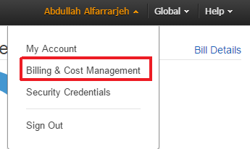
- In the left menu select Payment Methods
- Click on Add a Card button
- Provide your card information (Credit Card Number, Name of Cardholder, Expiration Data)

4. Set up the Default Elastic Beanstalk Application
- From the Services drop down in the top left select Console Home.
- From the list of Amazon Web Services, select Elastic Beanstalk, under Deployment & Management.
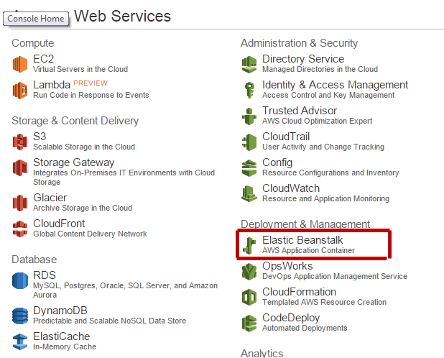
- Select Create a New Application in the top left menu and follow the Wizard.
- In the Application Info section, select a name for your application. Click Next.
- In the New Environment section: click on the Create Web Server button
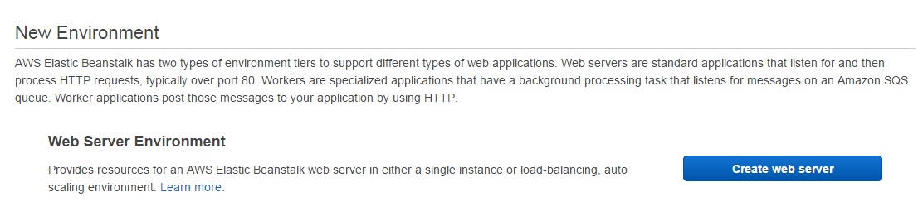
- In the Permissions pop-up window, select “Create an IAM role and instance profile”. Then click on the next button.
- In the Environment type section: choose the following options in the drop-down list
  - Predefined Configuration: PHP
  - Environment Type: Single Instance.
Then click on Next
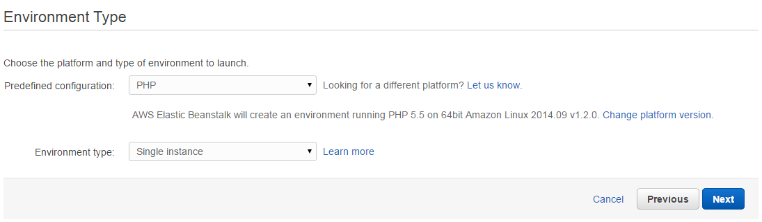
- In the Application Version section, select Sample Application. Click Next
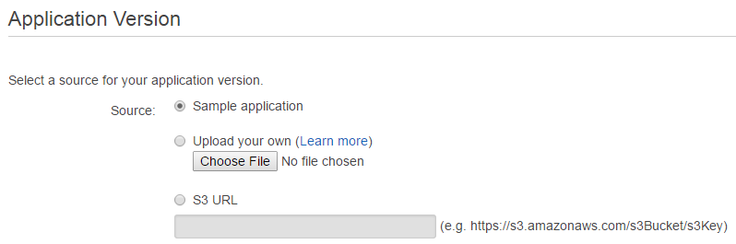
- In the Environment Information section, select an Environment URL (use the default or check availability of your own subdomain of elasticbeanstalk.com). Click on “Check Availability” button. Your URL should be green. Otherwise you should change the environment URL. Click Next.
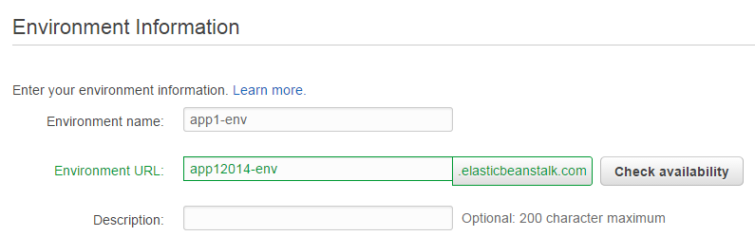
- In the Additional Resources section leave all boxes unchecked. Click Next.
- In the Configuration Details section. Accept default configuration (e.g., instance type is t1.micro) and click Next.
- In the Environment Tags section click Next.
- In the Review section click Launch, The default "My First Elastic Beanstalk Application will be created.

You will need to wait for several minutes as your Linux + Apache + PHP-5 instance is created and launched. You will see a rotating wheel next to the “Monitor” button. Once creation and launch are completed, you will see the wheel turn into a green round circle with a check mark in the middle.
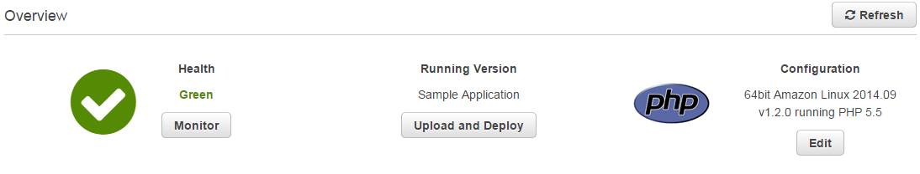

Beside “Default-Environment” subtitle there is a link such as YourAppName-env.elasticbeanstalk.com, click on it. You should see the "Congratulations" page. If you see it so your application and environment have been created properly. Then go back to Elastic Beanstalk console.
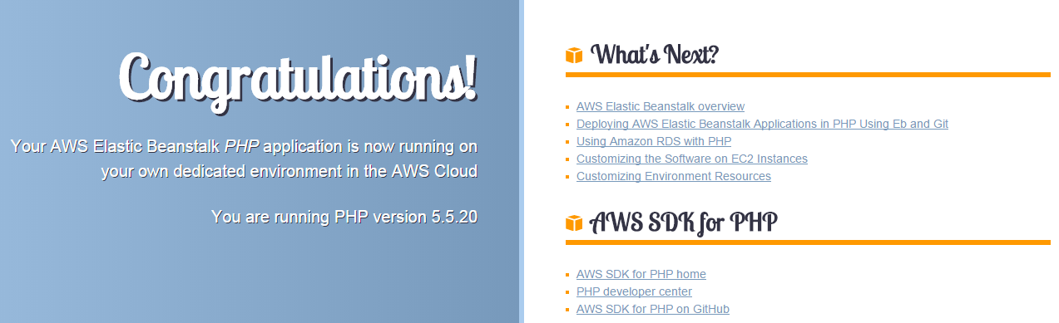

5. Upload your PHP application

Develop your PHP server application, and make sure that you name the file index.php. Compress the file with ZIP so that the resulting file is named index.php.zip. On a Mac you can use zip or gzip. On Windows there are several free programs 7-Zip or FreeZip, etc. that you can use.

From the Elastic Beanstalk console click on the Upload and Deploy button.

The Upload and Deploy popup will display. Enter a Version label (e.g., version1.0). Click on the Choose File button and select the index.php.zip file. Then click on Deploy button. Again wait several minutes for the rotating wheel to finish and the green circle with checkmark to appear. Click again on the link “YourAppName-env.elasticbeanstalk.com”. Check that your PHP app is running correctly.
- Important Note: in the future if you want to upload an updated version of index.php, you should enter a different version label. Otherwise, you will get an error.

To browse how your web service and application has been set up, go to the Services console (which is located in the top menu of Elastic Beanstalk console) and select the EC2 Service. You should see that you have 1 Running Instance (the 64-bit Linux service), 1 Volume (the 8GB disk hosting your instance), and 1 or no Load Balancer (managing port 80).

6. Set up Exploring Your Instance (Optional)

If you want to explore your Instance and create your own domain based URL with SSH control, you can add the following steps.

6.1 Get and Setup SSH

Once the PHP app with SSH-enabled environment is running, you can get access using SSH. You can use ssh on a Mac running OS X, or Putty when running on Windows.

On a Mac, SSH is built into OSX X and can be accessed through the Terminal app and there is no additional setup needed.

On a Windows PC, you will need to download the complete PuTTY distribution at:

http://www.chiark.greenend.org.uk/~sgtatham/putty/download.html

You should download the file putty.zip that contains all the binaries, including PuTTYgen at:

http://tartarus.org/~simon/putty-snapshots/x86/putty.zip

PuTTY needs additional setup as it needs to use a converted version of the private key. The instructions on how to perform such conversion are available here:

http://docs.aws.amazon.com/AWSEC2/latest/UserGuide/putty.html

6.2 Create a Key Pair

- From the Services drop down in the top right select Console Home.
- From Services, select the EC2 dashboard.
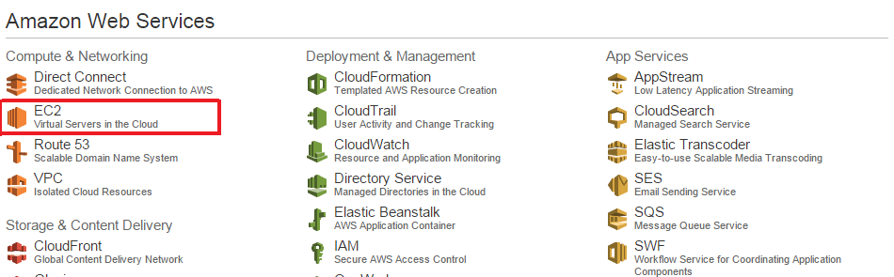
- Under NETWORK AND SECURITY select Key Pairs.
- Click on the button Create Key Pair.
- Enter a name like phphosts (you must have your own random name!) and click on Yes.
- A download of your private key should start. Save the key, like phphosts.pem, in an appropriate location.

6.3 Access your Linux Instance with SSH

- To see how to launch your SSH client go to Services and select EC2.
- Select Instances in the navigation pane at left.
- Select your instance in the table and select Connect button.
- “Connect To Your Instance” popup will display. Click on Connect with a standalone SSH client.

6.4.1 Mac running OS X / ssh

On a Mac you will need to enter a command like this one:

ssh -i phphosts.pem ec2-user@ec2-54-235-60-138.compute-1.amazonaws.com

type yes, when asked. Make sure that you are executing the ssh command in the same folder that contains the key. You should see output similar to this one:

$ ssh -i phphosts.pem ec2-user@ec2-54-235-60-138.compute-1.amazonaws.com
The authenticity of host 'ec2-54-235-60-138.compute-1.amazonaws.com (54.235.60.138)' can't be established.
RSA key fingerprint is 47:f7:b3:2f:88:b5:62:d9:6c:7c:60:19:53:cd:1a:0c.
Are you sure you want to continue connecting (yes/no)? yes
Warning: Permanently added 'ec2-54-235-60-138.compute-1.amazonaws.com,54.235.60.138' (RSA) to the list of known hosts.

__| __|_ )
_| ( / Amazon Linux AMI
___|\___|___|

https://aws.amazon.com/amazon-linux-ami/2012.09-release-notes/
There are 15 security update(s) out of 56 total update(s) available
Run "sudo yum update" to apply all updates.
[ec2-user@ip-10-158-56-168 ~]$

You can find more info here:

http://docs.aws.amazon.com/AWSEC2/latest/UserGuide/AccessingInstancesLinux.html - AccessingInstancesLinuxSSHClient

6.4.2 PC running Windows / PuTTY

In the popup windows titled Connect To Your Instance, click on Connect using PuTTY. You will be redirected to the URL.

http://docs.aws.amazon.com/AWSEC2/latest/UserGuide/putty.html

6.5 Explore

You can now explore your Instance. When you login with SSH, your account home directory will be located at:

/home/ec2-user

That folder is empty, and is not where your apache / PHP files are. Run 'ps -ax', and you should see several instances of httpd:

1940 ? S 0:00 /usr/sbin/httpd -D FOREGROUND
1941 ? S 0:00 /usr/sbin/httpd -D FOREGROUND
1942 ? S 0:00 /usr/sbin/httpd -D FOREGROUND
1944 ? S 0:00 /usr/sbin/httpd -D FOREGROUND
1945 ? S 0:00 /usr/sbin/httpd -D FOREGROUND

To see your mounted volumes, run 'df -h':

[ec2-user@ip-10-158-56-168 sbin]$ df -h
Filesystem Size Used Avail Use% Mounted on
/dev/xvda1 7.9G 1.3G 6.6G 17% /
tmpfs 298M 0 298M 0% /dev/shm
[ec2-user@ip-10-158-56-168 sbin]$

To see your document root, run 'ls /var/www/html/':

[ec2-user@ip-10-158-56-168 html]$ ls -l /var/www/html
lrwxrwxrwx 1 root root 16 Mar 22 20:38 /var/www/html -> /var/app/current
[ec2-user@ip-10-158-56-168 html]$

To see your uploaded index.php file:

[ec2-user@ip-10-158-56-168 sbin]$ cd /var/www/html
[ec2-user@ip-10-158-56-168 html]$ ls -l
total 4
-rw-r--r-- 1 webapp webapp 3723 Feb 5 02:09 index.php
[ec2-user@ip-10-158-56-168 html]$

To see your php.ini file, 'ls -l /etc/php.ini':

[ec2-user@ip-10-158-56-168 html]$ ls -l /etc/php.ini
-rw-r--r-- 1 root root 65782 Mar 22 20:38 /etc/php.ini
[ec2-user@ip-10-158-56-168 html]$

Have fun exploring AWS!!

