Installation **of Jenkins on Ubuntu.**

1. <https://vexxhost.com/resources/tutorials/how-to-install-configure-and-use-jenkins-on-ubuntu-14-04/>

**Step 1 : Sudo apt-get update**

**Step 2 : Basic Web Server**

Jenkins requires the basic web server installed on your system, so if you don’t have any of your web server installed on your operating system, you can execute the following command to install the web server.

apt-get install nginx

Once your Nginx web server is installed check the status of its services with the command below.

service nginx status

Expected output : * nginx is running

It means `Nginx` is working fine, so let’s proceed to next step.

**Step 3 : Java Installation**

Now install the Java first through the `apt-get` package manager. For this purpose, you will need to install open source implementation of JAVA Version 7. This is quite easy to do so by executing the command below.

apt-get install openjdk-7-jdk

It will take a few minutes to complete the Java installation. Once it is done, run the command below to check the installed version of Java on your system as shown.

java –version

**Step 4: Jenkins Installation and Configuration**

Now we are ready to install `Jenkins`. So before the package installation, we have to add the key and source list to apt for Jenkins. To do so, issue the following two commands in the terminal.

wget -q -O - https://jenkins-ci.org/debian/jenkins-ci.org.key | sudo apt-key add -

OK

You will get the `OK` status after you add the key. For the source list, here is the command to run.

**Step 5 :**

sudo sh -c 'echo deb http://pkg.jenkins-ci.org/debian binary/ > /etc/apt/sources.list.d/jenkins.list'

Now it needs to update `apt’s` cache before moving to Jenkins so that it can refresh the operating system’s repository for the latest packages.

**Step 6 : root@ubuntu-14:~# apt-get update**

**Step 7 : Install jenkins.**

Once your system is updated, execute the command below for the installation of Jenkins and type the `Y` key to proceed with the installation process.

apt-get install Jenkins

The installation process will end up with starting its daemon. To check the status of Jenkins service, the command below will show you its status with running process ID. Jenkins service run with its default user name `jenkin`.

service jenkins status

Jenkins Continuous Integration Server is running with the pid 16997

If you need to update the configurations of Jenkins as per your requirements, then you can find its configuration file under the `/etc/default/` directory and can make the changes.

vim /etc/default/Jenkins

Jenkins runs on port 8080 by default for HTTP connector. Now let’s open your web browser to use its GUI.

Jenkins GUI

Step 1 :

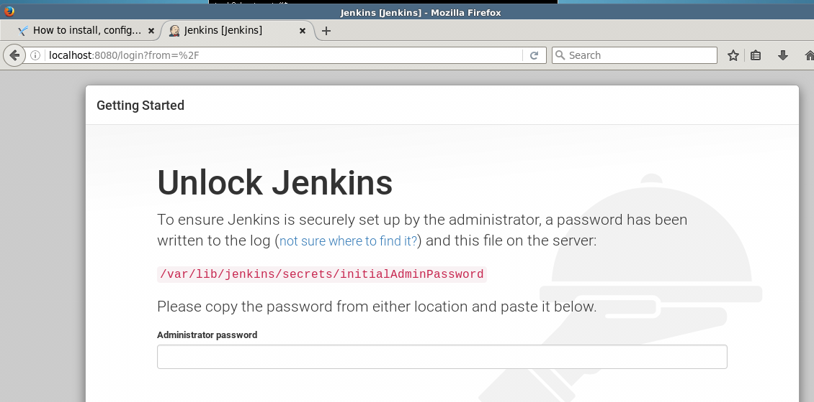

Step 2: Setup proxy

Server 10.207.192.131

Port 808

Step 3: Install plugins

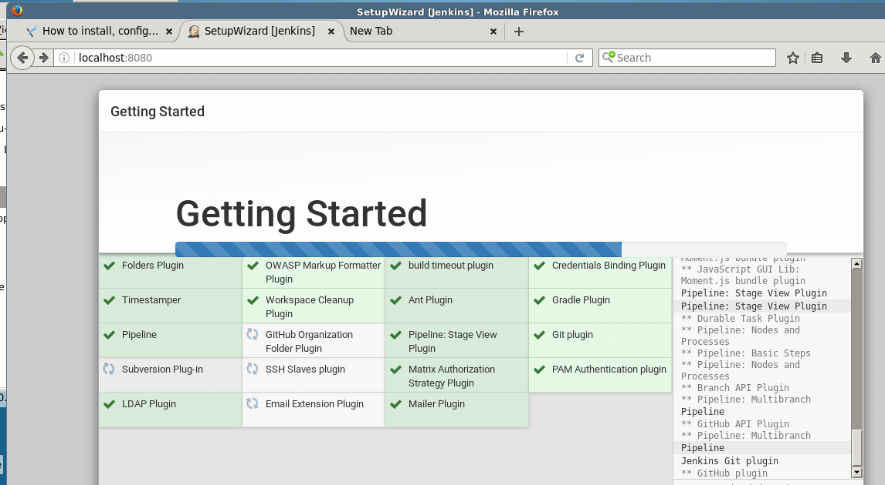

Step 4 : Create admin user

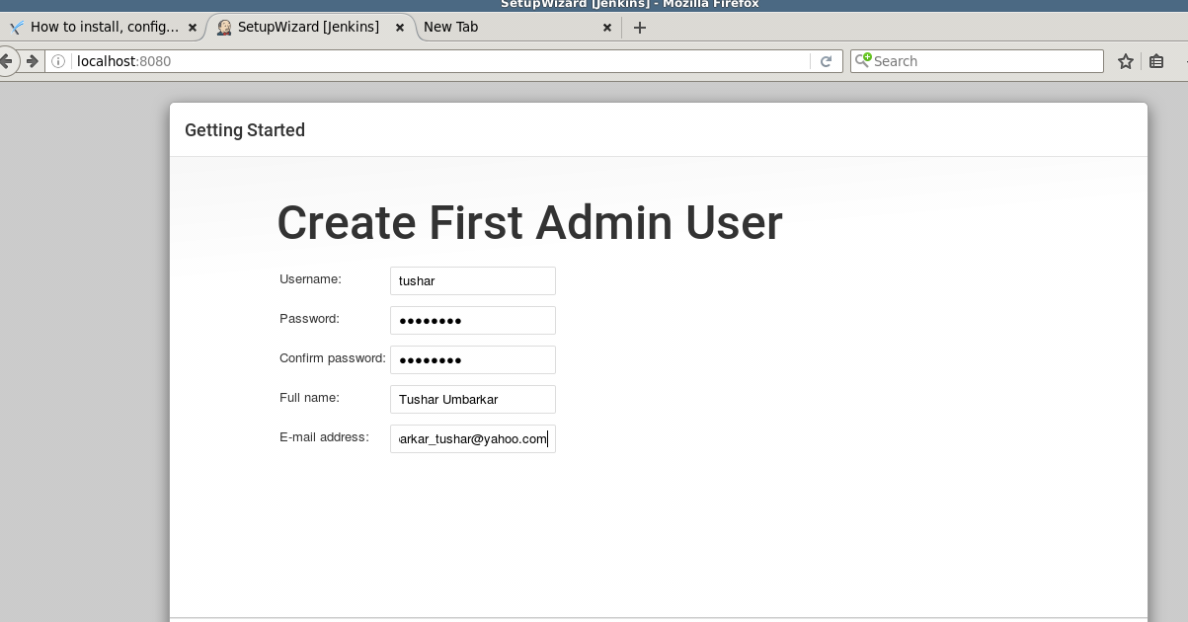

tushar/hpinvent

Step 5 : Ready to create jenkins job

