**Step 1 : Create user Jenkins**

stack@ubuntu-ci:~$ sudo su -s /bin/bash jenkins

[sudo] password for stack:

jenkins@ubuntu-ci:/home/stack$

**step 2 : generate sshkey**

jenkins@ubuntu-ci:/home/stack$ ssh-keygen -t rsa -b 4096

Generating public/private rsa key pair.

Enter file in which to save the key (/var/lib/jenkins/.ssh/id_rsa):

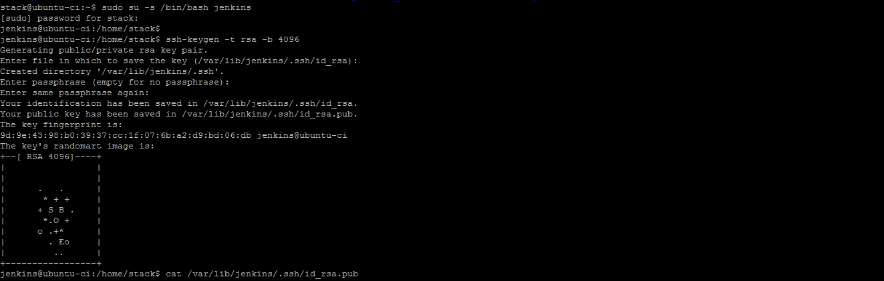

**Step 3 : start the ssh-agent in the background**

eval $(ssh-agent -s)

**Step 4 : Add your SSH key to the ssh-agent**

$ ssh-add ~/.ssh/id_rsa

**Step 5 : Copy the public key and add it to the github account.**

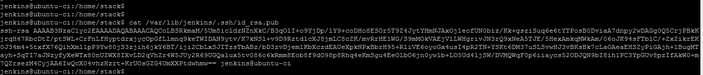

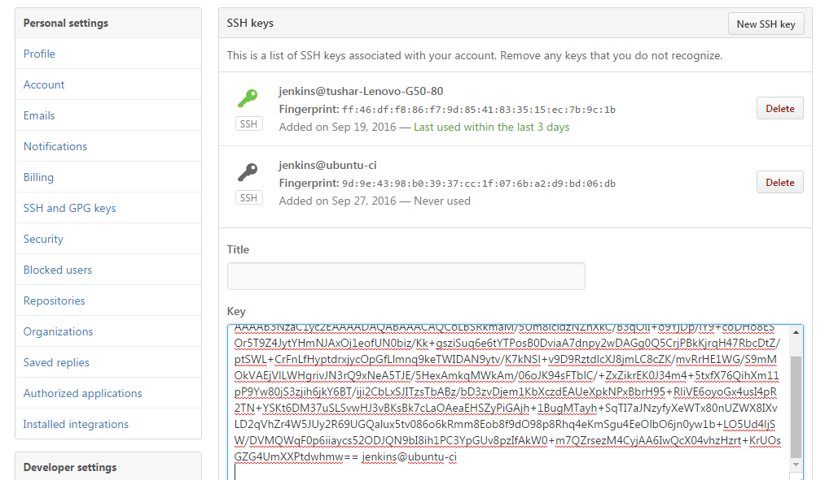

**Step 4 : Try to access github.com using ssh**

ssh -T [git@github.com](mailto:git@github.com)

**expected output –**

The authenticity of host 'github.com (192.30.252.1)' can't be established.

RSA key fingerprint is nThbg6kXUpJWGl7E1IGOCspRomTxdCARLviKw6E5SY8.

Are you sure you want to continue connecting (yes/no)?

**Verify that the fingerprint in the message you see matches the following message, then type yes**

Hi username! You've successfully authenticated, but GitHub does not provide shell access.

**Step 5 : Install git plugin and github plugin in manage plugin option.**

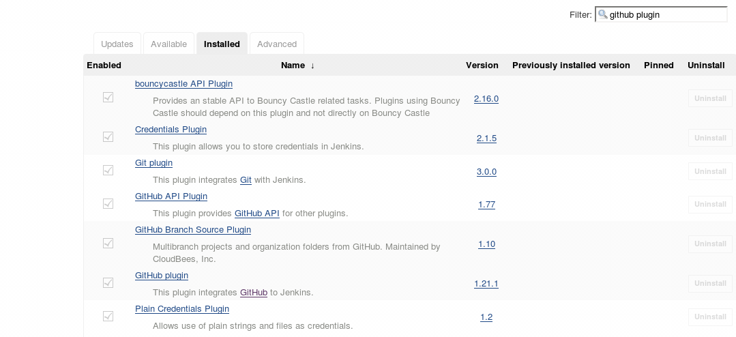

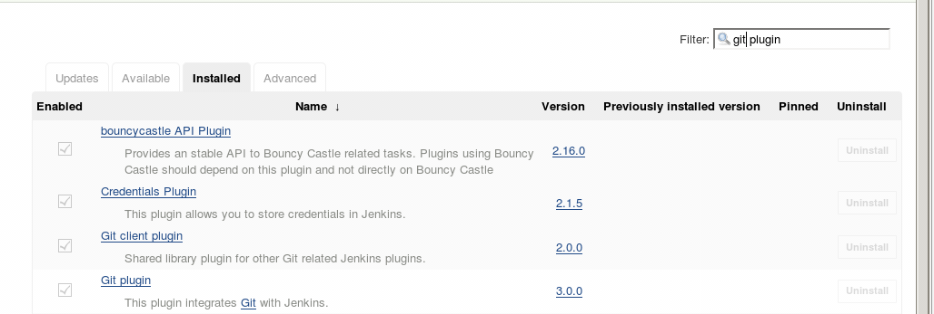

**Step 6: Setup credentials in Jenkins**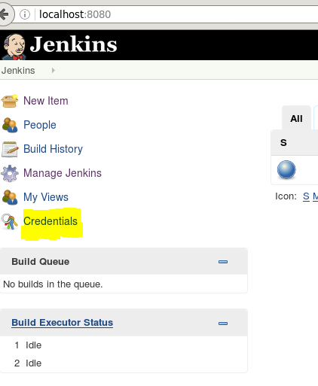

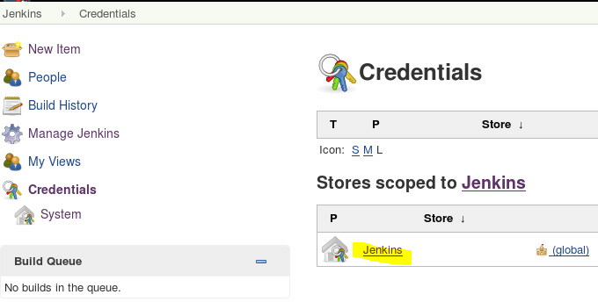

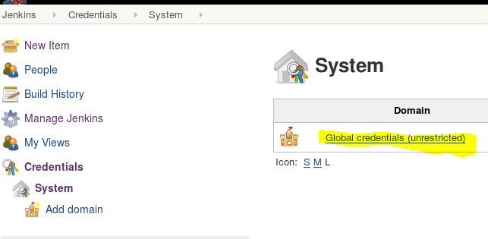

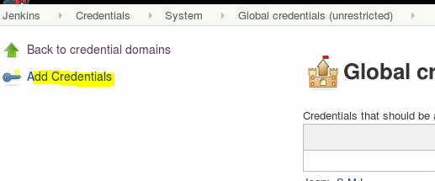

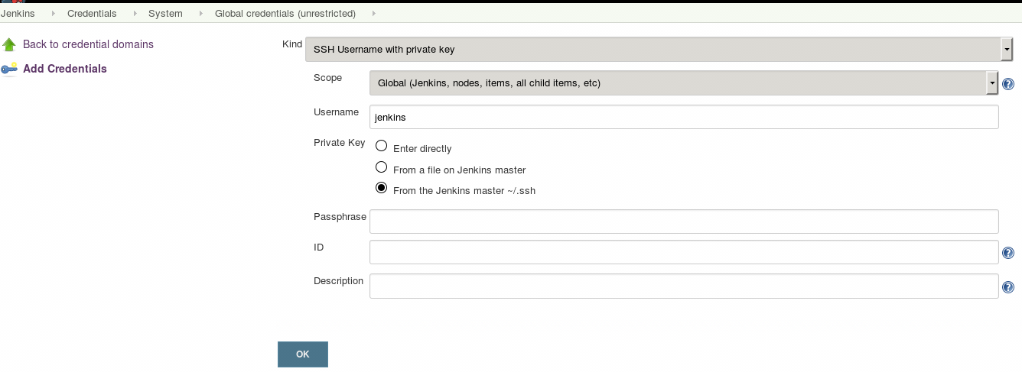

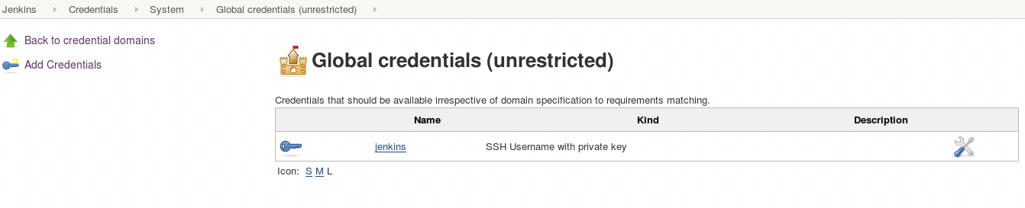

Step 7 : Create a new github project in Jenkins

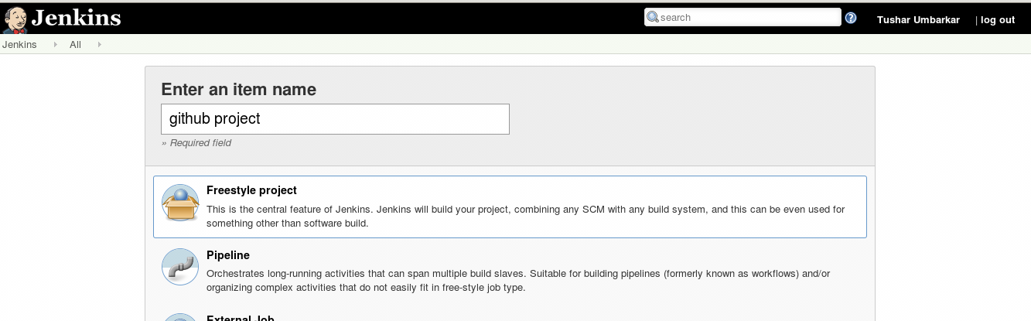

Step 8 : Copy the URL of repository from github.

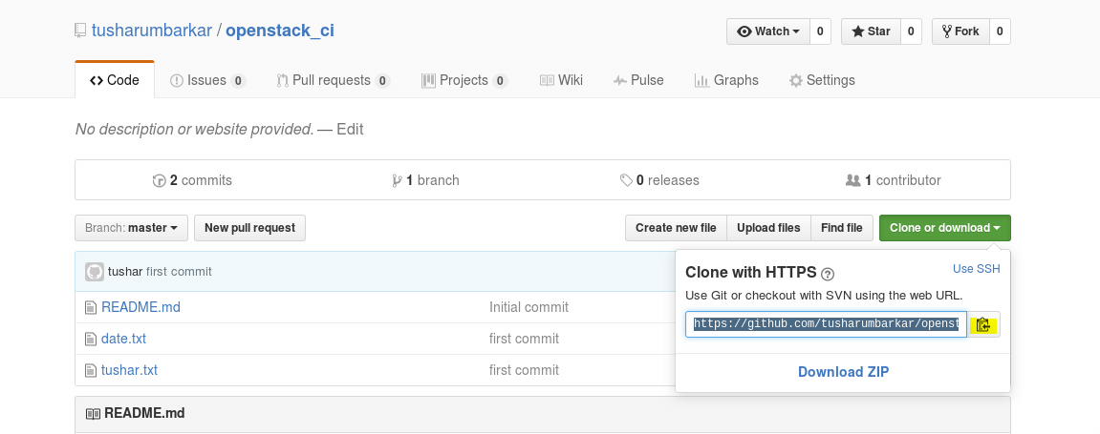

Step 9: Add the HTTPS URL in Jenkins project.

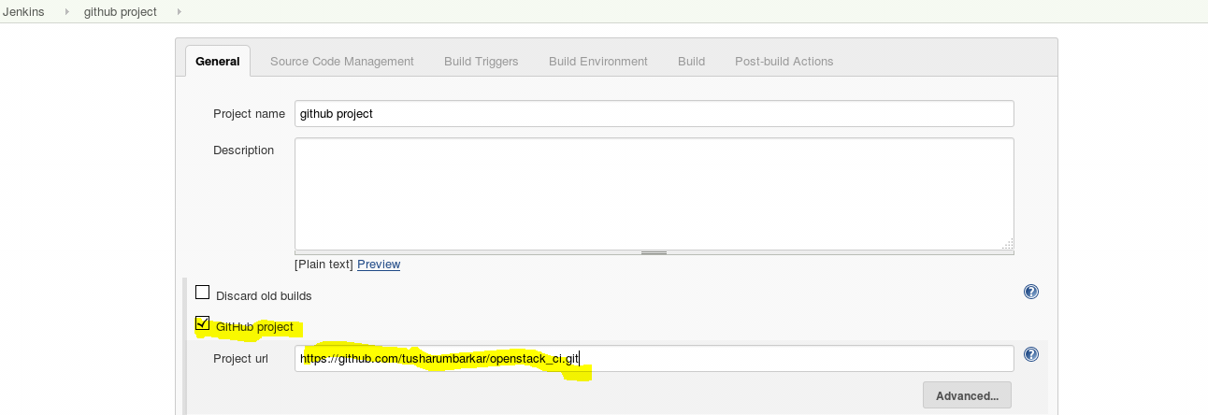

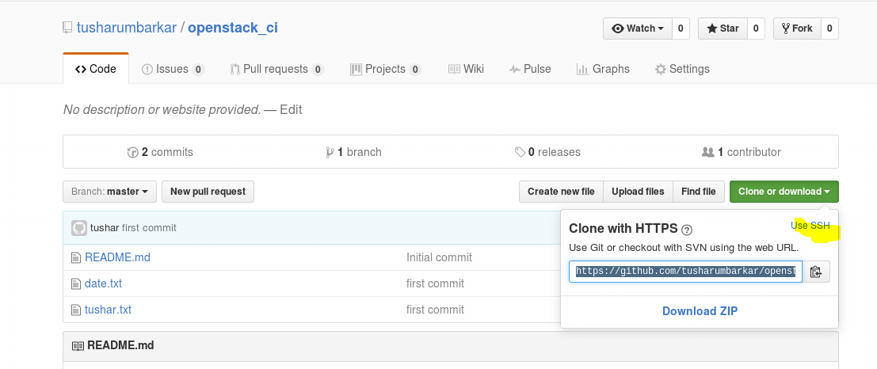

Step 10: Add the Repository URL in Jenkins project.

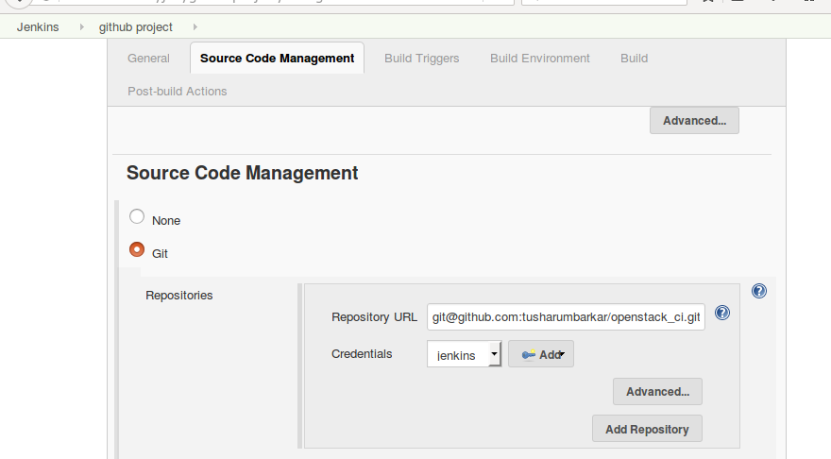

**Step 11: Select build triggers option.**

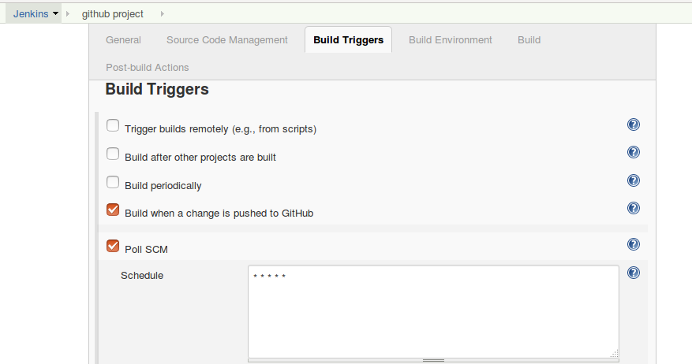

**Step 12 : Copy the hook url under github section in Jenkins.**

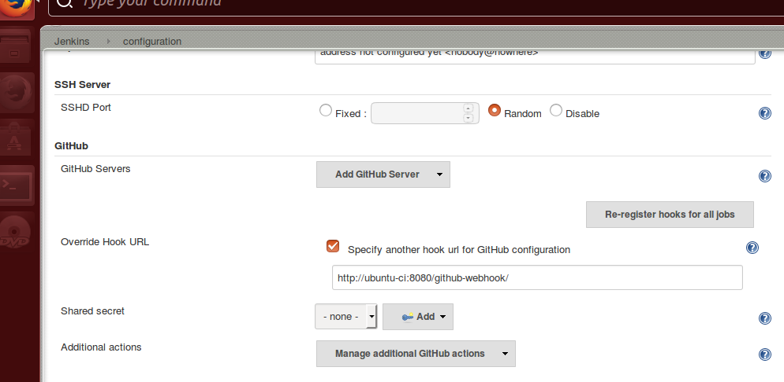

**Step 13 : Add the webhook url in github account.**

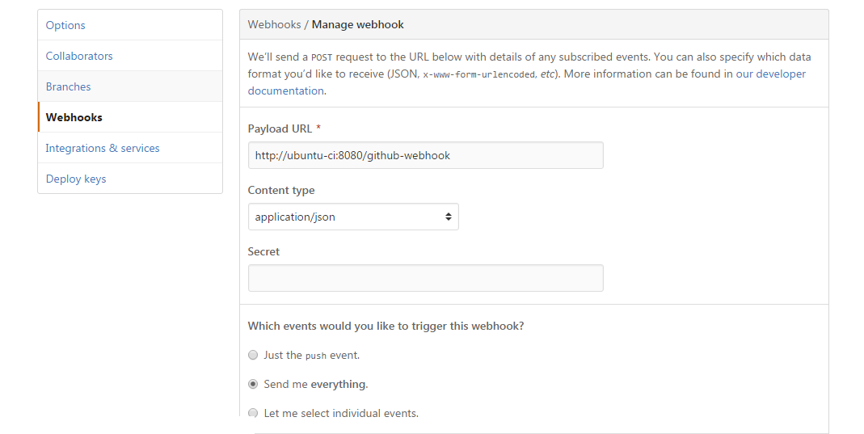

Push the new patch in github repository , the build should be triggered automatically.