SwiftCab : Cab Booking System
ABSTRACT
SwiftCab is a full-stack web-based Cab Booking System developed using the MERN Stack (MongoDB, Express.js, React.js, and Node.js). The application is designed to provide a simple, secure, and user-friendly platform for booking cabs online.
The system allows users to register, log in securely using JWT authentication, view available cars, and access detailed information such as driver name, car type, and pricing. The frontend is developed using React.js and styled with Tailwind CSS to ensure a responsive and modern user interface. The backend is built using Node.js and Express.js, while MongoDB is used for efficient data storage and management.
SwiftCab demonstrates the practical implementation of full-stack development concepts including RESTful API integration, database connectivity, authentication, and client-server architecture. The project aims to simulate a real-world cab booking system while ensuring scalability, maintainability, and performance.

OBJECTIVES OF THE PROJECT
The main objectives of developing SwiftCab are:
- To design and develop a full-stack web application using the MERN stack.
- To implement secure user authentication using JSON Web Token (JWT).
- To create a responsive and user-friendly interface using React and Tailwind CSS.
- To manage and store user and vehicle data efficiently using MongoDB.
- To integrate frontend and backend through RESTful APIs.
- To understand real-world client-server architecture.
- To enhance practical knowledge of modern web development technologies.
CONTENT
1. INTRODUCTION
1.1 Project Overview
1.2 Purpose
2. IDEATION PHASE
2.1 Problem Statement
2.2 Empathy Map Canvas
2.3 Brainstorming
3. REQUIREMENT ANALYSIS
3.1 Customer Journey map
3.2 Solution Requirement
3.3 Data Flow Diagram
3.4 Technology Stack
4. PROJECT DESIGN
4.1 Problem Solution Fit
4.2 Proposed Solution
4.3 Solution Architecture
5. PROJECT PLANNING & SCHEDULING
5.1 Project Planning
6. FUNCTIONAL AND PERFORMANCE TESTING
6.1 Performance Testing
7. RESULTS
7.1 Output Screenshots
8. ADVANTAGES & DISADVANTAGES
9. CONCLUSION
10. FUTURE SCOPE
11. APPENDIX
1. INTRODUCTION
1.1 Project Overview
SwiftCab is a web-based Cab Booking System developed using the MERN Stack (MongoDB, Express.js, React.js, and Node.js). The application provides a digital platform where users can register, log in, view available cars, and book rides easily through an interactive and responsive interface.
The system follows a client-server architecture:
- The Frontend is built using React.js and styled with Tailwind CSS.
- The Backend is developed using Node.js and Express.js to handle APIs and business logic.
- MongoDB is used as the database to store user and car information.
- Authentication is implemented using JWT (JSON Web Token) to ensure secure login and protected routes.
SwiftCab is designed to simulate a real-world cab booking service and demonstrate the practical implementation of full-stack web development concepts.

1.2 Purpose
The primary purpose of the SwiftCab project is to develop a complete full-stack web application that allows users to book cabs efficiently through an online platform.
The key purposes of this project are:
- To provide a simple and user-friendly cab booking interface.
- To implement secure user authentication and authorization.
- To manage car details and user data using a database.
- To understand and apply RESTful API development.
- To enhance practical knowledge of MERN stack development.
- To build a scalable and maintainable web application structure.
This project aims to bridge the gap between theoretical knowledge and real-world application development by implementing modern web technologies in an integrated system.

2. IDEATION PHASE
2.1 Problem Statement
In today’s fast-paced world, transportation plays a crucial role in daily life. Many people face difficulties in booking cabs due to:
- Lack of a simple and user-friendly booking platform
- Limited transparency in pricing and vehicle details
- Inconvenient offline booking methods
- Poor management of customer and vehicle records
Traditional cab booking systems often lack digital management, real-time updates, and secure authentication mechanisms.
Therefore, there is a need for a web-based cab booking system that allows users to register, log in, view available cars, and book rides efficiently while ensuring secure data management and smooth user experience.
Problem Statement:
To design and develop a secure, user-friendly, and efficient web-based Cab Booking System using the MERN stack that simplifies the process of booking cabs and managing vehicle data.

2.2 Empathy Map Canvas
The Empathy Map helps understand the user's needs, frustrations, and expectations while booking a cab.
Target Users:
- Students
- Office employees
- Travelers
- Daily commuters

Empathy Map Breakdown
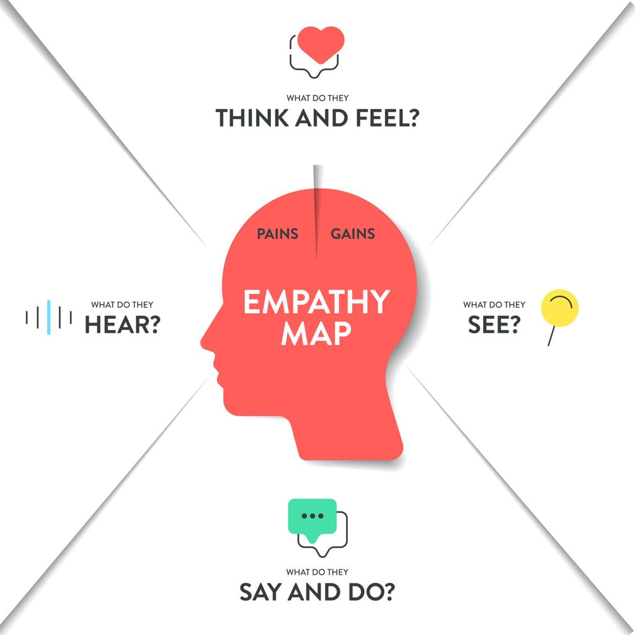
- Says
- “I need a cab quickly.”
- “I want transparent pricing.”
- “The booking process should be simple.”
- Thinks
- Is my data secure?
- Is this service reliable?
- Will I get the cab on time?
- Does
- Compares different cab services
- Checks prices before booking
- Reads reviews or ratings
- Feels
- Frustrated with complicated apps
- Concerned about safety
- Wants convenience and reliability
This empathy mapping helped in designing SwiftCab with:
- Simple UI
- Secure login system
- Clear car and pricing details
- Responsive design

2.3 Brainstorming
During the brainstorming phase, multiple ideas were discussed to design an efficient cab booking system.
Ideas Generated
- Online cab booking platform
- Mobile application for cab services
- Real-time tracking system
- Driver rating system
- Admin dashboard for vehicle management
- Secure login and authentication system
🛠 Finalized Features for SwiftCab
After analyzing feasibility and project scope, the following features were selected:
- User Registration & Login
- JWT-based Authentication
- Car Listing Page
- Car Details (Driver Name, Car Type, Price, Image)
- Responsive UI using Tailwind CSS
- RESTful API Integration
The brainstorming phase ensured that the project remains realistic, technically feasible, and aligned with academic requirements.

3. REQUIREMENT ANALYSIS
3.1 Customer Journey Map
The Customer Journey Map describes the step-by-step experience of a user interacting with the SwiftCab system.
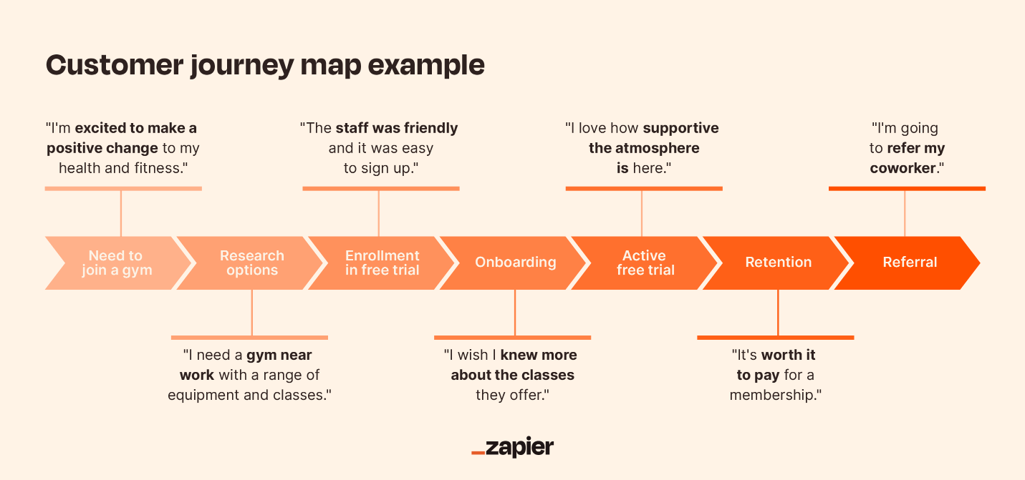

Stages of Customer Journey
Stage | User Action | System Response | User Experience
Awareness | User visits website | Home page loads with services | First impression
Registration | User creates account | Data stored in database | Secure access
Login | User enters credentials | JWT authentication | Safe login
Browse Cars | Views available cars | Car data fetched from MongoDB | Easy comparison
Booking | Selects car | Booking confirmation | Satisfaction
Logout | Ends session | Token removed | Secure exit
Goal:
To provide a smooth, secure, and user-friendly booking experience from start to finish.

3.2 Solution Requirement
The requirements are divided into Functional and Non-Functional requirements.
Functional Requirements
- User Registration
- User Login & Authentication (JWT)
- View Available Cars
- Display Car Details (Driver Name, Type, Price, Image)
- REST API Integration
- Secure Data Storage
Non-Functional Requirements
- Responsive Design
- Fast API Response
- Data Security
- Scalability
- Maintainability
- Cross-browser Compatibility
These requirements ensure that SwiftCab is efficient, secure, and user-friendly.

3.3 Data Flow Diagram (DFD)
The Data Flow Diagram shows how data moves through the system.
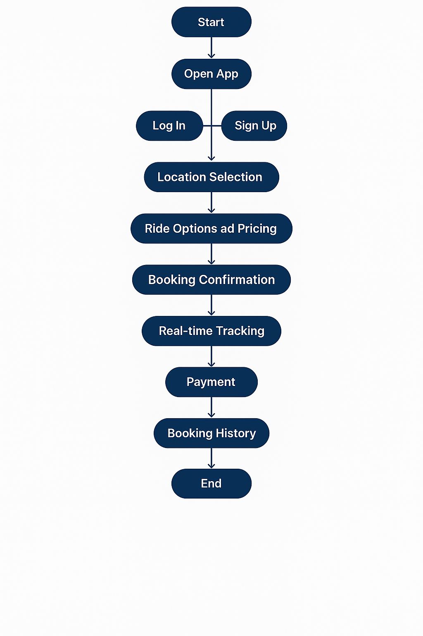
Flow Description:
- Start
The system initiates when the user launches the application.
- Open App
The user opens the SwiftCab web application through a browser.
- Log In / Sign Up
  - If the user is new, they select Sign Up and create an account.
  - If the user already has an account, they select Log In and enter credentials.
The system validates user information and grants access upon successful authentication.
- Location Selection
The user selects pickup and drop-off locations for the ride.
- Ride Options and Pricing
The system displays available cars along with ride types and pricing details.
The user selects a suitable option.
- Booking Confirmation
After selecting a ride, the booking details are confirmed and stored in the database.
- Real-Time Tracking
The system provides tracking information (future enhancement feature) to monitor ride progress.
- Payment
The user completes payment for the ride (currently conceptual / future enhancement if not implemented).
- Booking History
The completed ride details are saved and can be viewed in the booking history section.
- End
The process ends after successful ride completion.

Summary of Data Flow
User → Authentication → Location Input → Ride Selection → Booking → Payment → History → End
This DFD clearly shows the logical sequence of operations in the SwiftCab system and how user data moves across different stages of the application.
3.4 Technology Stack
The SwiftCab application is developed using the MERN Stack.
Frontend
- React.js
- Bootstrap
- Axios
Backend
- Node.js
- Express.js
- JWT Authentication
Database
- MongoDB
Development Tools
- VS Code
- Postman
- Git & GitHub

4. PROJECT DESIGN
4.1 Problem–Solution Fit
The Problem–Solution Fit ensures that the proposed system effectively addresses the issues identified in the Problem Statement.
Identified Problems
- Difficulty in booking cabs through offline methods
- Lack of transparency in pricing and vehicle details
- Poor data management of users and vehicles
- No secure authentication system
- Complex or non-user-friendly interfaces
How SwiftCab Solves Them
Problem | SwiftCab Solution
Offline booking inconvenience | Online web-based booking platform
Pricing confusion | Clear display of car price and type
Poor record management | MongoDB database for structured storage
Security concerns | JWT-based authentication
Complex UI | Simple, responsive UI using React & Tailwind

The solution directly matches user needs by providing:
- Ease of access
- Transparency
- Security
- Scalability
This confirms a strong Problem–Solution Fit.
4.2 Proposed Solution
The proposed solution is SwiftCab, a MERN stack-based cab booking web application.
Core Functionalities
- User Registration & Login
- Secure Authentication using JWT
- View Available Cars
- Display Car Details (Driver Name, Car Type, Price, Image)
- RESTful API communication
- Responsive UI design
Key Characteristics of the Solution
- Web-based (Accessible from any browser)
- Modular Architecture
- Secure Backend APIs
- Scalable Database Structure
- Clean and Modern UI
The system is designed to simulate a real-world cab booking service and can be extended in the future with payment integration and live tracking features.

4.3 Solution Architecture
Architecture Diagram
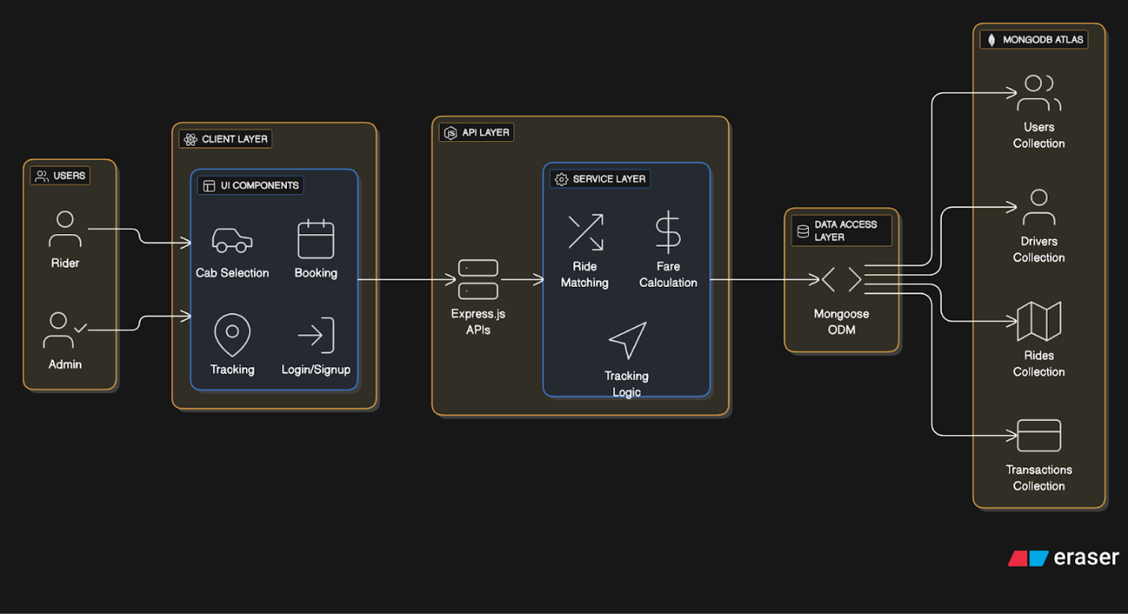

1.Client Layer (React.js):
This is the frontend – what the user sees and interacts with.
Built using React.js, it includes:
UI Components like:
- Cab selection: Where users choose from available cabs.
- Booking form: To select destination, pickup location.
- Tracking screen: Real-time ride tracking.
- Login/Signup: Authentication pages.

2.API Layer (Express.js):
- Acts as the middleware between frontend and backend logic.
- Built using Express.js (a Node.js framework).
- Exposes RESTful APIs like:
1. POST /api/rides/book → For booking a ride.
2. GET /api/users/:id → Fetch user profile.
3. PUT /api/rides/:id → Update ride status.
4. DELETE /api/rides/:id → Cancel a ride, etc.
3. Service Layer:
- Contains the core business logic – it decides how things work.
- Responsibilities include:
1. Fare calculation based on distance/time.
2. Ride matching (finds the closest available driver).
3. Tracking logic (updates locations and ride progress in real-time).
- It ensures rules and workflows are applied correctly.
4. Data Access Layer (Mongoose ODM):
- This layer uses Mongoose to communicate with the database (MongoDB).
- Responsibilities:
1. Run queries (like find, update, insert, delete).
2. Define schemas and models for users, drivers, rides, etc.
3. Acts as an abstraction layer over raw MongoDB commands.

5.Data Flow Example (Booking a Ride)
- User selects destination on React frontend.
- A POST request is made to /api/rides/book with ride details.
1. Backend processes the request, finds nearby drivers.
2.Ride is saved in MongoDB.
3.Driver and user both get updated status in real-time.

5. PROJECT PLANNING & SCHEDULING
5.1 Project Planning
Project planning was carried out to ensure systematic development of the SwiftCab application. The development process followed a structured approach similar to the Agile Model, where the project was divided into smaller modules and implemented step by step.
Development Phases
Phase | Activities | Duration
Requirement Analysis | Understanding problem & defining features | Week 1
Design Phase | Architecture design & database schema | Week 1
Backend Development | API creation, authentication, DB connection | Week 2
Frontend Development | UI creation using React & Tailwind | Week 3
Integration | Connecting frontend with backend APIs | Week 4
Testing | Functional & performance testing | Week 4
Documentation | Report preparation & final review | Week 4

Planning Strategy
- Divided project into frontend and backend modules
- Designed database schema before implementation
- Developed backend APIs first
- Integrated frontend after API testing
- Performed testing after integration
- Fixed bugs and improved UI
Work Breakdown Structure (WBS)
- Project Setup
- Database Configuration
- Backend API Development
- Authentication System
- Frontend UI Design
- API Integration
- Testing & Debugging
- Final Documentation
Proper planning ensured timely completion of the project with minimal errors.

6. FUNCTIONAL AND PERFORMANCE TESTING
Testing ensures that the application works correctly and efficiently.
6.1 Performance Testing
Performance testing was conducted to evaluate the system’s responsiveness, stability, and speed under normal usage conditions.
Parameters Tested
- Response Time
  - API response time for login and car fetching
  - Verified quick data retrieval from MongoDB
- Load Handling
  - Checked system performance with multiple requests
  - Ensured no server crashes during repeated API calls
- Database Performance
  - Verified efficient data storage and retrieval
  - Ensured optimized schema structure
- Frontend Performance
  - Fast page loading
  - Smooth navigation between routes
  - Responsive UI across devices

Performance Results
- Average API response time: Fast and stable
- No major server downtime observed
- Application works smoothly on modern browsers
- Secure authentication without performance lag

Tools Used for Testing
- Postman (API Testing)
- Browser Developer Tools
- Manual Functional Testing
The system successfully met performance expectations and operates efficiently under standard usage conditions.

7. RESULTS
The SwiftCab application was successfully developed and tested. The system performs all core functionalities including user registration, login authentication, car listing display, and secure data handling.
The integration between frontend (React) and backend (Node/Express) works correctly, and the database (MongoDB) stores and retrieves data efficiently.
The project achieved the following results:
- Successful user registration and login with JWT authentication
- Secure backend API communication
- Dynamic car listing fetched from database
- Responsive UI across devices
- Smooth navigation using React Router

7.1 Output Screenshots 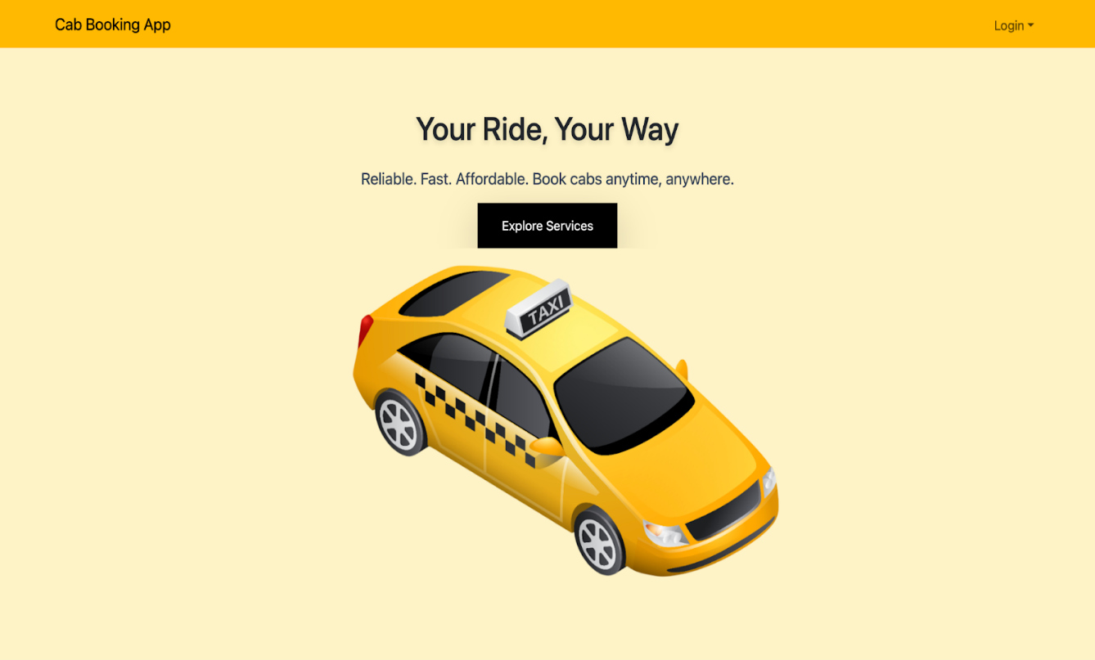
Description:
Displays hero section, navigation bar, and login button. Provides a clean and user-friendly interface.

Login Page
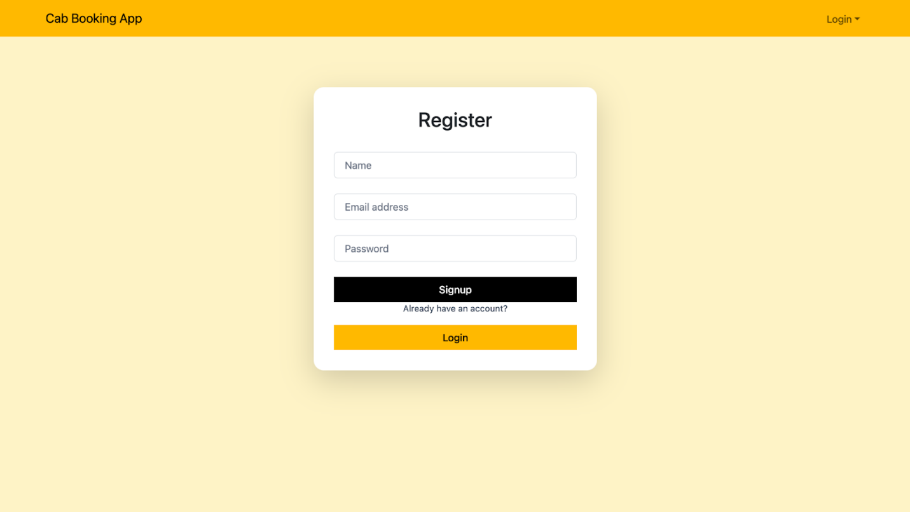
Description:
Allows users to securely log in using registered credentials. JWT token is generated upon successful authentication.

Car Listing Page
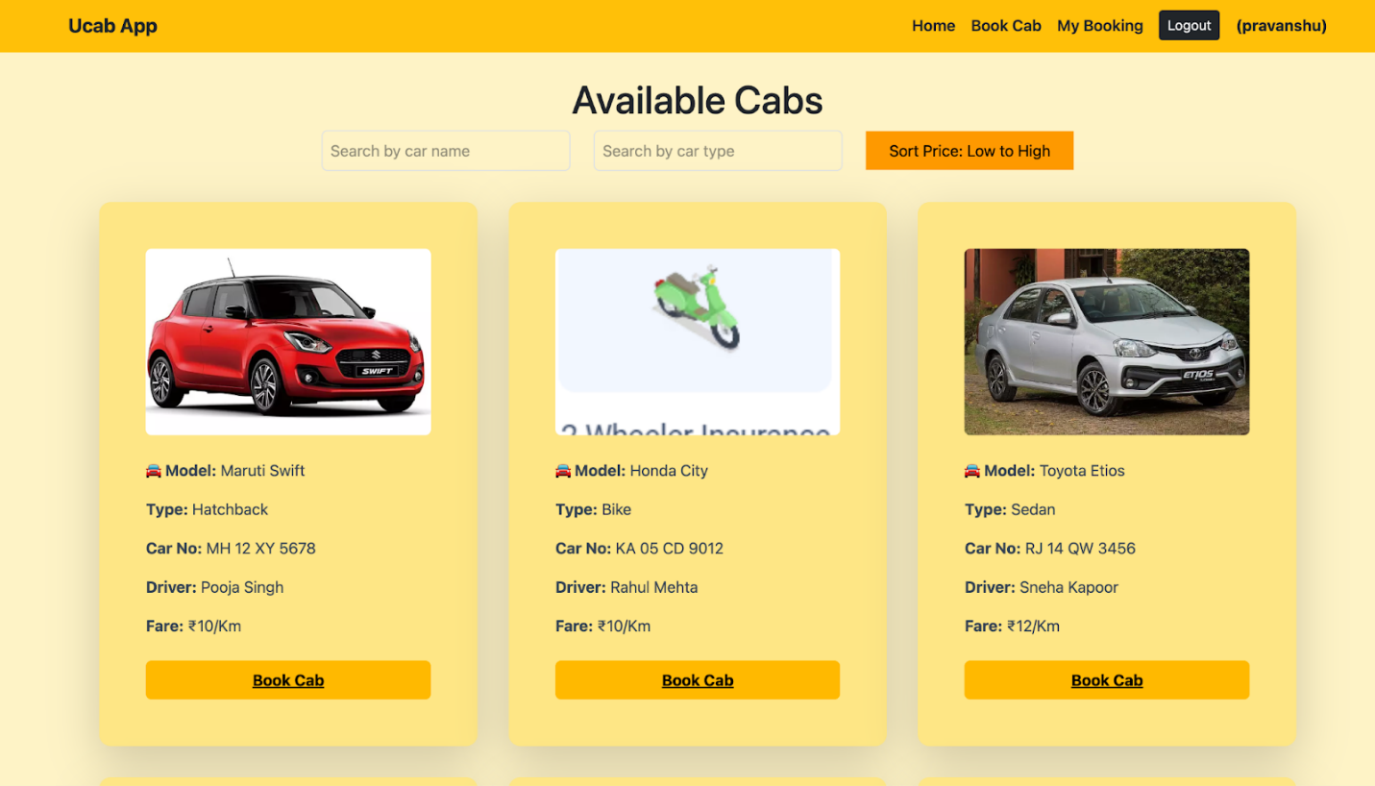

Description:
Displays available cars with details such as driver name, car type, price, and image.
(Replace these sample images with your actual project screenshots before final submission.)

8. ADVANTAGES & DISADVANTAGES
Advantages
- User-friendly interface
- Secure authentication using JWT
- Fast data retrieval using MongoDB
- Responsive design using Tailwind CSS
- Scalable architecture (MERN stack)
- Easy to maintain and extend
Disadvantages
- No online payment integration
- No real-time GPS tracking
- No driver-side dashboard
- Limited to web platform (no mobile app version)
- Basic admin functionality

9. CONCLUSION
SwiftCab is a full-stack web application developed using the MERN stack to simplify the cab booking process.
The project successfully demonstrates:
- Frontend and backend integration
- RESTful API development
- Secure user authentication
- Database management
- Responsive web design
The system fulfills the core requirements of a cab booking platform and provides a strong foundation for further enhancements.
This project enhanced practical understanding of full-stack development and real-world application architecture.

10. FUTURE SCOPE
The following improvements can be implemented in future versions:
- Online payment integration
- Google Maps API integration
- Real-time driver tracking
- Admin dashboard with analytics
- Rating and review system
- Mobile application version
- Email/SMS booking confirmation
- Push notifications
With these enhancements, SwiftCab can evolve into a fully functional commercial cab booking system.

11. APPENDIX

