Report
Of
Web Development Internship at Myra's Global Tech

Submitted
To
School of Computer Science and Engineering
IILM University, Greater Noida, U.P.

In partial fulfilment of the requirement of degree of
B.Tech CSE



By
Roll Number of Student: 25SCS1003004920
Name of Student: TUSHAR KUMAR VERMA
Batch: 2026-27

2026-27

CANDIDATE'S DECLARATION
I, TUSHAR KUMAR VERMA, do hereby declare that the internship report titled "Web Development Internship at Myra's Global Tech" has been completed by me to fulfil the requirement for the award of the degree of Bachelor of Technology in CSE. All the references have been quoted and I have not taken as such any material from any other source. I affirm to you that this report is my own and has not been submitted to any other institute for any degree/diploma requirement and further I shall be solely responsible for any kind of copyright violation in this regard.

Signature
Student Name: Tushar Kumar Verma
Roll No.: 25SCS1003004920

ACKNOWLEDGEMENT
I am using this opportunity to express my gratitude to everyone who supported me throughout the Internship Program at Myra's Global Tech. I am thankful to Dr. Manish Jha (Founder) and Ms. Sudha Devraj (Co-Founder) for their aspiring guidance, invaluably constructive criticism, and friendly advice during this work. I am sincerely grateful to them for sharing their truthful and illuminating views on a number of issues related to this work.
I would also like to thank the faculty of the School of Computer Science and Engineering, IILM University, for their continuous support and encouragement throughout this internship.
I express my gratitude to my parents for their blessings.

Signature
Student Name: Tushar Kumar Verma
Roll No.: 25SCS1003004920

TABLE OF CONTENTS
Chapter No. | Chapter Name | Page Nos.
 | Cover Page | ---
1. | Candidate's Declaration | i
2. | Acknowledgement | ii
3. | Internship Completion Certificate | ---
4. | Project Description
 | 4.1 Introduction | 1
 | 4.2 Organization Profile | 1
 | 4.3 Problem Statement | 1
 | 4.4 Project Objectives | 1
 | 4.5 Scope of the Project | 2
 | 4.6 Technologies and Tools Used | 2
 | 4.7 System Architecture | 2
 | 4.8 Methodology | 3
 | 4.9 Expected Outcomes | 3
 | 4.10 Certificate of Completion | 4
5. | Bibliography / References | 4

INTERNSHIP COMPLETION CERTIFICATE
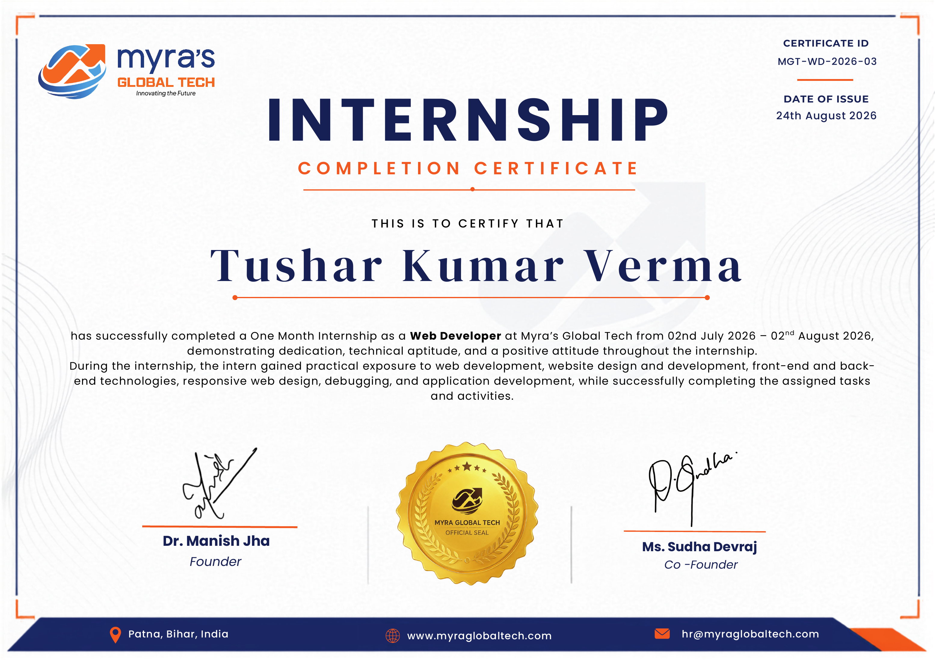

4. Project Description
4.1 Introduction
This report presents the work carried out during a one-month Web Developer internship undertaken at Myra's Global Tech, Patna, Bihar, from 02nd July 2026 to 02nd August 2026. The internship was undertaken as part of the academic curriculum of the B.Tech CSE program at IILM University, and was aimed at providing practical, industry-oriented exposure to web development in a real client-facing environment.
During the internship, practical experience was gained in website design and development, front-end and back-end technologies, responsive web design, debugging, and complete application development, while working on live client projects for multiple schools.
4.2 Organization Profile
Myra's Global Tech is a technology company based in Patna, Bihar, India, focused on web development and digital solutions, with a mission of "Innovating the Future." The organization is led by Dr. Manish Jha (Founder) and Ms. Sudha Devraj (Co-Founder), and provides hands-on internship programs designed to build practical, industry-ready skills in aspiring developers.
The organization undertakes real client projects — including the design and development of websites for schools — giving interns direct exposure to end-to-end project delivery rather than only theoretical training.
Website: www.myraglobaltech.com
Email: hr@myraglobaltech.com
4.3 Problem Statement
Many schools lack an effective, affordable, and professionally designed online presence. Building a website from scratch for each institution using enterprise-grade agencies is often costly and slow, while many schools nevertheless need a functional, responsive, and easy-to-navigate website to communicate information to students, parents, and the public. There was, therefore, a need for a small, agile development approach that could deliver custom, working school websites within a reasonable budget and timeframe.
4.4 Project Objectives
- To apply classroom concepts of web technologies to real, live client projects.
- To gain hands-on experience across both front-end and back-end development.
- To learn to design and build websites that are fully responsive across devices and screen sizes.
- To develop the ability to identify, troubleshoot, and fix real-world code issues through structured debugging.
- To understand the complete lifecycle of a client project — from requirement gathering to final delivery.
- To build professional workplace skills such as communication, time management, and quality-focused delivery.
4.5 Scope of the Project
The internship's scope covered the design, development, and deployment of complete school websites for multiple client institutions. This included front-end interface design, responsive layout implementation, back-end application logic, and testing/debugging of the delivered websites. Each project was scoped and priced individually based on the client's specific requirements, with project values ranging from approximately ₹25,000 to ₹80,000 depending on the features and complexity involved.
The scope did not extend to large-scale enterprise software systems, mobile application development, or advanced database administration, as the projects were focused specifically on functional, responsive institutional websites.
4.6 Technologies and Tools Used
- Front-End: HTML5, CSS3, JavaScript, Responsive Web Design techniques
- Back-End: Server-side logic and application development for dynamic website functionality
- Practices: Debugging and testing, cross-device quality assurance, and client requirement analysis
- Supporting Tools: Code editors, browser developer tools, and version-friendly development workflows
4.7 System Architecture
Each school website followed a standard three-layer web application architecture, described below:
- Presentation Layer (Front-End): Built using HTML5, CSS3, and JavaScript, this layer was responsible for the visual interface, page layout, navigation, and responsive behaviour across desktop, tablet, and mobile devices.
- Application Layer (Back-End): Handled the underlying logic required for dynamic content, form processing, and page behaviour beyond static content.
- Data Layer: Managed the information displayed on the website, such as institutional content, images, and contact details, ensuring it could be updated and maintained by the client.
Requests from a user's browser were processed through the presentation layer, with dynamic operations handled by the application layer before the appropriate content was rendered back to the user, ensuring a smooth and responsive browsing experience.
4.8 Methodology
- Requirement Gathering: Understanding each school's specific needs, content, and desired features.
- Design: Planning the page layout, navigation structure, and visual style suited to the institution.
- Development: Building the front-end interface and back-end functionality in parallel, using responsive design practices throughout.
- Testing & Debugging: Systematically testing each page and feature across devices and browsers, identifying issues, and resolving them before delivery.
- Client Review: Sharing progress with the client and incorporating feedback and requested revisions.
- Deployment & Handover: Finalizing and delivering the completed, working website to the client.
4.9 Expected Outcomes
- Multiple fully functional, responsive school websites successfully designed, developed, and delivered to clients.
- Strengthened practical command of front-end and back-end web development.
- Improved debugging discipline and structured problem-solving under real project constraints.
- First-hand experience delivering complete, client-ready software from requirement to deployment.
- Better time-management skills gained from handling multiple live projects simultaneously.
- Increased confidence in translating client requirements into functional, working websites.
4.10 Certificate of Completion
The Internship Completion Certificate issued by Myra's Global Tech (Certificate ID: MGT-WD-2026-03, dated 24th August 2026) is attached in Chapter 3 of this report as proof of successful completion of the one-month Web Developer internship.
5. Bibliography / References
1. Mozilla Developer Network (MDN Web Docs) — HTML, CSS, and JavaScript documentation. Available at: https://developer.mozilla.org
2. W3Schools — Web development tutorials and reference material. Available at: https://www.w3schools.com
3. Myra's Global Tech — Official website and internship documentation. Available at: https://www.myraglobaltech.com
4. Internship Completion Certificate (Certificate ID: MGT-WD-2026-03), issued by Myra's Global Tech, dated 24th August 2026.

