Curriculum Vitae

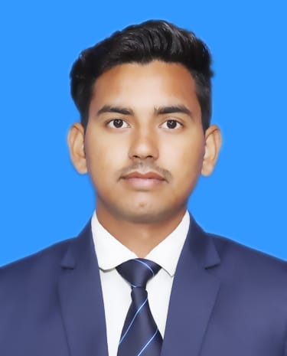



Name: Shivam Singh

**Mob:**  9721217937

Email[: ss9297442@gmail.com](mailto::%20%20ss9297442@gmail.com)

LinkedIn ID:

<https://www.linkedin.com/in/shivam-singh-035805252/>

Career Objective

To grow my skills and learn new things which are beneficial for me and to serve an organization and also help to progress professionally and personally.

Education Qualification

|  |  |  |  |  |
| --- | --- | --- | --- | --- |
| **Standard** | **Board/University** | **School/College Name** | **Year of Passing** | **Division& Percentage** |
| BCA | CSJMU | PSIT College Of Higher Education | 2025 | 53% (upto 3rd sem) |
| Intermediate | CBSE Board | Maharishi Vidhya mandir Kanpur | 2020 | 56.2% |
| High School | ICSE Board | Sardar Patel Public School, Kanpur | 2018 | 57.6% |

**Professional Certification**

* Infosys Springboard Certification on Programming Fundamentals using Python

(October 26th, 2023).

* Infosys Springboard Certification in Practical HTML and CSS (September 16th, 2023).

Project

* Currently developing personal Portfolio website using Html and CSS.

This website serves as a comprehensive representation of my work, expertise, and achievements, providing a platform for potential employers or clients to learn more about me. The design emphasizes simplicity, usability, and visual appeal to effectively communicate my capabilities and personality.

|  |  |
| --- | --- |
| **Soft Skills** | **Technical Skills** |
| * Quick Decision Making * Quick Learner * Good Command Over Calculation * Can Work Under Stressed Condition | * C and C++ * Python (Basics) * Html and CSS * Conversant in MS Office (Excel, Power Point & Word) |

Co-curricular Activities

* Participated in Footprints Annual sports event of PSIT in Badminton.
* Participated in Inter-School 100 m race

Hobbies& Interests

* Learning New skills
* Travelling
* Playing Cricket

Personal Details

Father’s Name: Mr. Ranveer Singh.

Address: 557, Ramaipur, Kanpur Nagar

DOB: 18/10/2003

Gender: Male Marital Status: Single

**Language Known:** English & Hindi

# Declaration

I hereby declare that the information furnished above is true to the best of my knowledge and belief.

**Place:** Kanpur **Signature**

**Date:** March 2024 **( Shivam Singh**