Network Time Synchronization System

1. Problem Statement
- Build a simplified time-synchronization application using UDP sockets.
- Multiple clients synchronize their clocks with a reference server.
- Run on an emulated network with controlled delay, prioritized sync traffic and congestion.

2. Components
- Reference server: h1 (10.0.0.1), timesync_server.py
- Clients: h2 (10.0.0.2), h3 (10.0.0.3), timesync_client.py
- Congestion generator: h4 (10.0.0.4), iperf UDP
- Switch: s1 (Open vSwitch) with built-in OVS controller
- Topology script: topo_sdn.py
- Plotting script: plot_results.py

3. Requirement 1: UDP Timestamp Exchange
- Client sends T1 (8-byte double) to server UDP port 12345.
- Server records T2 on receive and T3 before reply.
- Server replies with T1, T2, T3 (24 bytes, network byte order, format !ddd).
- Client records T4 on receive.
- Each client runs 20 probes at 0.5 s intervals with a 2 s timeout.
- Each probe is logged to CSV: Iteration, T1, T2, T3, T4, Delay_ms, Offset_ms.

4. Requirement 2: Round-Trip Delay
- Delay = (T4 - T1) - (T3 - T2)
- Server processing time (T3 - T2) is removed from the round trip.
- Reported in milliseconds.

5. Requirement 3: Clock Offset Estimation
- Offset = ((T2 - T1) + (T3 - T4)) / 2
- Assumes equal forward and return path delay.
- Reported in milliseconds.

6. Requirement 4: Multiple Clients
- Server handles requests from any client address in one receive loop.
- Replies are sent to the source address of each request.
- Clients h2 and h3 both synchronize with h1.
- h2 (10 ms link) and h3 (15 ms link) give different delays, as expected.

7. Requirement 5: Prioritize Synchronization Traffic
- Client marks sync packets with IP_TOS 0xB8 (DSCP 46, Expedited Forwarding).
- OpenFlow rule on s1: priority 65535, UDP, tp_dst=12345, actions=normal.
- Default rule on s1: priority 100, IP, actions=normal.
- Rules installed with ovs-ofctl after the network starts.

8. Requirement 6: Controlled Network Delay
- Mininet TCLink with fixed delay and 10 Mbps bandwidth per host link.
- h1: 5 ms. h2: 10 ms. h3: 15 ms. h4: 2 ms.
- Expected RTT for h2 = 2 x (10 + 5) = 30 ms.
- Expected RTT for h3 = 2 x (15 + 5) = 40 ms.
- Measured RTT for h2 = 30.79 ms (probes 2-20).
- Measured RTT for h3 = 40.54 ms (probes 2-20).

9. Requirement 7: Synchronization Error
- All Mininet hosts share one system clock, so the true offset is 0 ms.
- The measured offset is therefore the estimation error.
- h2, normal, probes 2-20: mean offset 0.148 ms.
- h3, normal, probes 2-20: mean absolute offset 0.069 ms.
- h2, congested: mean offset 0.28 ms, max 0.67 ms.
- Probe 1 outlier: h2 16.11 ms, h3 21.31 ms (start-up cost such as ARP).

10. Requirement 8: Performance under Congestion
- Congestion source: h4 sends UDP iperf at 10 Mbps (iperf -c 10.0.0.2 -u -b 10M -t 30).
- Runs recorded: sync_normal.csv (h2), sync_h3_normal.csv (h3), sync_congested.csv (h2).
- Normal h2: mean delay 32.41 ms, max 63.33 ms (30.79 ms mean without probe 1).
- Normal h3: mean delay 42.69 ms, max 83.48 ms (40.54 ms mean without probe 1).
- Congested h2: mean delay 31.09 ms, max 31.87 ms, 0 timeouts.
- Congested probes 1-11: delay 31.2-31.9 ms, offset 0.36-0.67 ms.
- Congested probes 12-20: delay about 30.6 ms, offset under 0.1 ms.
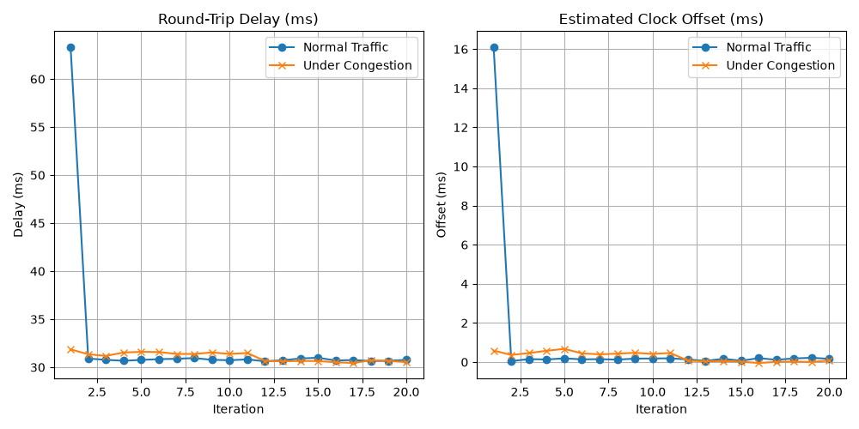
Figure 1: Round-trip delay and offset, normal vs congested (h2).

11. Scope Notes
- No congested run without the priority rule was recorded, so no with/without comparison is reported.
- The priority rule uses actions=normal; no separate queue is configured.
- Clients estimate the offset; they do not adjust a clock.
- Timeouts are not logged, so packet loss is not tabulated.
- h2 and h3 runs were recorded separately.

12. Conclusion
- UDP timestamp exchange, delay calculation and offset estimation work as designed.
- Two clients synchronize with one server over links with controlled delay.
- Measured RTTs match the configured delays within about 1 ms.
- Offset error stays below 0.7 ms after the first probe in all runs.
- With cross-traffic and the priority rule in place, delay rose by about 0.5 ms.

Appendix: How to Run
sudo python3 topo_sdn.py
mininet> h1 python3 timesync_server.py &
mininet> h2 python3 timesync_client.py 10.0.0.1 sync_normal.csv
mininet> h3 python3 timesync_client.py 10.0.0.1 sync_h3_normal.csv
mininet> h4 iperf -c 10.0.0.2 -u -b 10M -t 30 &
mininet> h2 python3 timesync_client.py 10.0.0.1 sync_congested.csv
python3 plot_results.py sync_normal.csv sync_congested.csv

