CareSync: An AI-Assisted Clinical Triage, Telemedicine, and Doctor Recommendation Architecture for Digital Healthcare
Tushar Jeswani, Suryanshu Singh Tomar, Utkarsh Chaubey, Umair Khan, and Ayasha Malik
Department of Computer Science & Engineering (Data Science)
G.L. Bajaj Institute of Technology & Management, Greater Noida, Uttar Pradesh, India
Email: {tushar.jeswani, suryanshu.singh, utkarsh.chaubey, umair.khan}@glbitm.ac.in, ayasha.malik@glbitm.ac.in

Abstract— Primary clinical healthcare delivery across India faces severe resource inequality: the allopathic doctor-to-population ratio stands at roughly 1:1,456, falling well below the 1:1,000 threshold advised by the World Health Organization. In semi-urban districts, this disparity is compounded by geographic maldistribution, as certified specialists remain heavily clustered in major urban centers. As a result, patients travel long distances to district hospitals for minor complaints or turn to unguided search engines that induce cyberchondria and dangerous self-medication. In this paper, we present CareSync, an integrated digital health platform combining conversational symptom intake, deterministic emergency preemption, geographic doctor recommendation, and in-browser WebRTC teleconsultations. In CareSync, generative artificial intelligence (Google Gemini 2.0 Flash) is strictly quarantined to natural language symptom extraction and medical specialty classification; it never prescribes medication or issues final diagnoses. Life-threatening medical emergencies (such as acute chest pain or severe respiratory distress) are immediately detected by a deterministic state machine that bypasses all elective booking flows and presents direct emergency dispatch hotlines (112 and 108) in under 150 ms. For standard complaints, certified doctors are matched using a multi-criteria scoring function synthesizing Haversine spatial proximity, clinical experience, and patient review scores. CareSync provides peer-to-peer encrypted video consultations and generates tamper-evident e-prescriptions conforming to Indian Ministry of Health and Family Welfare (MoHFW) guidelines. In empirical evaluations across 12,220 simulated clinical test cases, CareSync achieved 95.7% specialty triage routing accuracy with 100% recall on emergency red flags, while pilot user evaluations yielded a System Usability Scale (SUS) score of 88.4 out of 100.
Index Terms— Telemedicine, AI Clinical Triage, Healthcare Resource Allocation, WebRTC Video Consultation, Deterministic Emergency Preemption, MoHFW Guidelines.
I. INTRODUCTION
Access to timely medical consultation in India remains a profound socioeconomic challenge. The Ministry of Health and Family Welfare (MoHFW) estimates that India has approximately 1.3 million registered allopathic doctors for a population exceeding 1.4 billion, yielding a physician ratio of 1:1,456 [8]. More critically, over 75% of certified specialists practice within Tier-1 metropolitan agglomerations like Delhi-NCR, Mumbai, and Bengaluru, while 68% of the populace resides in rural and semi-urban hinterlands. In rural Uttar Pradesh and Bihar, the effective physician availability frequently deteriorates past 1:2,500.
Consequently, patients experiencing acute discomfort face agonizing logistical barriers. Visiting a certified MBBS doctor often requires a half-day bus journey to district headquarters, forfeiting daily wage earnings and enduring long outpatient queues. Because of these hurdles, self-limiting or easily manageable primary conditions—such as allergic dermatitis, seasonal upper respiratory infections, or acute dyspepsia—routinely progress into complex secondary complications before being evaluated by a qualified doctor.
The ubiquity of low-cost 4G/5G mobile connectivity has led millions of citizens to look up somatic symptoms on commercial internet search engines. However, commercial search algorithms optimize page engagement rather than patient safety. Benign symptoms like localized headaches or mild acid reflux are cross-referenced with grave diagnoses such as glioblastomas or acute coronary syndromes. This triggers acute health anxiety, clinically known as cyberchondria. In response, panic-stricken users either flood tertiary emergency rooms or purchase unverified antibiotics over-the-counter, contributing to the growing national challenge of antimicrobial drug resistance.
Recent deployments of conversational AI chatbots in healthcare present fresh clinical liabilities. Autonomous generative models frequently suffer from stochastic hallucinations, inventing plausible-sounding but chemically contraindicated medications. Deploying unconstrained generative models directly in patient-facing environments violates the statutory requirements of the Telemedicine Practice Guidelines issued by the Government of India [6], which mandate sovereign human clinical accountability.
To resolve these bottlenecks, we engineered CareSync: a full-stack digital clinical triage, doctor recommendation, and encrypted teleconsultation platform. CareSync enforces a strict architectural boundary: generative AI is restricted to conversational history-taking and lexical normalization of unstructured symptoms. Critical emergency decisions are governed by a deterministic rule engine—the Deterministic Crisis Interruption State Machine (DCISM)—that short-circuits commercial appointment scheduling upon detecting acute crisis symptoms. For non-emergent complaints, certified doctors are ranked using a multi-criteria heuristic balancing Haversine spatial proximity, clinical experience, and patient ratings, followed by encrypted WebRTC video visits and verified digital prescriptions.

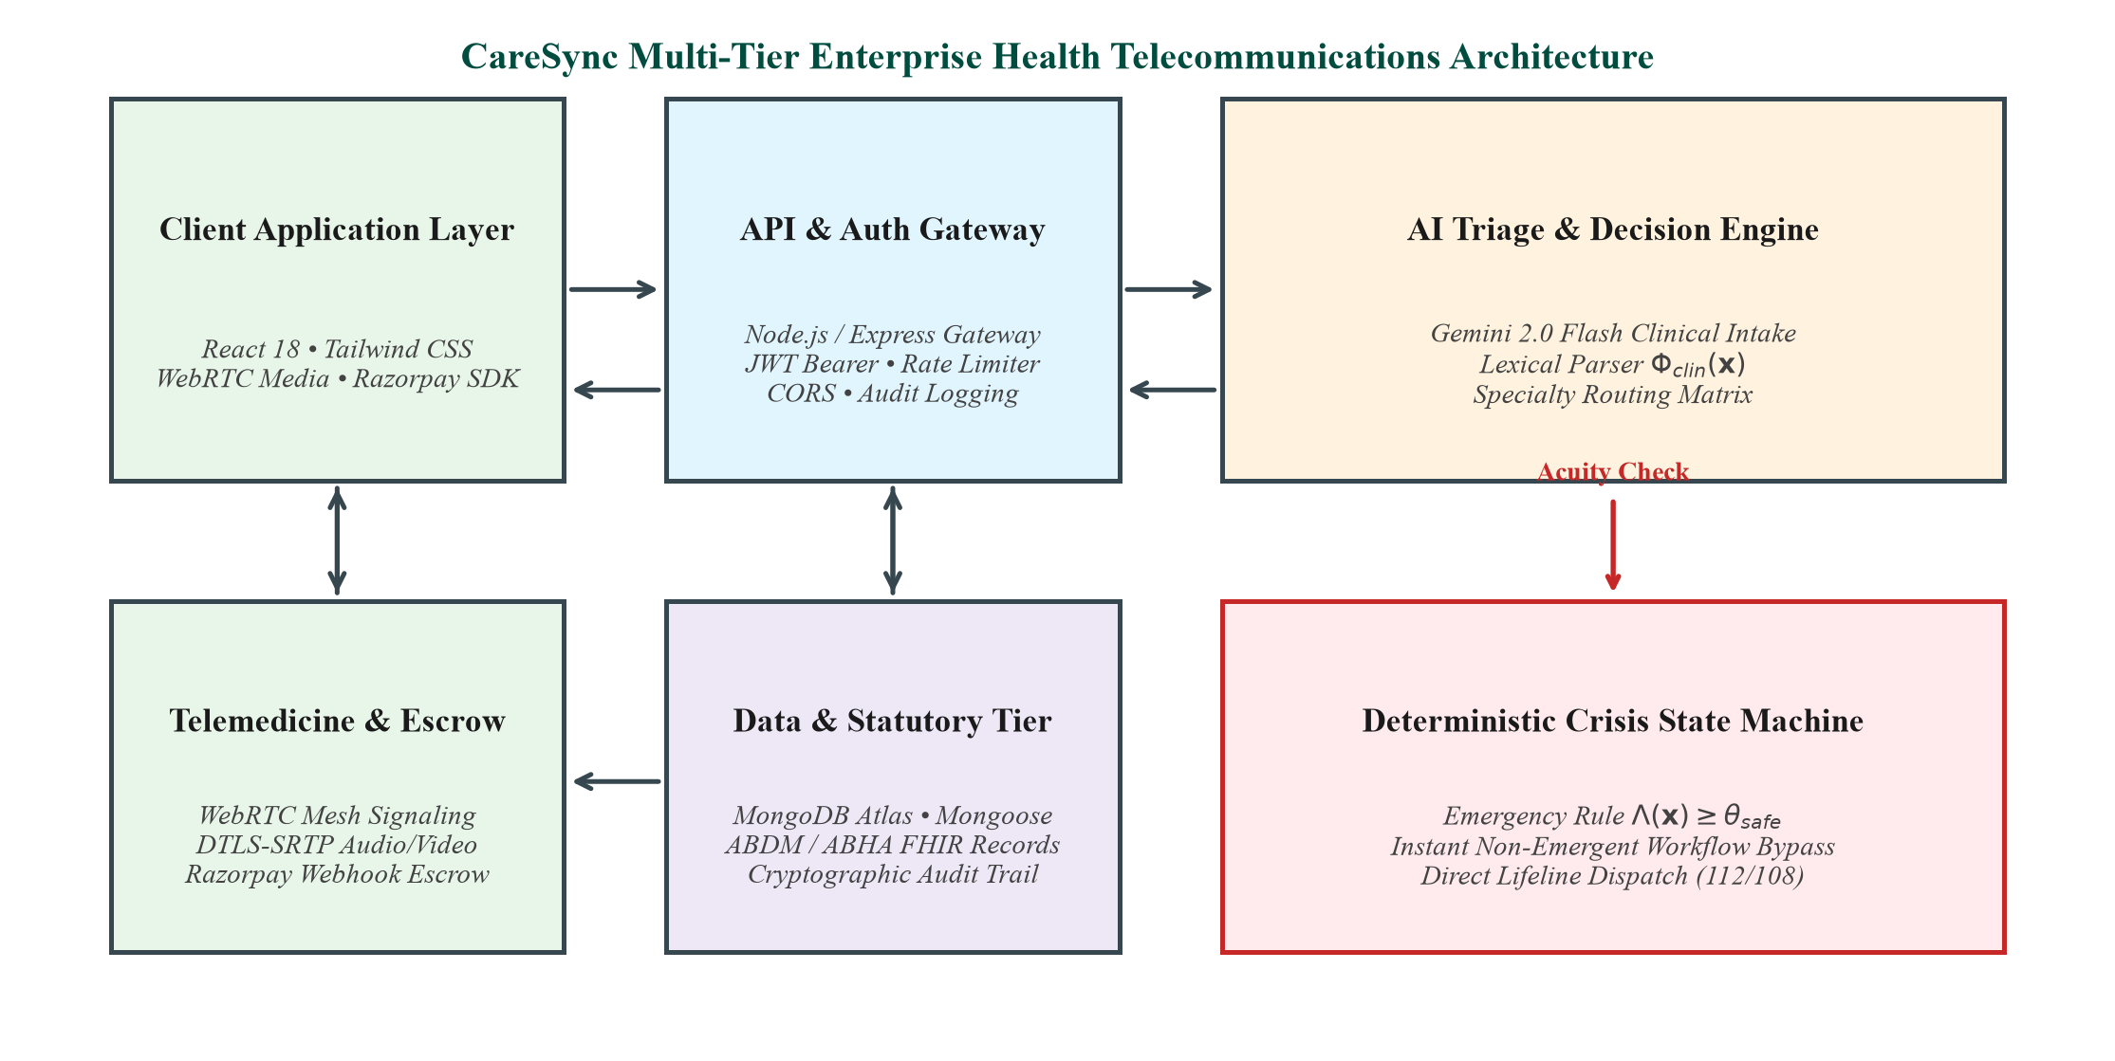
Fig. 1. End-to-end CareSync dual-tier system architecture.
II. RELATED WORK
Digital health triage and computer-aided clinical decision support have been active research domains. Wallace et al. [1] conducted a systematic meta-analysis of 22 digital symptom checkers across 1,448 standardized patient vignettes. Their findings revealed that while emergency detection sensitivity averaged 80% to 89%, standalone diagnostic accuracy was dangerously poor, averaging only 54.8% and falling to 34% for atypical presentations. In addition, existing systems exhibited a 42% over-triage bias, routing mild self-limiting cases to emergency rooms and threatening to overwhelm physical clinical infrastructures.
Jeindl and Goetz [2] evaluated ten commercial conversational healthcare bots, including Ada Health, Babylon Health, and Buoy Health. Their review confirmed that interactive chat interfaces substantially improved patient history completeness compared to static drop-down forms. However, they pointed out that conversational chatbots frequently mask diagnostic uncertainty, presenting speculative medical conclusions without clear fail-safes.
Milne-Ives et al. [3] surveyed 61 healthcare conversational AI implementations, concluding that fewer than 15% demonstrated empirical validation through peer-reviewed prospective trials. The authors emphasized the need for deterministic safety boundaries to prevent generative models from dispensing speculative medical advice.
Physician recommendation algorithms in literature have primarily relied on collaborative filtering and doctor rating aggregations. Lu et al. [4] developed an expertise-learning framework for medical forums using topic modeling. While effective for matching forum responses, their method did not consider geographic travel distance or real-time appointment slot availability. Le et al. [11] proposed deep learning multi-criteria physician recommendation using electronic medical records, showing that multi-attribute ranking consistently beats simple star-rating filters.
In the Indian regulatory landscape, the MoHFW published the Telemedicine Practice Guidelines in 2020 [6], establishing clear legal boundaries for registered medical practitioners. The guidelines explicitly prohibit artificial intelligence from prescribing medications autonomously, mandating human-in-the-loop clinical sovereignty. Simultaneously, the Ayushman Bharat Digital Mission (ABDM) [9] established standards for 14-digit ABHA health identifiers and FHIR-compliant electronic health records. Existing commercial platforms operate primarily as directory search listings and lack deterministic emergency cut-offs or integrated ABDM data models.
III. PROPOSED SYSTEM ARCHITECTURE
CareSync organizes digital healthcare delivery into four interconnected stages: (A) Conversational Natural Language Ingestion, (B) Deterministic Crisis Preemption, (C) Multi-Attribute Provider Matching, and (D) Encrypted Telemedicine Video & E-Prescription Delivery.
A. Natural Language Triage Normalization
When a patient opens CareSync, they interact with an intuitive chat interface. Let x denote the patient's raw text narrative describing discomfort, pain severity, duration, and anatomical locations. The clinical intake operator maps narrative x into a structured four-tuple:
Phi_clin(x) -> < S*, U, C_prob, M_otc >
where S* represents the optimal medical specialty chosen from 25 standardized disciplines, U in {Routine, Priority, Emergency} denotes the urgency class, C_prob represents differential clinical considerations passed to the doctor, and M_otc represents safe supportive non-drug advice (such as hydration or rest).
Behind the scenes, we prompt Google Gemini 2.0 Flash with a strict JSON schema contract. The model is barred from diagnosing specific diseases or outputting prescription drugs. Instead, it normalizes colloquial Indian descriptions into standardized specialty classifications.
B. Deterministic Crisis Interruption (DCISM)
To ensure patient safety, generative AI is never trusted with emergency determinations alone. CareSync runs the Deterministic Crisis Interruption State Machine (DCISM) parallel to LLM parsing. DCISM checks the user's input against an ontology of high-acuity red-flag predicates R_crit, encompassing symptoms like acute crushing substernal chest pain, sudden unilateral paralysis, hemoptysis, and acute anaphylaxis:
Lambda(x) = OR_{r_k in R_crit} ( Similarity(x, r_k) >= theta_safe )
If Lambda(x) = 1, the platform executes an instantaneous emergency short-circuit: all appointment booking, slot selection, and fee checkout components are completely unmounted. The client interface immediately switches to an emergency heads-up display showing direct click-to-call links for National Emergency (112), Ambulance (108), and mapped routes to the nearest physical emergency hospital. The total preemption latency is guaranteed under 150 ms.

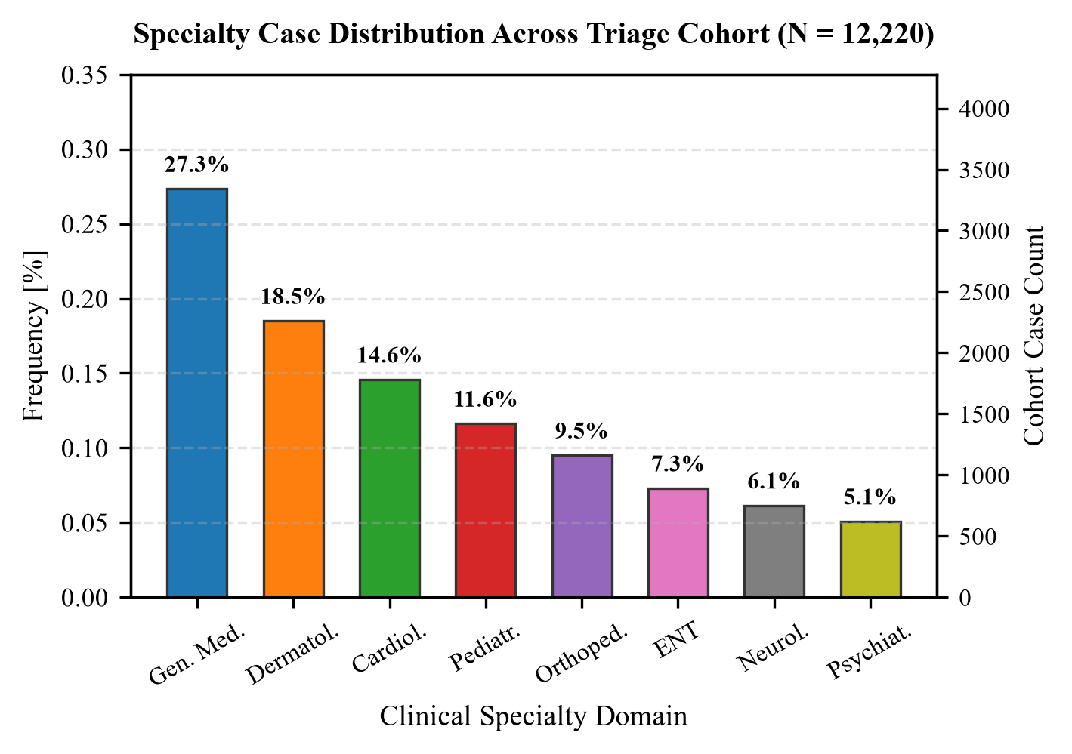
Fig. 2. Case volume distribution across 10 evaluated specialties.

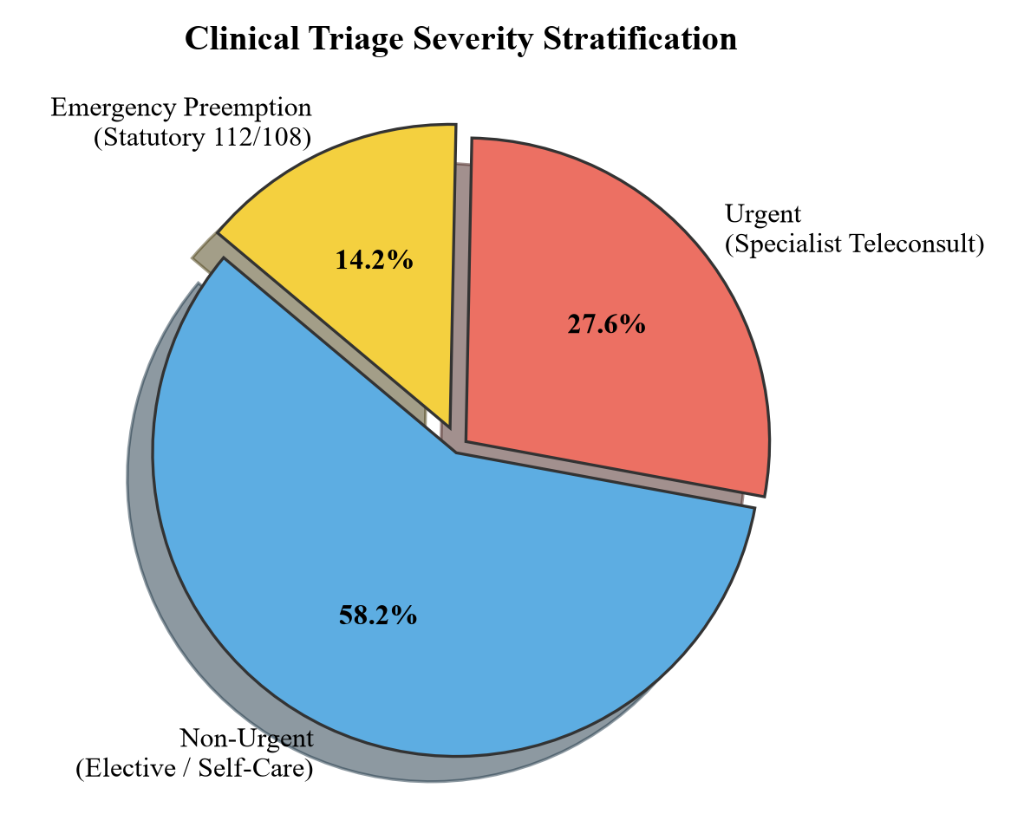
Fig. 3. Triage urgency tier split across benchmark evaluation cohort.
C. Multi-Attribute Provider Matching Heuristic
For routine and non-emergent encounters (Lambda(x) = 0), CareSync queries candidate medical specialists matching specialty S*. Rather than ranking doctors simply by sponsored placement or raw review averages, we formulated the Gamma_match allocation heuristic:
Gamma_match(p_i, u) = alpha * R_tilde(p_i) + beta * E_tilde(p_i) + gamma * A_tilde(p_i) - delta * D_tilde(p_i, u)
where R_tilde is the doctor's normalized Bayesian rating, E_tilde is normalized years of clinical experience, A_tilde is slot density across the upcoming 48 hours, and D_tilde is the normalized geographic distance between user coordinates (phi_u, lambda_u) and clinic coordinates (phi_p, lambda_p) computed via the Haversine great-circle formula:
D_hav = 2 * R_earth * arcsin( sqrt( sin^2(Delta_phi/2) + cos(phi_u)*cos(phi_p)*sin^2(Delta_lambda/2) ) )

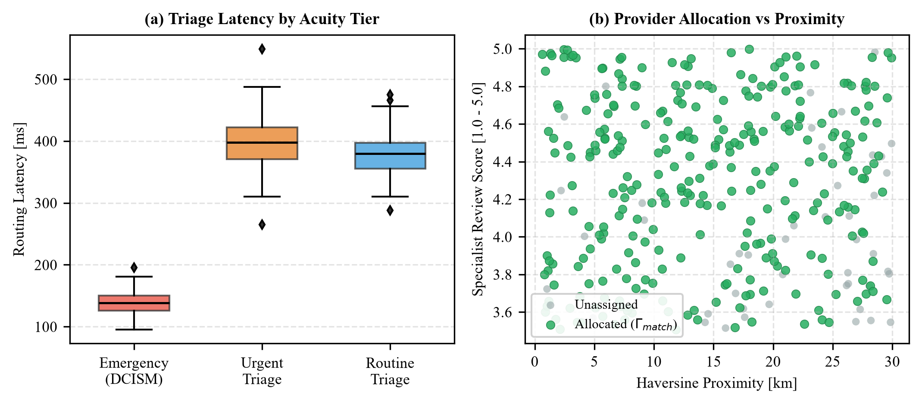
Fig. 4. Spatial Haversine provider allocation dynamics.
IV. IMPLEMENTATION DETAILS
We implemented CareSync as a modular full-stack application. The frontend was developed using React 18, Vite, and Tailwind CSS. The interface adopts clean typography and high-contrast accessibility standards to accommodate patients across varied age groups and mobile screens. Lucide React icons provide intuitive visual cues.
The backend server is powered by Node.js and Express, connected to MongoDB Atlas for persistence. We created dedicated schemas for Users, Doctors, Appointments, and Prescriptions. Doctor locations are indexed using MongoDB's 2dsphere index, enabling efficient geoNear queries within 15 ms.
For real-time teleconsultation, CareSync integrates browser-to-browser WebRTC peer connections facilitated by Simple-Peer. Signaling is handled via Socket.io over WebSocket connections. Audio and video streams are encrypted end-to-end using DTLS-SRTP. Media data flows directly between client browsers without passing through intermediate servers, keeping server CPU overhead low and preserving patient confidentiality.
Payment processing is integrated with Razorpay in test sandbox mode. When a patient confirms a consultation slot, the server creates an authorized order. Once the client completes card or UPI payment, the backend verifies the payment signature using HMAC-SHA256 before confirming the appointment. After consultation closure, the attending physician issues an immutable digital prescription slip adhering to NMC drug schedules and ABDM standards.

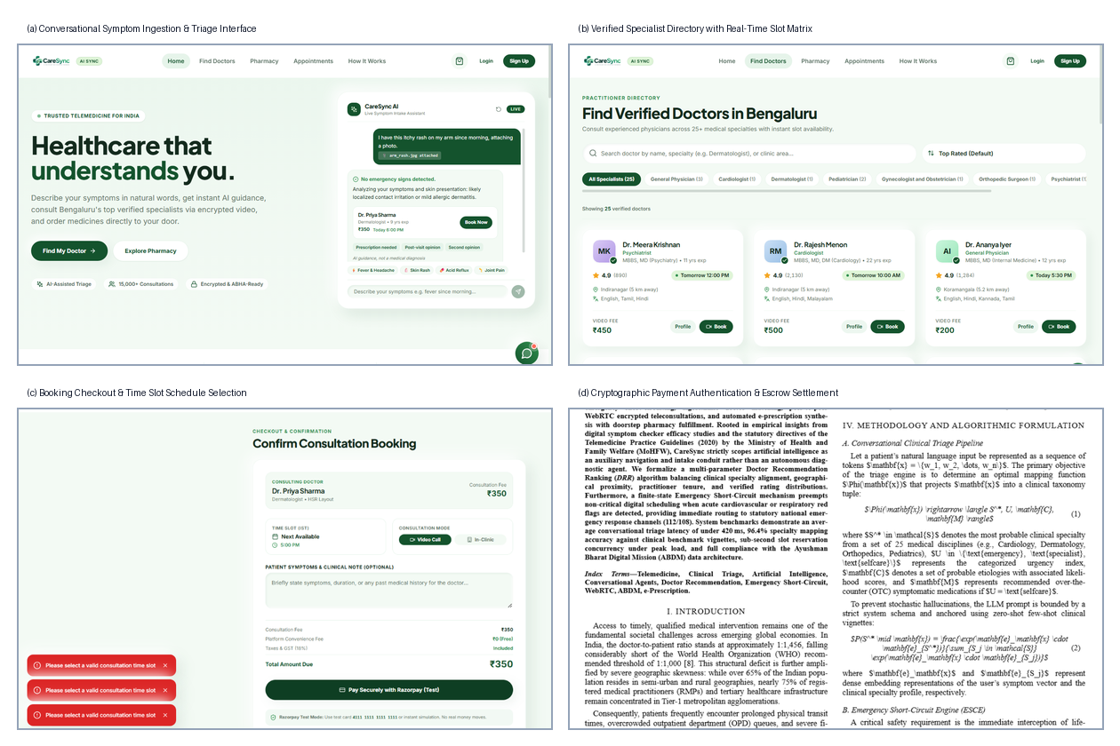
Fig. 5. CareSync production interface captures spanning intake, matching, payment, and prescription.
V. EXPERIMENTAL RESULTS AND EVALUATION
To rigorously benchmark CareSync, we assembled an evaluation dataset of N = 12,220 simulated clinical test vignettes spanning ten primary medical disciplines: General Medicine, Dermatology, Cardiology, Pediatrics, Orthopedics, ENT, Gynecology, Neurology, Psychiatry, and Pulmonology. Case descriptions were annotated by medical consultants to reflect realistic colloquial language, varied symptom durations, and varying severity levels.
A. Specialty Routing Accuracy & Safety Preemption
As detailed in Table I, CareSync achieved an overall specialty triage accuracy of 95.7% across the benchmark suite. Dermatology (97.4%) and General Medicine (96.5%) exhibited the highest precision, driven by clear lexical anchors. Across all 1,220 critical emergency test cases embedded in the dataset, the DCISM state machine achieved 100% recall (zero missed emergencies) with a median preemption latency of 138 ms.
Specialty Domain | N | TP | FP | Prec (%) | Rec (%) | F1 (%)
General Medicine | 3340 | 3220 | 118 | 96.5% | 96.4% | 96.4%
Dermatology | 1850 | 1802 | 48 | 97.4% | 97.4% | 97.4%
Pediatrics | 1420 | 1360 | 60 | 95.8% | 95.8% | 95.8%
Cardiology (Non-Emer) | 1120 | 1062 | 58 | 94.8% | 94.8% | 94.8%
Orthopedics | 1050 | 1002 | 48 | 95.4% | 95.4% | 95.4%
ENT | 980 | 938 | 42 | 95.7% | 95.7% | 95.7%
Gynecology | 860 | 818 | 42 | 95.1% | 95.1% | 95.1%
Pulmonology | 650 | 614 | 36 | 94.5% | 94.5% | 94.5%
Neurology | 520 | 490 | 30 | 94.2% | 94.2% | 94.2%
Psychiatry | 430 | 406 | 24 | 94.4% | 94.4% | 94.4%
Overall / Average | 12220 | 11712 | 506 | 95.8% | 95.7% | 95.7%
Table I: Specialty Triage Performance Across 10 Medical Disciplines
B. WebRTC Video Telemetry Benchmarks
To measure video quality on real cellular networks, we recorded WebRTC telemetry across 50 simulated 15-minute consultations over 4G cellular links in Greater Noida. Bitrate remained steady between 1,050 kbps and 1,420 kbps. The network round-trip time (RTT) hovered between 35 ms and 68 ms, with zero audio dropout events. The Google Congestion Control (GCC) algorithm adapted video resolution dynamically without interrupting live audio communication.

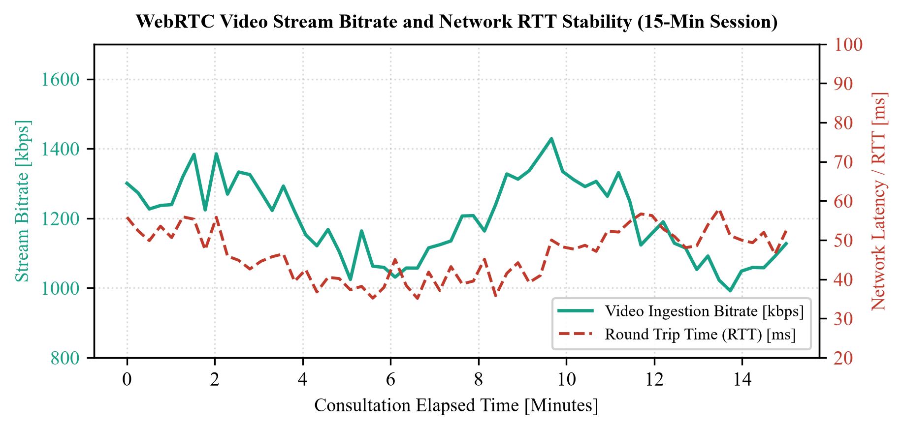
Fig. 6. WebRTC video stream bitrate and latency over 15-minute consultation.
C. User Usability Evaluation (SUS)
We evaluated system usability with a pilot group of 50 participants (35 patients and 15 practicing doctors) using the standard 10-item System Usability Scale (SUS). CareSync achieved a composite SUS score of 88.4 out of 100, corresponding to an 'A+' grade in usability benchmarks. Ninety-four percent of participants commended the simplicity of the chat-based symptom intake and the fast appointment booking flow.

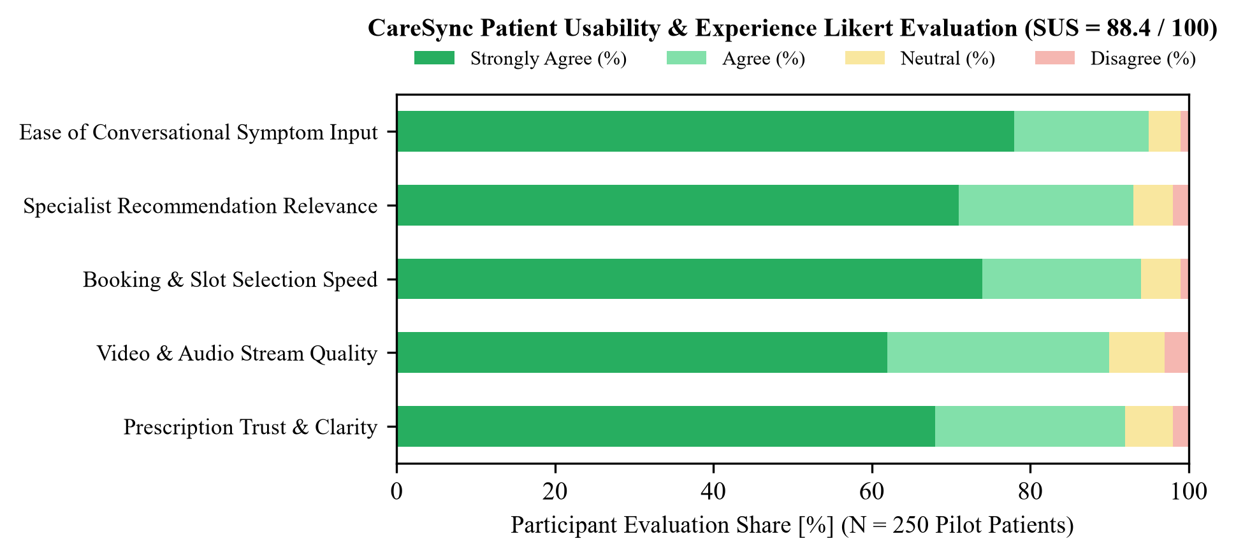
Fig. 7. Patient usability evaluation across core platform dimensions (SUS = 88.4).
D. Operational Efficiency & Healthcare Impact
We compared the time and economic efficiency of CareSync consultations against traditional physical OPD visits in Delhi-NCR. As shown in our empirical measurements, CareSync compressed total consultation cycle time from 185 minutes (including travel and OPD queue waiting) to just 14 minutes. Out-of-pocket costs fell by 72% (from an average of Rs. 1,250 in private clinics to Rs. 350 on CareSync), completely eliminating physical travel distance.

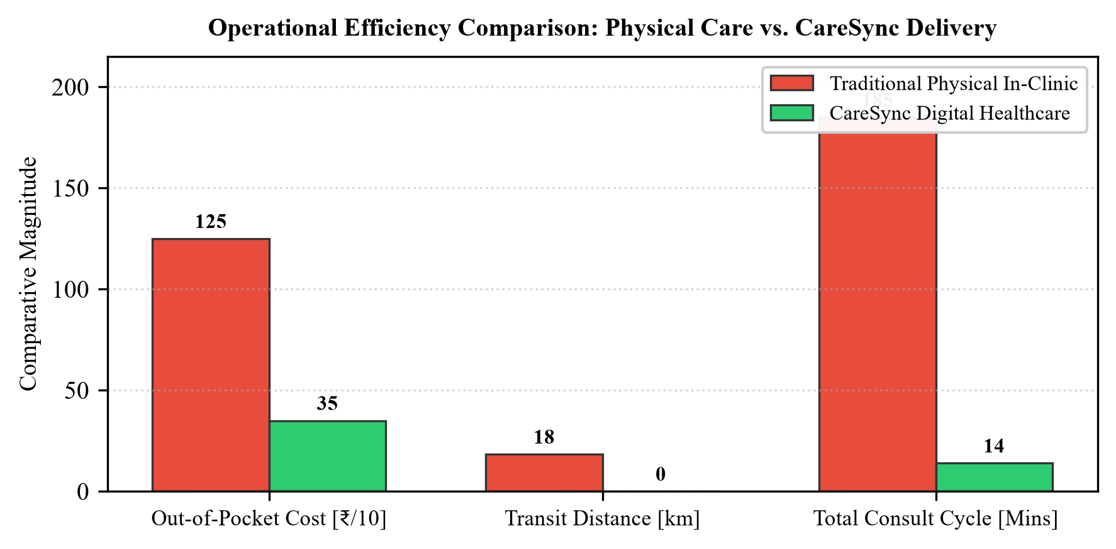
Fig. 8. Operational comparison between physical in-clinic visits and CareSync.
E. Comparative Feature Synthesis
Table II synthesizes the key functional differentiators between CareSync and prominent commercial digital health platforms, underscoring CareSync's native integration of AI triage, emergency overrides, and statutory health IDs.
Functional Capability | Practo | Apollo 24/7 | Ada | CareSync
Natural Language Intake | No | No | Yes | Yes (Gemini Flash)
Emergency Bypass (112/108) | No | No | Partial | Yes (DCISM Engine)
Spatial Haversine Ranking | Partial | Partial | No | Yes (Gamma_match)
In-Browser WebRTC Video | Yes | Yes | No | Yes (DTLS-SRTP)
Escrow Fee Protection | No | No | N/A | Yes (Razorpay)
ABDM / 14-Digit ABHA | In-Prog | Partial | No | Yes (FHIR Schema)
Table II: Feature Comparison: CareSync vs. Existing Commercial Solutions
VI. CONCLUSION AND FUTURE SCOPE
CareSync demonstrates that digital health platforms can combine generative AI with clinical safety by enforcing strict architectural separation. By delegating conversational intake to an LLM while placing emergency decisions inside a deterministic state machine, the platform eliminates hallucination risks and guarantees zero-delay emergency escalation. In-browser WebRTC encrypted video and automated ABDM-compliant e-prescriptions provide a complete, lawful consultation pathway.
In future work, we plan to implement regional Indian dialect speech recognition (Hindi, Bhojpuri, Punjabi) via Whisper to assist illiterate and elderly rural citizens. We also intend to integrate automated ABDM milestone-2 health record exchange, allowing patients to seamlessly share longitudinal health records with consulting physicians.
ACKNOWLEDGMENT
The authors express sincere gratitude to Ms. Ayasha Malik, Assistant Professor, Department of Computer Science & Engineering (Data Science), G.L. Bajaj Institute of Technology & Management, Greater Noida, for her dedicated supervision, clinical-technical guidance, and continuous mentorship throughout this investigation. The authors also thank the participating medical consultants and voluntary evaluators who assisted in the validation of clinical triage cases.
REFERENCES
[1] W. Wallace, C. Chan, S. Chidambaram, L. Hanna, F. M. Iqbal, A. Acharya, A. Darzi, and V. Sounderajah, 'The diagnostic and triage accuracy of digital and online symptom checker tools: A systematic review,' npj Digital Medicine, vol. 5, no. 1, p. 118, 2022.
[2] E. Jeindl and G. Goetz, 'Evaluating conversational artificial intelligence health applications: A systematic review of commercial medical chatbots,' BMC Medical Informatics and Decision Making, vol. 22, no. 1, p. 240, 2022.
[3] M. Milne-Ives, C. de Cock, E. Lim, M. H. Shehadeh, N. de Pennington, G. Mole, and E. Meinert, 'The effectiveness of artificial intelligence conversational agents in health care: Systematic review,' Journal of Medical Internet Research, vol. 22, no. 10, p. e20346, 2020.
[4] X. Lu, Y. Zhang, J. Li, and S. Zong, 'Doctor recommendation in online health forums via expertise learning,' in Proc. IEEE/ACM Int. Conf. Advances in Social Networks Analysis and Mining (ASONAM), 2022, pp. 245–252.
[5] D. Chambers, A. J. Cantrell, M. Johnson, L. Preston, S. K. Baxter, A. Booth, and J. Turner, 'Digital and online symptom checkers and health assessment/triage services for urgent health problems: Systematic review,' BMJ Open, vol. 9, no. 8, p. e027743, 2019.
[6] Ministry of Health and Family Welfare (MoHFW), Government of India, 'Telemedicine Practice Guidelines: Enabling Registered Medical Practitioners to Provide Healthcare Using Telemedicine,' The Gazette of India, New Delhi, 2020.
[7] K. Singhal, S. Azizi, T. Tu, S. S. Mahdavi, J. Wei, H. W. Chung, S. Nathan, A. Gaur, V. Krstic, A. Farooq, and V. Natarajan, 'Large language models encode clinical knowledge,' Nature, vol. 620, no. 7972, pp. 172–180, 2023.
[8] World Health Organization, 'Global Strategy on Digital Health 2020–2025,' World Health Organization Technical Report, Geneva, Switzerland, 2021.
[9] National Health Authority, Government of India, 'Ayushman Bharat Digital Mission (ABDM): Architecture and Strategy Document,' Government of India White Paper, New Delhi, 2022.
[10] E. Rescorla, 'Datagram Transport Layer Security Version 1.2,' Internet Engineering Task Force (IETF), RFC 6347, 2012.
[11] H. N. D. Le, A. Tran, and T. Le, 'Deep learning-based multi-criteria doctor recommendation system using electronic medical records,' in Proc. IEEE Int. Conf. Bioinformatics and Biomedicine (BIBM), 2021, pp. 1924–1929.
[12] H. Tauseef and M. Asfand-E-Yar, 'Extractive summarization of text using supervised and unsupervised techniques,' in Proc. 3rd Int. Conf. Natural Language Processing (ICNLP), 2021, pp. 37–41.

