Secure Private Infrastructure Deployment
Bastion Access and IAM Role-Based Architecture
Region: us-west-2 (Oregon) | Account: 098688552647
Internship Project Set-5 | Project 1

1. Project Overview
This project implements a production-grade secure AWS infrastructure for a fintech company. Application servers run in private subnets with no public IP, accessible only through a hardened Bastion Host. All EC2 instances use IAM Roles — no hardcoded credentials anywhere in the system.

2. Architecture Diagram
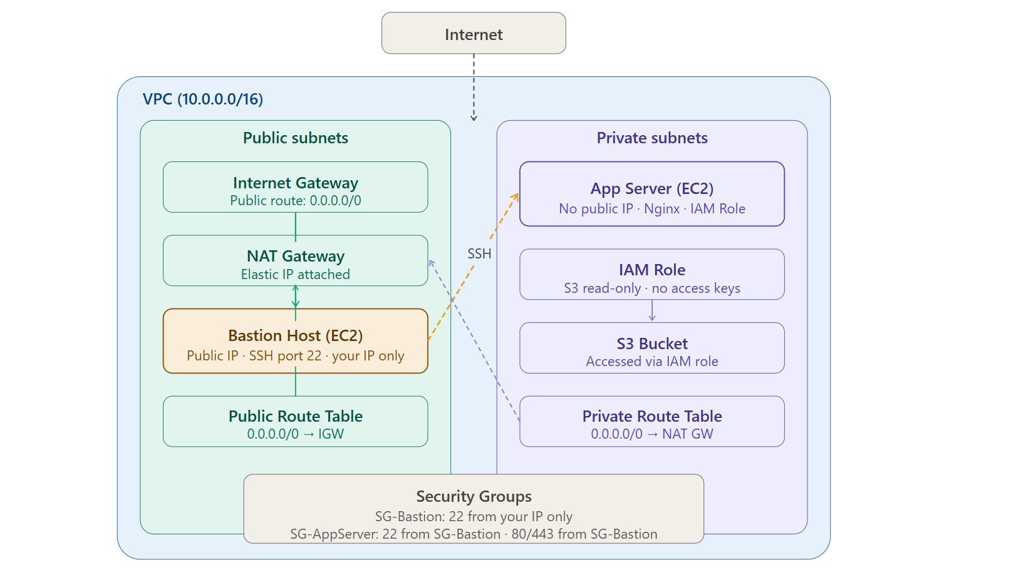
Figure 1 — architecture.png: Full AWS infrastructure layout (us-west-2)

Architecture Explanation
The infrastructure is built inside a custom VPC (fintech-vpc, vpc-0f37ec6ae5fe55c98) with CIDR 10.0.0.0/16 across two availability zones in us-west-2. Public subnets host the Bastion Host and NAT Gateway. Private subnets host the application server with no public IP and no direct internet route.

Traffic flow:
- Developer SSHs from local machine → Bastion Host (public subnet, IP-whitelisted on port 22)
- From Bastion (10.0.1.199), developer hops to App Server via private IP 10.0.3.108
- App Server reaches internet outbound-only via NAT Gateway (52.89.54.67)
- No inbound traffic from the internet can reach the private app server directly

Network Layout
Component | ID / Detail | CIDR / Value
fintech-vpc | vpc-0f37ec6ae5fe55c98 | 10.0.0.0/16
public-subnet-1 | subnet-0752a6f323ceed782 | 10.0.1.0/24
public-subnet-2 | subnet-00fb9854ec0d04038 | 10.0.2.0/24
private-subnet-1 | subnet-04f832eb5d0a055cb | 10.0.3.0/24
private-subnet-2 | subnet-0fdc95f91346307b7 | 10.0.4.0/24
fintech-igw | igw-03bc679829d99a05d | Attached to fintech-vpc
fintech-nat-gw | nat-022d26bd503594c74 | Public IP: 52.89.54.67
public-rt | rtb-05babe915393dcaa6 | 0.0.0.0/0 → IGW
private-rt | rtb-0b3b9ce01a54eb317 | 10.0.0.0/16 → local + NAT GW

3. Network Configuration Screenshots

3.1 VPC Details
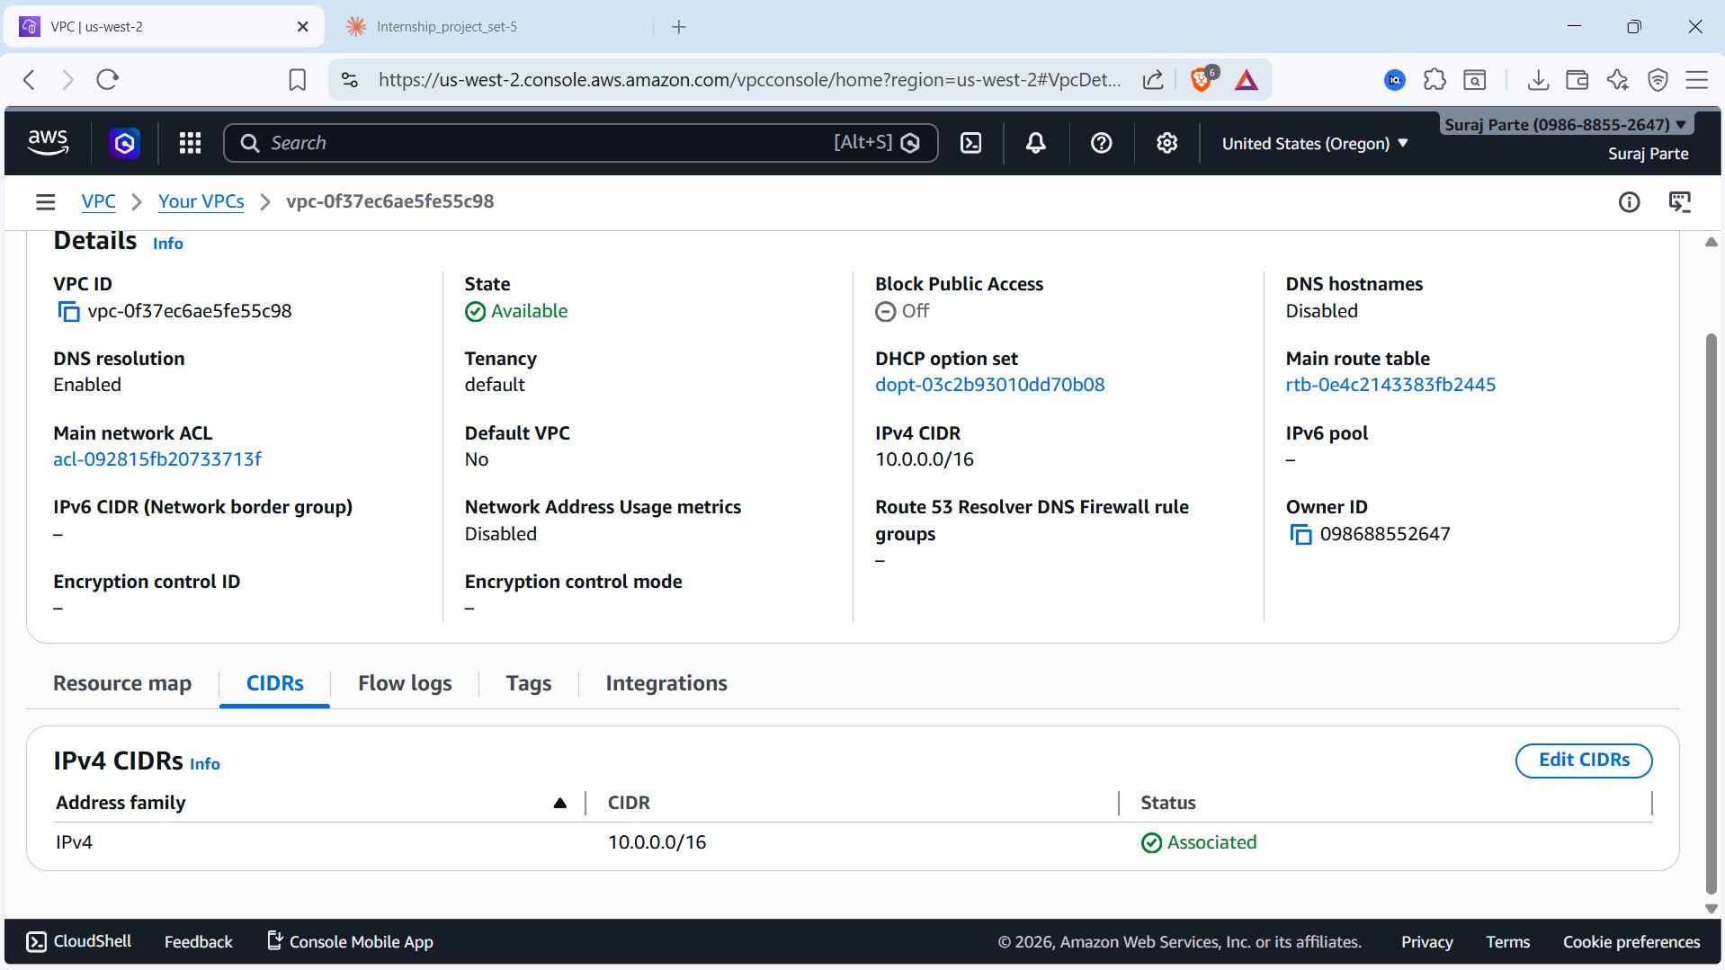
Figure 2 — 01_vpc_details.png: fintech-vpc (vpc-0f37ec6ae5fe55c98), CIDR 10.0.0.0/16, State: Available

3.2 Subnets List
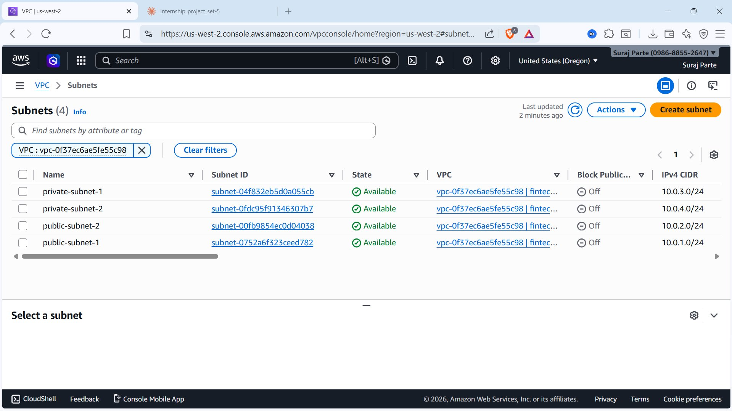
Figure 3 — 02_subnets_list.png: All 4 subnets (2 public, 2 private) in fintech-vpc — all Available

3.3 NAT Gateway
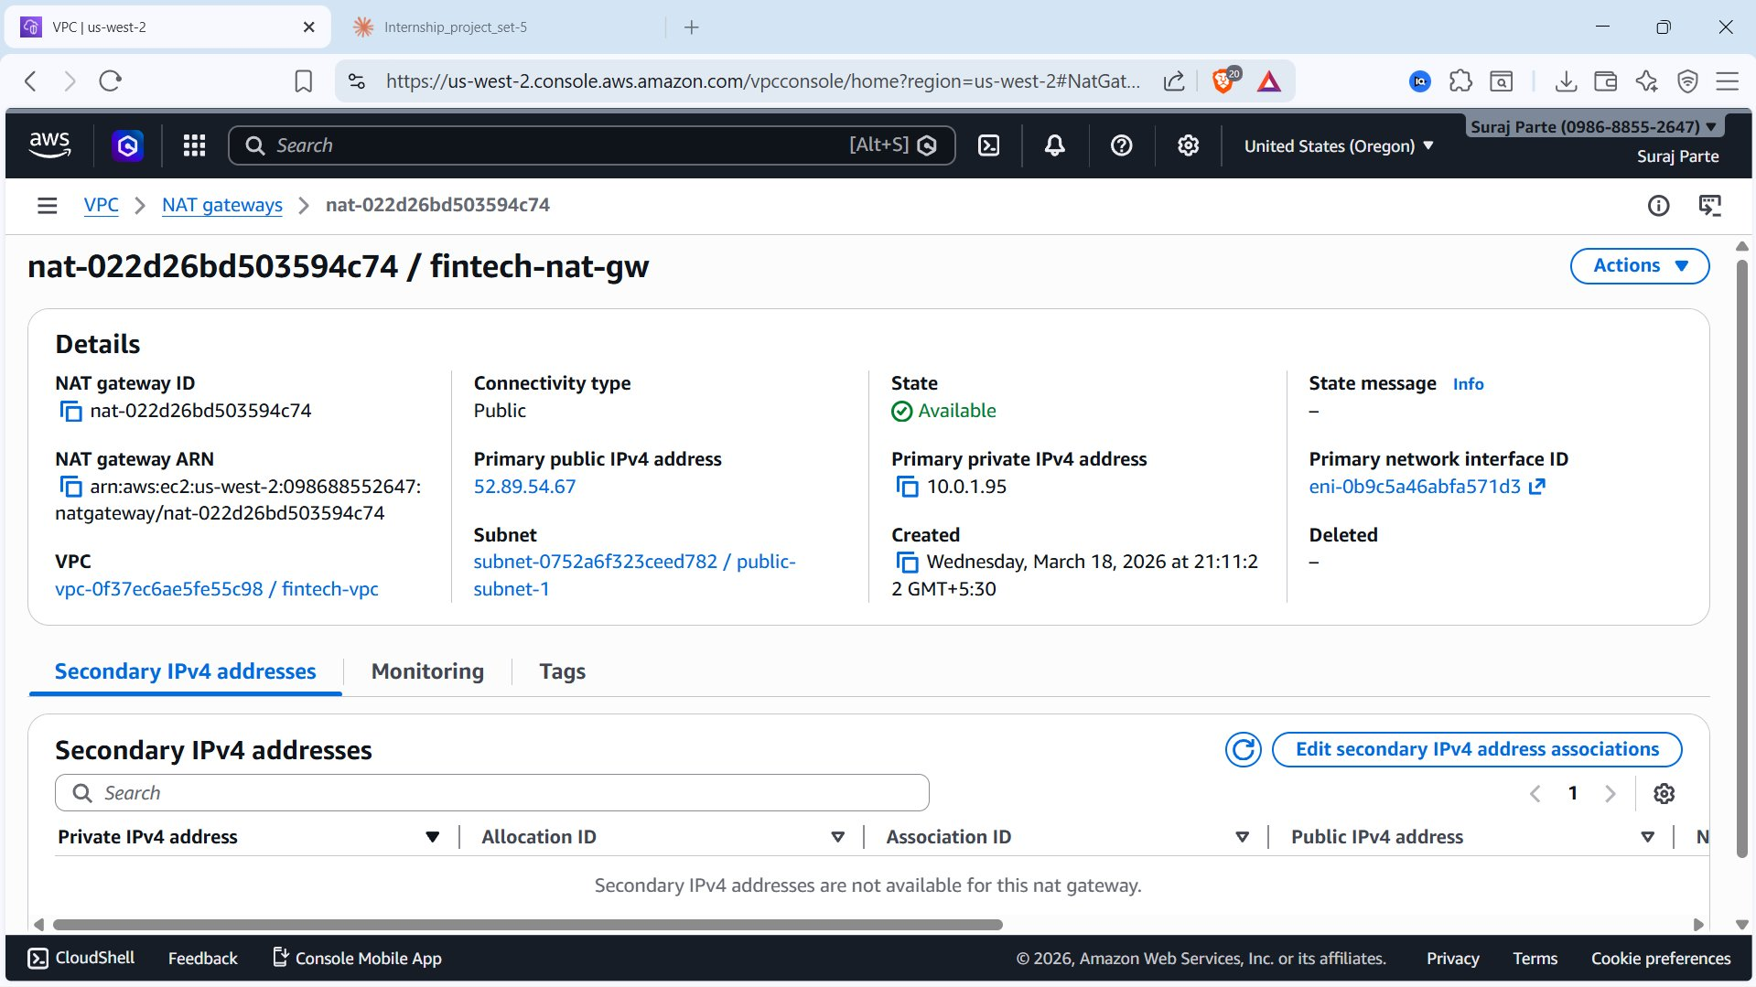
Figure 4 — 04_nat_gateway_available.png: fintech-nat-gw (nat-022d26bd503594c74) — State: Available, Public IP: 52.89.54.67, in public-subnet-1

3.4 Internet Gateway — Attached
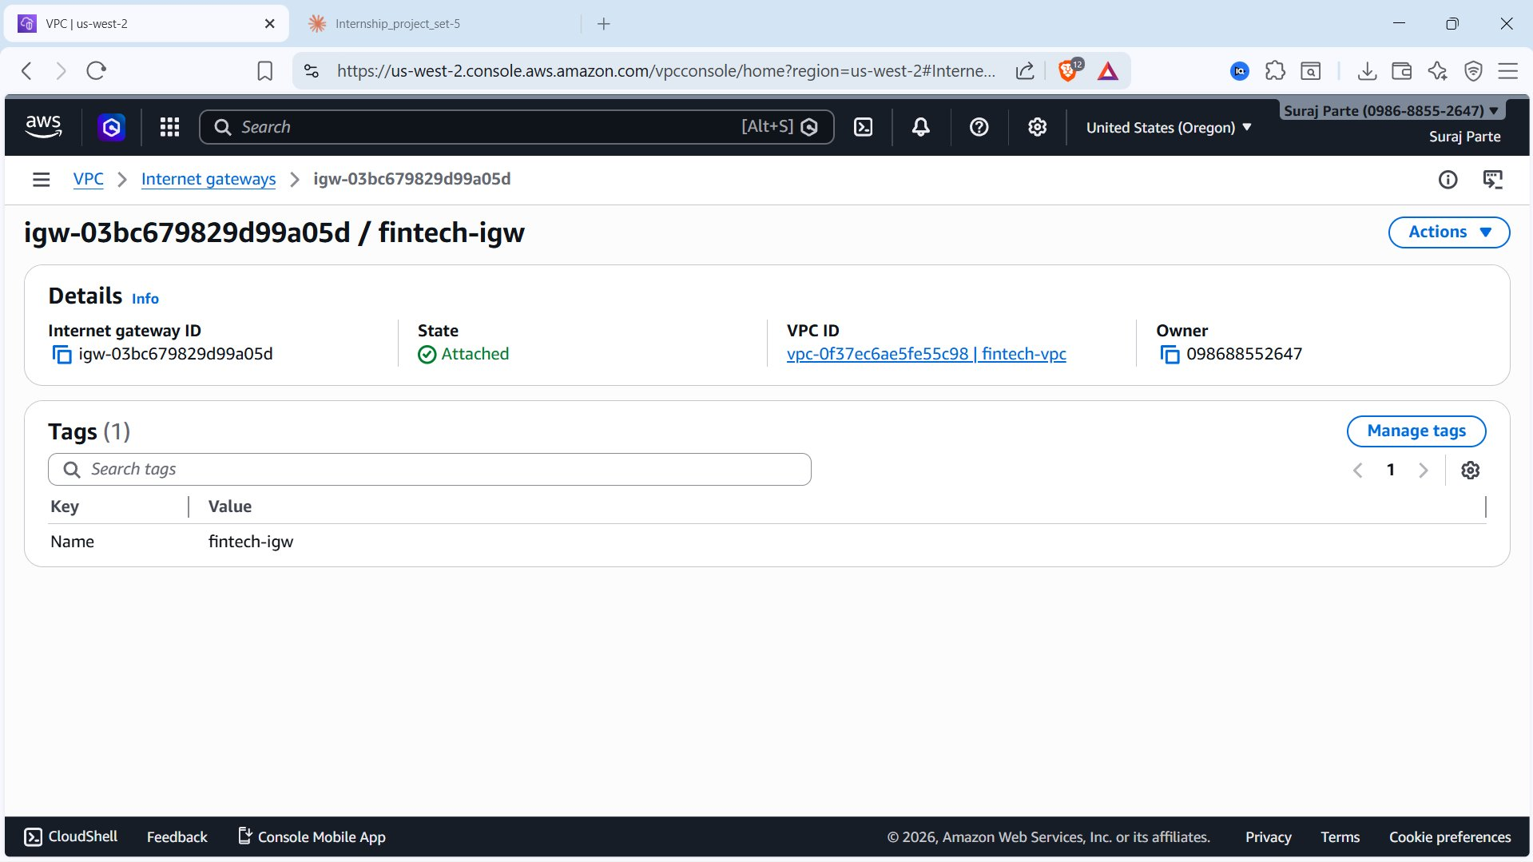
Figure 5 — 03_igw_attached.png: fintech-igw (igw-03bc679829d99a05d) — State: Attached to fintech-vpc

3.5 Public Route Table
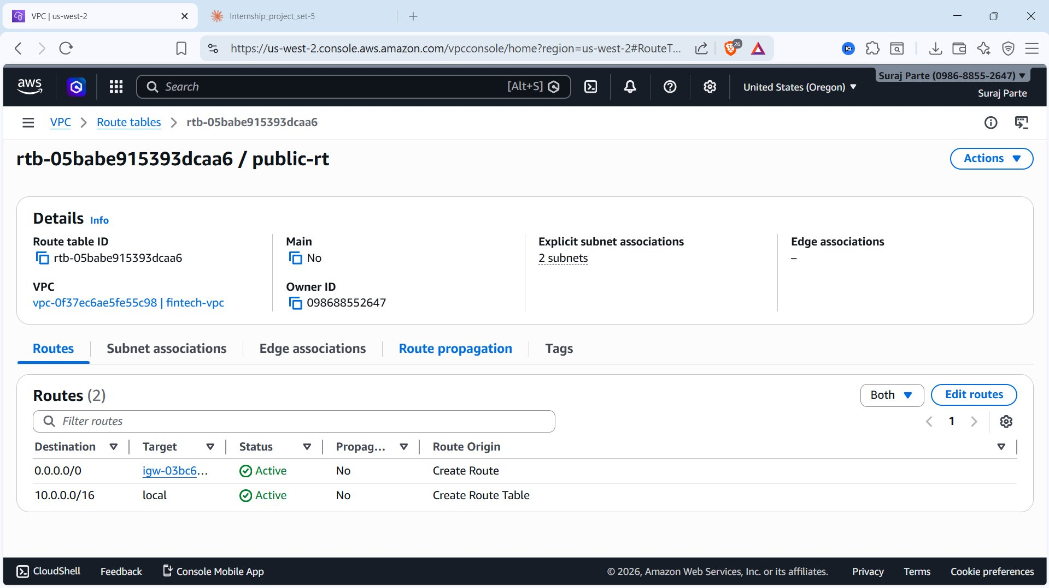
Figure 6 — 05_public_route_table.png: public-rt (rtb-05babe915393dcaa6) — Route 0.0.0.0/0 → IGW, 2 subnet associations

3.6 Private Route Table
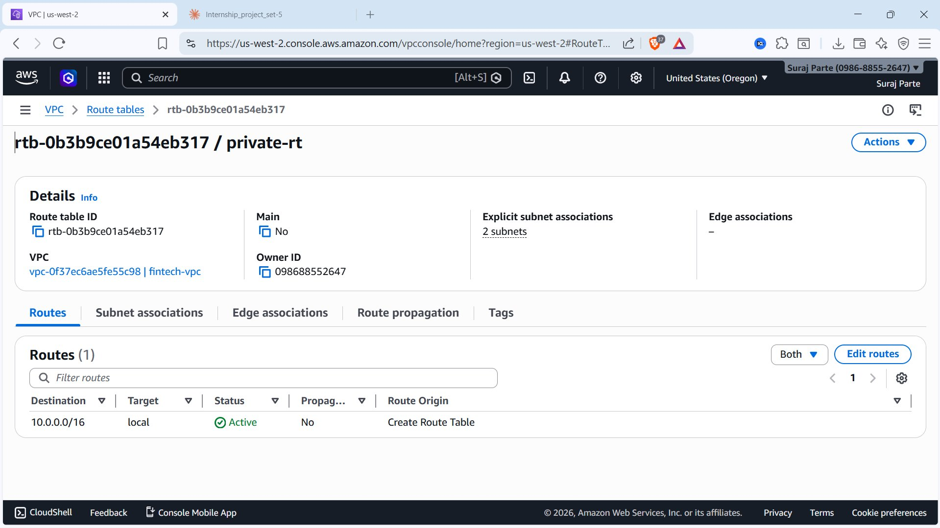
Figure 7 — 06_private_route_table.png: private-rt (rtb-0b3b9ce01a54eb317) — 10.0.0.0/16 local only, 2 subnet associations

4. Security Design Decisions

4.1 Bastion Host
- Deployed in public-subnet-1, Public IP 16.148.97.77 (instance i-053dc425d1536ab9f)
- SSH (port 22) restricted to your IP only — security group bastion-sg (sg-0651c18e2244fd108)
- Password login disabled — key-pair finetech-key.pem only
- Only 1 inbound rule exists — no other ports open

4.2 Private Application Server
- No public IP — private IP 10.0.3.108 only (instance i-04fdf0c9f8ced234f)
- Deployed in private-subnet-1 — unreachable from internet directly
- Security group appserver-sg (sg-0b22d17276040db6a) — SSH and HTTP from bastion-sg only
- Outbound routes through NAT Gateway — no direct internet exposure

4.3 Security Groups
Security Group | Rule | Source
bastion-sg (sg-0651c18e2244fd108) | SSH — Port 22 | Your IP /32 only
appserver-sg (sg-0b22d17276040db6a) | SSH — Port 22 | bastion-sg reference
appserver-sg (sg-0b22d17276040db6a) | HTTP — Port 80 | bastion-sg reference

4.4 IAM Role
- Role ec2-role (arn:aws:iam::098688552647:role/ec2-role) with AmazonS3ReadOnlyAccess
- Attached to app-server via instance profile arn:aws:iam::098688552647:instance-profile/ec2-role
- No ~/.aws/credentials on server — temporary credentials via instance metadata

5. Security Group Configuration Screenshots

5.1 Bastion Security Group (bastion-sg)
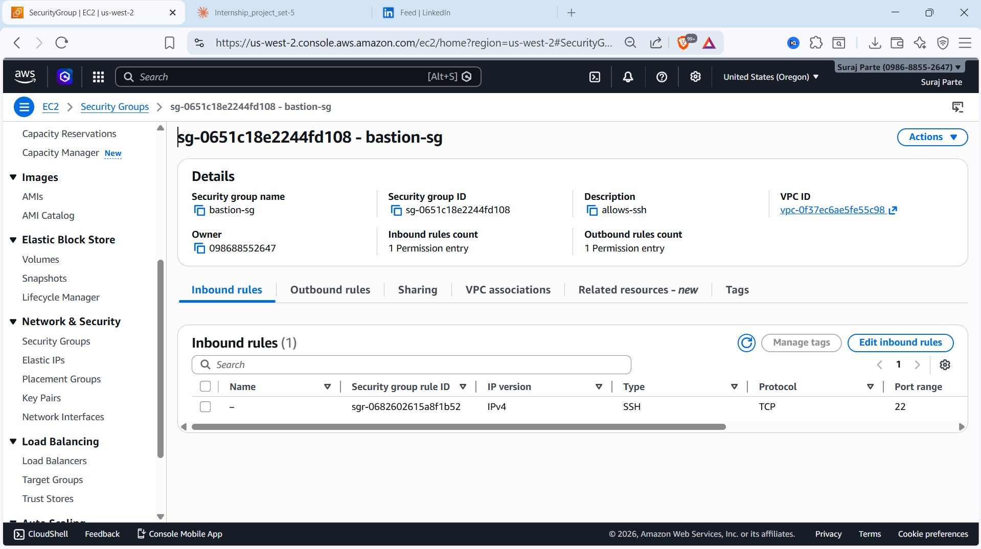
Figure 8 — 07_sg_bastion_inbound.png: bastion-sg — 1 inbound rule, SSH port 22, IPv4 only

5.2 App Server Security Group (appserver-sg)
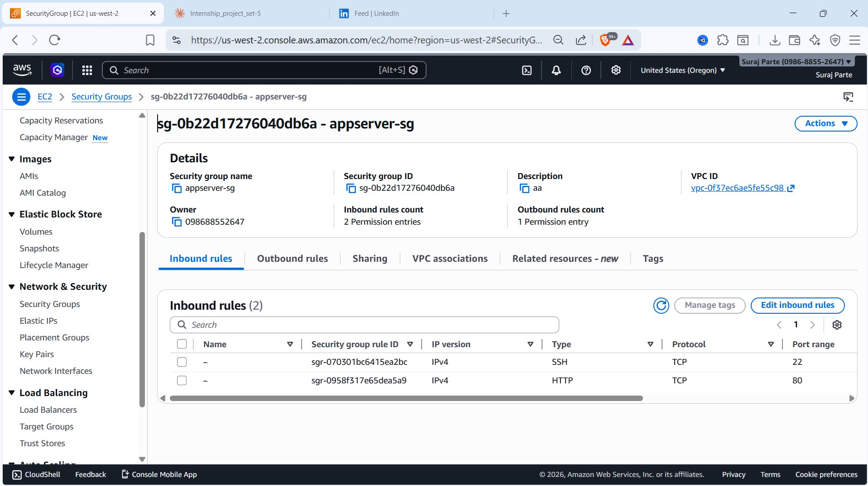
Figure 9 — 08_sg_appserver_inbound.png: appserver-sg — 2 inbound rules, SSH port 22 and HTTP port 80

6. Bastion Access Proof

6.1 Bastion Host EC2 Details
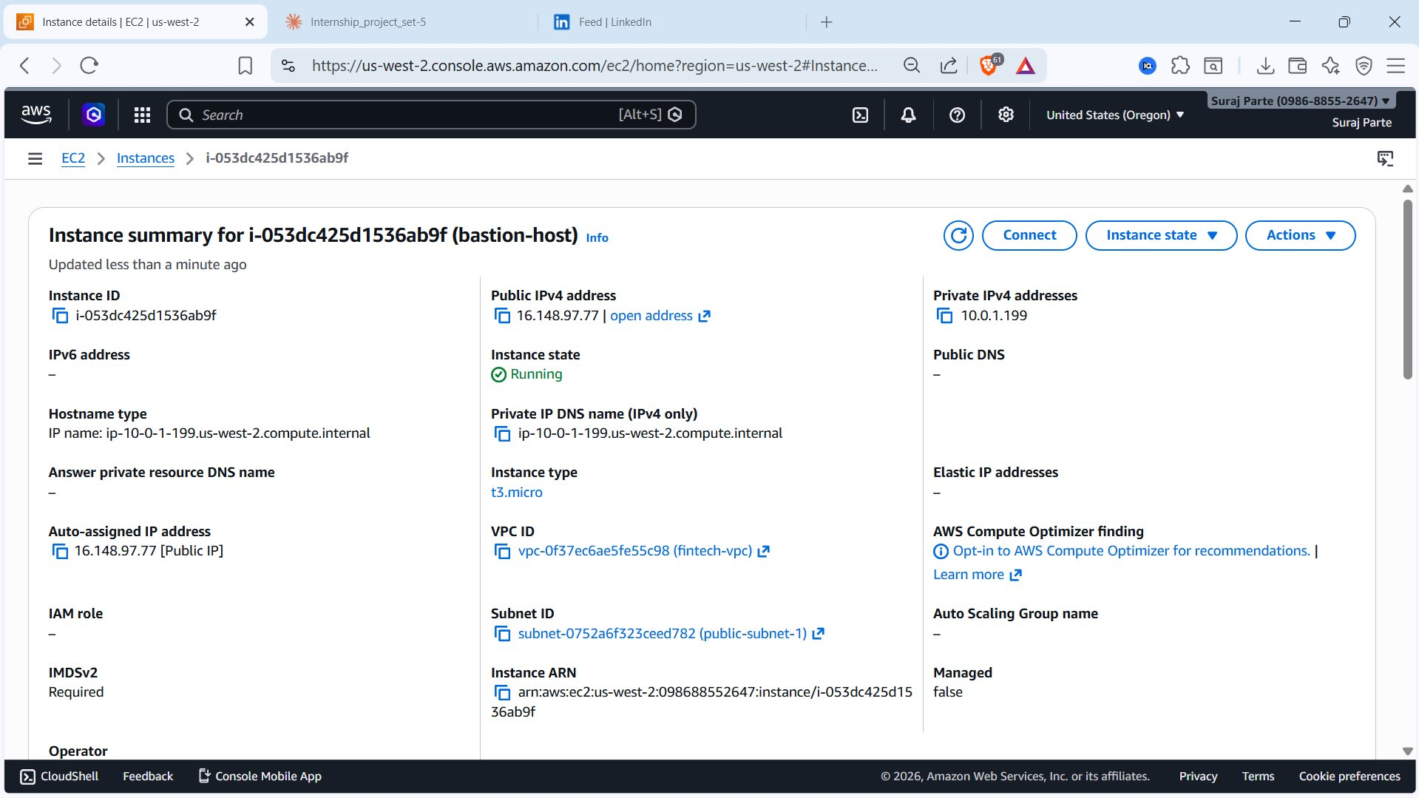
Figure 10 — 09_bastion_ec2_details.png: bastion-host (i-053dc425d1536ab9f) — Public IP 16.148.97.77, Subnet public-subnet-1, VPC fintech-vpc, Running

6.2 App Server EC2 Details
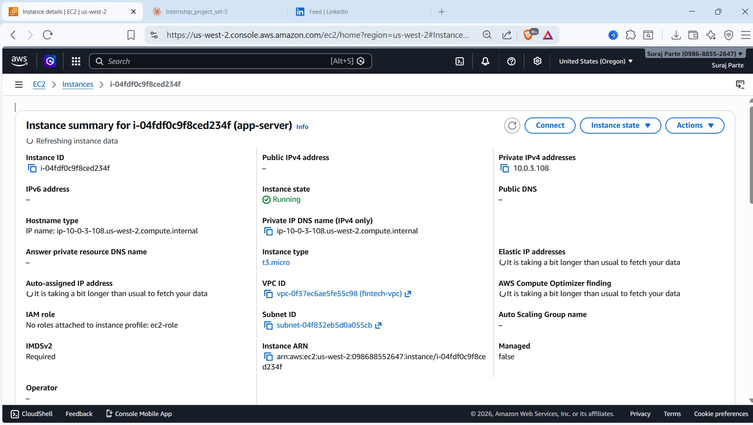
Figure 11 — 10_appserver_ec2_details.png: app-server (i-04fdf0c9f8ced234f) — No Public IP, Private IP 10.0.3.108, Subnet private-subnet-1, IAM role: ec2-role

6.3 Successful SSH — Bastion to App Server
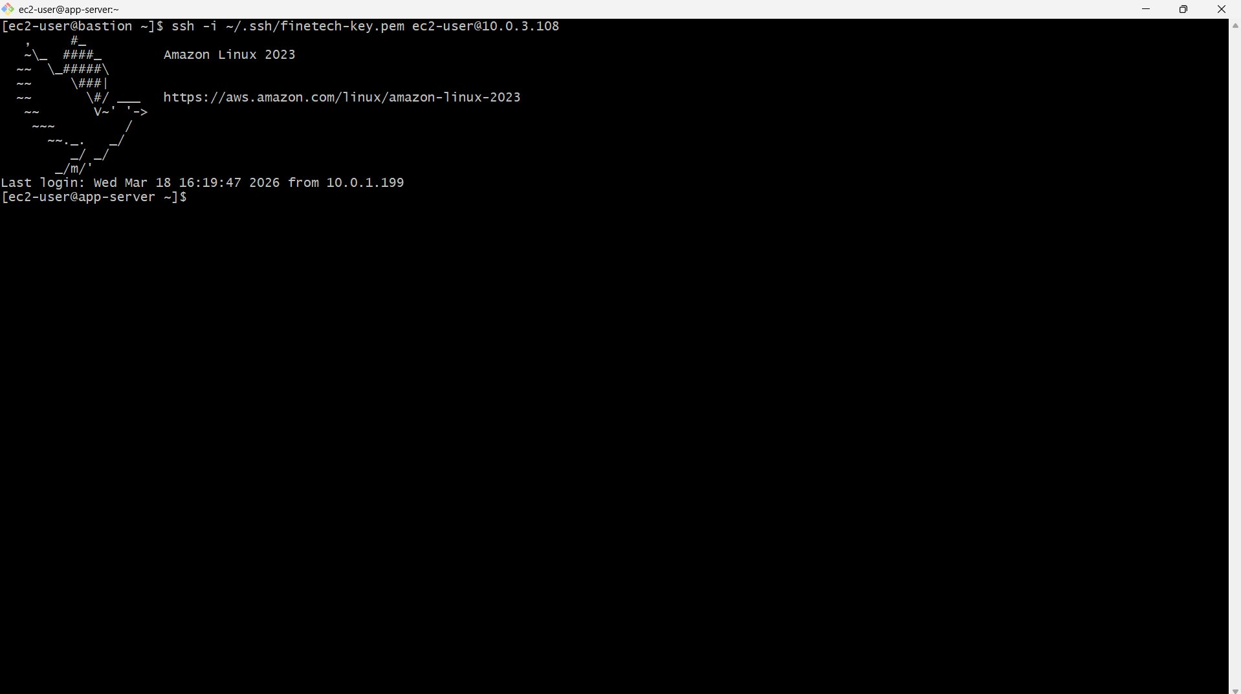
Figure 12 — 11_ssh_into_bastion.png: SSH from bastion (10.0.1.199) into app-server (10.0.3.108) — login successful, Amazon Linux 2023

6.4 Direct SSH Timeout — Security Validation
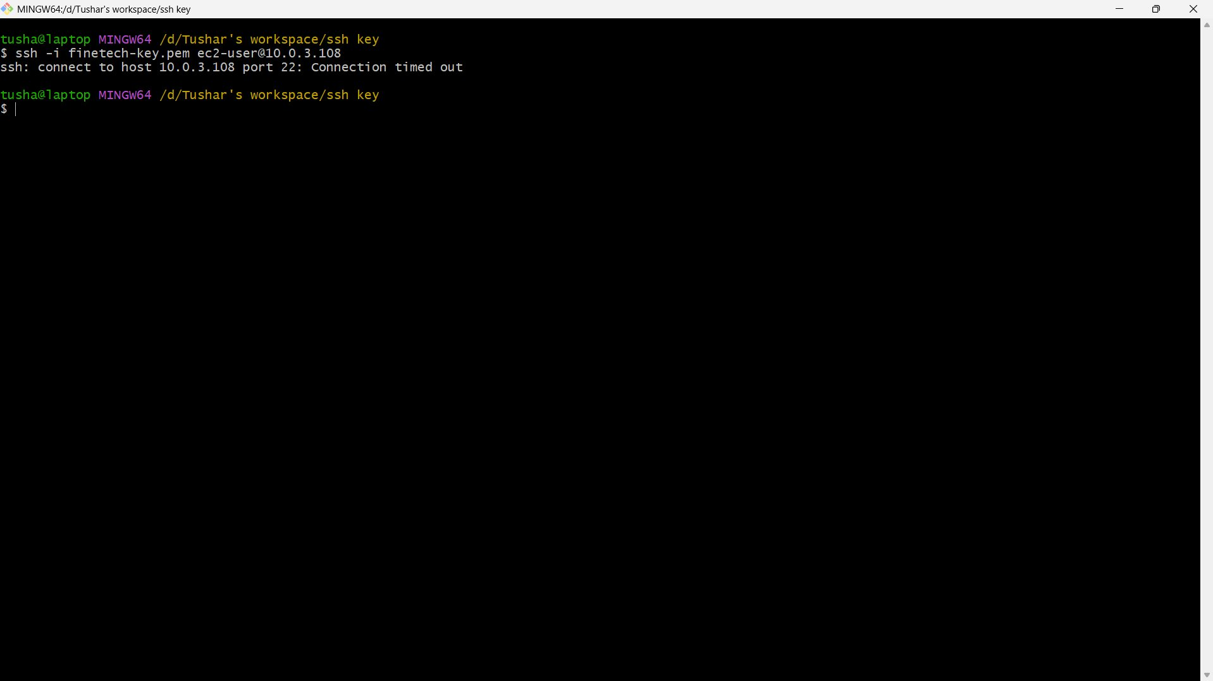
Figure 13 — 13_direct_ssh_timeout.png: Direct SSH to 10.0.3.108 from local machine — Connection timed out. Private server unreachable from internet.

7. IAM Role Attachment Proof

7.1 IAM Role Policy
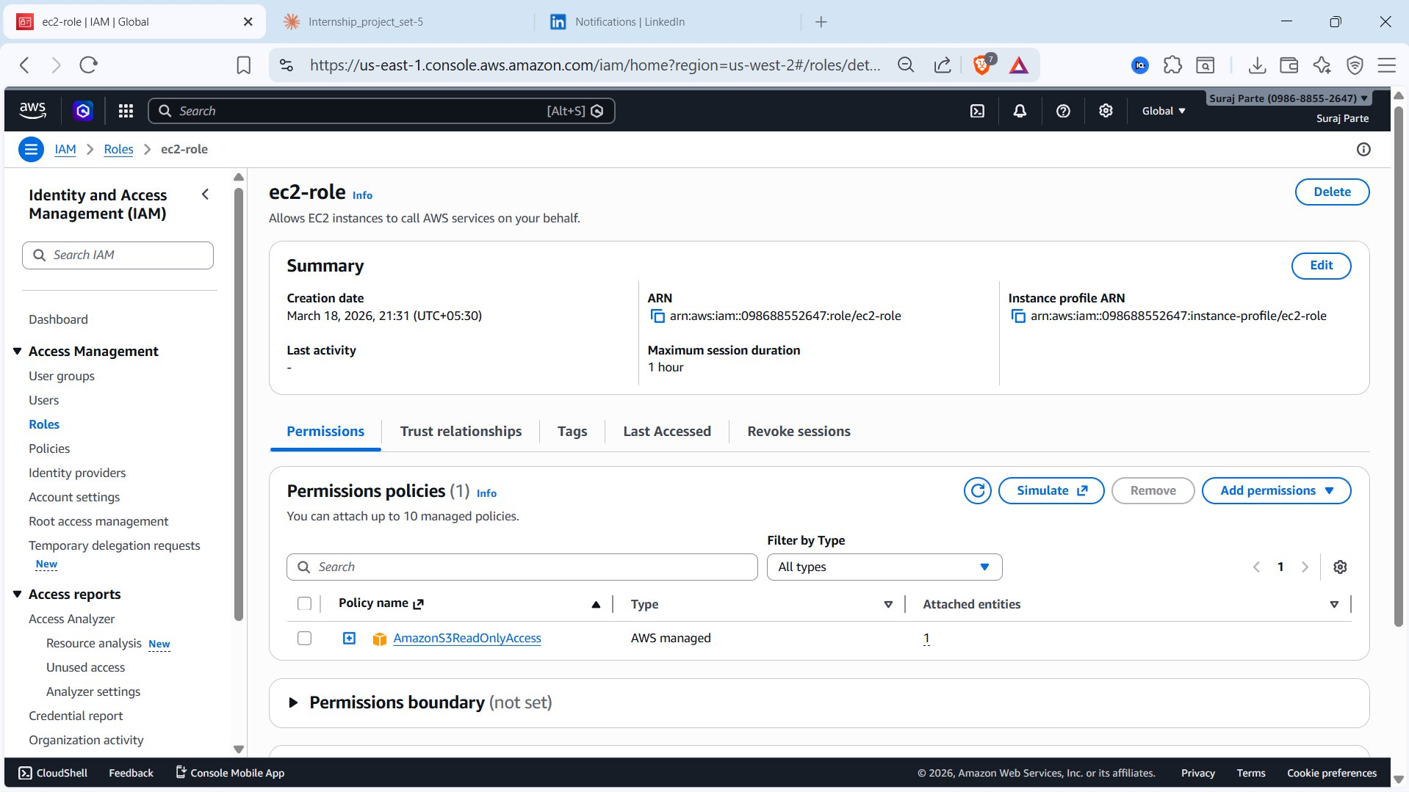
Figure 14 — 14_iam_role_policy.png: ec2-role with AmazonS3ReadOnlyAccess (AWS managed) — 1 attached entity

7.2 Role Attached to App Server
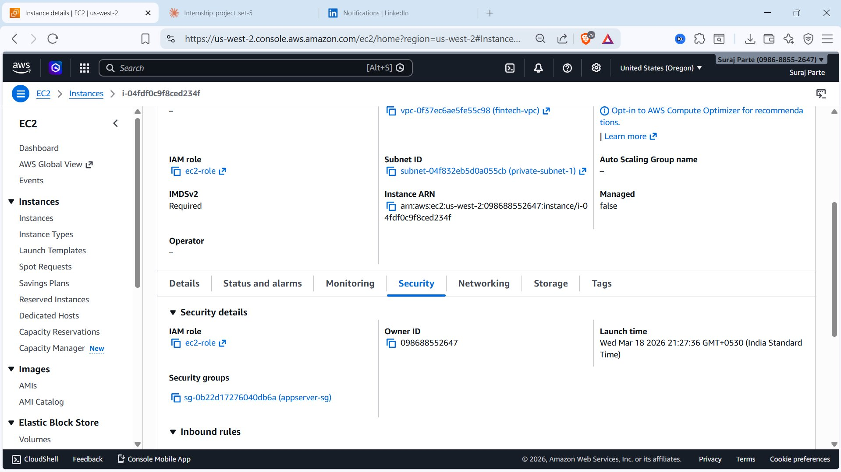
Figure 15 — 15_iam_role_attached_ec2.png: app-server Security tab — IAM role: ec2-role, Security group: appserver-sg, Subnet: private-subnet-1

8. Access Flow
# Step 1 — On local machine
chmod 400 finetech-key.pem
scp -i finetech-key.pem finetech-key.pem ec2-user@16.148.97.77:~/.ssh/
ssh -i finetech-key.pem ec2-user@16.148.97.77

# Step 2 — Inside bastion, hop to app server
chmod 400 ~/.ssh/finetech-key.pem
ssh -i ~/.ssh/finetech-key.pem ec2-user@10.0.3.108

# Step 3 — Verify IAM role (no credentials file)
curl http://169.254.169.254/latest/meta-data/iam/security-credentials/
# Returns: ec2-role

9. Setup Steps Summary
Step | Action | Location
1 | Create VPC fintech-vpc (10.0.0.0/16) | VPC Console
2 | Create 4 subnets (2 public, 2 private) | VPC → Subnets
3 | Create and attach Internet Gateway fintech-igw | VPC → Internet Gateways
4 | Create NAT Gateway fintech-nat-gw in public-subnet-1 | VPC → NAT Gateways
5 | Create public-rt — 0.0.0.0/0 → IGW | VPC → Route Tables
6 | Create private-rt — 0.0.0.0/0 → NAT GW | VPC → Route Tables
7 | Create bastion-sg — SSH port 22 from your IP only | EC2 → Security Groups
8 | Create appserver-sg — SSH + HTTP from bastion-sg | EC2 → Security Groups
9 | Launch bastion-host in public-subnet-1 (public IP on) | EC2 → Launch Instance
10 | Launch app-server in private-subnet-1 (no public IP) | EC2 → Launch Instance
11 | Create ec2-role with S3ReadOnly, attach to app-server | IAM → Roles

10. Lessons Learned
- Never assign public IPs to application servers — private subnets with Bastion access is the correct secure pattern
- Security group chaining (referencing another SG as source) is more secure than IP-based rules for internal traffic
- IAM Instance Profiles eliminate static credentials entirely — no access keys to rotate, leak, or store
- NAT Gateway provides necessary outbound internet for private instances with zero inbound exposure
- Route tables are the key control point — a private subnet with a route to IGW is effectively public
- Restricting Bastion SSH to a /32 IP dramatically reduces attack surface compared to 0.0.0.0/0
- The jump-host pattern (Local → Bastion → Private EC2) enforces two access control layers in practice
- The private-rt screenshot revealed it only had a local route — the NAT route must be explicitly added

11. Technologies Used
Technology | Purpose
Amazon VPC | Network isolation — custom CIDR, subnets, route tables
Amazon EC2 | Bastion Host (t3.micro) and private application server (t3.micro)
Internet Gateway | Inbound/outbound internet access for public subnet resources
NAT Gateway | Outbound-only internet access for private subnet instances
IAM Roles | Credential-free AWS service access via instance profile
Amazon S3 | Storage accessed via IAM role — no static access keys
Security Groups | Stateful firewall — enforces least privilege per resource

