

Budapest University of Technology and Economics

Faculty of Electrical Engineering and Informatics

Department of Telecommunications and Media Informatics

**WebRTC Laboratory Report**

**Student:** Bat-Erdene Tushig **Neptun#:** QBI3JH

**Field:** Computer Engineering **Specialization:** Infocommunication

**Github: https://github.com/tushig0826/MMS**

**Date: 2023 October 20**

Exercise 1:

callButton.onclick = call;

setBandwidthButton.onclick = setBandwidth;

pc.onicecandidate = onLocalICECandidateGenerated;

pc.oniceconnectionstatechange = onIceConnectionStateChange;

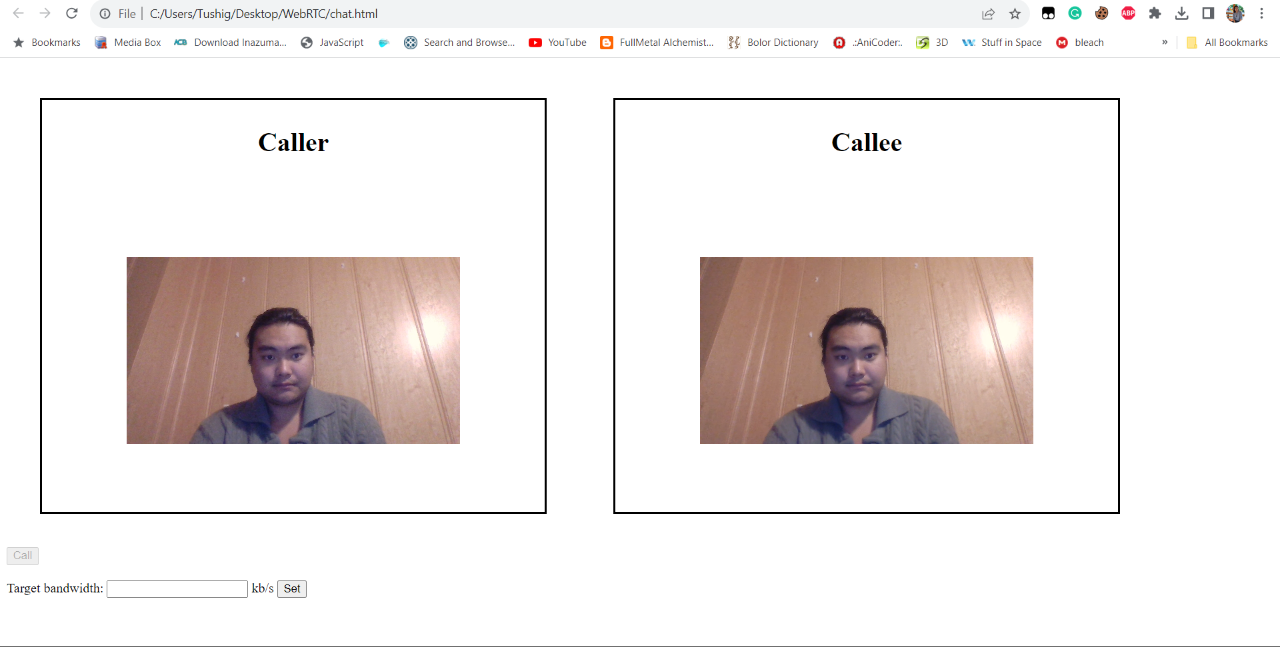

Exercise 2:

1. When the user clicks on a call button, the call function will be called and it sets calling variable to true. Then it creates an offer based on pc.createOffer() function.
2. setBandwidth funcion will be called if user clicks on a button and it will set up the parameters for making it the maximum bitrate of the video stream.
3. onSignallingMessage will work if signalling message is received from remote peer.
4. setRemoteDescription() will set up the remote description.

Exercise 3:

Session Description Protocol is for describing multimedia sessions such as session announcement, session invitation, and so on. The offer/answer model

Exercise 4:

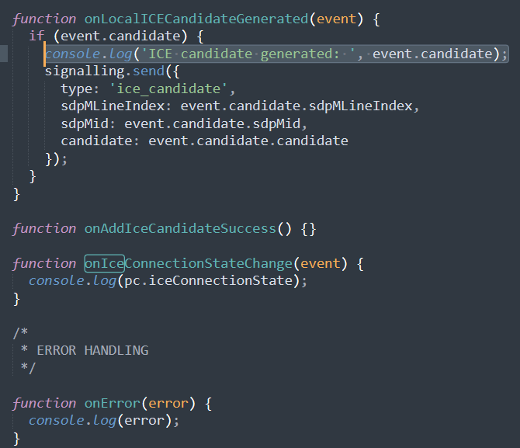

Exercise 5:

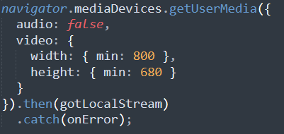

640x480

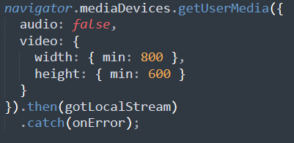

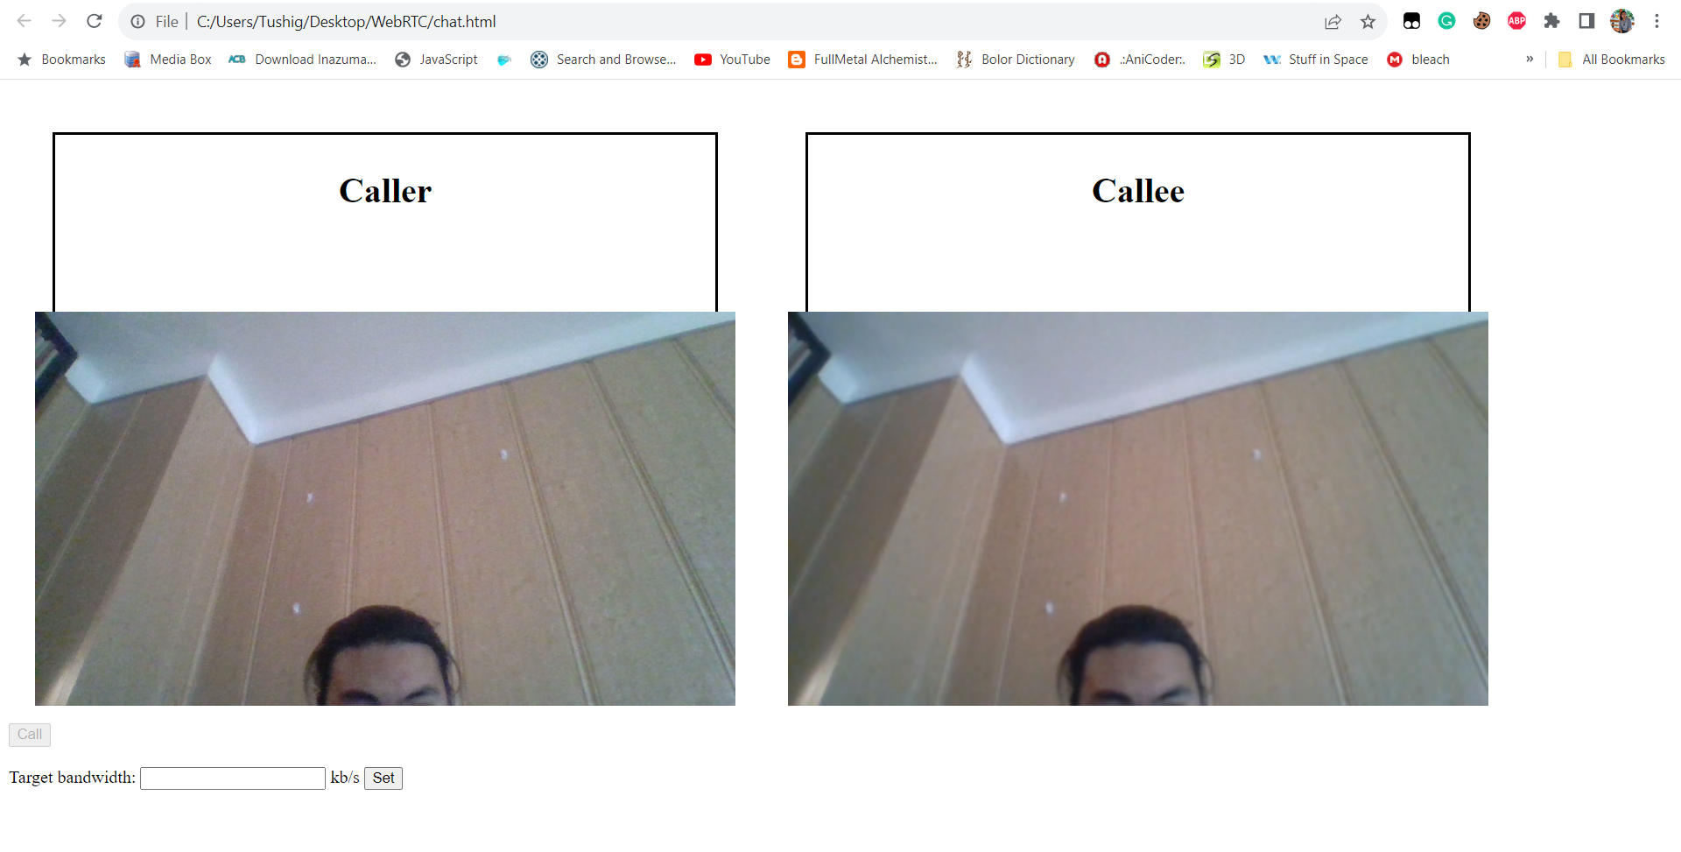

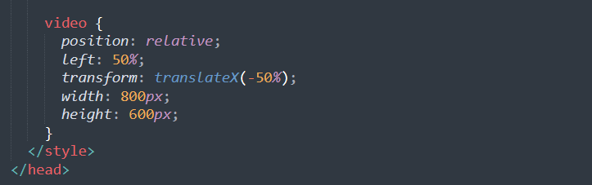

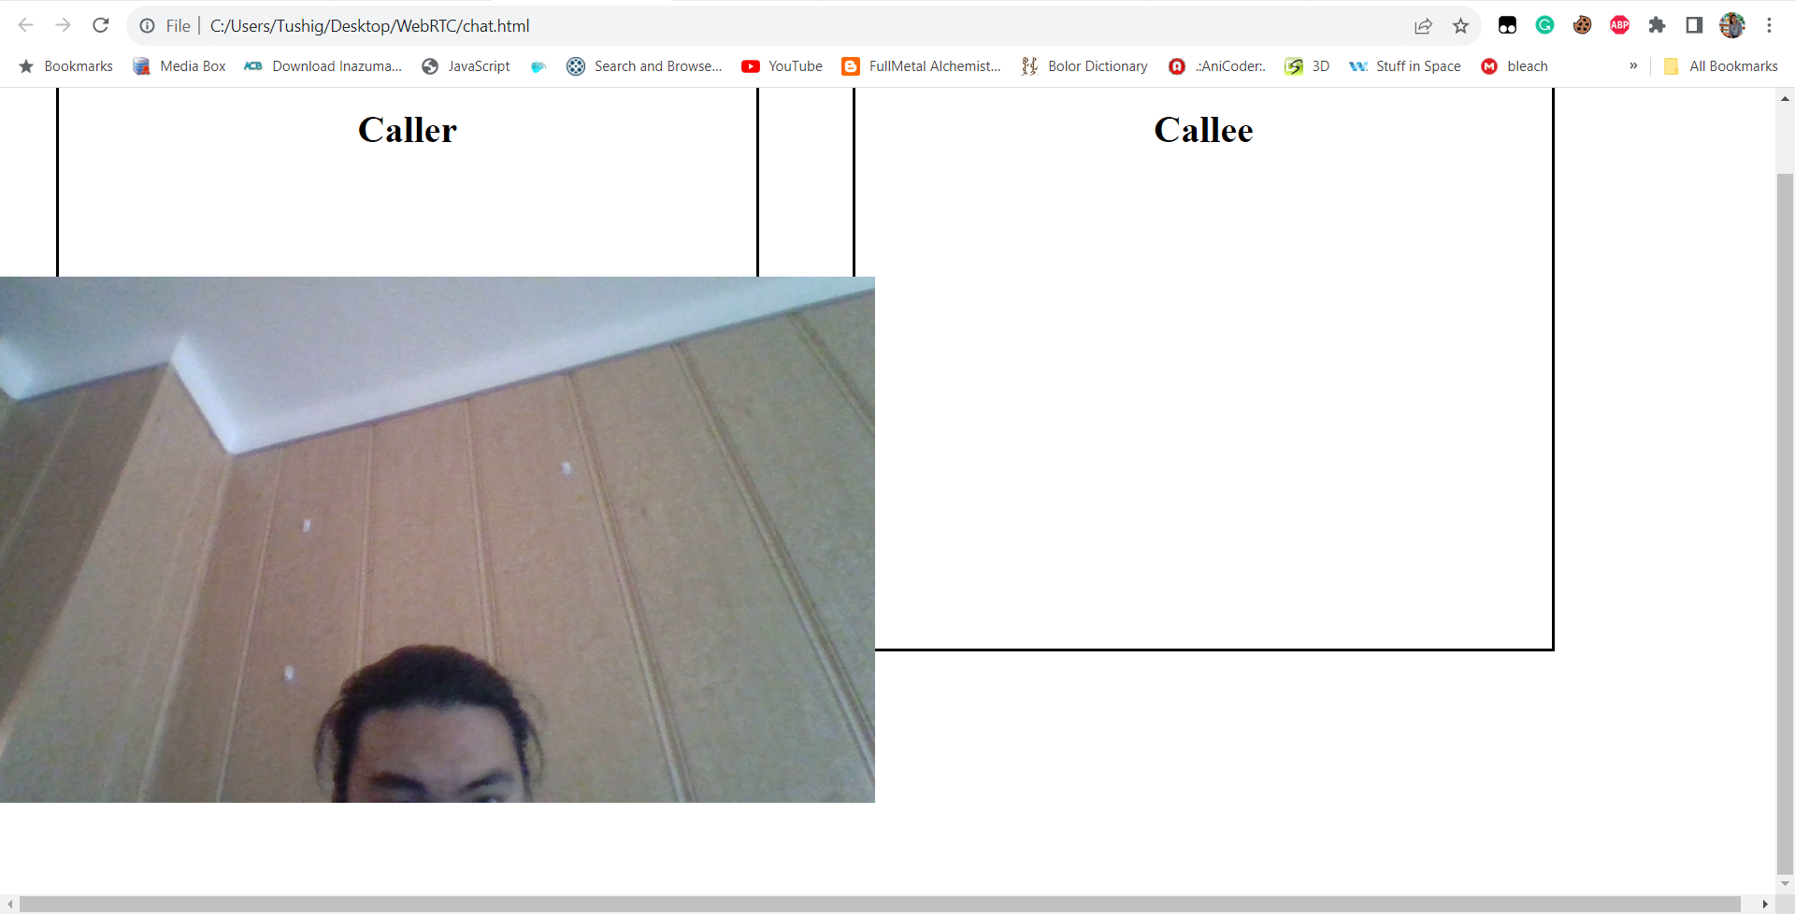

Exercise 6:

