**C2C Project:- Welcome to Yoga Club and Book your First Trial class.**

Created by :- Tushita Roy

Project Submission :- 28Aug 2024

Mentor :- Moronke Fajobi

Course :- Web development

**Project source code:-**

This project contains 4 Files ,

1. Two html file (index.html and Booking .html )

2. Style.css

3.Script.js

4. Readme.md file

Additional info :- This project can be viewed using proxy server <http://127.0.0.1:5500/index.html> or Right click on html file 🡪 Reveal on Folder 🡪 Right click and open with Chrome browser.

Project Zip file-



Project description:-

This webpage provides information about Yoga and different type of yoga Asanas.This also allow you to book your first trial class for Yoga.

If you meet the conditions:-

1. Age between 15 and 55 , over 55 needs doctor’s Approval letter .

2. Booking Date should be future date.

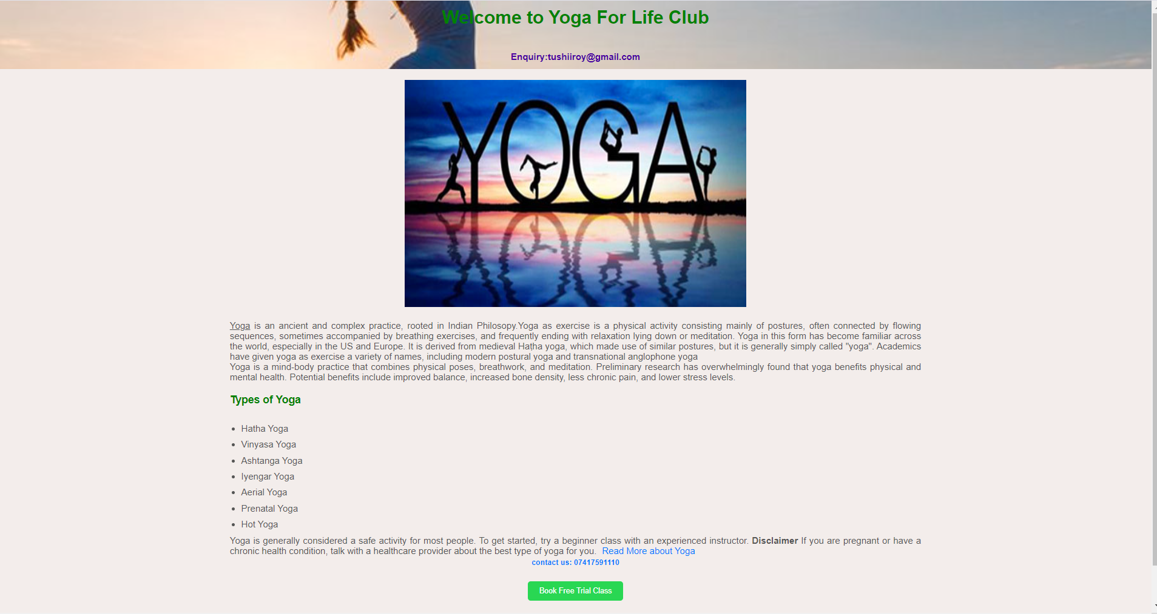

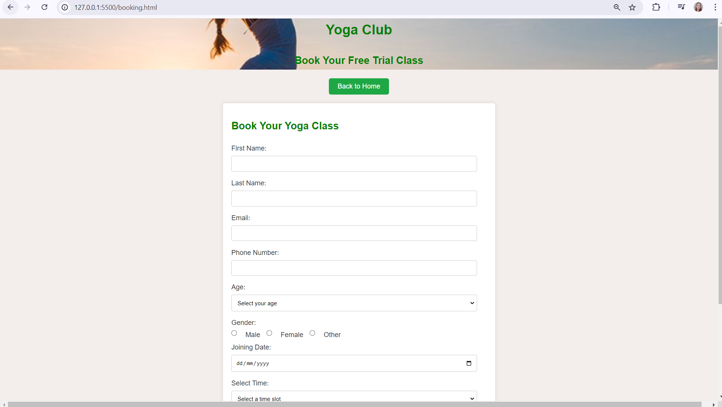

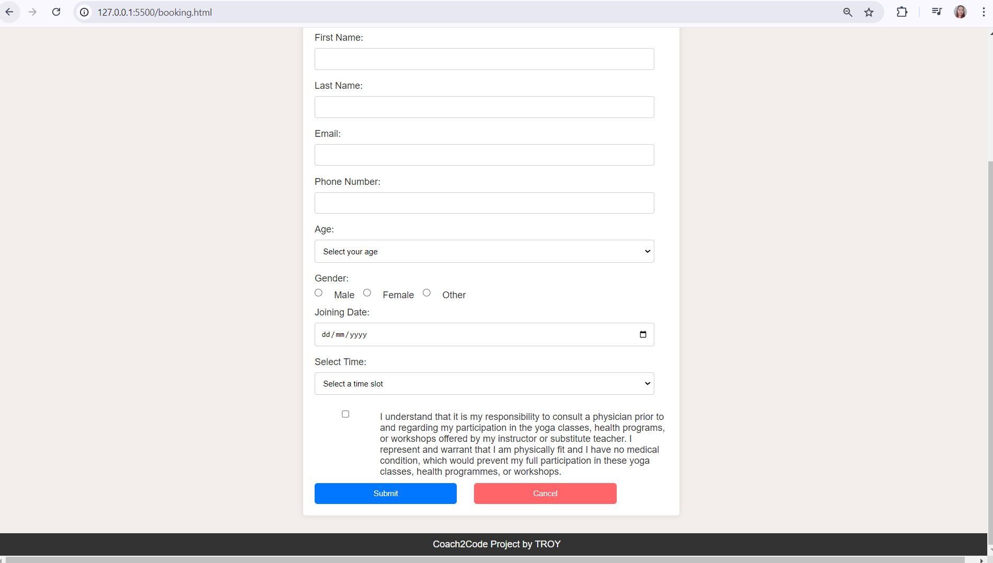

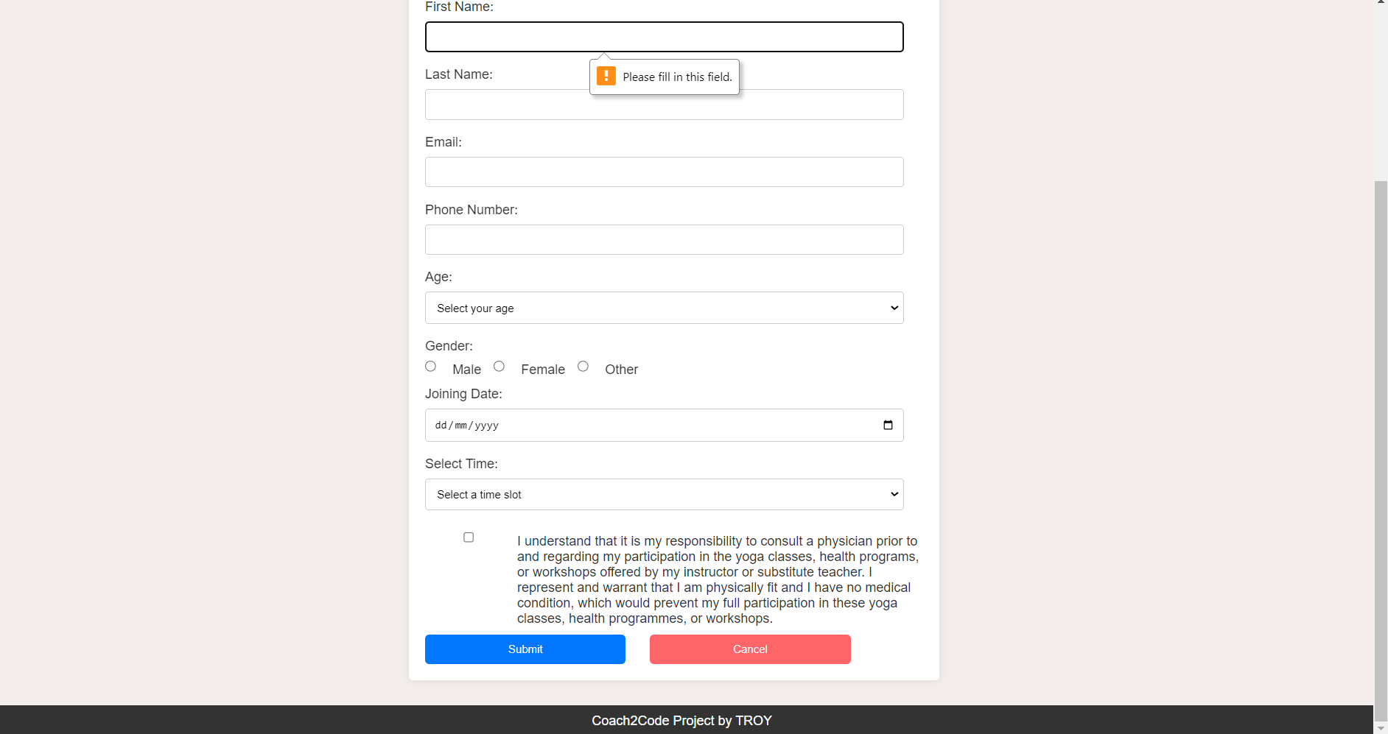

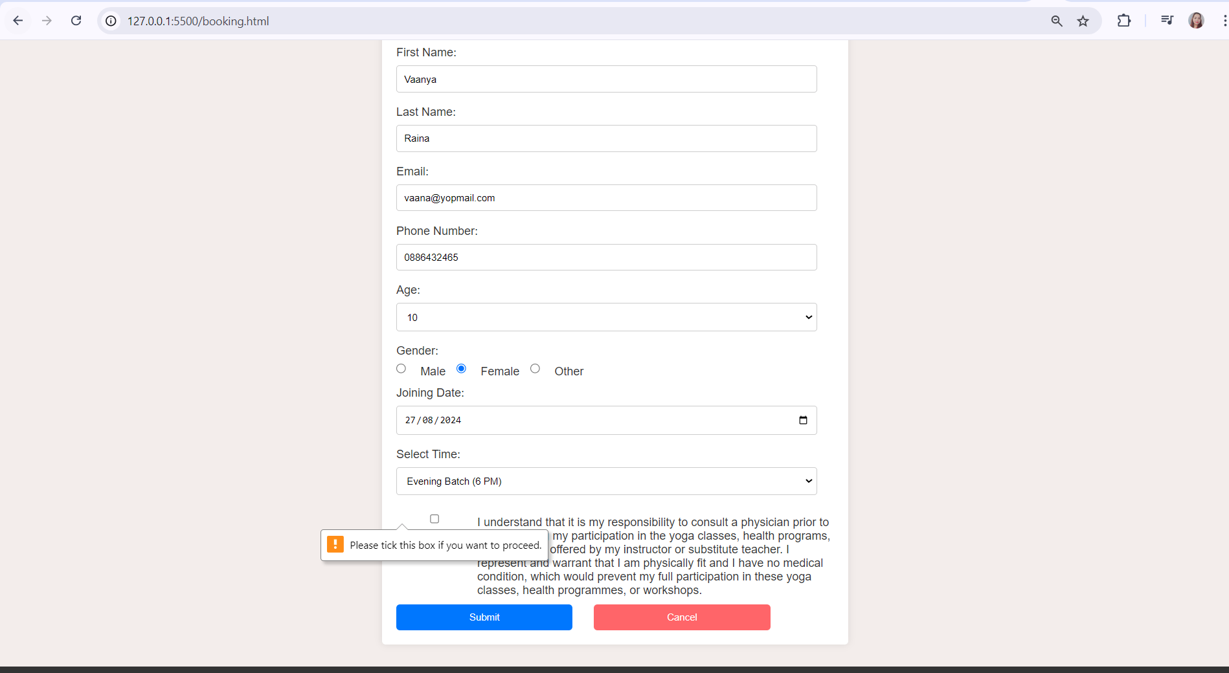

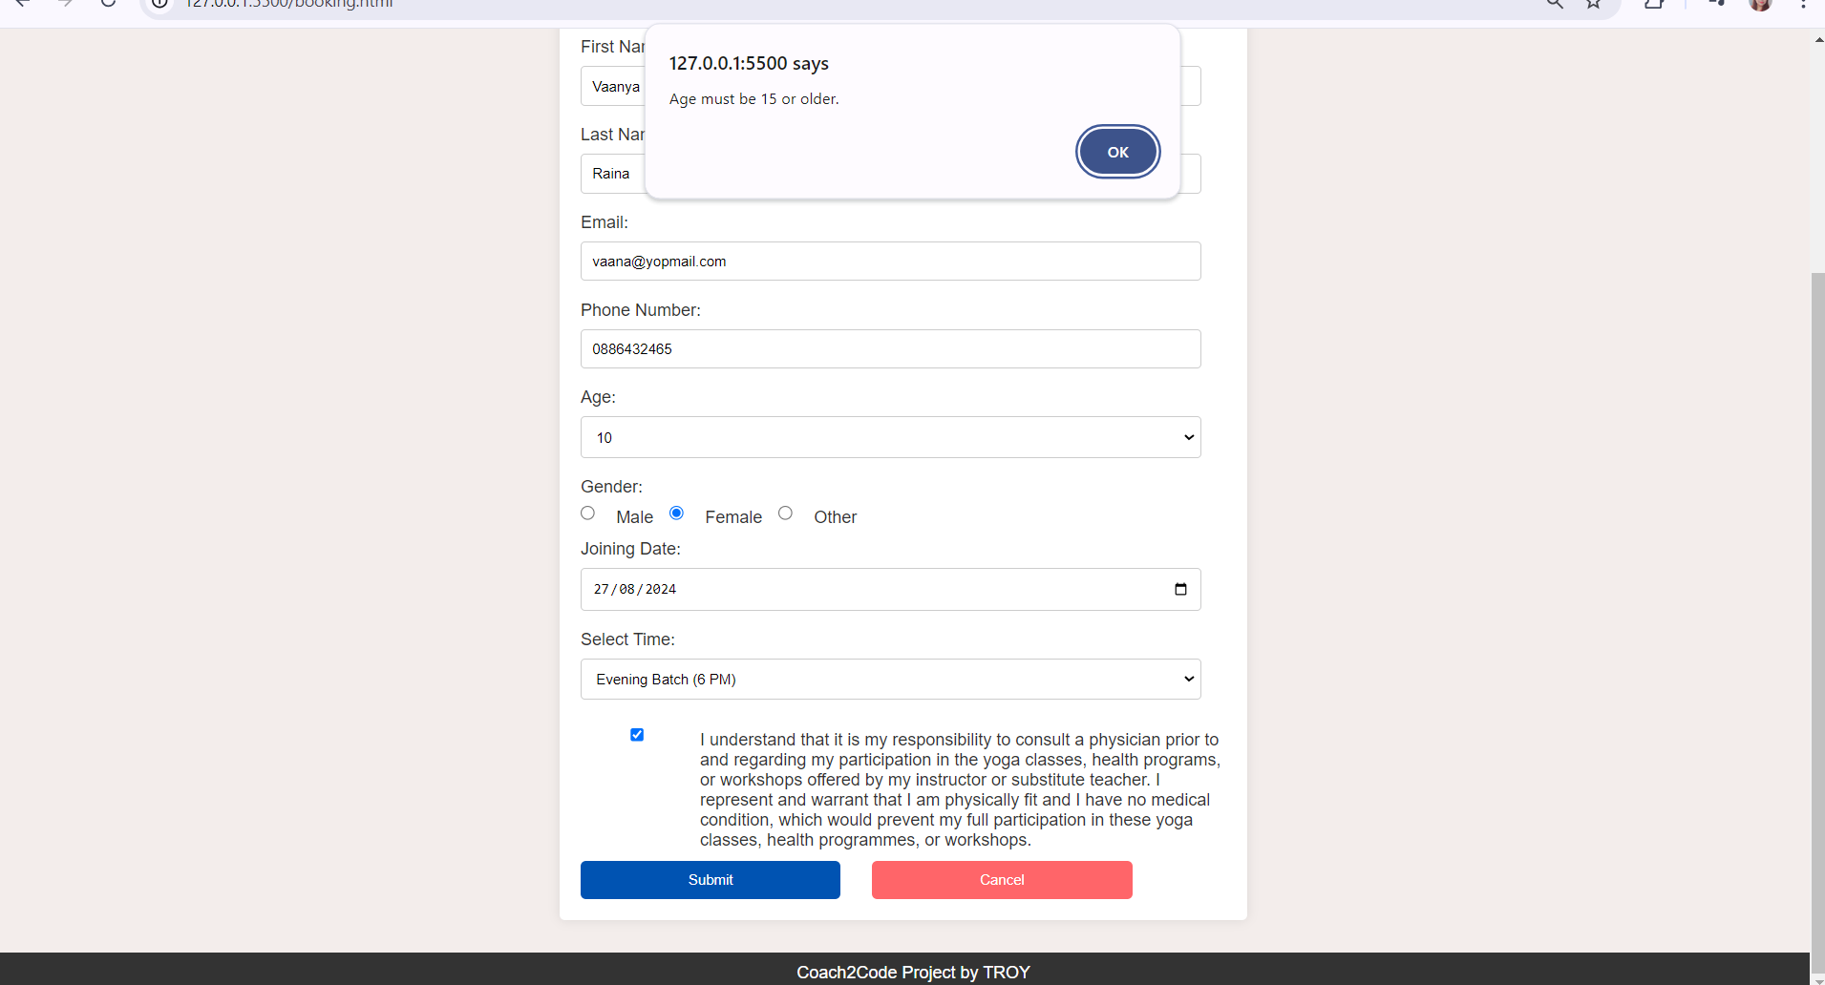

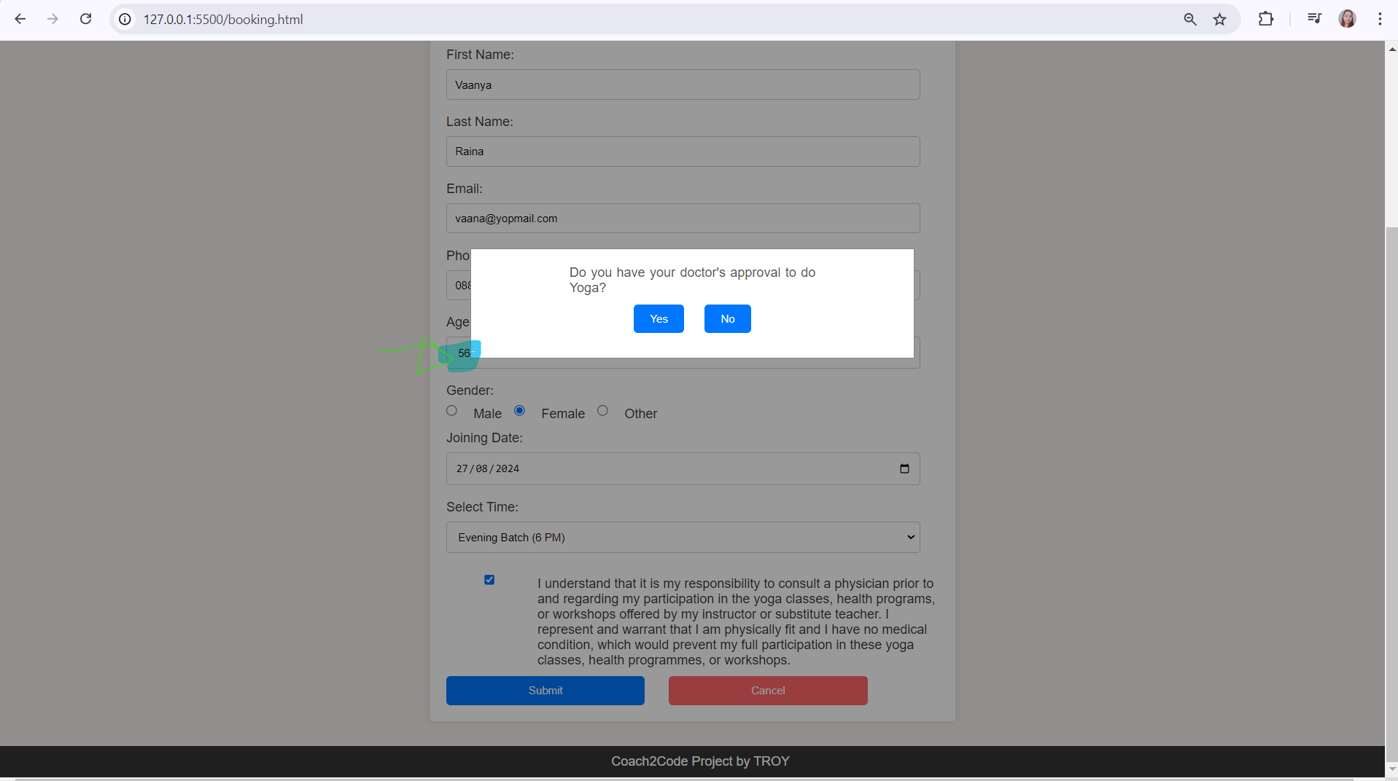

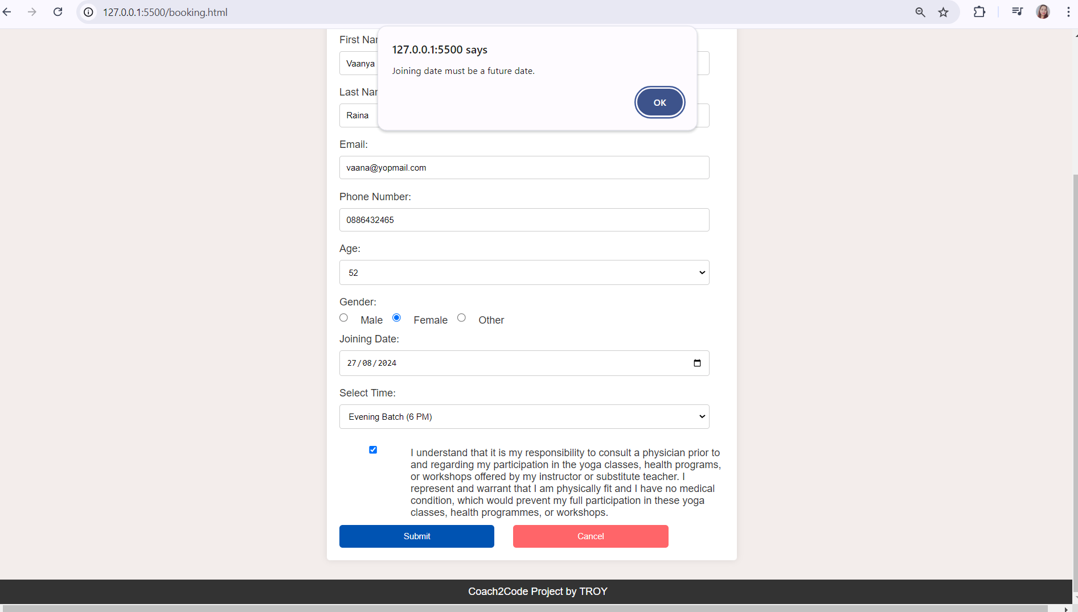

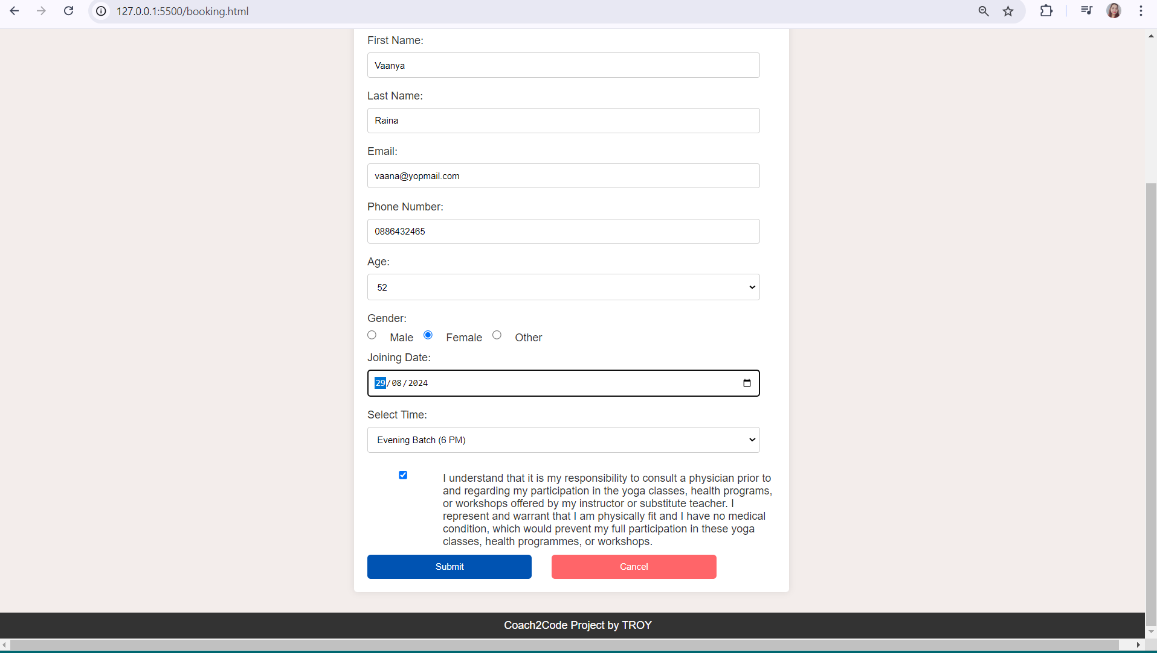

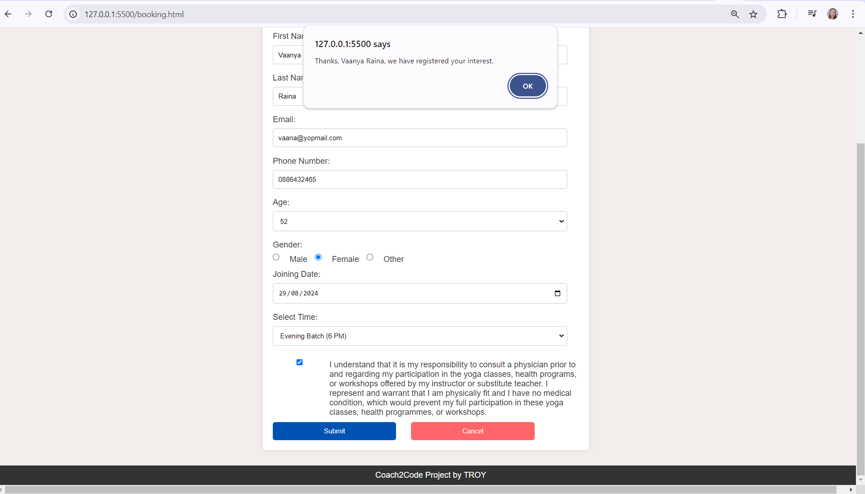

Thanks for C2C team / Community for their continuous support and learning guidance provoided through Codecademy , materials and monthly catch up during this 6 months duration. Thanks to my mentor , Moronke Fajobi for giving us ample support and her time during this C2C journey.